

|  |
| --- |
| How to view contract documents in the Service Agreement Module (SAM) |
|  |

Contents

Introduction 1

What are the contract documents? 1

Using this guide 2

Viewing contract documents 2

Navigate to the Agreements tab 2

Review the contract documents 3

How do I view older agreement versions? 3

Why not use the top level contracts tab? 4

# Introduction

The Service Agreement Module (SAM) in My Agency provides registered users from funded agencies with access to their service agreement information.

As the organisation is legally obliged to comply with the terms and conditions of the service agreement, it is important that the contract documents are reviewed by the organisation on a regular basis.

This document provides information on how to access your contract documents.

Note: My Agency is the secure area of the Funded Agency Channel (FAC) website. If you are not a registered user, refer to [Accessing My Agency](https://fac.dhhs.vic.gov.au/funded-agency-channel/my-agency-non-dhhs-staff#panel-2566) <https://fac.dhhs.vic.gov.au/my-agency-non-dhhs-staff>.

### Important information

Only registered users with Financial access can view service agreement contract information. If the Agreements tabs do not appear you will not be able to access the Contract documents

## What are the contract documents?

In each four year agreement period, for example. 2019-2023, a service agreement commences as version 1. Throughout the agreement period the agreement may be varied several times. Each variation changes the agreement version number, that is version 2, version 3 and so forth.

Each version of the service agreement has three different contract documents on SAM: either a full agreement (version 1) or variation agreement (subsequent versions); the contract payment schedule and the agreed service agreement performance targets.

The full agreement comprises Background; Details of the agreement; Terms and conditions; and Schedules 1 to 3. A variation agreement comprises Details of the variation and Schedules 1 to 3.

While both versions have a signatory pages, this is only required for a first time agreement with a department which can also be approved online. See [How to approve a first time agreement on SAM](https://fac.dhhs.vic.gov.au/how-accept-first-time-agreement-service-agreement-module) for further information.

The organisation signatory receives an email when a variation is available for review. The signatory has approximately five days to review the documents before they become contract. Each variation is deemed approved unless the department is otherwise advised.

# Using this guide

In this document we will show you how to:

* Navigate to the contract tab
* Review contract documents.

A red box outline will identify the area you need to select, action or note in each screenshot. In the example below, we’ve outlined the organisation name.

Example screenshot

Screenshot of the Service Agreement Module, Organisation tab, with the name of the organisation outlined with a red box indicating what should be selected, as described under the Using this guide section.

# Viewing contract documents

## Navigate to the Agreements tab

Log into My Agency and select Service Agreement Module (SAM) – [External Link], located under the Service Agreement Module section at the top of the page.

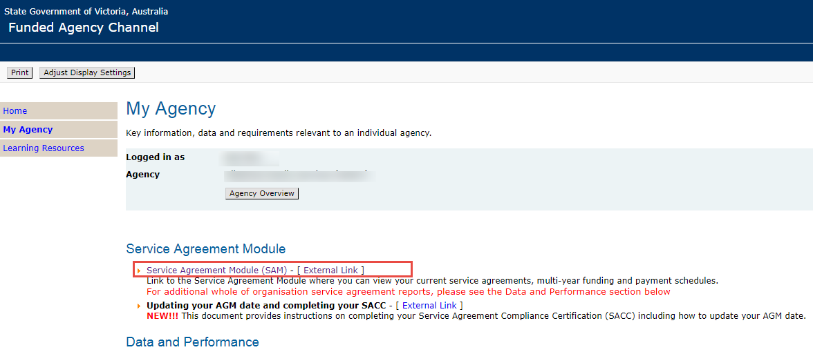

SAM will open in a separate tab or window.

The Organisations tab will default.

Select the Current Agreements tab at the top of the screen.

The current version of each of your agreements will display.

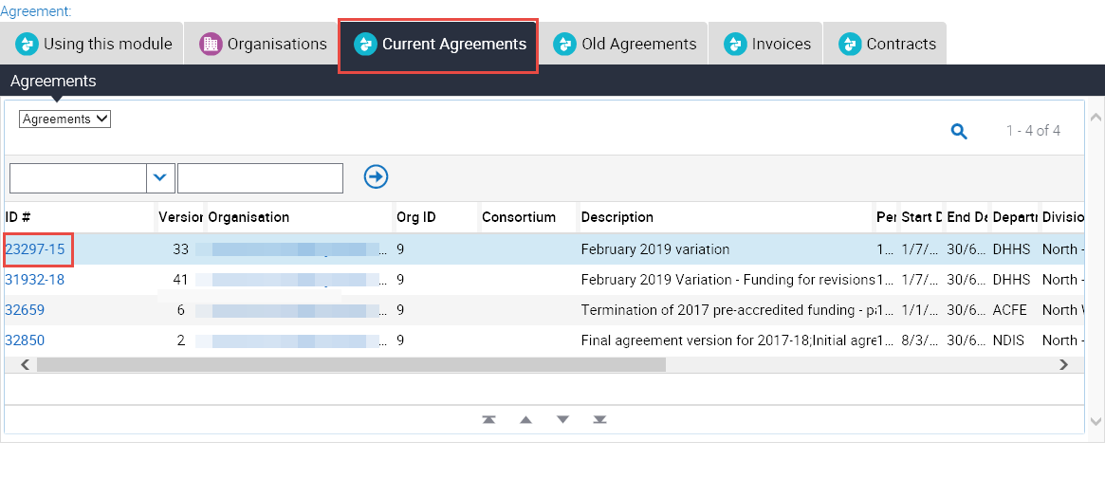

Select the record for the agreement you wish to view by clicking the agreement ID.

The record will open and a series of tabs will display below the summary information.

Select the Contract tabs at the lower level.

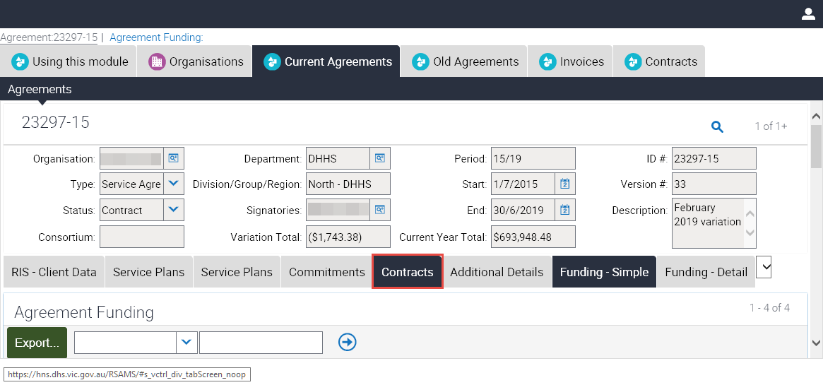

## Review the contract documents

Your organisation’s contract documents will display.

There are three documents for each version of the agreement: the full or variation agreement; the contract payment schedule and the service agreement performance document.

Review all documents to determine whether to approve or reject the agreement. To reject the variation you must contact your department team member.

As previously stated, aach variation is deemed approved unless the department is otherwise advised.

## How do I view older agreement versions?

If your service agreement has a version number higher than one, previous versions can be found via the Old Agreements tab.

You can access this via either the lower or top level tabs. The advantage of using the lower level tab is that you will remain in the same agreement. The top level tabs display every previous version of all agreements with all departments since 2011.

You may have to click the dropdown box to view Old Agreements.

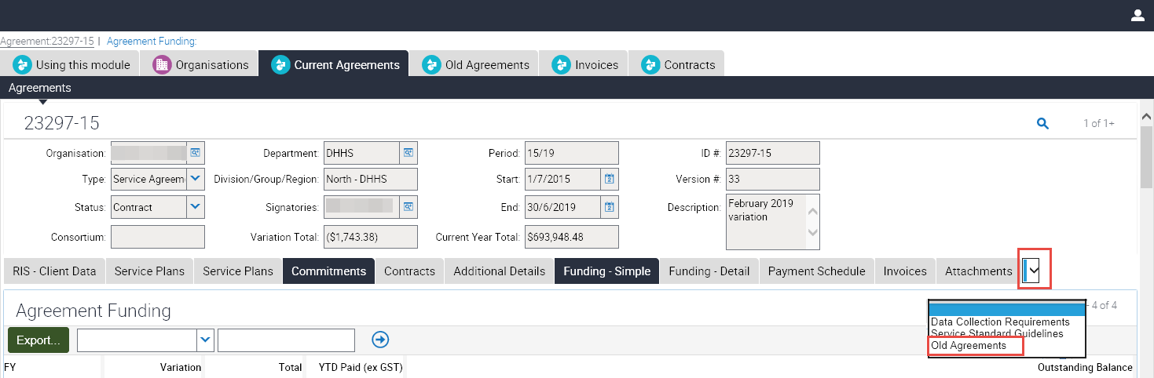

The 20 most recent versions will display but you can use the navigation arrows at the bottom of the screen to scroll through the versions.

Select the version you want then repeat the steps above to view the documents.

## Why not use the top level contracts tab?

The top level Contracts tab displays only five contract documents at a time for the first and most recent version of any service agreement your organisation has held with the all departments since 2011.

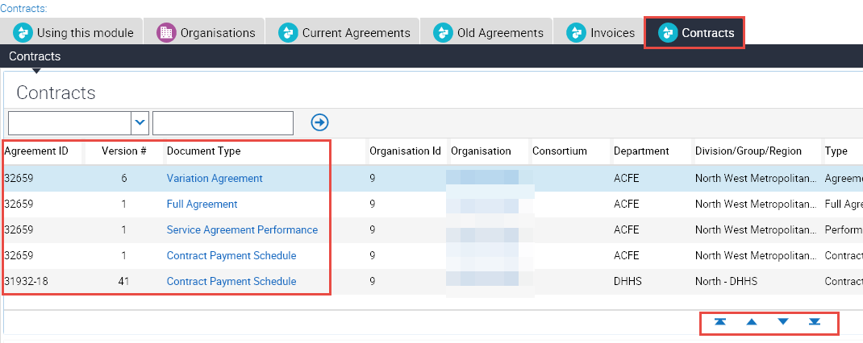

You can sort the records by Agreement ID, Version # or Document Type or scroll through the records to locate your document.

If you know the agreement ID and Version, you can find the relevant contract documents by clicking the Query (magnifying glass) to display the query screen.

Enter the Agreement ID and the version, then click the right arrow to run the query.

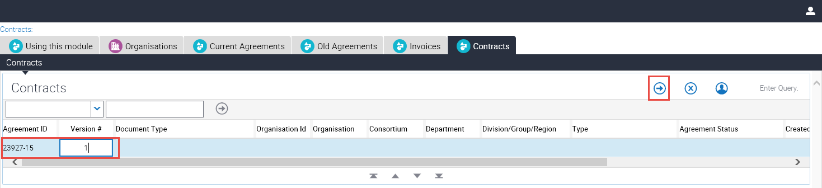 The relevant contract documents will display.

While you can certainly find the document using this tab, the lower lever Contracts tab in the service agreement record is an easier way to find your contract documents.

|  |
| --- |
| For Funded Agency Channel or My Agency enquiries, contact 1300 799 470 toll free. You can also email [fac@dhhs.vic.gov.au](mailto:fac@dhhs.vic.gov.au).  To receive this publication in an accessible format, email the [Funded Agency Channel](mailto:fac@dhhs.vic.gov.au) <fac@dhhs.vic.gov.au>  Authorised and published by the Victorian Government, 1 Treasury Place, Melbourne.  © State of Victoria, Department of Health and Human Services, April 2019.  Available on the [Funded Agency Channel](https://fac.dhhs.vic.gov.au/my-agency-non-dhhs-staff) <https://fac.dhhs.vic.gov.au/my-agency-non-dhhs-staff> |