
IRIS - clients & cases
IRIS training notes
Contents
Background 1
Business rules regarding dates in IRIS 1
Search first 2
Searching for related persons or a child 2
How to enrol a new client 3
Date of birth 3
State, suburb & LGA 4
Other fields 4
Attach case 4
Adding issues, services, related persons & case notes 5
Issues: 5
Related persons: 5
Services: 6
Case notes: 6
Close case 6
Quarterly data export 7
If you require assistance with IRIS 7

Background
The Integrated Reports & Information System (IRIS) is a software tool developed for agencies to use for the collection and reporting of data on funded service delivery to the Department of Health and Human Services (the department) and other Victorian State Government departments. IRIS collects client, case management, and service provision details for departmental funded casework and offers client alerts, key performance indicator and timeline management, referral tracking, integrated reporting tools and automatic data transfer to the department.
This document is for new IRIS users or those who want a refresher in the basic processes of enrolling an organisation’s clients in IRIS and then assigning related persons, cases and services. All IRIS documentation is available by contacting the IRIS Helpdesk (see below.)

Business rules regarding dates in IRIS
Dates in IRIS must follow logical rules.
For example the client’s date of birth must be before the referral date for a case
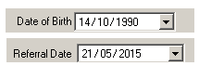
The date of any service provided in a case cannot be before the referral date or after the closure date of the case (although services can be provided on the same day as the case was referred or closed.)
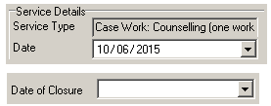
You cannot enter a future date in any of these fields either.
IRIS will not let you close a case if these rules are not followed.

Search first
Before recording a client’s details in the IRIS database you should always search to check whether the client is already listed. IRIS databases often have multiple users and it is possible for clients’ entries to become duplicated. Client duplication causes data entry errors, (cases spread across different entries) and interferes with IRIS alerts, client management and reporting.
- Click the Clients button on left hand side. The Client List screen appears.
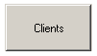
- Search for your client using any of the fields under Search Filter Options. A typical search will use the client’s first name or surname. If you are unsure of the spelling, you can use an asterisk as a wild card. In the case of SMITH, SMITHE, or SMYTH type in *sm (the search fields are not case-sensitive).
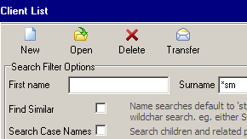
Ticking the Find Similar checkbox can also help in this regard.
- Problems can occur if IRIS has multiple entries for a single client, so make sure you tick the Include Inactive checkbox when you search so that previously deactivated clients can be found and reactivated when service provision resumes.
- Click Search or Refresh to search the database. If the client is already in your database they will show in the Client List below.
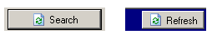
- An inactive client should be reactivated rather than enrolling them a second time so that correct and complete client histories can be maintained and accessed. To reactivate a client click the Edit button at the top right of the client information screen then put a tick in the Active checkbox.
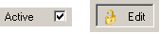.
- If the search does not return the client you can enrol him or her as a new client (see below.)
- If the search returns duplicates see ‘Client Merge’ in IRIS’s help menu.
- If the client is already enrolled and active in the client list double click (or highlight and click Open) to access the client’s information.
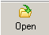
Note that if the Current Only checkbox is ticked, the search will only return clients who have open cases and will not search the entire client list, allowing client entry duplications to occur.

Searching for related persons or a child
For some case types (Family Services, MCH Enhanced Home Visiting, Stronger Families and Indigenous In-Home Support) it is important to be able to search for related persons or a child. This method of searching is the same as searching for a client, except that the Search Case Names option must be ticked.
A positive search will return the IRIS client to which the related person or child was attached in a case. For example searching case names for surname ‘Brown’ may bring up a client with the surname ‘Smith’. The related person or child with the name Brown is in a case belonging to the client named Smith.

How to enrol a new client
- Click Clients then New to display the New Client screen (Figure 1)
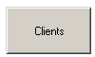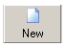
- Complete all mandatory fields (highlighted in yellow) and add any other information you want to then click Apply.
Date of birth
Type the date in DDMMYYYY format (for example 01031990). The day month and year can be increased or decreased by highlighting the required section and clicking the up or down arrows.
If you don’t know the client’s data of birth, put a tick in Declined DoB field. You can remove the tick later and enter the correct date when you know it.

Clicking the large down arrow will produce the calendar and today’s date will appear in the date field.
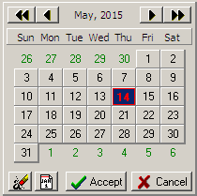

The date can be altered by clicking on the inner back and forward arrows for month and the outer back and forward double arrows for year and any date square can be selected by clicking on it.

Figure 1 New Client screen
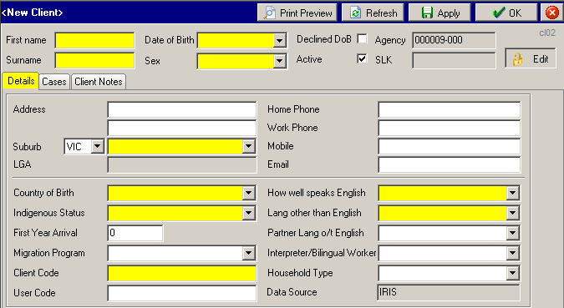

The buttons at the bottom of the calendar (L to R)
- Clear the date, leaving 00/00/0000
- Enter today’s date
- Accept and save the date you have entered
  - Cancel

State, suburb & LGA
Select a state (default is VIC) and the relevant suburbs will be available in the Suburb field. Type the first few letters of the suburb name or click the dropdown to view suburb list. Click to select.
The local government area will automatically appear in the LGA field once a suburb is selected.
If you don’t know the suburb, type ‘not’ and ‘Not known’ will become available.
If the client is from interstate (a state not in IRIS) type ‘int’ into the Suburb field and IRIS will select ‘Interstate’.

Other fields
If you don’t know the information for the following fields:
- Country of Birth
- Indigenous Status
- How Well Speaks English
  - Language Other Than English
You can select ‘Did not meet client – could not ascertain’, which is a catchall for ‘Do not know the information’ or ‘None of the above apply’.
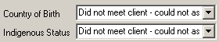

Client Code is a unique ID number for your client. IRIS does not generate the Client Code so your agency will need to have an appropriate client numbering system. If your agency does not have a client numbering system, contact the IRIS Helpdesk.
User Code is not compulsory, but is a text field provided for the agency’s own use to give information and alerts to staff. Some examples of its use include:
- To indicate that the client is on the waiting list,
- To allocate the client to a case worker,
  - To indicate that there is something that the agency staff member should know before they contact the client, for example: client’s partner is aggressive or client works on certain days so don’t call home number on those days, shift workers at the client’s house would prefer not to get calls during certain hours, order an interpreter for the client when booking appointments, etc.
- Once all mandatory fields have been completed, click the Apply button to save the new client.
- Select the Client Notes tab.
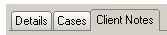
Useful (but not confidential!) information can be entered here. For example: days client would prefer to be contacted; times client would prefer not to be called (eg due to shift workers or nap time for baby); whether to identify agency to your client’s partner or family; if your client’s partner or family is aggressive. You may also indicate in the User Code field that there is something in the client notes screen that should be read.

Important:
- Never put information in the Client Notes screen regarding client’s issues or counselling – put this information in Case Notes (see below).
- Notes are not exported to the department.
  - Use the Apply button frequently to save your work.

Attach case
- Select the Cases tab and click New Case button on the right side of the screen (see Figure 2 below)

Figure 2 Cases tab
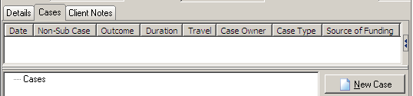

- The Select Case dialog box will appear listing all the case types that your agency has funding for and that you have permission to use. Select the case type you require and click OK.
- Complete all mandatory fields (highlighted in yellow) then click Apply.
Reference Code is a unique code automatically generated by IRIS for each case.
Case Code is a non-compulsory 16 character free text field for the agency’s own use, similar to User Code, where a case can be labelled.
The Case Details tab contains a set of standard questions in the top section with questions specific to the case type in the area below.
For MCH Enhanced Home Visiting and Indigenous In-Home Support case types, details of each child receiving services are entered by clicking the ‘New’ button on the Case Details tab – do not put children receiving a service in the Related Persons tab.
When you click New the First name window appears.
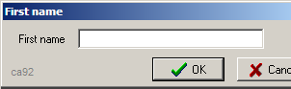
Type the child’s first name and click OK and a screen for the rest of the child’s details appears. Complete all the mandatory fields in it then click Apply to save the child. For each additional child receiving service click New and enter their details. The list of children grows as required.
Use the Apply button frequently to save your work.

Adding issues, services, related persons & case notes
Some case types do not have an Issues tab and some do not have a Services tab. Agencies providing these case types can ignore the steps for Issues and Services where not relevant.
If a tab is displayed and is yellow that means that at least one Issue/Service must be added before the case can be completed.

Issues:
- At least one issue must be added if the Issues tab displays yellow as in the image below.
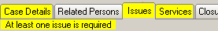
- To record an issue click the Issues tab then click New.
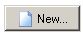
- Add as many issues as are applicable to your case by placing ticks in the appropriate check boxes. (The issues show how complex the client is.)
- Complete as much information as you can under ‘Selected Issue Details’. It is OK to leave some mandatory fields yellow for now but you must complete them before closing the case.

Related persons:
- For MCH Enhanced Home Visiting and Indigenous In-home Support case types add children receiving services by clicking New in the Case Details tab.
Otherwise select the Related Persons tab and click New to display the relationships window. Family Services and Stronger Families cases must have at least one related person aged between zero and sixteen who is a child, step child, foster child, grandchild or unborn child.
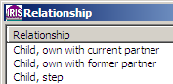
- Select the closest matching relationship from the list. The list is not exhaustive so select the best fit and click OK.
- Enter the person’s name, complete all mandatory fields then click Apply. If the related person’s age is unknown you can estimate. If the relationship is ‘unborn child’ enter zero (0) for age. Entering date of birth will automatically calculate age. Remember, you can complete any or all of the white fields, but the yellow fields must be completed in order to save the data.
- Any tabs with unfilled mandatory fields will turn yellow to help you identify what still needs to be completed.
- Use the Apply button frequently to save your work.

Services:
- At least one service must be recorded if a services tab displays yellow as in the image below. To add a service select the Services tab and click New.
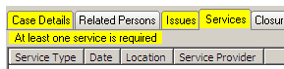
- Select the appropriate service type from the list then click OK. Expand the list of options by clicking on the plus signs (+) so you can see the full list.
- Complete all mandatory (yellow) fields for the service then click Apply before adding another service.
- Some fields are set automatically but can be changed if you want:
Date will default to today’s date
Service Provider will default to the person who is logged in (you).
Suburb will default to the outlet this person selected when logging in.
- Repeat to add as many services as required. New services should be added every time you do work for the client, whether it is direct (face-to-face) or indirect (on behalf of the client).
- Use the Apply button frequently to save your work.

Case notes:
Adding case notes in IRIS is not mandatory - It is up to you and your agency to decide whether to use notes in IRIS. Notes in IRIS have a spell checker with a range of options for its use.
Notes are NOT exported to the department.
- Select the Case Notes tab and click New.
- Enter text by typing directly into the text window or cut and paste from other documents. If your agency has templates enabled click the Load Template button to select a template. Add extra text to complete the note.
- Click Apply regularly to save your notes

Close case
When appropriate a case should be closed in IRIS. To close a case all mandatory fields must first be completed. Incomplete mandatory fields and their related tabs appear highlighted in yellow and the Status will display as Open (Incomplete).
- Complete all mandatory fields in the case then click Apply. Status will change to Open (Complete)
- Select the Closure tab and click Update Case Status
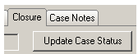.
The Update Case Status window contains instructions on how to close the case, the case closure data fields and the Case Closure Checklist. If any mandatory fields remain unfilled the checklist will indicate the incomplete tab(s)
- Enter the Date of Closure in the dialogue box keeping in mind that it cannot be a date in the future and it cannot be before the date of last service (It must be the same day or later.)
- Complete the Point of Closure, Reason for Closure and Case Outcome then click OK
- Click Apply. The case status will change to Closed.
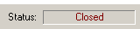
- Click OK twice to return to the Client List screen.
- If the client does not have any other open cases you may want to make them inactive so that they don’t keep appearing in your active client list. If the client later returns to your agency you can reactivate their entry. It may also be good practice to label inactive clients in the User Code field.
Important: If a case is still open do not make the client inactive.

Quarterly data export
When your organisation’s administrator does the quarterly data export, an encrypted IRIS data export file will be automatically sent via email to the department. All data regarding clients with open or closed cases will be included in the export, except for information that will identify the client or their related persons. IRIS case notes and client notes are not sent with the quarterly data export.
For instructions on the quarterly data export, see ‘IRIS training notes – IRIS quarterly data export process’. All IRIS documentation is available from the IRIS Helpdesk or your IRIS trainer. If you require assistance with the quarterly data export please contact the IRIS Helpdesk.

If you require assistance with IRIS
Please contact the IRIS Helpdesk on (03) 9096 6919 or IRIS.Helpdesk@dhhs.vic.gov.au
More information on IRIS can be found in the IRIS User Guide which is included with the IRIS installation. Data dictionaries and other IRIS resources are also available. Ask the IRIS Helpdesk or your contact person within the department.

To receive this publication in an accessible format phone 03 9096 6919, using the National Relay Service 13 36 77 if required, or email IRIS.Helpdesk@dhhs.vic.gov.au
Authorised and published by the Victorian Government, 1 Treasury Place, Melbourne.
© State of Victoria, October 2015
Available at the Funded Agency Channel website <www.dhs.vic.gov.au/funded-agency-channel/information-technology>

