
eBusiness Organisation Authority validation instructions
OFFICIAL

To validate requests for your organisation, please log into eBusiness here - https://eus.webapp.dhs.vic.gov.au/EUSPortal/
Once you have logged in, please select the Enterprise User Service under My Applications
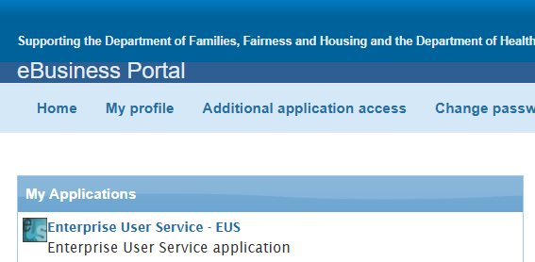
Once you have opened EUS, please select Validate Registration on the left.
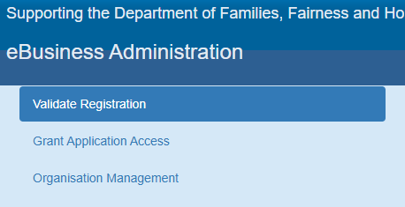
You can then click the Request ID number, confirm the user’s details, and select accept and validate at the bottom.
To receive this document in another format, email <FAC@dffh.vic.gov.au>.
Authorised and published by the Victorian Government, 1 Treasury Place, Melbourne.
© State of Victoria, Australia, Department of Families, Fairness and Housing, August 2026.
ISBN 978-1-76171-225-8 (MS word)
Available at Funded Agency Channel <https://fac.dffh.vic.gov.au/>

