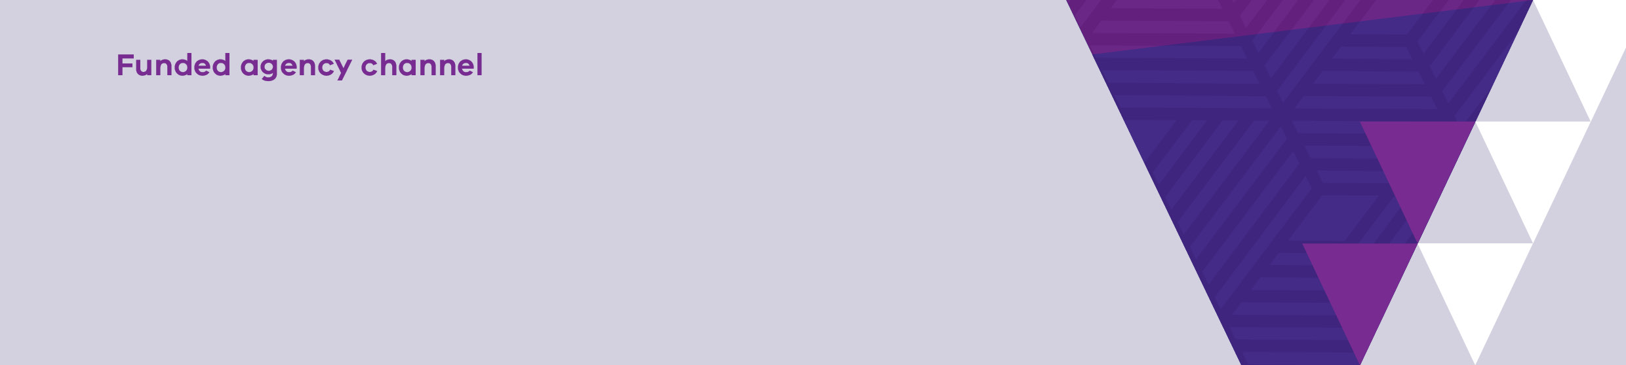
Service Delivery Tracking manual submission
Quick Guide
OFFICIAL

Navigating to the acquittal tab
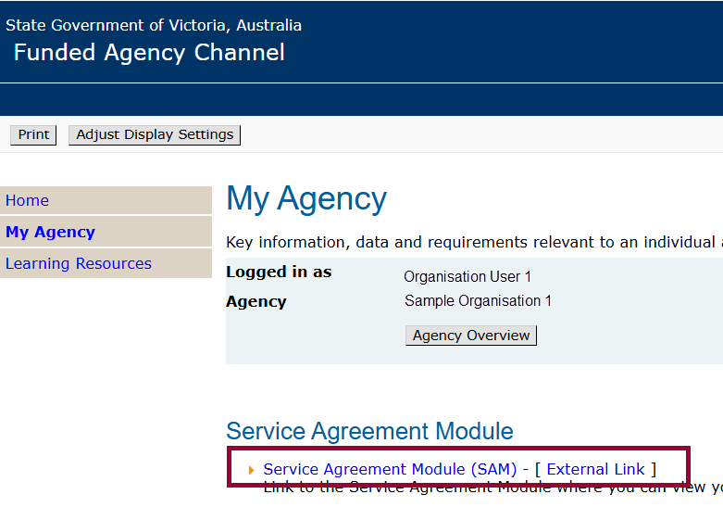
Log into My Agency and click on the Service Agreement Module (SAM) link

Manually Completing the Acquittal template
The Acquittal template can be completed manually by entering the data directly in the screen.
- After logging into the Service Agreement Module (SAM), click on the Acquttial tab
- Under the Actual Responses section of the screen, select the month for which data is to be submitted
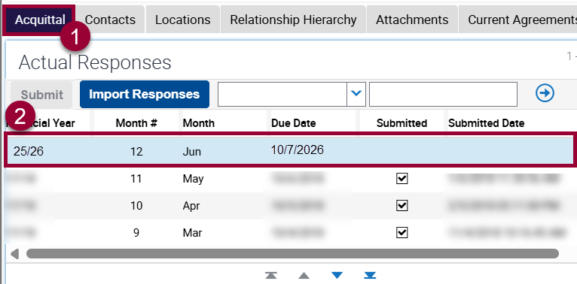
- Scroll down to the Actual Response Details section of the screen
- And then across to the Actual Units and Comments fields
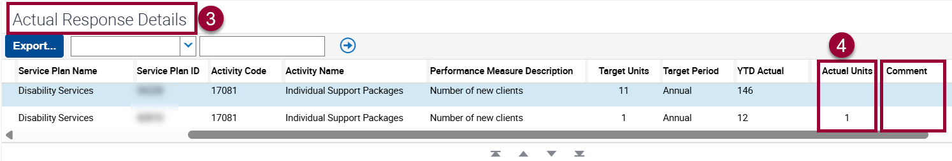
- Against each activity, enter the actual number of units delivered in the month in the Actual Units field. If services are provided across multiple divisions and areas, enter only the data relevant to the Division/Group/Region and Service Plan Area specified in the Service Plan Division/Group/Region and Service Plan Area fields.
- Comments are not mandatory, but should include explanations for targets not being met, and remediation strategies, where applicable. To maintain client confidentiality, client details should not be included.
Up to 1,000 characters can be entered in the Comment field. It is advisable to enter summarised comments in the field, and it is recommended to limit these to around 255 characters.
- Save at any time by pressing and holding the ctrl and then S keys.
- Once all the Actual Units fields have been completed, the Submit Button in the Actual Responses section becomes enabled. Click the Submit button
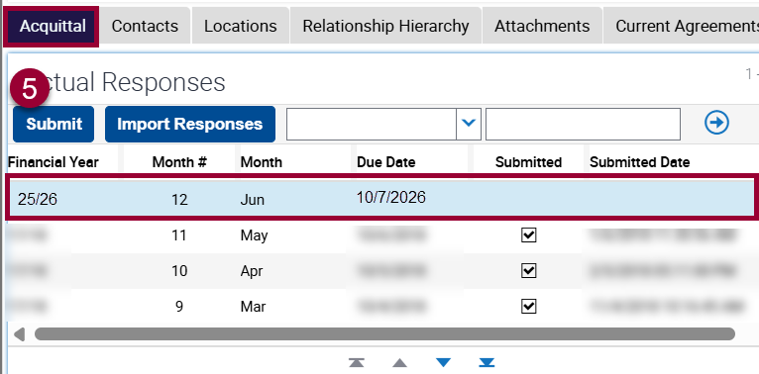
- The Submit and Import Responses buttons become disabled and the Submitted, Submitted Date and Submitted by fields are automatically completed. 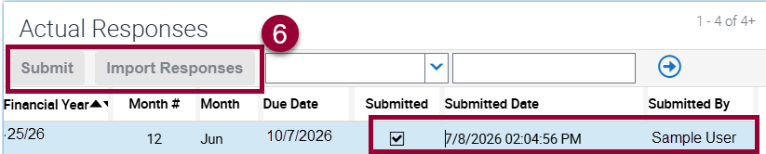
To receive this document in another format, email <FAC@dffh.vic.gov.au>.
Authorised and published by the Victorian Government, 1 Treasury Place, Melbourne.
© State of Victoria, Australia, Department of Families, Fairness and Housing, August 2026
Available at Funded Agency Channel <https://fac.dffh.vic.gov.au/>

