

How to approve a first time agreement in the Service Agreement Module (SAM)
Contents
Introduction 1
What is a first time agreement? 1
Are you the organisation signatory? 1
Using this guide 2
Approving a first time agreement 2
Navigate to the first time agreement 2
Review the contract documents 3
Approve a first time agreement 3
Reject a first time agreement 3

Introduction
The Service Agreement Module (SAM) in My Agency allows funded organisations to access their agreement information and update records and documents through interactive modules.
One of these modules provides organisation signatories with the ability to approve first time agreements online.
Note: My Agency is the secure area of the Funded Agency Channel (FAC) website. If you are not a registered user, refer to Accessing My Agency <https://fac.dhhs.vic.gov.au/funded-agency-channel/my-agency-non-dhhs-staff>.

What is a first time agreement?
A first time agreement is in place when an organisation receives funding for the first time in an agreement period under a service agreement. Four year agreement periods are as follows: 2015-2019, 2019-2023 etc. If your organisation already has a service agreement with the same department in the current agreement period, it is not a first time agreement and does not require approval.
Similarly, agreements rolled over from a previous year, and any variations to a current agreement are not a first-time agreement and do not require approval. If you do not agree with the details of a variation or rolled over agreement, contact the relevant department team member to discuss.

Are you the organisation signatory?
Only the organisation signatory can approve a first time agreement. In many cases, the Primary Contact and Signatory is the same person.

Using this guide
In this document we will show you how to:
- Navigate to a first-time agreement
- Review contract documents
- Approve or reject a first-time agreement.
A red box outline will identify the area you need to select, action or note in each screenshot. In the example below, we’ve outlined the organisation name.
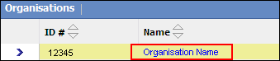

Approving a first time agreement

Navigate to the first time agreement
Log into My Agency and select Service Agreement Module (SAM) – [External Link], located under the Service Agreement Module section at the top of the page.
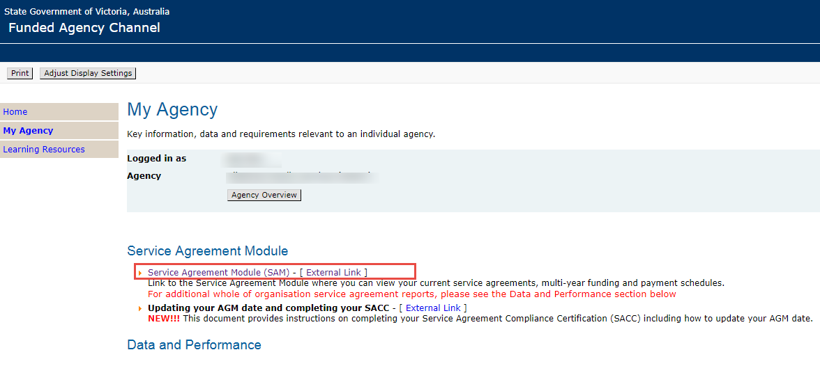
SAM will open in a separate window. The Organisations tab will default. Select the Current Agreements tab at the top of the screen.
Under the heading Signatories, the name of your organisation’s signatory will display. If you’re the signatory, you may proceed. If you are not the signatory, you will not be able to approve the first time agreement.
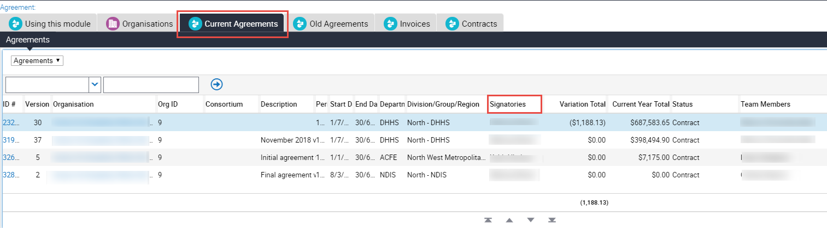

Review the contract documents
Select the Contracts tab. Your organisation’s contract documents will display. There are three documents for each version of the agreement: the full agreement; the contract payment schedule and the service agreement performance document.
Review all documents to determine whether to approve or reject the agreement.

Approve a first time agreement
If you are the signatory for your organisation, you will see a record to approve or reject.
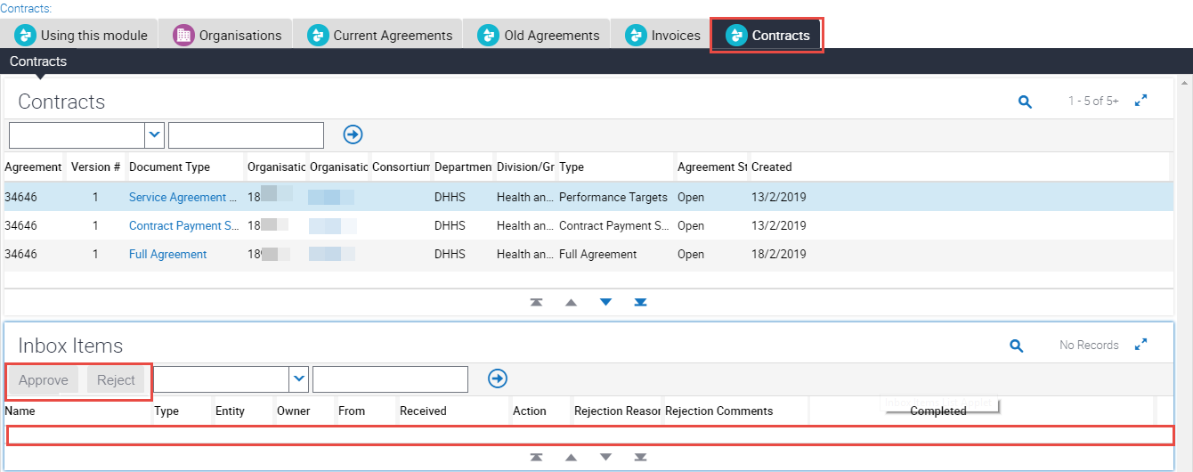
If you choose to approve the agreement, select Approve, read the statement that appears and select Yes, accept.
Once you accept, the agreement is approved and no further action is required.

Reject a first time agreement
You may, after reviewing the contract documents, choose to reject the agreement.
Select Reject, and a reason for the rejection from the drop down list. Write an explanation in the Comments section, and select Yes, reject.
Once rejected the contract documents are no longer visible. Your department team member will renegotiate the details and regenerate the contract documents. You will receive an email when these documents are available for viewing.

For Funded Agency Channel or My Agency enquiries, contact 1300 799 470 toll free. You can also email fac@dhhs.vic.gov.au.
To receive this publication in an accessible format, email the Funded Agency Channel <fac@dhhs.vic.gov.au>
Authorised and published by the Victorian Government, 1 Treasury Place, Melbourne.
© State of Victoria, Department of Health and Human Services, April 2019.
Available on the Funded Agency Channel <https://fac.dhhs.vic.gov.au/my-agency-non-dhhs-staff>

