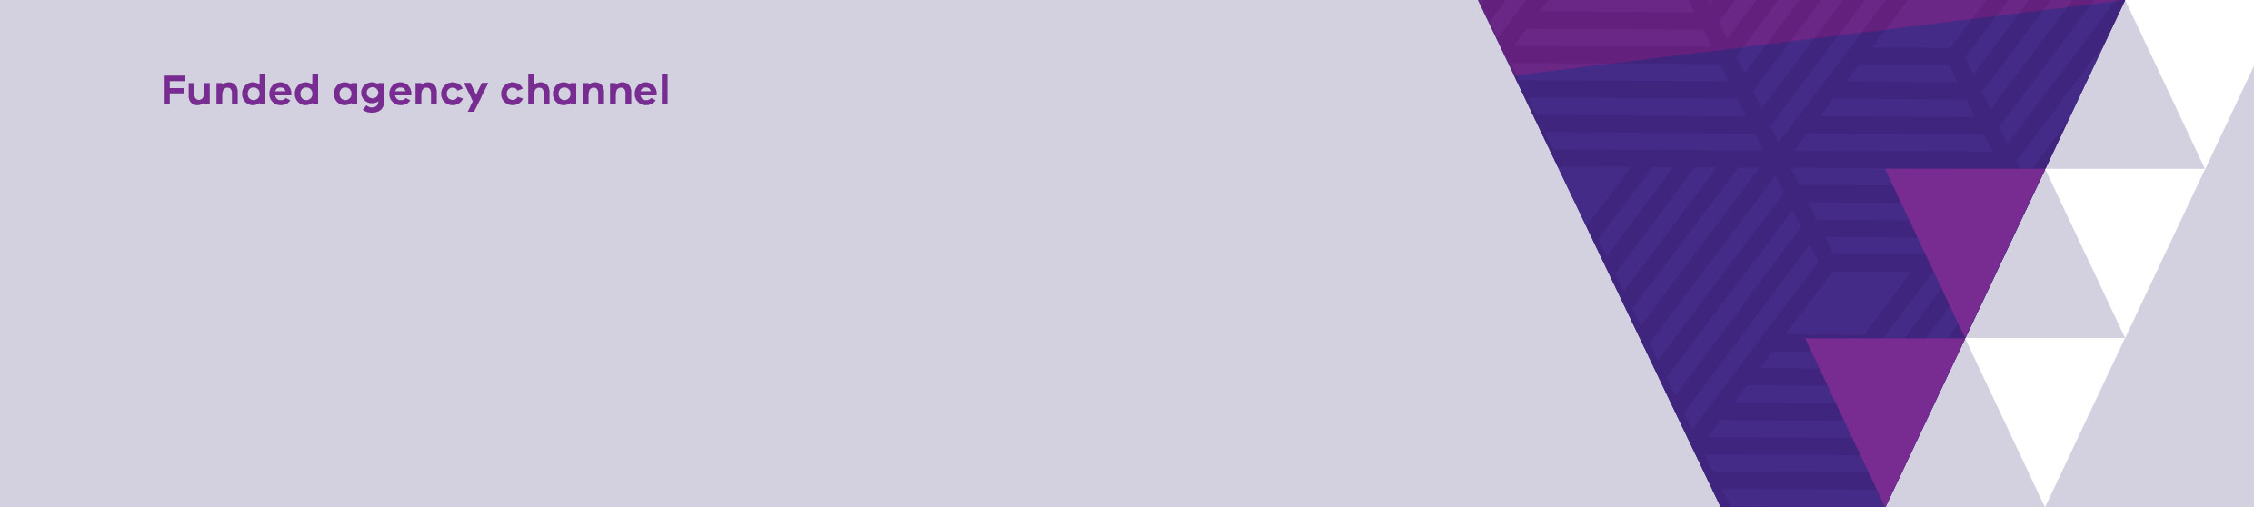
Multiple organisation access to My Agency and the Service Agreement Module (SAM)
OFFICIAL
Contents
What is multiple organisation access? 1
Requesting multiple organisation access 1
Authorisation and confirmation of multiple organisation access 1
How to access another organisation in My Agency 2
Accessing the Service Agreement Module (SAM) 2

What is multiple organisation access?
My Agency and SAM users may have a role with more than one related organisation, which may be under ‘Common Ownership,’ connected Health Services, Neighbourhood houses, or other organisation types. Access to multiple organisations is required in these instances to be able to login once, and switch between organisations.

Requesting multiple organisation access
Only one eBusiness account is required to access multiple organisations in My Agency and SAM, however, depending on the role and organisations requested, a separate eBusiness account may be required. For example, if a user is an employee of an organisation and a volunteer with an unrelated organisation, separate login credentials would be required.
To request additional organisation access, email the Funded Agency Channel (FAC) Helpdesk fac@dffh.vic.gov.au listing the organisation(s) you currently have access to, and the additional organisation(s) you require. You do not need to request any additional access via eBusiness, requests submitted through this channel will be declined as they are not required.

Authorisation and confirmation of multiple organisation access
The FAC helpdesk will seek authorisation from the primary contact(s) of the additional organisation(s). Once authorised, multiple organisation access will be configured and a confirmation email sent to the requester.

How to access another organisation in My Agency
On receiving your confirmation email log in to My Agency. You will be presented with the following text.
“You currently belong to more than one agency on the Funded Agency Channel. If you want to change to another agency, please click on the link ‘Change to another agency’ on the left navigation sidebar.
- Click on ‘Change to another agency’ link on the left had side of the screen.
- The Change Agency screen will be displayed. Click on the organisation you wish to view.
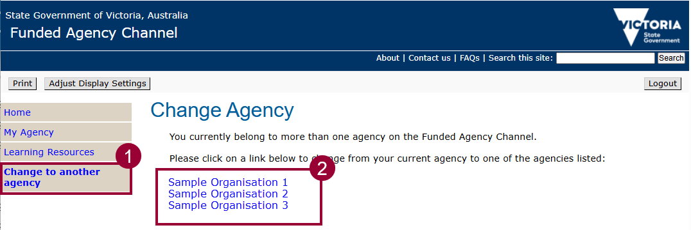 Figure 1 Change Agency screen

Accessing the Service Agreement Module (SAM)
Click the Service Agreement Module link to enter SAM.
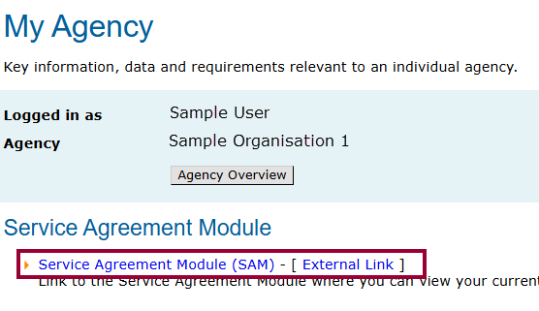
Figure 2 - Service Agreement Module link

In SAM:
- A list of organisations a user can access are displayed, click on the link to drill into the organisation record.
- the number of organisations available are displayed, up to 20 can be displayed on the screen.
- if there are more than 20 organisations available, use the scroll buttons at the bottom of the screen to move between screens.

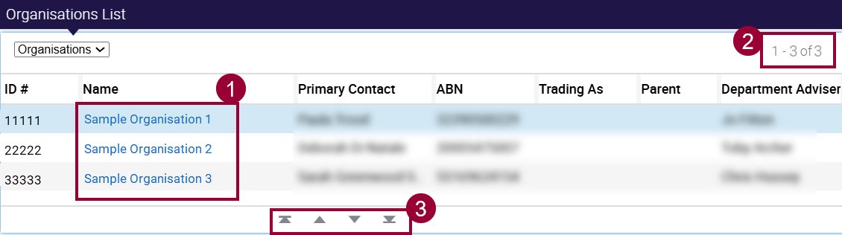
Figure 3 - List of the available organisations in the Service Agreement Module
Contact us to receive this document in another format. Please email Service Agreement Performance branch Communications team SAComms@dffh.vic.gov.au
Authorised and published by the Victorian Government, 1 Treasury Place, Melbourne.
© State of Victoria, Department of Families, Fairness and Housing, May 2026
ISBN 978-1-76171-111-4 (MS word)
Available on the Funded Agency Channel <https://fac.dffh.vic.gov.au/>
For further assistance, contact the Funded Agency Channel helpdesk FAC@dffh.vic.gov.au

