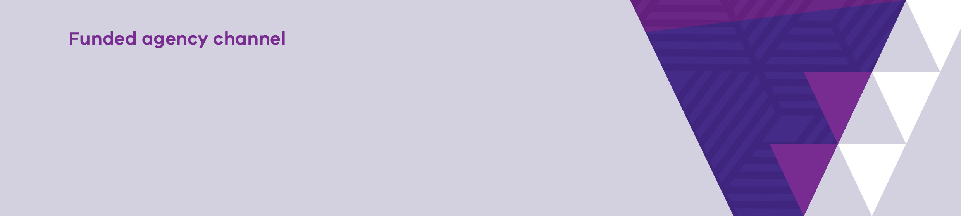
Change your eBusiness profile details

Contents
What is eBusiness? 1
What is my eBusiness profile? 1
How to change your business profile details 1
Help 5

What is eBusiness?
For all users other than Department of Health and Department of Families, Fairness and Housing employees the eBusiness Portal is the entry point to many applications including My Agency.

What is my eBusiness profile?
Your eBusiness profile contains your personal information and is created when you register for eBusiness. If you wish to change your profile details, you can do so via the eBusiness Portal. Profile details that can be changed include your:
• Email address
• Business phone number
• Mobile phone number
• Security question and answer (labelled personal question and personal answer)

How to change your business profile details
- Log into the eBusiness Portal via https://eus.webapp.dhs.vic.gov.au/EUSPortal/
- On the eBusiness Login page, enter your username and password. Select the Login button.
Note: You must tick the check box stating you have read, understood and agree to abide by the Conditions of Use and Monitoring of Computer Services to proceed. Please ensure that you have read and understood them. A copy can be found by clicking on the hyperlinks or selecting the Conditions of Use or Monitoring of Computer Services tabs at the top of the screen.
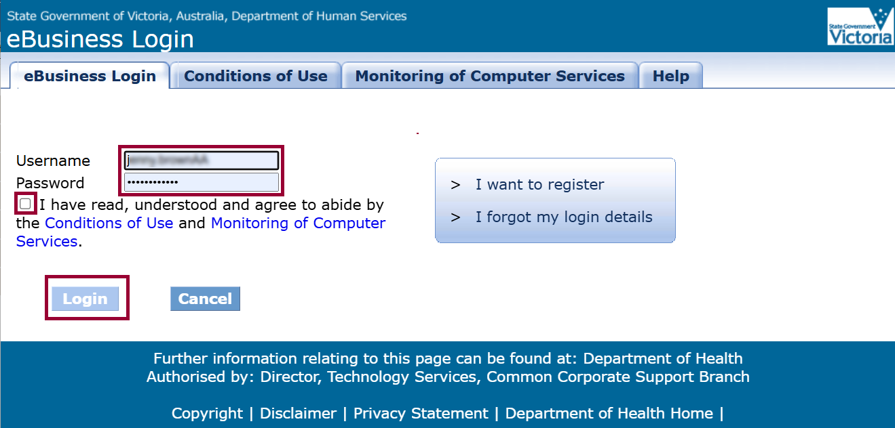

Figure 1 Screenshot of the eBusiness Login page
- The eBusiness Portal screen displays. Select My Profile.
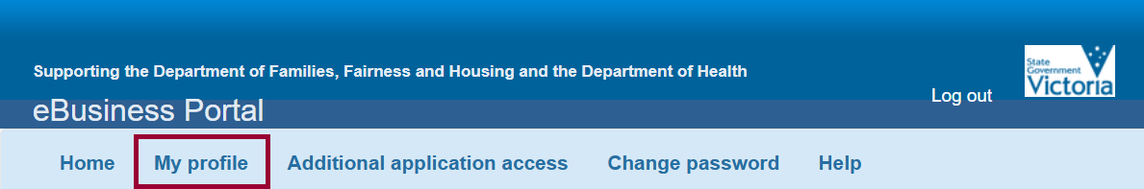

Figure 2 Screenshot of eBusiness Portal page
- The My Profile screen displays, with your current registered details shown. Change the fields you wish to update, ensuring all mandatory fields, indicated by a red star, are completed.
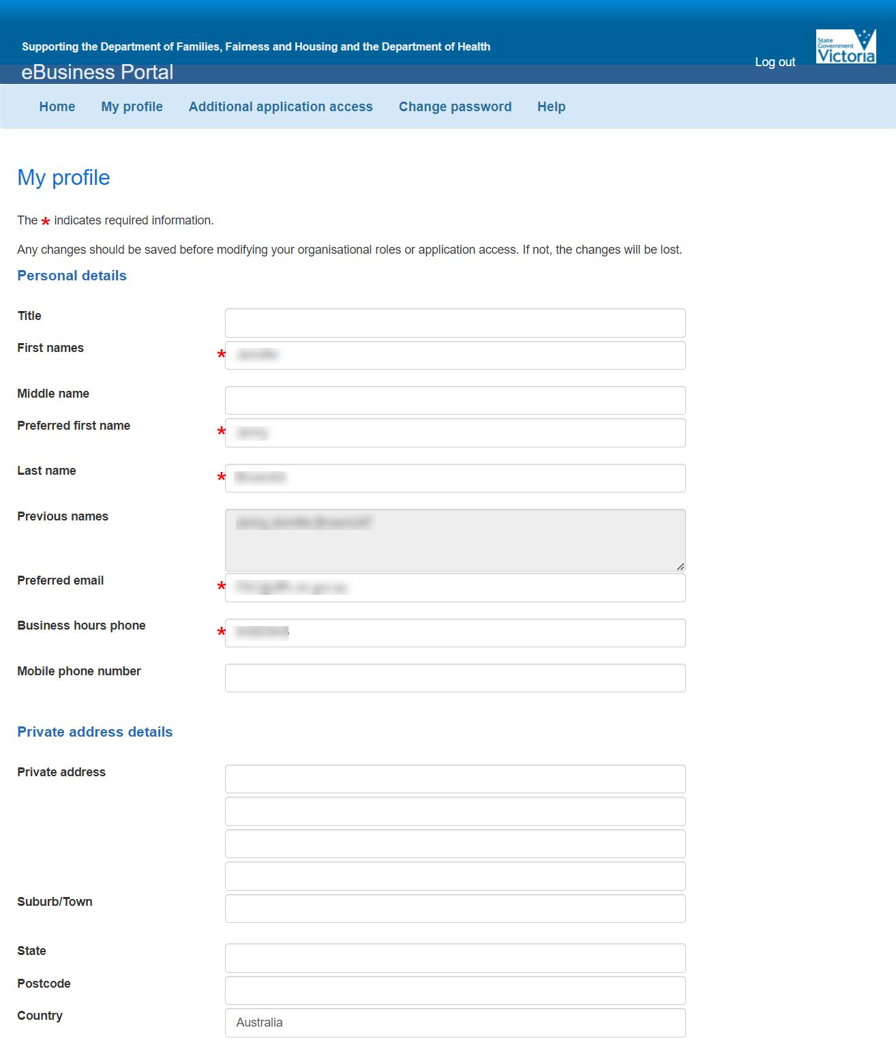
Figure 3 Screenshot of 1st half of the My profile screen
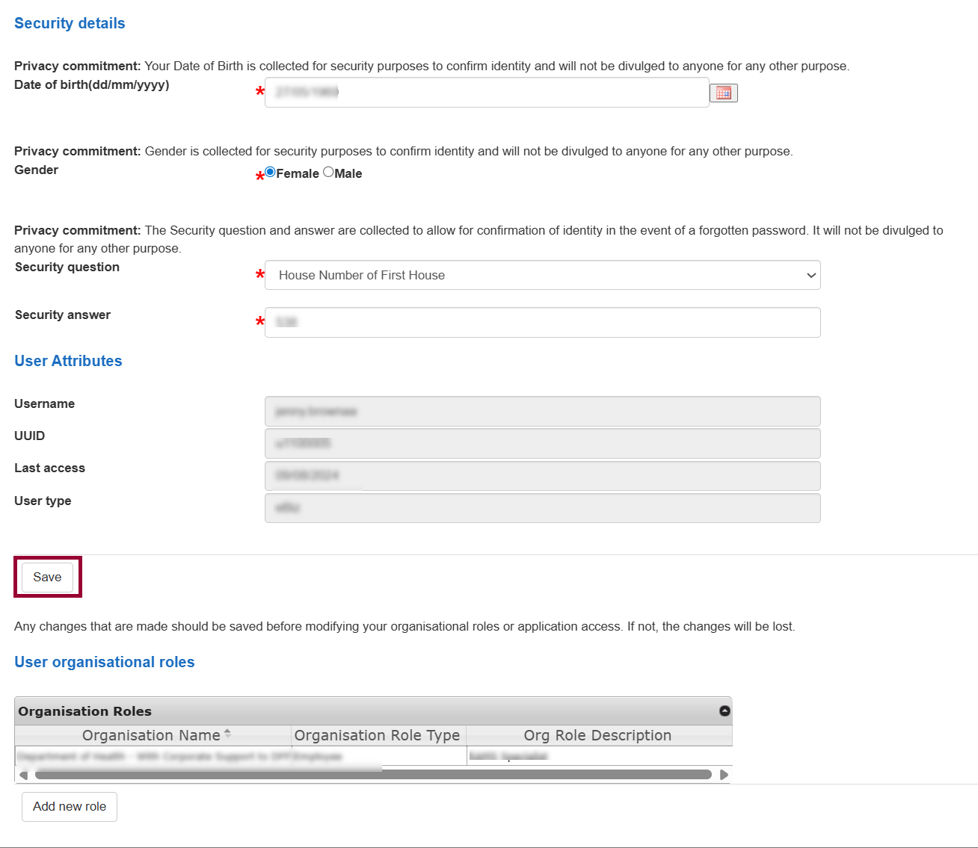
Figure 4 Screenshot of the 2nd half of the My profile screen
- Press the Save button.

- The Confirm your profile updates screen displays. Check that the changed details are correct. If yes, select the Confirm button. If no, select the Cancel button to start again. 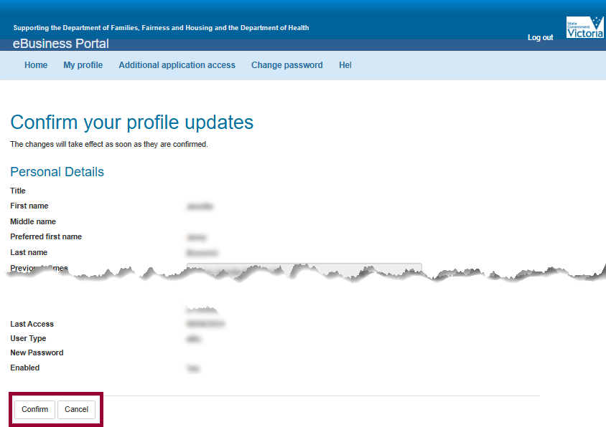
Figure 5 Screenshot of Confirm your profile screen
- Confirmation message displays.
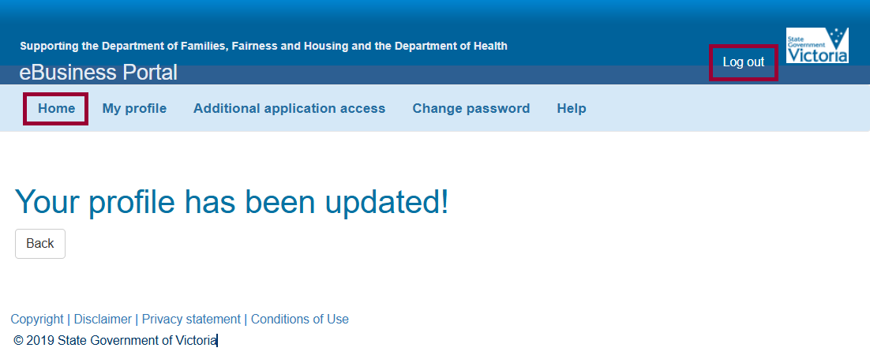
Figure 6 screenshot of the confirmation of your profile has been updated
Select the Home tab to return to the eBusiness Portal page or select Log out to end the session.
If you experience any difficulties updating your profile, please contact the eBusiness helpdesk at eBiz@support.vic.gov.au

Contact us to receive this document in another format. Please email Service Agreement Performance branch Communications team SAComms@dffh.vic.gov.au
Authorised and published by the Victorian Government, 1 Treasury Place, Melbourne.
© State of Victoria, Department of Families, Fairness and Housing, May 2026
ISBN 978-1-76171-122-0 (MS word)
Available on the Funded Agency Channel https://fac.dffh.vic.gov.au/change-your-ebusiness-profile-details

