
How to access My Agency and the Service Agreement Module (SAM)
OFFICIAL
Contents
Accessing My Agency and SAM 1
Via the Funded Agency Channel website 1
Via the eBusiness Portal 2
Troubleshooting 3

Accessing My Agency and SAM
Access is via the eBusiness portal either directly or via the Funded Agency Channel website.

Via the Funded Agency Channel website
You can navigate to My Agency from the Funded Agency Channel website https://fac.dffh.vic.gov.au/ by clicking on the tile titled My Agency login on the homepage.
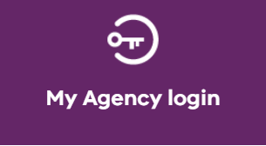
Figure 1 The My Agency login tile
This will take you to another page titled ‘Access the system’ where a link titled My Agency login is displayed in a box as per below
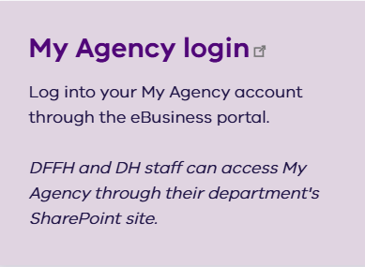
Figure 2 The My Agency login box

When you move your mouse over the box, it will change colour and the link will become underlined
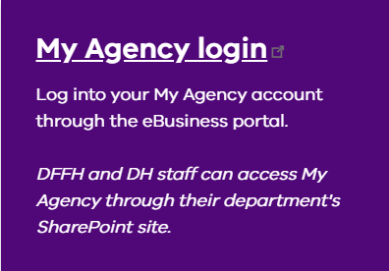
Figure 3 The My Agency active link
You will then be redirected to the eBusiness Login screen.

The eBusiness Portal
- To access via eBusiness go to the portal https://eus.webapp.dhs.vic.gov.au/EUSPortal/ and from the eBusiness Login tab
- enter your Username and Password
- read the conditions of use and tick the checkbox
- click on the Login button.
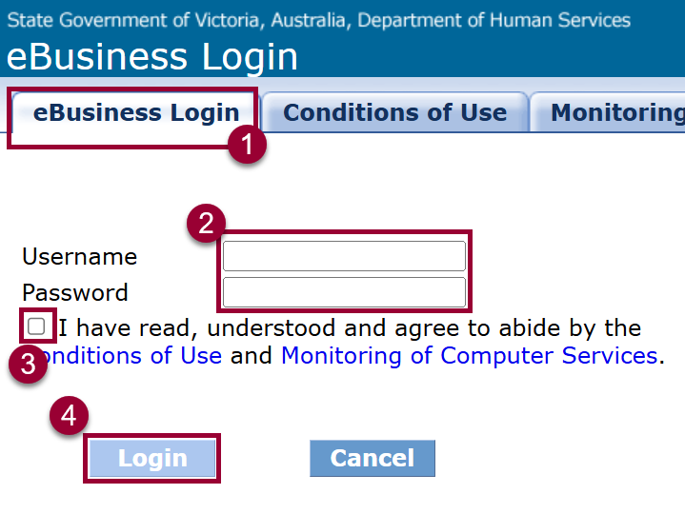
Figure 4 screenshot of the eBusiness login form

You will be presented with a list of the applications you have access to via the eBusiness portal.
Click on Funded Agency Channel – My Agency
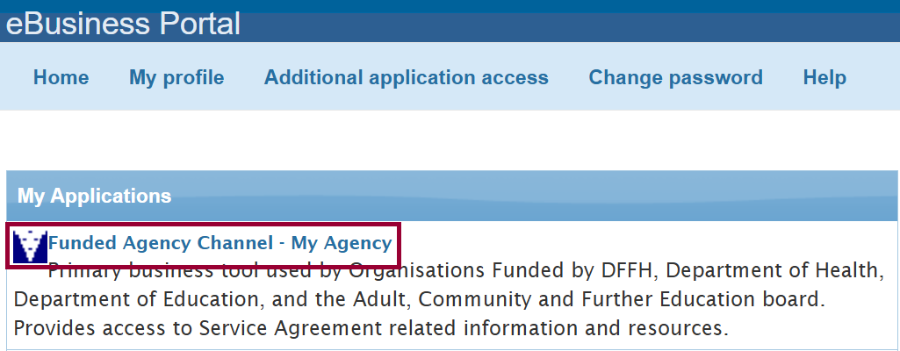
Figure 5 screenshot of the ‘My Applications’ screen in eBusiness
If this is the first time you have logged in, or you have cleared your browser cache since the last log in, you are presented with a second Security verification screen. Re-enter your eBusiness username and password and click Verify.
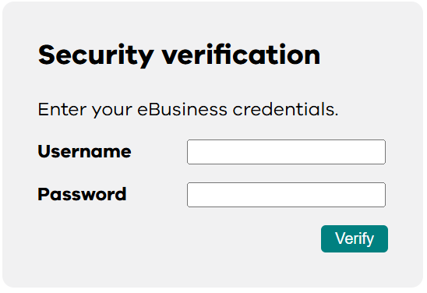
Figure 6 the login form on the security verification page
The My Agency page will load. The link to the Service Agreement Module (SAM) is displayed near the top of the page.
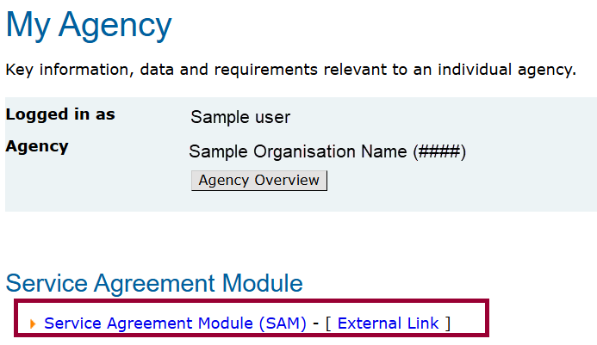
Figure 7 The My Agency home page

Troubleshooting
Username or password
If you have forgotten your eBusiness username or password, you can follow the instructions here https://fac.dffh.vic.gov.au/forgotten-ebusiness-username-or-password or email eBiz@support.vic.gov.au
Issues with My Agency or the Service Agreement Module (SAM)
Please email FAC@dffh.vic.gov.au with the description and screenshots if applicable.

To receive this document in another format, email <FAC@dffh.vic.gov.au>.
Authorised and published by the Victorian Government, 1 Treasury Place, Melbourne.
© State of Victoria, Australia, Department of Families, Fairness and Housing, April 2026
Available at Funded Agency Channel <https://fac.dffh.vic.gov.au/>

