

9. Emergency Management Housing
Operational Guidelines
OFFICIAL
Contents
Revision history 2
When do these operational guidelines apply? 2
What is a major state emergency? 2
Purpose statement 2
Applying for Emergency Management Housing 2
Eligibility criteria 3
Application effective date 3
Emergency help 3
Language link 4

Revision history
Version | Amended section | Effective | Detail
1.0 |  | March 2026 | - Revision table introduced  - Reason for Emergency Management Housing added, outlining eligibility criteria for the time-limited priority type “2026 Bushfires.”  - Evidence requirements section updated to include alternative acceptable documentation specific to the 2026 Bushfires.

When do these operational guidelines apply?
These guidelines apply when a major state emergency is:
- of large-scale
- declared by the Victorian Government and
- announced by the department
Updates to these guidelines are periodic and based on the declared emergency.
The appropriateness of continuing specific Emergency events will be reviewed at least every 24 months or as specified by the department.

What is a major state emergency?
A major state emergency is often a widespread event that poses a serious threat to:
- public safety
- infrastructure, and/or
- the environment within the state or region.
It requires coordinated response efforts to ensure the safety of affected communities. These efforts involve:
- government agencies
- emergency services
- other stakeholders

Purpose statement
The Emergency Management category is for people whose:
- housing is no longer safe or habitable due to an emergency. For example, a bushfire, flood or storm or
- for people requiring housing as part of a response to a state declared emergency such as a pandemic.

Applying for Emergency Management Housing
Applications under the Emergency Management category may be submitted by a:
- designated service provider
- recovery agency such as the local council, or
- social housing organisation acting as the applicant’s tenancy manager.

Eligibility criteria
Eligibility criteria include meeting the core Victorian Housing Register eligibility requirements. These guidelines are accessible at https://fac.dffh.vic.gov.au/eligibility-criteria-0.

Reason for Emergency Management Housing
The 2026 Bushfires is the sole reason an applicant can be considered eligible under the Emergency Management Housing category.
To be eligible for the 2026 Bushfires priority type, applicants must meet the following criteria:
- Proof of identity
- Australian citizen or permanent resident
- Victorian resident
- Household is displaced, homeless, or at immediate risk of homelessness as a direct result of the 2026 bushfires
- Principal place of residence is destroyed, damaged, unsafe, or inaccessible due to fire impact, evacuation orders, or loss of essential services
- Immediate need for emergency or temporary housing assistance (e.g., unable to stay with family or friends)
- the applicant is receiving case-managed support from a designated emergency recovery support service provider
- the applicant has been referred to the temporary accommodation support program
- the applicant does not own another property that they could live in.

Evidence requirements
Confirmation that the applicant's home is uninhabitable due to the emergency.
Alternative acceptable documentation for households impacted by the 2026 bushfires includes:
- fire damage certificates
- council confirmation

Application effective date
Generally, the effective date is the date the housing became uninhabitable.

Emergency help
For the latest updates on current emergencies and help available, visit:
- Vic Emergency website at https://emergency.vic.gov.au/relief/#current_events.
- Vic Councils website at https://www.viccouncils.asn.au/find-your-council/council-contacts-list.
- Personal Hardship Assistance Program webpage at https://services.dffh.vic.gov.au/personal-hardship-assistance-program.

Language link
This publication is about housing. If you speak a language other than English or have difficulty reading written information, you can get help over the telephone. For more information:
- visit Housing.vic Interpreter services https://www.housing.vic.gov.au/interpreter-services, or
- contact your local housing office https://www.dffh.vic.gov.au/contact-us (See, Housing enquiries and offices), or
- call Language Link on (03) 9280 0799 for an interpreter.
For other languages, an interpreter is available through your local office.
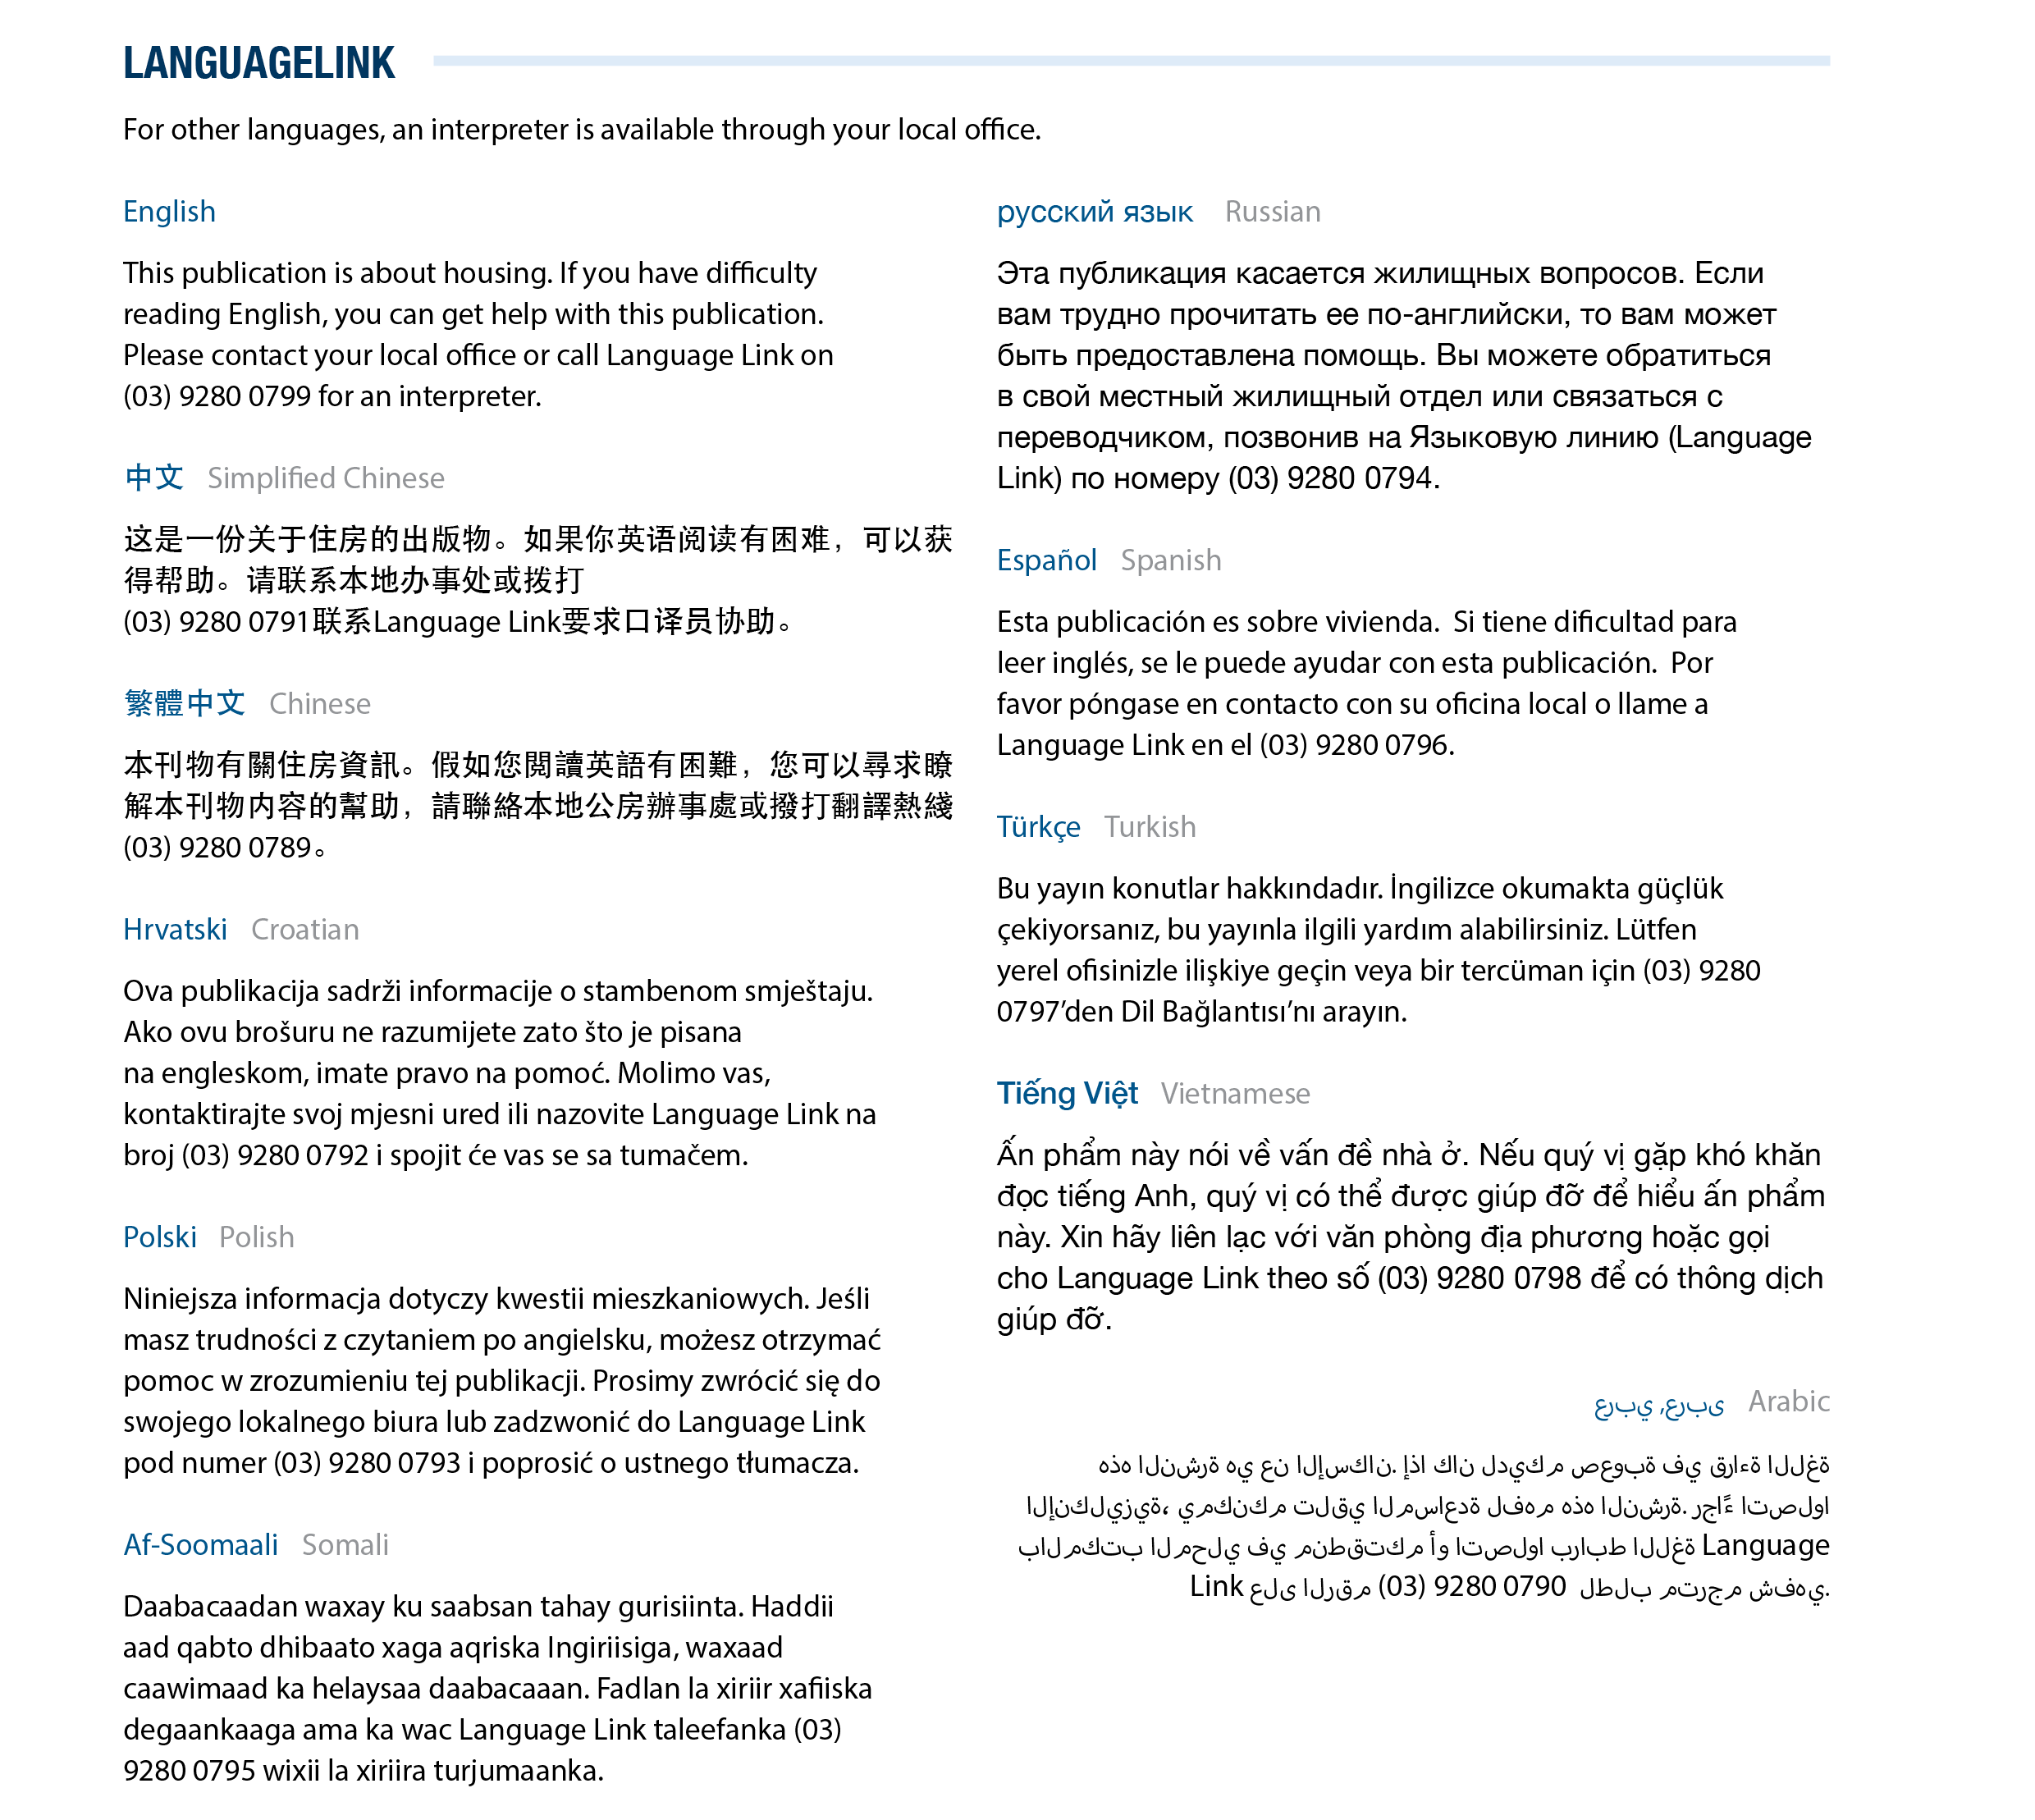

For more information contact your local housing office https://www.dffh.vic.gov.au/contact-us (See, Housing enquiries and offices)
To receive this document in another format, email the Victorian Housing Register VictorianHousingRegister@homes.vic.gov.au
Authorised and published by the Victorian Government, 1 Treasury Place, Melbourne.
© State of Victoria, Australia, Department of Families, Fairness and Housing, March 2026.
ISBN 978-1-76171-083-4 (pdf/online/MS word)
Available at the Victorian Housing Register website <https://fac.dffh.vic.gov.au/victorian-housing-register>

