

How to access My Agency and the Service Agreement Module (SAM)
OFFICIAL
Contents
Accessing My Agency and SAM 1
Via the eBusiness Portal 1
Via the Funded Agency Channel website 3
Troubleshooting 4
Username or password 4
Issues with My Agency or the Service Agreement Module (SAM) 4

Accessing My Agency and SAM
Access is via the eBusiness portal or the Funded Agency Channel website.

Via the eBusiness Portal
- To access via eBusiness go to the portal https://eus.webapp.dhs.vic.gov.au/EUSPortal/ and from the eBusiness Login tab
- enter your Username and Password
- read the conditions of use and tick the checkbox
- click on the Login button.
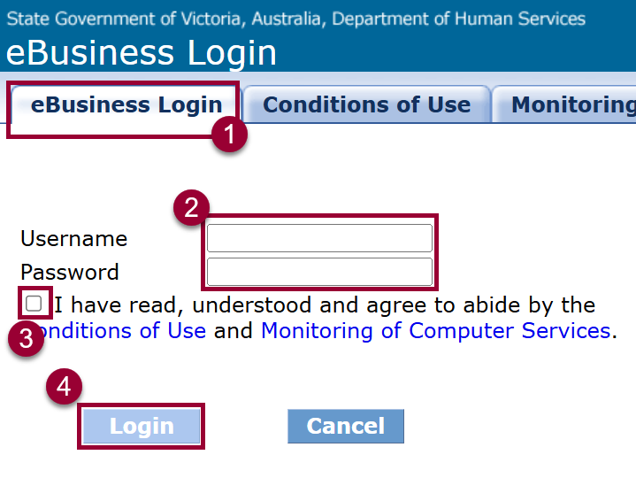
Figure 1 screenshot of the eBusiness login form
You will be presented with a list of the applications you have access to via the eBusiness portal. Click Funded Agency Channel – My Agency
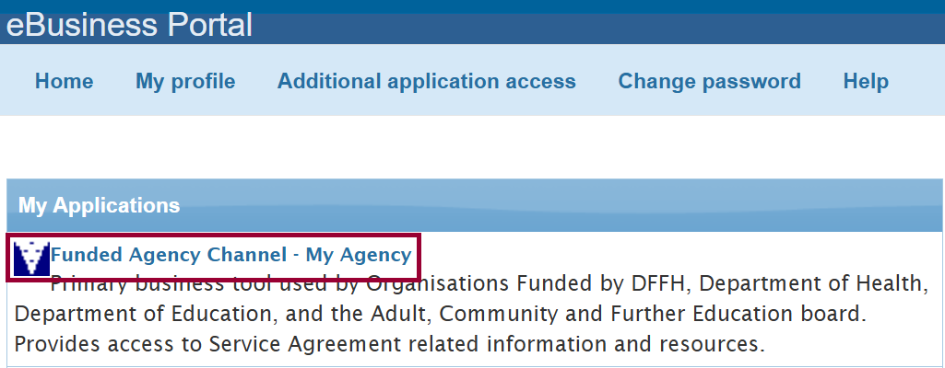
Figure 2 screenshot of the My Applications screen in eBusiness
If this is the first time you have logged in, or you have cleared your browser cache since the last log in, you are presented with a second Security verification screen. Re-enter your eBusiness username and password and click Verify.
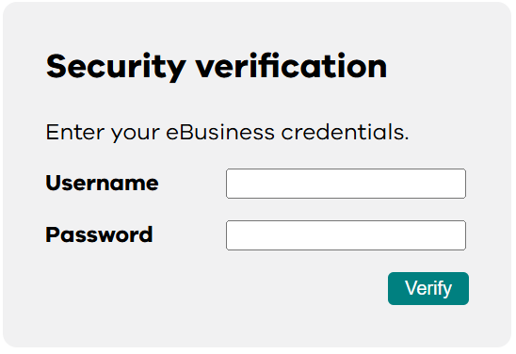
Figure 3 the login form on the security verification page
The My Agency page will load. The link to the Service Agreement Module (SAM) is displayed near the top of the page.
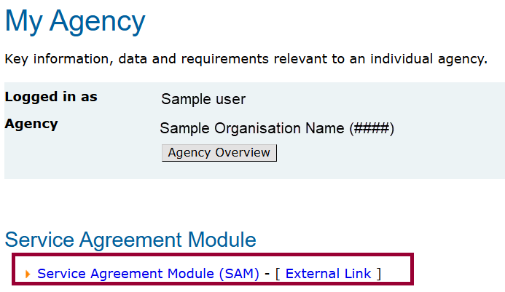
Figure 4 The My Agency home page

Via the Funded Agency Channel website
You can access My Agency directly from the Funded Agency Channel website https://fac.dffh.vic.gov.au/ by clicking on the below tile on the homepage.
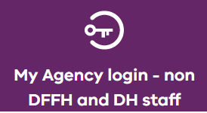
Figure 5 The My Agency login - non DFFH and DH staff

A security verification login form will appear if you are accessing My Agency for the first time or if you have recently cleared your browser cache. Enter your eBusiness username and password and click Verify to proceed.
Figure 6 The Security verification login form
The My Agency page loads. The link to the Service Agreement Module (SAM) is displayed near the top of the page.
Figure 7 The My Agency home page

Troubleshooting

Username or password
If you have forgotten your eBusiness username or password, you can follow the instructions here https://fac.dffh.vic.gov.au/forgotten-ebusiness-username-or-password or email eBiz@support.vic.gov.au

Issues with My Agency or the Service Agreement Module (SAM)
Please email FAC@dffh.vic.gov.au with the description and screenshots if applicable.

To receive this document in another format, email FAC@dffh.vic.gov.au
Authorised and published by the Victorian Government, 1 Treasury Place, Melbourne.
© State of Victoria, Australia, Department of Families, Fairness and Housing, February 2026
Except where otherwise indicated, the images in this document show models and illustrative settings only, and do not necessarily depict actual services, facilities or recipients of services.
In this document, ‘Aboriginal’ refers to both Aboriginal and Torres Strait Islander people. ‘Indigenous’ or
ISBN/ISSN number (online/PDF/Word) or (print)
Available at https://fac.dffh.vic.gov.au/my-agency-non-dffh-and-dh-staff

