

Forgotten eBusiness username or password

About eBusiness
For users outside of the Department of Health and Department of Families Fairness and Housing, My Agency, the Service Agreement Module (SAM) and other applications are accessed via the eBusiness Portal.

Forgotten eBusiness login details
If you have forgotten your eBusiness password or username, you can email ebiz@support.vic.gov.au
Alternatively, you can reset your password using the security question on your account.
- Go to the eBusiness login page https://eus.webapp.dhs.vic.gov.au/EUSPortal/
On the eBusiness Login page, select the I forgot my login details link on the right-hand side of the page.
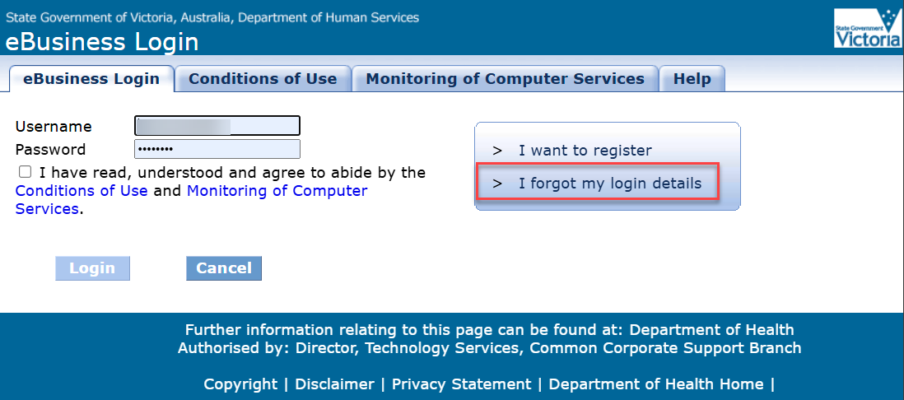
Figure 1 The eBusiness login page

You will be presented with the Reset password request form. Complete all fields and press Request password. (Note: your email address in eBusiness must be correct for you to receive notification)
The new password you enter in this form is a temporary password only, you will have to change it once you log in successfully.
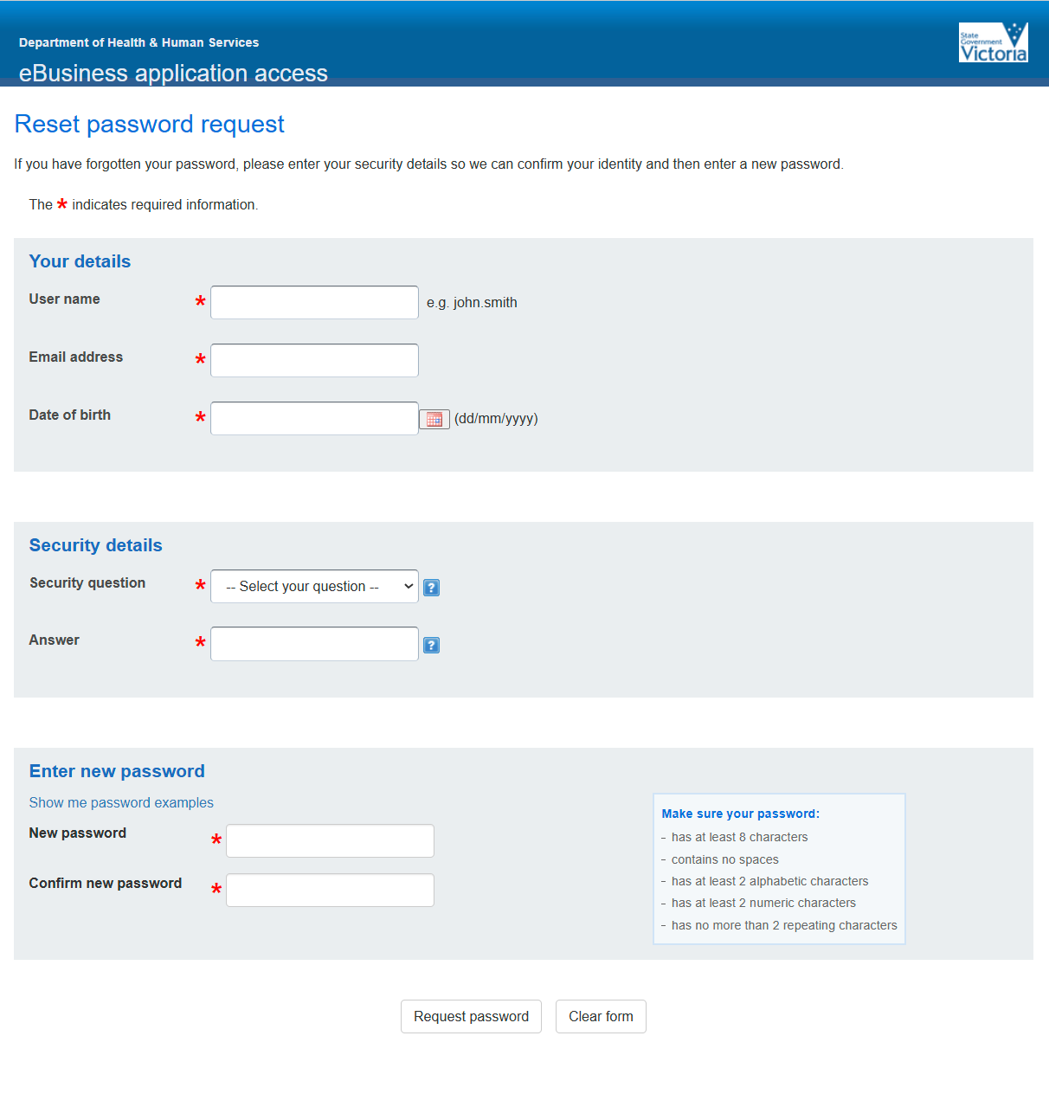
Figure 2 the Reset password requests online form

Confirmation of the password reset request
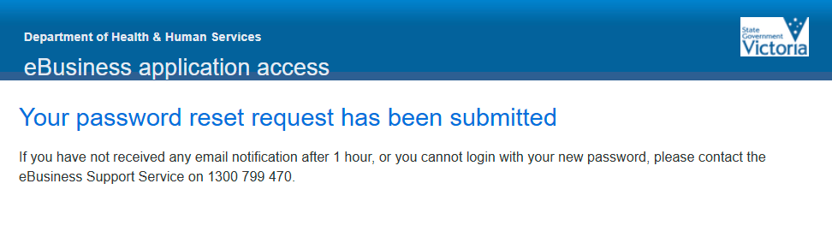
Figure 3 Acknowledgement of request
Incorrect information rejection email
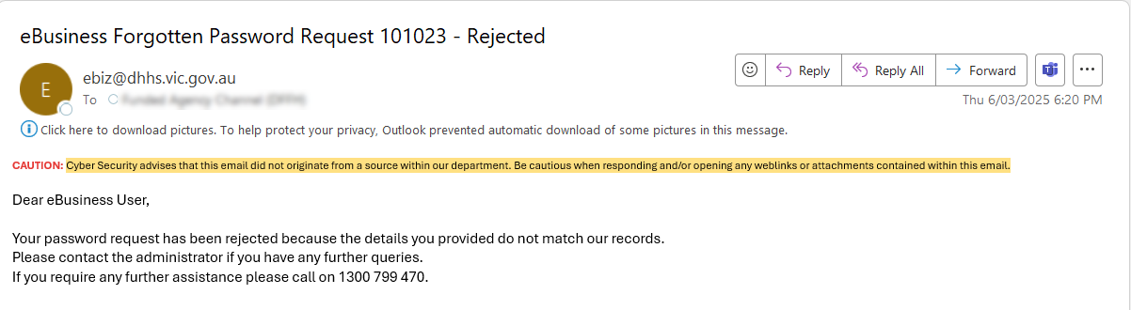
Figure 4 request rejected email
Successful request confirmation email
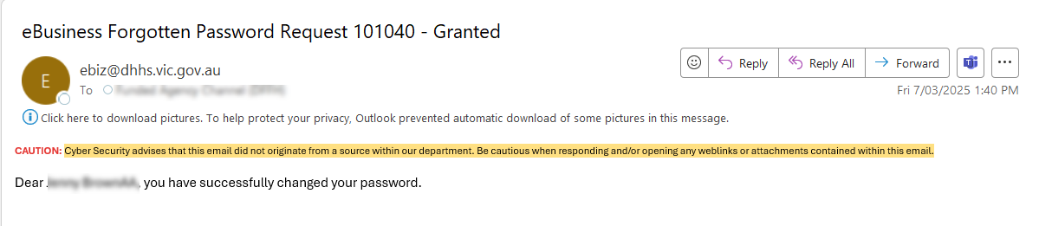
Figure 5 eBusiness Forgotten Password Request - Granted email.

Log in with temporary password

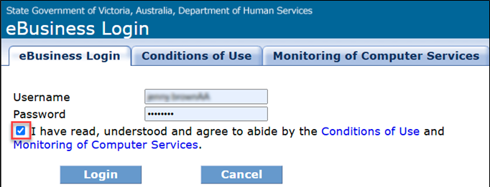
Figure 6 eBusiness log in screen

Enter the temporary password, then a new password twice. (Note: this can be the same as your temporary password)
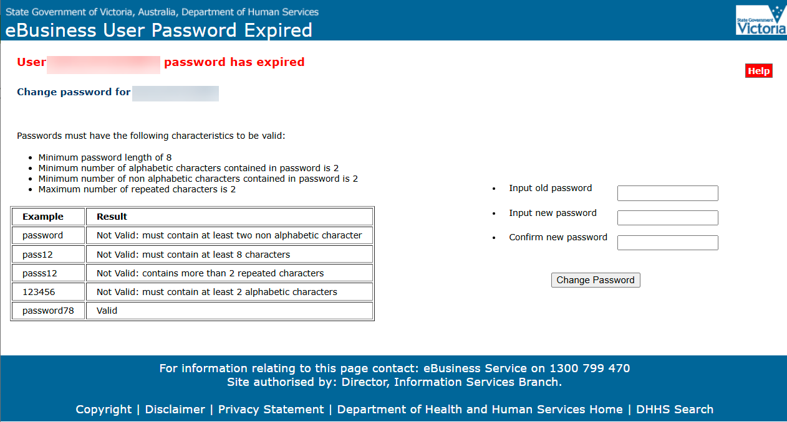
Figure 7 eBusiness Password Expired screen
To receive this publication in another format, email: fac@dffh.vic.gov.au
ISBN 978-1-76130-745-4
Authorised and published by the Victorian Government, 1 Treasury Place, Melbourne.
© State of Victoria, Department of Families, Fairness and Housing, February 2026
Available on the Funded Agency Channel <https://fac.dffh.vic.gov.au/my-agency-non-dffh-and-dh-staff>

