
How to submit insurance documents in Service Agreement Module
OFFICIAL
Contents
Purpose 1
What is an insurance record? 1
How to submit insurance documents in SAM 2
Further information 4

Purpose
Most organisations funded through a Service Agreement with the Department of Families, Fairness and Housing (DFFH) or the Department of Health (DH) can access insurance coverage through the Victorian Managed Insurance Authority (VMIA). For information on VMIA eligibility, email your lead department’s Insurance Services team at:
- DH insuranceservices@health.vic.gov.au
- DFFH insuranceservices@dffh.vic.gov.au.
If your organisation has service agreements with both DH and DFFH you can contact either team.

Where an organisation is ineligible for VMIA cover or insurance coverage for example via a parent organisation or peak body, it needs to provide the department its commercial insurance documents to demonstrate that it complies with its Service Agreement insurance requirements.
This document provides guidance on how organisations can upload these documents to their Service Agreement Module (SAM) via Funded Agency Channel (FAC).

What is an insurance record?
Information captured in the insurance record includes the name of the insurer, the type of insurance cover provided and the start and end dates of the policy.
The first insurance record for an organisation needs to be created and completed by departmental staff in the Service Agreement Management System 2 (SAMS2). SAMS2 will automatically generate subsequent records. These become visible to the organisation via SAM thirty days before the end date of the current insurance record. The organisation then updates this new record with insurance documentation for the next period of cover. Failure by the organisation to update insurance records will result in non-compliance with service agreement requirements.

If there are no insurance records visible in SAM, please contact your monitoring coordinator (your organisation’s primary contact in DH or DFFH) and ask them to set up your initial insurance record. Otherwise, follow the steps below.

How to submit insurance documents in SAM

Step 1
Log into My Agency (via eBusiness). From My Agency page, click: “Service Agreement Module [External Link]”.

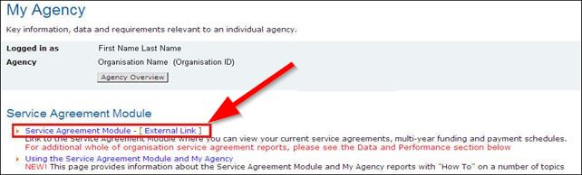

Step 2
A new window will open, and SAM will be displayed. The “Organisations” tab at the top of the screen is selected by default. Select the hyperlink (blue text) with the name of your organisation.

Step 3
The Organisation screen will open with a row of tabs below the organisation’s details. The Contacts tab will load by default. Select the Compliance tab.
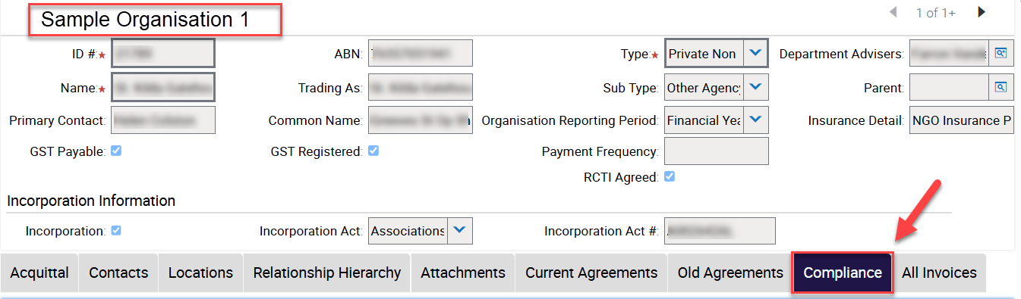

Step 4
Select the insurance record to be completed. Check that the record you are working on has a status of Open. Note that the Description field will be blank. The Sub Type field will be populated based on the previously submitted insurance document. In this case it is PI (Professional Indemnity), PL (Public Liability) and Child Abuse. Note: The Type, Sub Type, Start date, End date, Due Date, Submitted Date, Completed Date fields are not editable.
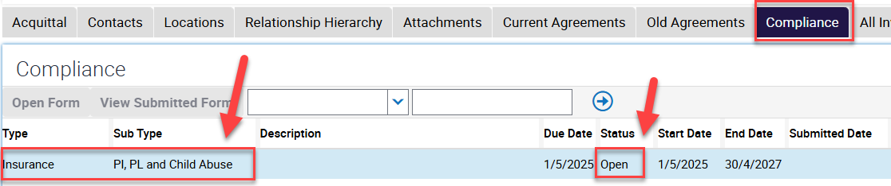

Step 5
After selecting the insurance record, scroll to the bottom of the screen, and locate the Attachments section. Select “New File” so that you can upload your full insurance policy and certificate of currency

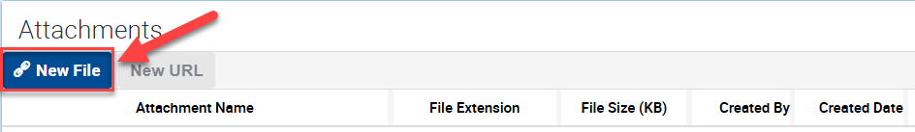

Step 6
The “Choose File to Upload” pop up box will display. You can only upload one document at a time. Highlight the document you wish to attach and select Open.

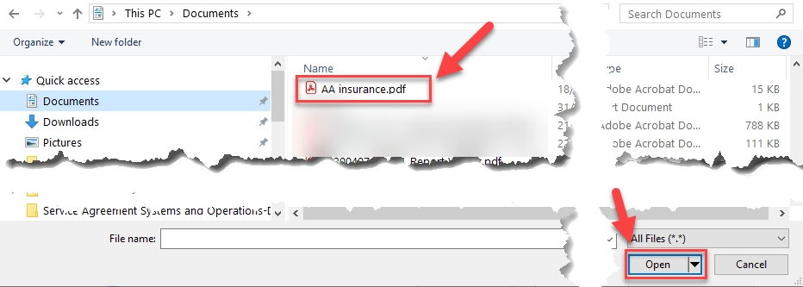

Step 7
Clicking “Open” will take you back to the Compliance Attachments section and the document you added will display in the Attachment Name field. If required, you may also add comments (in the Comments field).

If you need to attach further documents repeat Step 6.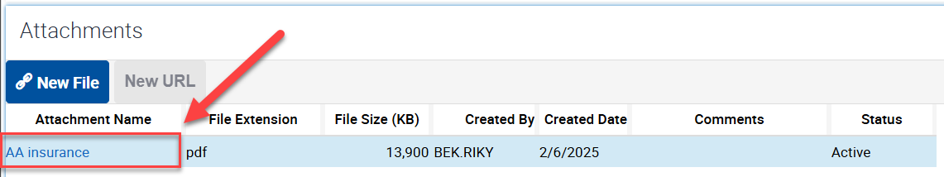

Step 8
Once all the documents related to the insurance record are uploaded:
- enter the name of the insurer in the Description field, and
- change the status of the insurance record from Open to Submitted.

The organisation’s primary contact and the department will receive a system generated email confirming that the insurance record has been submitted. The department will assess the documents and contact you if further information is required.

Further information
For further information, please contact your lead department contact for your service agreement.

To receive this document in another format email Service Agreement Performance branch SAComms@dffh.vic.gov.au
Authorised and published by the Victorian Government, 1 Treasury Place, Melbourne.
© State of Victoria, Australia, Department of Families, Fairness and Housing, December 2025.
Available at Funded Agency Channel
ISBN 978-1-76130-923-6 (pdf/online/MS word)
Available at Funded Agency Channel Policies and Procedures <https://fac.dffh.vic.gov.au/policies-and-procedures>

