Crisis Supported Accommodation
Therapeutic Model
Operational Program Guidelines 2025
OFFICIAL
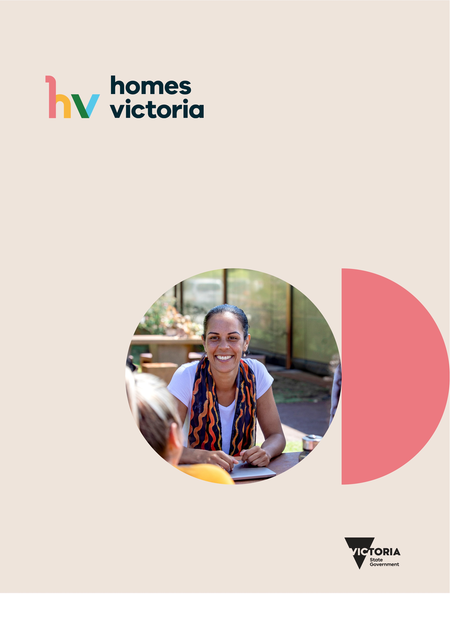

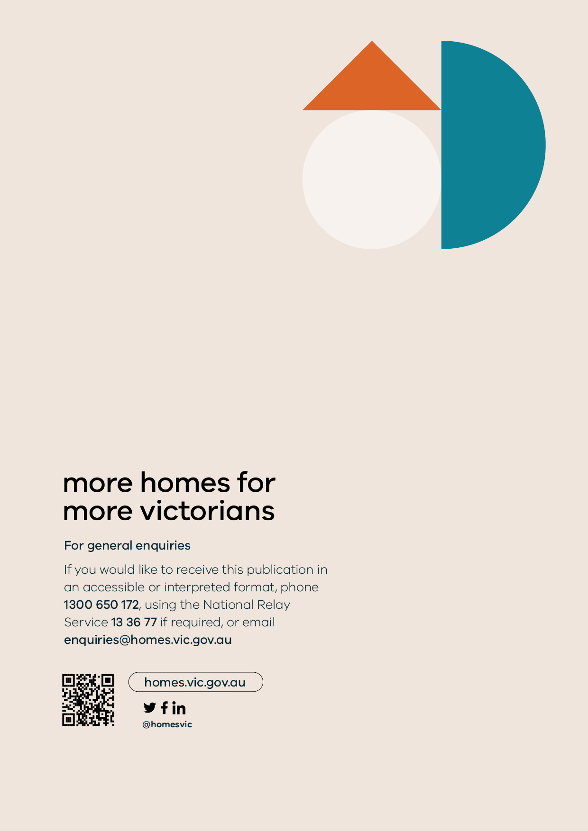
CRISIS SUPPORTED ACCOMMODATION
THERAPEUTIC MODEL
Operational Program Guidelines 2025

The Crisis Supported Accommodation – Therapeutic Model Program Guidelines will be routinely reviewed every five years. Should there be significant changes to the Victorian Homelessness System before the scheduled review, the Guidelines will be updated to reflect these changes.
Version and Review History
Version | Approved by | Approval Date | Next Revision Due
Version 1.0 | Executive Director, Homelessness and Housing Support Branch, Homes Victoria | November 2025 | November 2030

Authorised and published by the Victorian Government, 1 Treasury Place, Melbourne.
© State of Victoria, Australia, Homes Victoria, November 2025.
Except where otherwise indicated, the images in this document show models and illustrative settings only, and do not necessarily depict actual services, facilities or recipients of services. This document may contain images of deceased Aboriginal and Torres Strait Islander peoples.
In this document, ‘Aboriginal’ refers to both Aboriginal and Torres Strait Islander people. ‘Indigenous’ or ‘Koori/Koorie’ is retained when part of the title of a report, program or quotation.
ISBN 978-1-76130-874-1 (pdf/online/MS word)
Available at Homelessness Operational Program Guidelines webpage
<https: //www.dffh.vic.gov.au/homelessness-operational-guidelines?auHash=5nNzNDof62h0sHeI0tswNvHkH-Pxh8NTgca07L1FcpA>

Acknowledgement
The Department of Families, Fairness and Housing acknowledges Aboriginal and Torres Strait Islander people as the Traditional Custodians of the land and acknowledges and pays respect to their Elders, past and present.
The department is committed to safe and inclusive workplaces, policies and services for people of LGBTIQA+ communities and their families.


Contents
Contents 6
1. Program Overview 7
1.1. Purpose of these guidelines 7
1.2. How to use these guidelines 7
2. Eligibility and Access 8
2.1. Eligibility criteria 8
2.2. Intersection between CSA-TMs and other programs, systems or initiatives 9
3. Program components 10
3.1. The CSA-TM role 11
3.2. Brokerage 14
3.3. Stakeholders 14
4. Data collection and reporting 16
4.1. Reporting 16
5. Appendix 1: Program Logic 18
5.1. Program Logic 18
5.2. Program goal 18
5.3. Program objectives 18
5.4. Program logic for CSA-TM 19

Program Overview
Homes Victoria, as a part of the Department of Families, Fairness and Housing (DFFH), funds three homelessness service providers to deliver the Crisis Supported Accommodation - Therapeutic Model program (CSA-TM). This model supports people experiencing homelessness to access an enhanced accommodation and service response compared to traditional Crisis Supported Accommodation (CSA).
CSA-TM supports single people or couples aged over 18 who are experiencing or at risk of homelessness. CSA-TM clients receive both accommodation and support services, as outlined in section 3.1 below.
The key objectives of CSA-TM, as outlined in the Program Logic at Appendix 1, include:
- Clients are safe during their stay.
- Clients are offered onsite alcohol and other drug services and receive these services if they choose.
- Clients are offered specialist and universal health services and receive services if they choose.
- Clients have choice and control in how they receive services.
- Clients improve their health and wellbeing.
- Clients reduce the number of times they exit and re-enter CSA compared to traditional CSA services, through the provision of a longer and more flexible stay.
- Clients remain engaged until they have stabilised, and their support goals are met.
- Clients secure and sustain relevant community-based supports.
- Clients move into medium- or long-term housing.
- Clients are stable in their new housing and do not need to return to CSA.
The CSA-TM program provides services to address homelessness in the DFFH Local Areas of Bayside Peninsula and Western Melbourne. Launch Housing and VincentCare Victoria deliver CSA-TM to people of all genders, The Salvation Army focuses on providing CSA-TM to people who identify as male.
As of 2025 the CSA-TM program operates in the following locations:
Location | Agency | DFFH area
Southbank | Launch Housing | Bayside Peninsula
Ozanam House | VincentCare Victoria | Western Melbourne
Flagstaff | The Salvation Army | Western Melbourne
The Open Door | The Salvation Army | Western Melbourne

Purpose of these guidelines
These guidelines have been developed to ensure quality and consistency in the practice approach and delivery of CSA-TM. Developed in consultation with CSA-TM providers, the guidelines outline the requirements, objectives, and expected outcomes of CSA-TM in Victoria.

How to use these guidelines
To effectively implement these guidelines, it is essential to consider them alongside the Service Agreement that each Specialist Homelessness Service (SHS) has with the Department of Families, Fairness and Housing (DFFH).
The Service Agreement outlines the legislative requirements that each SHS is required to adhere to and includes a list of program requirements, including complying with the Social Services Standards under the Social Services Regulation Act 2021 (Vic). The Residential Tenancies Act 1997 (Vic) does not apply to this program, as CSA-TM is defined as temporary crisis accommodation (see section 22 of the Act).
These guidelines should be read in conjunction with the Homelessness and Housing Support Guidelines 2025 which are included in each organisations Service Agreement.
Service Agreement Requirements
https://fac.dhhs.vic.gov.au/service-agreement-requirements
Social Services Regulation Act 2021 (Vic)
https://www.legislation.vic.gov.au/in-force/acts/social-services-regulation-act-2021/003
Residential Tenancies Act 1997 (Vic)
https://www.legislation.vic.gov.au/in-force/acts/residential-tenancies-act-1997/110
Homelessness and Housing Support Guidelines 2025
https://fac.dffh.vic.gov.au/homelessness-and-housing-support-guidelines-2025-0

Service Agreement with Department of Families, Fairness and Housing
Legislative Framework, Standards, Social Service Regulator, Policy requirements
Homelessness Services Guidelines 2025
Individual program guidelines

Eligibility and Access
This section outlines the specific eligibility criteria and access pathways for the CSA-TM program. Understanding these criteria is essential for both service providers and potential participants to ensure appropriate referrals and service delivery.

Eligibility criteria
The target group for CSA-TM is single people or couples aged over 18 who are experiencing or at risk of homelessness.

Assessment, access and referral
All clients are referred into the CSA-TM program through homelessness entry points.
Clients may present at any homelessness entry point to access CSA-TM, through which they can be referred to either:
- Launch Housing’s St Kilda Entry Point, which manages all referrals into Flagstaff, the Open Door and Southbank.
- VincentCare Victoria’s dedicated intake team, located onsite at Ozanam House.

Allocation Process and Vacancy Management System
Clients are prioritised for the CSA-TM program (including both accommodation and support services) based on the complexity of their support needs, which are determined through either formal assessment tools or a worker’s assessment of current need.
Having previously stayed in a CSA-TM does not preclude a client from being considered for another stay at a CSA-TM.
Service providers may also conduct secondary assessment to evaluate whether the CSA-TM site is an appropriate referral option.
Residents are required to sign an agreement upon entering the CSA-TM program which outlines their roles and responsibilities, conditions of stay and service charges.
To ensure transparency of resources, all SHS must log all DFFH funded resources on the Vacancy Management System (VMS), as this allows each SHS to view the range of funded programs. When a SHS has a vacancy, such as an available THM property, support capacity or flexible funding, then the VMS should be updated to reflect this vacancy.
The VMS is available through SHIP or through a specific licence for non-SHIP users. CHP provide training on the VMS, for further information please refer to the SHS Learning Hub linked below.
CHP SHS Learning Hub
https://chp.org.au/sector-learning-and-development/shs-learning-program/

For access or more information, email Housing and Homelessness Support branch at Homes Victoria.
Homes Victoria Housing and Homelessness Support branch email
HHS@homes.vic.gov.au

Intersection between CSA-TMs and other programs, systems or initiatives
To effectively serve clients experiencing homelessness, collaboration and coordination with other systems and programs is crucial. This section highlights how CSA-TMs interact with other service providers, organisations, and agencies, ensuring comprehensive support while avoiding duplication of effort. Understanding these interconnected relationships empowers staff to navigate referrals, share resources, and ultimately maximise client outcomes. Recognising that CSA-TM clients have a range of support needs, multidisciplinary services may be provided or referred, as guided by a client’s case plan. These include:
- mental health support (which may include clinical services, counselling, mental health nurses, mental health case management, or access to specialist services)
- physical health support (which may include access to a general practitioner, support with pharmacotherapy, care coordination, allied health services, and other health and wellbeing services)
- dual diagnosis support for people with both mental health and AOD needs (which may include counselling, forensic services or other community or specialist services)
- therapeutic recreation and/or social inclusion activities (which may be provided on-site, in the local community, or access to a specialist activity off-site)
- peer support (which may include peer support workers, access to lived experience reference groups, or other supports)
- facilitating secondary consults and coordinated responses, as appropriate.
CSA-TM providers may refer clients to external specialised supports not available on-site, such as culturally specific services delivered by Aboriginal Community Controlled Organisations (ACCOs) and other relevant specialist supports.
CSA-TM providers may request that specialist supports attend the site based on each client’s specific support needs.

Program components
This section outlines the expectations of workers within CSA-TMs.
Homes Victoria is committed to supporting SHS to achieve high standards of practice and service in the delivery of homelessness services. SHS are expected to uphold key service delivery principles that ensure Victorians experiencing or at risk of homelessness receive high-quality and effective support.
In addition to the principles outlined in the Homelessness and Housing Support Guidelines 2025, the CSA-TM program will also demonstrate the following additional principles:

Harm reduction
A harm reduction approach aims to reduce the negative consequences associated with alcohol and other drug use and reduces other related risk factors. This approach uses strategies such as education and safe consumption programs, without insisting on complete abstinence.
In practice this includes:
- Clients have access to alcohol and other drug (AOD) specialists and can choose whether to engage with AOD support.
- Clients have access to safe injecting equipment.
- Clients can be referred to external/offsite specialists or detoxification and rehabilitation services if required.

Culturally safe services for Aboriginal and Torres Strait Islander clients
The CSA-TM program should be delivered in a way that promotes cultural safety for Aboriginal and Torres Strait Islander people. Culturally safe practices are best practice and improve outcomes for the Aboriginal community.
Practices which may promote cultural safety include (but are not limited to):
- Signage placed in CSA-TM sites which acknowledges the Traditional Custodians of the land.
- Compulsory cultural safety training for all staff and an ongoing commitment to equipping staff with developing appropriate skills and attitudes to work with Aboriginal people.
- Recognising significant cultural events as part of on-site activities.
- Providing Aboriginal clients with information about both Aboriginal specific services and mainstream services and allowing them to choose which service they wish to receive.
- Having clear rules, as part of resident agreements stating that racism, or any other form of discrimination is not permitted on site.
- Collecting feedback on whether Aboriginal and Torres Strait Islander clients feel culturally safe during their stay.
- Embedding mechanisms to respond to feedback from Aboriginal and Torres Strait Islander people about the services they receive.
Cultural safety goes beyond signage and training and requires intentional critique of service offerings through being aware of difference, decolonising approaches, considering power relationships, implementing reflective practice and by allowing the individual to determine whether a support encounter is safe.
Decolonising approaches involve taking action to address the ongoing negative effects of colonisation. This may include strategies such as:
- Aboriginal and Torres Strait Islander leadership and governance
- employing Aboriginal and Torres Strait Islander staff
- working in ways consistent with sovereignty and self-determination
- anti-racism strategies
- action and advocacy on social determinants of Indigenous health in the community
- working in ways that strengthen cultural identity and integrity
- culturally respectful service provision within a welcoming and safe space
- integrating Aboriginal and Torres Strait Islander knowledges into practice.
Homelessness and Housing Support Guidelines 2025
https://fac.dffh.vic.gov.au/homelessness-and-housing-support-guidelines-2025-0

The CSA-TM role
The CSA-TM program aims to provide safe accommodation and support services to help clients achieve their goals. CSA-TM programs build on the supports offered by traditional Crisis Supported Accommodation (CSA) models. This includes longer stays and additional support elements compared with the existing base model for CSA. Key differences between the two models are outlined in the table below:
Function | Traditional CSA | CSA-TM
Length of stay | - Up to six weeks |  | - Targets a 13-week average stay
Support offered on site | - Case management for up to six weeks  - Referrals to external support  - Ad hoc on-site services |  | - Case management for duration of stay  - Alcohol and Other Drug (AOD) support  - Therapeutic recreation support  - Nursing support
Continuity of care | - Clients are linked in with external service providers upon exiting accommodation |  | - Services develop and maintain consistent and continuous supports for clients during and after their stay, including (in some cases) outreach case management post-exit

Engagement
CSA-TM clients are expected to have an assigned case manager or key worker, to act as a consistent point of contact and support for the client (see section 3.1.2.1 Case management below).
Once a client has been allocated a room in a CSA-TM site, their assigned case manager or key worker should make contact within 24 hours.
During a client’s stay, case managers or key workers should provide at least one hour of face-to-face case management support per week. Case managers are expected to spend additional time completing follow up paperwork and administration for each client on their caseload. While some clients may not wish to engage in this support each week, case managers are expected to proactively offer case management support to each client, for the duration of their stay.

Providing support
Clients are provided with a stay in a congregate setting that is staffed 24/7. The intended average stay for clients is 13 weeks, though the length of stay for individual clients may be flexible depending on their needs, preferences, and potential exit pathways.
On site, clients have access to a private room and a private bathroom, as well as shared common areas and facilities. All CSA-TM program clients have access to communal kitchens, dining rooms and laundry facilities. Service providers may also provide meals on site as part of the accommodation.
Providers should ensure the following support services are made available to each client throughout the entirety of their stay.

Case management
Clients are expected to have an assigned case manager or key worker (to act as a consistent point of contact and support for the client). Case management should include the following:
- Case plans are expected to be started within 14 days after a client has been allocated to a site.
- Case plan development should be led by the client wherever possible.
- Case management support is tailored to need and clients are expected to have an active case plan, meaning it is a live document, and new goals are added as they arise.
- A housing goal, intended to enable clients to transition from CSA-TM to medium or long term housing, or other accommodation options as guided by the client.

Alcohol and other Drug (AOD) support
CSA-TM offer specialist AOD support on-site for clients. Engagement with AOD support is voluntary, and may include:
- AOD case management/counselling
- AOD education
- needle and syringe programs
- specialist counselling
- provision of/referral to detoxification and/or rehabilitation services.

Health support
All four sites provide health services to CSA-TM residents. Each CSA-TM has a nurse on site to provide consultations to residents.
All sites must ensure that clients can access safe injecting equipment via the Victorian Needle and Syringe Program (NSP). The NSP helps reduce the spread of blood-borne viruses by offering clean injecting equipment and disposal, and information and advice on safe injecting practices.
CSA-TMs also provide other health services on site, via visiting or co-located services. Where required, staff should also make referrals for clients to seek off site health support. Further information about these services can be found in the following multidisciplinary supports section.
Clinical mental health services are not delivered directly by CSA-TM. Referrals should be made promptly for residents to external mental health services where a need is identified. Depending on acuity, referrals may range from seeking support through a General Practitioner to referring directly to the local Crisis Assessment and Treatment Team (CATT).
Homelessness and Housing Support Guidelines 2025
https://fac.dffh.vic.gov.au/homelessness-and-housing-support-guidelines-2025-0
Needle and Syringe Program – Department of Health (Victoria)
https://www.health.vic.gov.au/aod-treatment-services/needle-and-syringe-program

Therapeutic recreation
All CSA-TM sites must provide recreational activities for residents. Recreation is an important therapeutic activity which supports residents’ wellbeing and provides opportunities for social connection.
All CSA-TM sites must operate a regular calendar of recreational activities. Recreation activities may take place on site (e.g. cooking classes, meditation classes or board games) or offsite (e.g. walks, or visits to cafes and sporting centres). Wherever possible, recreational activities should be available to clients free of charge. If a cost for a particular recreational activity must be charged, it should be kept to the minimum feasible amount. Clients must be made aware of and consent to the cost.
All sites have common rooms and/or recreation rooms with televisions, games, and a range of other recreational equipment available to all residents.
Case managers at CSA-TM sites will support clients to identify and access recreational activities as part of their case planning that focuses on recovery and wellbeing.

Service fees
CSA-TM providers may require residents to contribute a proportion of their income as a service fee for living on site and accessing services. Service fees should be clearly outlined and explained to clients as part of the intake process. CSA-TM providers are encouraged to work with clients in a trauma-informed way to address any non-payment of service fees.

People exiting the program
CSA-TM providers should take steps to avoid clients exiting to homelessness once they leave the program. However, DFFH acknowledges that this will not always be possible, due to factors outside of the provider’s control.
Wherever possible, CSA-TM residents should exit the program with a plan for where they will live. A planned exit can involve a client entering another form of accommodation, or any other type of service where they can reside (for example, a hospital or rehabilitation clinic).
Wherever possible, clients exiting CSA-TM should also be linked in to support services to assist them after they leave the program. Relevant support services for exiting clients should be determined by their needs and preferences, and may include case management, AOD or health services.
CSA-TM providers are not required to provide any specific level or duration of support for clients once they have exited. However, providers may utilise other funding or services to provide outreach or case management support to clients exiting CSA-TM, at their discretion.

Brokerage

Homelessness Services brokerage
To access or sustain housing, workers of the CSA-TM program may apply for funding through one of the below brokerage programs, on behalf of clients where they provided consent. Any allocation of the below brokerage is at the discretion of the organisation providing the brokerage in accordance with relevant program guidelines.

Private Rental Assistance Program (PRAP)
CSA-TM staff are encouraged to utilise local area PRAP funds where available to establish private rental tenancies, where it is appropriate for a client to exit CSA-TM into a private rental. Please refer to the link below which provides oversight and guidance for the use of PRAP funds.
Private Rental Assistance Program Guidelines
https://fac.dffh.vic.gov.au/private-rental-assistance-program-guidelines

Aboriginal Private Rental Assistance Program (APRAP)
CSA-TM staff are encouraged to utilise local area APRAP funds for First People (who may choose this option) where available to establish private rental tenancies, where it is appropriate for the client to exit CSA-TM into a private rental. Please refer to the link below which provide oversight and guidance for the use of APRAP funds.
Aboriginal Private Rental Assistance Program (APRAP) Guidelines
https://fac.dffh.vic.gov.au/aboriginal-private-rental-assistance-program-aprap-guidelines

Housing Establishment Fund (HEF)
CSA-TM staff may request HEF brokerage from the local homelessness entry point to prevent a resident exiting into homelessness when all other sources of funding have been exhausted. Please refer to the link below for appropriate use of HEF.
Homelessness Services Guidelines and Conditions of Funding
https://fac.dffh.vic.gov.au/homelessness-services-guidelines-and-conditions-funding

Stakeholders
The effective delivery of the CSA-TM program requires clear understanding of roles, responsibilities, and relationships between various government and non-government stakeholders. This section outlines key partnerships, reporting relationships, and integration points that support CSA-TM outcomes. It defines how different parts of the service system work together to support people experiencing or at risk of homelessness.

Program stakeholders
Stakeholder | Roles and responsibilities
Homelessness and Housing Support, Homes Victoria | - Allocate program funding.  - Publish and review program guidelines as required.  - Act as an escalation point for issues or questions raised by:  - Agency Performance and System Support, Department of Families Fairness and Housing  - CSA-TM providers.  - Set overall homelessness policy and reform directions.
Agency Performance System Support, Department of Families, Fairness and Housing | - Manage service contracts.  - Monitor program reporting, (as outlined in section 4).  - Monitor incident reporting (as outlined in section 4).  - Act as the first point of contact for issues or questions raised by CSA-TM providers.  - Receive and assess manual reporting (as outlined in section 4) to inform performance monitoring.
CSA-TM providers (Launch Housing, The Salvation Army, VincentCare Victoria) | - Deliver CSA-TM in accordance with the program guidelines.  - Complete all required program reporting (as outlined in section 4).

Community partnerships
The following organisations partner with CSA-TM providers to deliver co-located services for clients.
Service provided | Partnering organisations
Health support | - Bolton Clarke – Homeless Persons Program  - Better Health Network  - Australian College of Optometry  - Victorian School of Optometry  - Endeavour College of National Health  - Hearing Australia  - Cohealth  - North West Primary Health Network  - Dental Health Services Victoria  - St Vincent’s Health  - Brunswick Community Medical Centre  - Atticus Health
Mental health support | - Inner West Area Mental Health Service (Royal Melbourne Hospital)
Legal advice | - Inner Melbourne Community Legal  - Southside Justice
Centrelink assistance | - Services Australia

Data collection and reporting

Reporting
Service delivery is captured through client data and manual reporting. This includes:
- Service Delivery Tracking (SDT) via the Funded Agency Channel.
- The monthly SHS Extracts from the Specialist Homelessness Information Platform (SHIP) or equivalent client management system certified by the Australian Institute of Health and Welfare (AIHW) to provide SHS client data.
- Any specific data requirements for homelessness activities as outlined in each of the Homelessness Service Responses. Refer to section twelve for further information on homelessness activities.
- Ad hoc requests related to program monitoring and evaluation, such as program evaluation required when funding is due to lapse.
Service Delivery Tracking – FAC
https://fac.dffh.vic.gov.au/service-delivery-tracking
SHIP: Specialist Homelessness Information Platform – AIHW
https://www.aihw.gov.au/about-our-data/our-data-collections/specialist-homelessness-services-collection/specialist-homelessness-information-platform

Manual reporting requirements
CSA-TMs are required to submit a quarterly manual report to DFFH within 10 business days of the reporting period ending. DFFH and Homes Victoria will provide instructions on how to complete and submit the quarterly manual report.
The manual reporting template captures:
- planned and unplanned exits (including housing and support outcomes)
- clients’ Victorian Housing Register status at the end of their support period
- client safety and wellbeing.

The manual report is an additional requirement for CSA-TMs, beyond the general reporting required under Activity 20081. The manual report captures additional information about client exits and the views of clients that is not captured through other reporting mechanisms.

DFFH may also review CSA-TM providers’ Specialist Homelessness Services Collection data to support their oversight of the program.

Performance and monitoring
As part of the Service Agreement between each SHS and DFFH contract management role, the DFFH local area APSS teams meet regularly with SHS to monitor performance, and an annual desktop review is undertaken. Some programs may be centrally contract managed and monitored by DFFH.
SHS are required to deliver services against the outputs outlined in their service plans. There may be instances where the DFFH local area will negotiate new targets with SHS.
Performance measures communicate performance expectations and measure outcomes of activities performed by SHS. These measures are quantifiable service goals for funded activities under the Service Agreement. They provide the basis for assessment of services’ performance against agreed targets.
Issues with performance and/or monitoring will be managed by the relevant APSS team using their local area guidance to ensure arrangements are appropriate.

Incident reporting
All homelessness funded programs are subject to the department’s Critical Incident Management System (CIMS). More information regarding CIMS including access to the system, guidance and policy updates can be found below.
Critical Incident Management System (CIMS) - DFFH Service Providers
https://providers.dffh.vic.gov.au/cims.

Appendix 1: Program Logic

Program Logic
A program logic provides a shared definition of what is to be evaluated, helps to identify data needs, and provides a point of comparison (ideal vs real life program). Before commencing the program logic, it is important to define program goal and objectives.
In the design and planning phase, the program logic can serve as a communication tool; assist with checking logical glitches / gaps; lead to shared understanding; and guide measurement. In the implementation phase, the program logic can be a yardstick for implementation progress and early outcomes. Once a program is operational, a program logic can be developed to inform program data collection and evaluation processes (conducted internally or by government).

Program goal
Crisis Supported Accommodation Therapeutic Models (CSA-TMs) aim to provide safe accommodation and an enhanced support service for clients to improve their experiences and outcomes.

Program objectives
The key objectives of CSA-TM include:
- Clients are safe during their stay.
- Clients are offered onsite alcohol and other drug services and receive these services if they choose.
- Clients are offered specialist and universal health services and receive services if they choose.
- Clients have choice and control in how they receive services.
- Clients improve their health and wellbeing.
- Compared to traditional CSA services, clients are provided a longer and more flexible length of stay to reduce the number of times they exit and re-enter CSA.
- Clients remain engaged until they have stabilised and their support goals are met.
- Clients secure and sustain relevant community-based supports.
- Clients move into medium- or long-term housing.
- Clients are stable in their new housing and do not need to return to CSA.

Program logic for CSA-TM
Situation | Inputs | Activities | Outputs | Short-medium term outcomes | Long term outcomes (impact)
Homelessness and rough sleeping remain persistent issues in metropolitan Melbourne. In 2022-23, 52.5% of people presenting to Specialist Homelessness Services from inner Melbourne were homeless on first presentation. This is notably higher than the Victorian average of 41.1%. (Source: AIHW, Specialist Homelessness Services annual report 2022-23)  Crisis Supported Accommodation (CSA) aims to improve housing and other outcomes for people in crisis and is one part of the broader SHS system.  Three CSA sites received $5.7 million in additional funding in 2017 to re-design innovative practice frameworks, introduce outcome measurement and streamline funding  and reporting requirements. The enhanced models are known as the CSA therapeutic models (CSA-TMs).  CSA-TMs are delivered through three providers across four sites in inner Melbourne, The Salvation Army, Launch Housing and VincentCare Victoria. | - Trauma-informed, therapeutic models of care  - Space for clients to stabilise and feel safe  - Staff training to deliver models of care  - Lived experience feedback  - Screening tools  - Community of Practice  - On-site Alcohol and Other Drugs support  - Recovery-oriented practices and  - Duty of care policies including dignity of risk  - On-site nurses  - Recreational services  - Wellbeing services  - Post-accommodation support (direct provision/referral)  - Service design support for Crisis Supported Accommodation (Nous Report)  - Staff and volunteers  - Funding:  - capital  - philanthropic  - operational  - service fees.  - Existing evidence base for service model (including The Trauma and Homelessness Service Framework)  - Secondary consultation  - Referrals pathways to and from external agencies  - External specialist  services (e.g., health, legal, and leisure)  - Corporate systems and structures Organisation wide systems and management structures.  - Service providers’ practice frameworks  - Emergency response processes  - Brokerage guidelines  - Client management systems (SRS, SAMIS)  - Practice tools including prioritisation, risk assessment, risk mitigation and case planning tools.  - Governance structures  - Social services regulations  - Frameworks and guidelines including:  - Opening Doors Framework  - 2014 Homelessness Service Guidelines*  - Mana-na woorn-tyeen maar-takoort - Every Aboriginal Person Has A Home  - Blueprint for an Aboriginal Homelessness System in Victoria  - Aboriginal Cultural Safety Framework  - Family Violence Multi Agency Risk Assessment and Management Framework  - LGBTQIA+ Homelessness Capacity Building Framework  - Homelessness and Rough Sleeping Action Plan  - Relevant legislation | - Initial Assessment and Planning (IAP)  - Referrals, intake, assessment/screening, allocation of units  - Referrals to health services and specialised services  - Extended accommodation duration (compared to traditional CSA)  - Unit set-up, purchasing and setting up furniture  - Responding to maintenance requests  - Managing multiple support agencies  - Resolving complaints  - Incident management  - Risk assessment  - Reporting  - Recruitment of staff  - Contracting security services  - Council permits  - Other stakeholder relationships such as VicPol  - Financial/budget management  - Case Management/Planning  - Client engagement activities  - Orientation and induction  - Obtain and distribute food donations  - De-escalation techniques and processes  - Build trust, rapport, and relationships  - Source material aid  - Employment, education and living skills development Local service navigation (pharmacy, dentist, train, shops, optometrist)  - Capacity building and empowerment  - Advocacy and policy – promoting awareness of discriminatory policies, advocacy for client group needs and system change  - Welfare checks of renters/residents  - Ensuring peer voice in all aspects of service delivery and design  - Monthly resident meetings/collecting feedback from clients  - Data collection | - Number of clients  - Number of support periods  - Number of accommodation stays  - Proportion of clients with a case plan or other support plan  - Number of client exits  - Proportion of client exits that are unplanned  - Number of clients with an active Victorian Housing Register (VHR) application  - Number of clients with supports in place at exit  - Number of clients who exit into medium-long term housing  - Number of referrals to external health services and specialised services  - Number of clients engaging with onsite AOD supports.  - Number of clients who report feeling safe during their stay  - Number of clients who report an improvement in their health and wellbeing during their stay  - Number of clients who report that services supported their cultural identity/felt culturally safe  - Number of clients who report services supported their gender identity  - Number of case management meetings  - Number of referrals to support services  - Percentage of clients who attended appointments with on-site nursing  - Proportion of clients who attended therapeutic recreation sessions  - Number of critical incidents  - Number of resident meetings  - Proportion of clients who attend resident meetings  - Number of clients assisted to address and prevent homelessness  - Number of clients assisted to address and prevent homelessness due to family violence.  - Proportion of clients that engage with support services and access or maintain housing. | - Clients experience an improvement in sense of safety.  - Clients experience an improvement in health and wellbeing.  - Increased attendance at health and service appointments (both on-site and external services).  - Clients achieve the support goals identified in their case plans.  - Clients secure relevant community-based supports.  - Clients move into housing. | - Clients are stable in their new housing.  - Clients sustain relevant community-based supports.  - Clients sustain improvements in health and wellbeing.  - Reduction in CSA-TM clients re-entering CSA.

