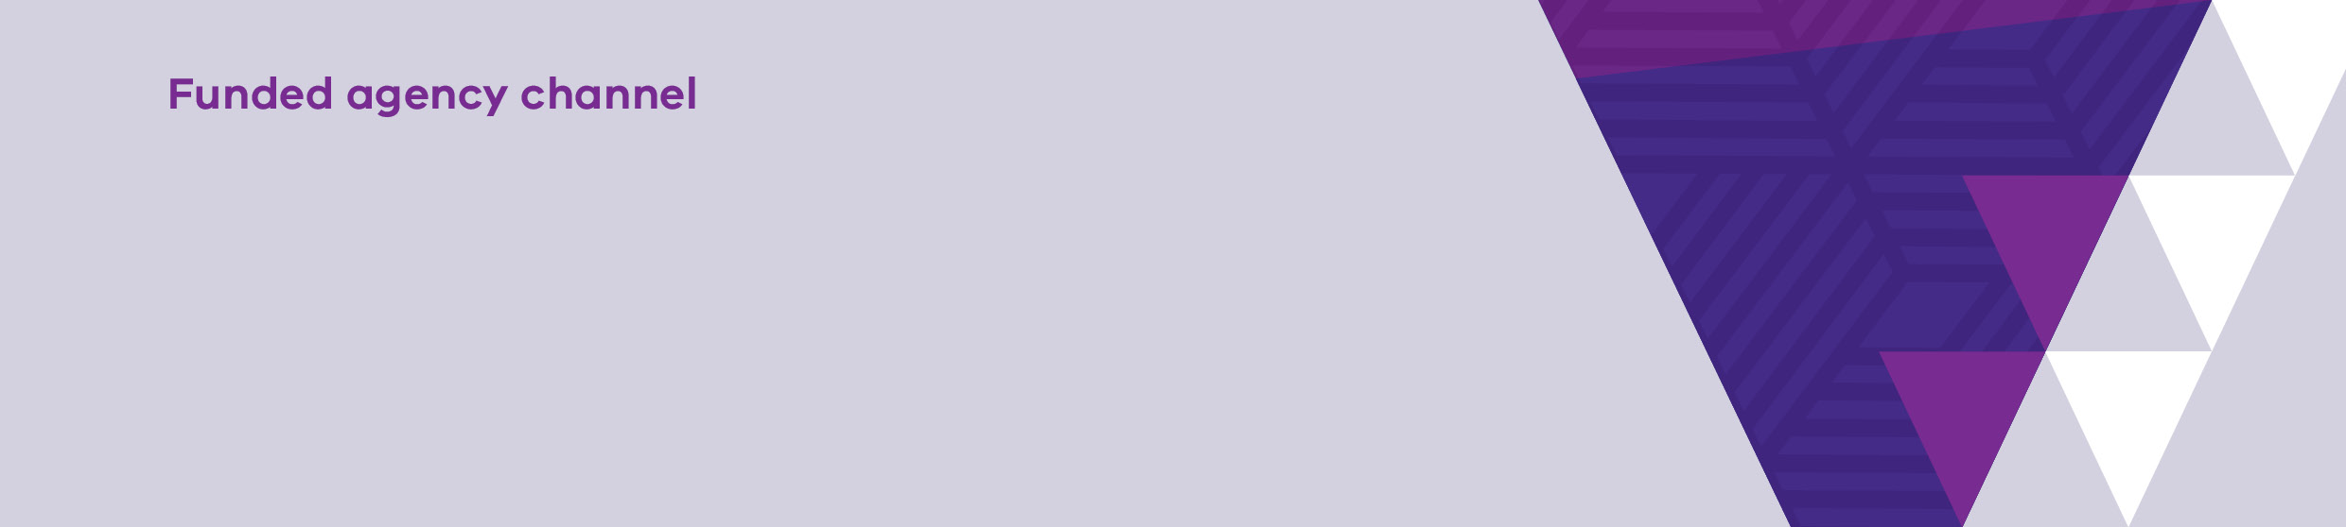

|  |
| --- |
| Service Delivery Tracking bulk upload process |
|  |
|  |

Contents

Introduction 1

Using this guide 1

Downloading the template 2

Navigate to the Service Delivery Tracking page 2

Running the report 3

Importing the data into SAM 6

The Acquittal screen 6

Submit the acquittal 8

Troubleshooting 8

Error Messages 8

# Introduction

To enhance funded organisations’ ability to complete their monthly Service Delivery Tracking (SDT) in the Service Agreement Module (SAM), new bulk upload functionality has been developed.

The SDT bulk upload function enables organisations to download a copy of monthly Service Delivery Tracking targets and then import responses directly into the acquittal screen.

Functionality contains validation checks to ensure data has been entered according to current requirements and allows for review and update before submission.

This enhancement moves away from manual data entry, reduces report line entry volumes, and improves accuracy.

The manual SDT acquittal process has not changed and will still be available.

The following instructions detail the steps required for organisations to import and submit their acquittal data.

## Using this guide

This document should be read in conjunction with the <https://fac.dffh.vic.gov.au/how-complete-your-sdt-acquittal-template-sam> guide, found on the [Funded Agency Channel](https://fac.dffh.vic.gov.au/) website <https://fac.dffh.vic.gov.au> under [Service Delivery Tracking](https://fac.dffh.vic.gov.au/service-delivery-tracking) <https://fac.dffh.vic.gov.au/service-delivery-tracking>

# Downloading the template

## Navigate to the Service Delivery Tracking page

1. Log in to My Agency, select Service Delivery Tracking Reports under the Data and Performance section.

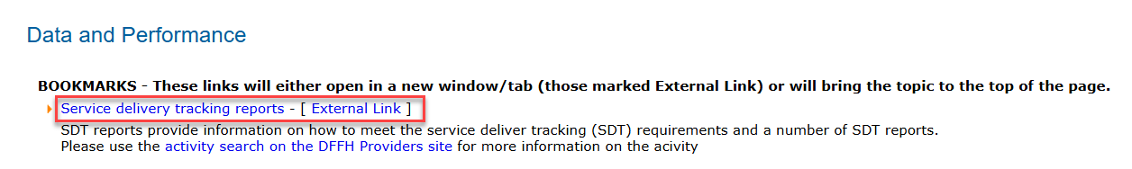

Figure 1 The Service delivery tracking reports link on My Agency

1. On the Service Delivery Tracking page, there is a report, SAM11 – Service Delivery Tracking Bulk Upload Template. This report displays the composition/breakdown of the target units in the selected SDT template month down to commitment and sub activity level, as well as the actual units, YTD, and any comments for each activity in the selected month for the selected financial year.

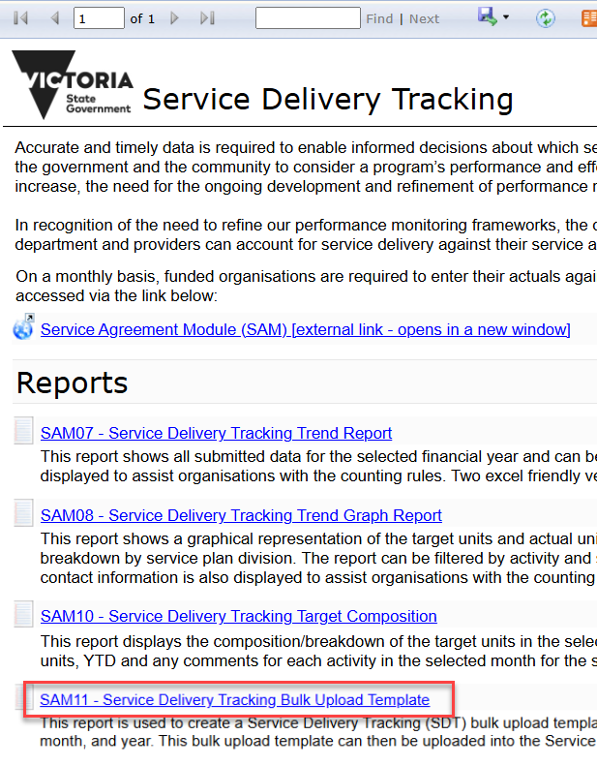

Figure 2 The Service Delivery Tracking reports page

## Running the report

Upon opening the report, it defaults to displaying the data for the current financial year and the most recent month that has a SDT template generated in SAM.

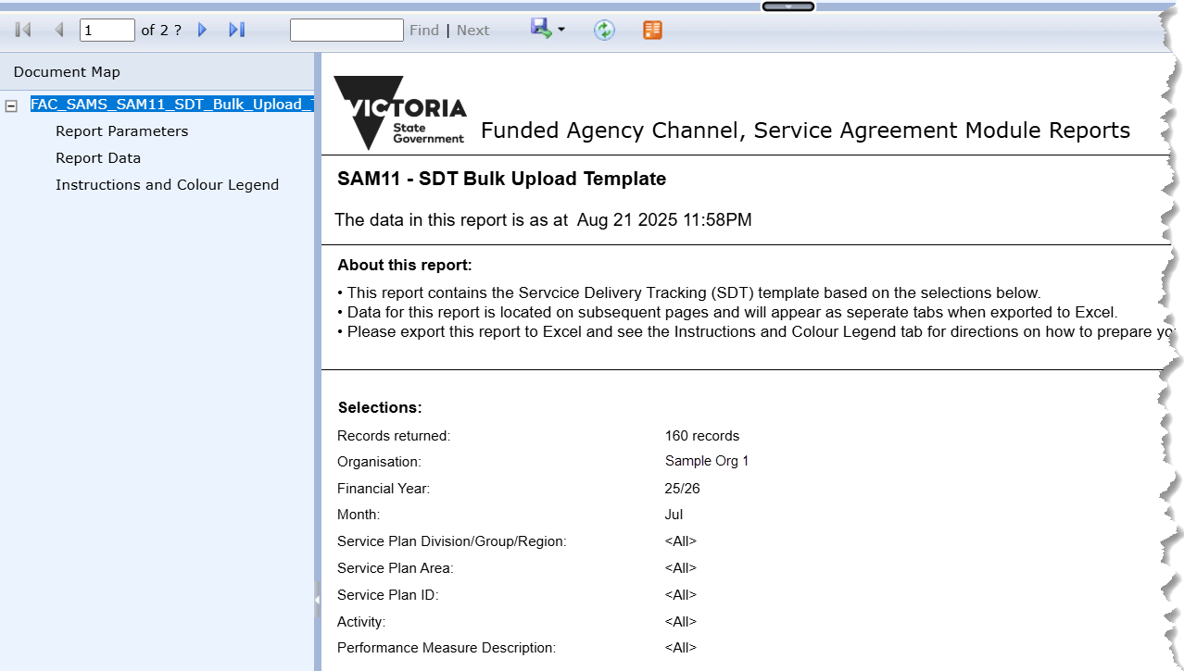

Figure 3 The Report Parameters page of the template

### Selecting different parameters

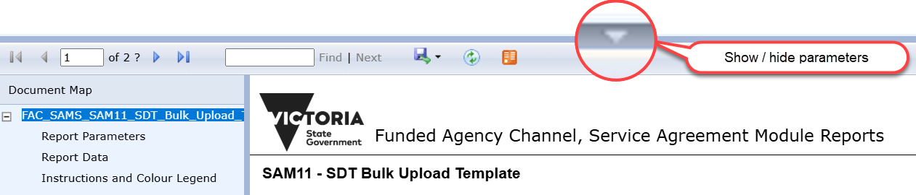

Figure 4 the show / hide parameters button

To select different parameters, click on the show / hide parameters button as depicted above.

If data is required to be submitted for a prior month, select the Month/Financial year in the drop-down selections and click on the view report button to refresh the data displayed.

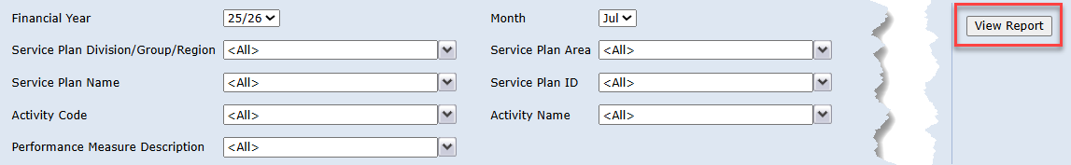

Figure 5 The view report button

Individual organisations may have one or more people providing the data for different parameters, a smaller data set can be downloaded if required for individual users who will be providing and/or uploading the data.

Service Plan Division/Group/Region can be filtered as required, as can Service Plan Area, Service Plan Name, Service Plan ID, Activity Code, Activity name and Performance Measure Description. Once the filters have been selected, click the View Report button to view the filtered data.

There are three pages in the report, the Report Parameters, the Report Data and the Instructions and Colour Legend. The report is best downloaded as an Excel file to work on.

### Download the filtered data

To download the file, click on the Export drop down menu icon.

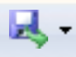

Figure 6 the export drop down menu icon

Select the Excel Option, the file will download, depending on the browser and settings, to the PC’s download folder.

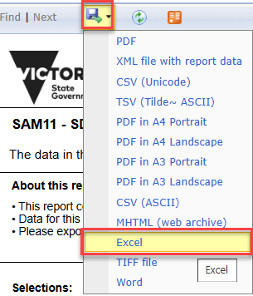

Figure 7 Export as Excel

### Complete the template

The Report Data worksheet is the template to be completed. The heading cells are coloured either grey, which denotes read only, or green which are editable fields to be completed by the user.

* Headings must not be edited, and columns must not be deleted or moved. Data in the read-only ‘grey’ columns must not be edited or deleted.

The columns to be completed are Response Details.Actual Units, which is mandatory and cannot be left blank, and Response Details.Comment, which is optional and cannot exceed 3000 characters.

The columns are a subset of the fields in the Acquittal screen in SAM.

Enter the actual units is the **Response Details.Actual Units** column and any comments in the **Response Details.Comments** field. Continue until all the required data is entered.

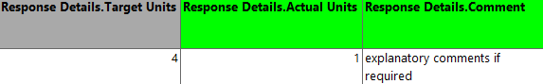

Figure 8 the editable fields with green headings in the report

**Notes**:

* If any rows in the acquittal screen in SAM have data already populated in either of these ‘green’ fields, it will be overwritten by the bulk import if the data is changed on the template.
* If the import csv contains any rows where the **Response Details.Actual Units is blank,** these rows should be deleted, as the file will not import.

Once satisfied the data is correct, copy the Report Data worksheet into a new file to be loaded into SAM.

1. In Excel, right-click the report data tab and select ‘Move or Copy…’,

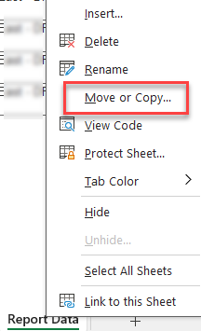

Figure 9 The Move or Copy menu option

1. Select the option for ‘(new book)

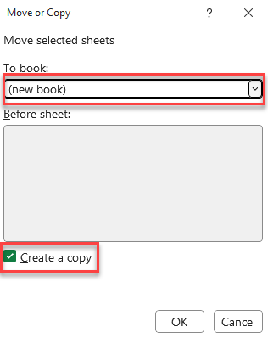

Figure 10 Create a copy as a new book

1. Save the new file with the bulk upload name and as type CSV (Comma delimited)

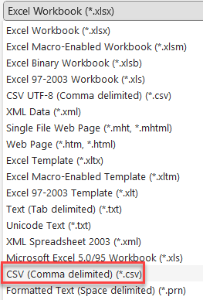

Figure 11 File type to save file as

# Importing the data into SAM

Log into the Service Agreement Module from My Agency and navigate to the Acquittal sub tab under the organisation

## The Acquittal screen

This screen contains six sections: The Organisation details, Actual Responses, Bulk Import Files, Actual Response Details, SDT Commitments and Key Sub-Activities.

### Actual Responses

The **Actual Responses** section is where the prepared CSV file can be imported.

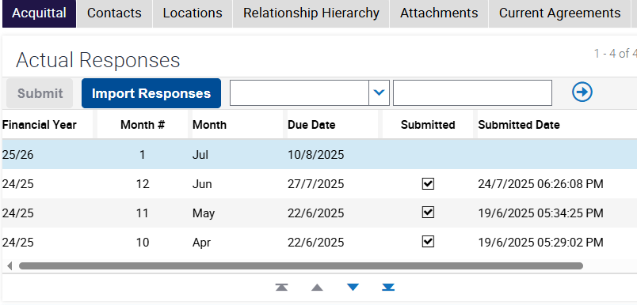

Figure 12 The Actual Responses section of the Acquittal screen displaying the Import Responses button

The current month to be submitted will be the first line to display at the top of the section followed by any previous months in descending order.

1. Select the month that for the data import and click on the Import Responses button.
2. The Bulk Upload File Import pop up is displayed. Select the Browse button, navigate to and select the file, then click the Import button.
3. The data will be imported into SAM.

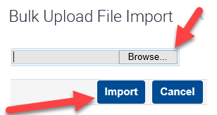

Figure 13 The file import pop up

**Note:**

* If the acquittal for a particular month has already been submitted, the import responses button will be disabled, the departmental advisor for the organisation can unsubmit if data needs to be corrected.

### Bulk Import files

To the right of the Actual Responses section, the files that have been imported are displayed along with the result. It is important to check the result for any rows of data that may have failed. Opening the related file via the File Name Hyperlink will show if there was any data missing which caused the failure. (This may be read-only data inadvertently deleted).

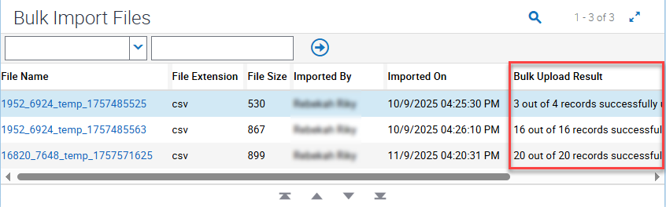

Figure 14 The Bulk Upload Result field in the Bulk Import Files section of the Acquittal screen

* A row that has failed the bulk upload can be manually entered under the Actual Response Details section, as per the manual process for inputting this data. This will display as Manual under the Update Source field in the Actual Response Details section

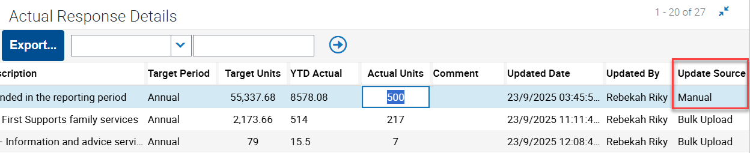

Figure 15 The Actual Response Details section of the Acquittal screen

* There cannot be any rows with no **Response Details.Actual Units** entered, the file will fail to import and display the error message “*The Actual Units value is mandatory and cannot be NULL. Please populate the required value(s) and try again.(SBL-EXL-00151*)”.
* Subsequent imports containing the same rows will overwrite what was previously imported.
* Rows can be deleted prior to importing if not required, to not overwrite existing data.

**Note:**

* In the event of an acquittal template completed via bulk upload being unsubmitted, the Bulk Import Files section of the screen will be cleared.

## Submit the acquittal

1. Once the Bulk Import/s have been completed, the Submit button becomes enabled and the data can be submitted.

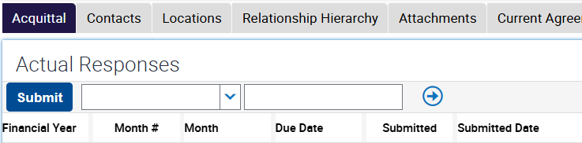

Figure 16 Actual Responses and Submit button

1. Once the acquittal has been submitted, the Submitted field will be checked and the Submitted Date and Submitted By fields against the selected month will be populated.
2. An email will be sent to person who submitted the acquittal.
3. The acquittal for the month is now complete.
4. If an acquittal has been submitted with incorrect data, please contact your department adviser as displayed in the Service Agreement Module (SAM) for assistance.

# Troubleshooting

* If a file fails to import and displays any of the following errors, cancel the attempted import, correct the file, and reimport.

## Error Messages

* The file is not a *.CSV file

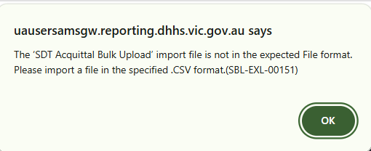

* The upload file contains a row that is blank in the *Response Details.Actual Units* field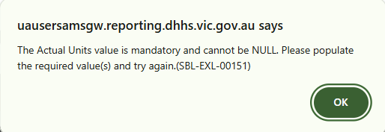
* The Organisation ID in the file does not match the target organisation

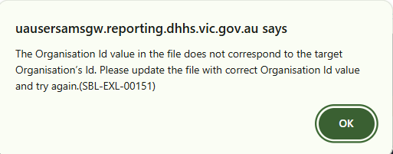

* The financial year in the file does not match the acquittal record selected  
  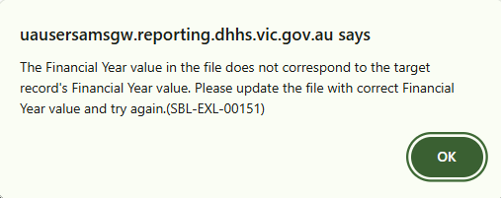
* The month in the file does not match the acquittal record selected

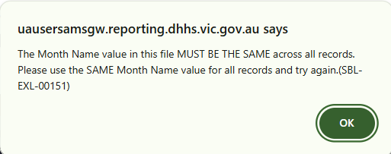

* The Organisation ID in the file is not the same across all rows  
  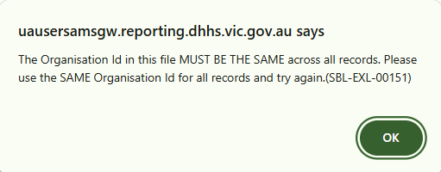
* The financial year in the file is not the same across all rows  
  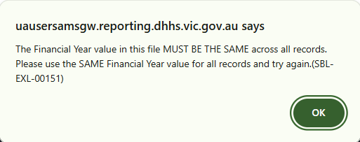
* The month in the file is not the same across all rows  
  
* A value has been entered in the *Response Details.Actual Units* field of the file that is not a number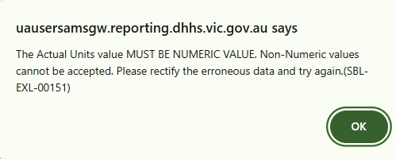
* The number of characters in the specified field/s exceeds the limit of the field in the file  
  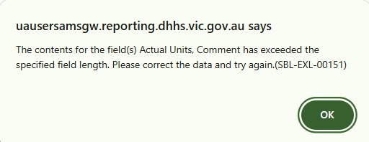

If you have any questions or require assistance with this process, please contact [FAC@dffh.vic.gov.au](mailto:FAC@dffh.vic.gov.au)

If you wish to receive a phone call, please include your best contact number in the email.

|  |
| --- |
| To receive this document in another format, email <[FAC@dffh.vic.gov.au](mailto:FAC@dffh.vic.gov.au)>.  Authorised and published by the Victorian Government, 1 Treasury Place, Melbourne.  © State of Victoria, Australia, Department of Families, Fairness and Housing, September 2025.  Available at [Funded Agency Channel](https://fac.dffh.vic.gov.au/) <https://fac.dffh.vic.gov.au/> |