

|  |
| --- |
| Service Delivery Tracking Data Collection Guidelines |
| May 2024 |
|  |

Contents

Introduction 1

Background 1

How SDT data is used 1

About this collection 2

Scope 2

Collecting data 4

Understanding targets 5

How to submit data 6

Timelines to submit data 6

Entering Data 6

Using the SDT template 7

Data Integrity Audits 7

# Introduction

## Background

In 2014 the department introduced the Service Delivery Tracking (SDT) process to strengthen the reporting of service delivery across the department by:

* reinforcing the accountability requirements for service provision through a monthly process
* consulting and engaging externally and internally on the reporting requirements that support this process
* the development of reports on funded organisation performance that will be available for departmental users and funded organisations
* the development of processes about SDT that align with and support funded organisation contract management roles and responsibilities at the divisional and area level.

This process is a simple, streamlined approach developed to improve the flow of information about service delivery**.**

## How SDT data is used

Information from SDT is used to support performance monitoring by acquitting performance against agreed targets as stated in service agreements. This will ensure that both the organisation and the department have a shared view of service delivery in a timely and regular manner. This will support organisations managing their progress towards meeting agreed targets and the department managing its broader and more formal government reporting commitments.

# About this collection

## Scope

Organisations funded to provide services from the activities listed in table below are required as stated in their services agreement to account for service delivery against agreed targets on a monthly basis via the SDT template.

#### List of activities in scope for SDT process

**Child Protection and Family Services**

|  |  |  |
| --- | --- | --- |
| **Service Type** | **Activity Number** | **Activity Name** |
| Placement Services | 31138 | Home based care – Permanent Care |
| 31140 | Care Hubs |
| 31141 | Two and three bed residential care |
| 31142 | Keep Embracing Your Success (KEYS) |
| 31188 | Lead Tenant |
| 31202 | Home based care – Kinship Care |
| 31205 | Home based care Adolescent Community Placement |
| 31214 | Home based care - General |
| 31216 | Home based care – Complex |
| 31413 | Home based care -Therapeutic Foster Care |
| 31415 | Residential Care |
| 31418 | Home based care – Intensive |
| Specialist support services | 31416 | Residential Care – Case Management |
| Family and community Services | 31289 | Intake and Access – Better Futures |
| 31290 | Individual, Child and Family Support – Better Futures |
| 31292 | Flexible funding – Better Futures |
| 31434 | Intake and Access |
| 31435 | Individual, Child and Family Support |
| 31437 | Flexible Funding |
| 31438 | Specialised Interventions |

**Disability Services**

|  |  |  |
| --- | --- | --- |
| Client services and capacity | 17085 | Assertive Outreach and Support |

**Early Planning centres**

|  |  |  |
| --- | --- | --- |
| Maternal and Child Health and parenting services | 28212 | Early Parenting Centres |

**Family Violence Service Delivery**

|  |  |  |
| --- | --- | --- |
| Family violence service delivery | 38010 | Support and Safety Hubs – service delivery |
| 38011 | Support and Safety Hubs – integrated practice support |
| 38012 | Support and Safety Hubs – flexible funding and brokerage |
| 38014 | Men’s Behaviour Change Corrections |
| 38016 | Sexual Assault Support Services |
| 38020 | Sexually Abusive Behaviour Treatment Services |
| 38021 | Aboriginal Family Violence Services |
| 38022 | Adolescent Family Violence Services |
| 38025 | Perpetrator Intake, Access Family Violence |
| 38026 | Flexible funding family violence and Sexual Assault |
| 38028 | Client Support Family Violence |
| 38029 | Perpetrators responses family violence |
| 38030 | Therapeutic Interventions Family Violence |
| 38032 | Holistic Aboriginal Family Violence |
| 38033 | Intake and Access Family Violence |
| 38034 | Supported Accommodation Family Violence |

**Housing Assistance**

|  |  |  |
| --- | --- | --- |
| Housing support and homelessness assistance | 20081 | Crisis Supported Accommodation |
| 20082 | Transition Support |
| 20083 | Homeless Persons Support Services |
| 20085 | Telephone information and referral |
| 91423 | Tenancy Plus – advocacy |
| 91424 | Tenancy Plus – establishment and intervention |
| 94113 | Homelessness Housing Establishment Fund (HEF) |
| 94587 | Tenancy Administration Crisis |
| 94588 | Tenancy Administration Transitional |
| 94589 | Initial assessment and planning |
| 94644 | Youth foyers - Operating (Broadmeadows) |
| 94646 | Youth foyers – Operating (Shepparton) |
| 94651 | Homelessness Adult Initiatives |
| 94652 | Homelessness accommodation options for families |
| 94653 | Support for families at risk of homelessness |
| 94654 | Homelessness A Place to Call Home |
| 94655 | Homeless children’s service |
| 94656 | Support to Maintain Tenancies - funding |
| 94658 | Homelessness youth services |
| 94651 | Homelessness adult initiatives |
| 94672 | Homelessness Opening Doors |
| 94675 | Private rental assistance |
| 94827 | Homelessness grant funding - Head Leasing |
| 94849 | Homelessness Client Support |
| 94851 | Homelessness Flexible Funding |

**Empowering Individuals and Communities**

|  |  |  |
| --- | --- | --- |
| Seniors programs and participation | 37413 | Carers Employment Support |
| Disability Services | 37041 | Disability Advocacy Program |

## Collecting data

Funded organisations are required to submit performance data on a monthly basis via templates generated on the first day of each month via the Funded Agency Channel of My Agency.

The current month to be submitted, will be the first line to display followed by any previous months in descending order. The fields included:

* Financial Year
* Month Number
* Month
* Due Date
* Submitted
* Submitted Date
* Submitted By

Each activity to be acquitted is listed, together with the Service Plan details relating to that activity. The fields include:

* Service Plan Division Group Region
* Service Plan Name
* Service Plan ID
* Activity Code
* Activity Name
* Performance Measure Description
* Target Period
* Target Units
* YTD Actual
* Actual Units
* Comment
* Updated Date
* Updated By

The [Service Agreement Requirements](https://fac.dffh.vic.gov.au/service-agreement-requirements-dffh-and-dh) <fac.dffh.vic.gov.au/service-agreement-requirements-dffh-and-dh> outlines the departmental responsibilities, policies and obligations that all funded organisations must comply with.

For activities mentioned above there are a set of reporting requirements and counting rules outlined in [Activity Descriptions](https://providers.dffh.vic.gov.au/families-fairness-housing-health-activity-search) <https://providers.dffh.vic.gov.au/families-fairness-housing-health-activity-search> to assist organisations on how and what is reported.

## Understanding targets

### Why is there a target period and what does it mean?

The target period is expressed as monthly or annual and reflects whether it is a non-cumulative or cumulative target.

A **non-cumulative** target has a *monthly* target period displayed on the SDT template. For non-cumulative targets, the Target Units section indicates what organisations are expected to provide each month. For example, an organisation funded to provide 150 beds is expected to provide and report 150 beds each month in the Actual Units column indicated in Figure 1.

Figure 1: Screen shot of non-cumulative targets

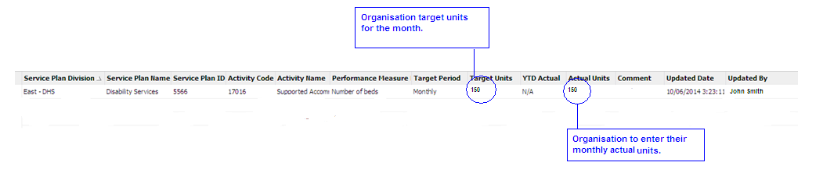

A **cumulative** target has an *annual* target period displayed on the SDT template. For cumulative targets, the Target Units section indicates what organisations are expected to perform for the full financial year. Organisations should report actual service delivery for the month in the Actual Units section indicated in Figure 2.

For example, an organisation funded to provide 40,000.33 client hours of community based respite for a financial year will be expected to provide and report actual service delivery for that month. The department recognises that performance for some activities with cumulative targets may vary from month to month due to seasonal demand for services such as school holidays.

Note: there is a Year-To-Date figure that will automatically total previous months displayed in the YTD Actual column.

Figure 2: Screen shot of cumulative targets

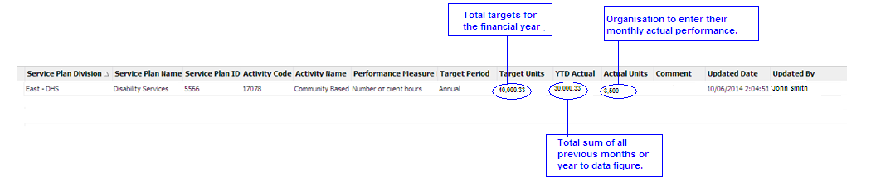

### What happens to a target less than one?

Where an organisation has a total target of less than ‘one’ that activity will not be visible in the SDT template. This may result in an organisation not having a SDT template generated, and therefore the organisation will not be required to report to SDT.

### Any queries on targets

If an organisation has a query regarding their targets recorded in the SDT template, they should raise this with the local departmental contact for the service agreement. The organisation should still enter its service delivery for the month and a note in the ‘Comments’ field that they are discussing the target with the department.

# How to submit data

## Timelines to submit data

All reporting for each month is to be completed **by the tenth day of the following month**. For example, the June acquittal data must be submitted by 10 July.

The service delivery tracking acquittal templates will be available for updating and submission from the first day of the month following the reporting month. For example, the June acquittal template will be available from 1 July.

## Entering Data

Organisations must provide actual service delivery against set targets for all activities for which they are funded and provide comments when required.

Comments should include explanations for targets not being met, and remediation strategies, where applicable. To maintain client confidentiality, client details should not be included in commentary.

## Using the SDT template

A guide on [How to complete your SDT acquittal template in SAM](https://fac.dffh.vic.gov.au/how-complete-your-sdt-acquittal-template-sam) <https://fac.dffh.vic.gov.au/how-complete-your-sdt-acquittal-template-sam> is available on the Funded Agency Channel.

**Access to the Service Agreement Module (SAM) to enter my SDT data**

Access to SAM is via My Agency (the secure section of the Funded Agency Channel). For this, you require a username and password to log in via eBusiness.

From My Agency, select the ‘Service Agreement Module’ link (under the Service Agreement Module section). In SAM, select your organisation name (hyperlink) then on the second level of tabs you will see the ’Acquittal’ tab. This is where you enter your data. Further information on how to enter your acquittal data can be found on the [Funded Agency Channel](https://fac.dhhs.vic.gov.au/service-delivery-tracking) < https://fac.DFFH.vic.gov.au/service-delivery-tracking>.

If you do not have an eBusiness account, detailed instructions on how to register for eBusiness can be found on the [Funded Agency Channel](http://www.dhs.vic.gov.au/funded-agency-channel/accessing-my-agency/accessing-my-agency-for-funded-organisation-users) <[www.dhs.vic.gov.au/funded-agency-channel/accessing-my-agency/accessing-my-agency-for-funded-organisation-users](http://intranet.dhs.vic.gov.au/resources-and-tools/FFOM0101/Local%20Settings/Temp/dsch1003/dsch1003/Local%20Settings/Temp/notesC479CE/www.dhs.vic.gov.au/funded-agency-channel/accessing-my-agency/accessing-my-agency-for-funded-organisation-users)>.

If you have queries about, or require assistance with, registering in eBusiness you can contact the Funded Agency Channel helpdesk on: [fac@dhs.vic.gov.au](mailto:fac@dhs.vic.gov.au).

# Data Integrity Audits

SDT is a self-reporting process. Self-reporting means the department will use the information you provide to record your service performance against service targets.

The SDT process will not check the accuracy of the details you provide, however at a later date we may examine the details provided more thoroughly by reviewing specific aspects of the data provided via a data integrity audit.

Data integrity audits provide assurance that self-reported service data is accurate and that high quality services are delivered efficiently and effectively.

A random sample will be conducted across all funded organisations. However specific audits in addition to the sampling program may be undertaken where service delivery tracking reporting indicates ongoing or abnormal performance issues.

For further information go to: ‘Service Delivery Tracking’ link under the ‘Data and Performance’ section in ‘My Agency’.

|  |
| --- |
| To receive this document in another format, email [Funded Agency Channel](mailto:fac@dffh.vic.gov.au) <fac@dffh.vic.gov.au>.  Authorised and published by the Victorian Government, 1 Treasury Place, Melbourne.  © State of Victoria, Australia, Department of Families, Fairness and Housing, September 2025.  ISBN 978-1-76130-536-8 (online/PDF/Word) or (print)  Available at [Funded Agency Channel](https://fac.DFFH.vic.gov.au/service-delivery-tracking) <https://fac.DFFH.vic.gov.au/service-delivery-tracking>  Prepared by Service Agreement Quality Services, Community Operations Practice Leadership |