

|  |
| --- |
| How to complete your service delivery tracking acquittal template in the Service Agreement Module |
|  |
|  |

Contents

Introduction 1

Using this guide 1

Completing your acquittal 2

Navigate to the Service Delivery Tracking page 2

Service Agreement Module 3

The Acquittal screen 3

Completing your organisation’s acquittal 5

Submit the acquittal 5

Exporting data to Excel 6

Counting rules 6

# Introduction

The Service Delivery Tracking process is for organisations to account for service delivery against their service agreement targets.

My Agency is the secure area of the Funded Agency Channel (FAC) website where registered users from funded organisations can access funding and payment information about their service agreement. If you require access to FAC and/or are not a registered user, please refer to the [Accessing My Agency](https://fac.dffh.vic.gov.au/my-agency-non-dffh-and-dh-staff) <https://fac.dffh.vic.gov.au/my-agency-non-dffh-and-dh-staff> section of FAC.

Within My Agency, the Service Agreement Module (SAM) allows funded organisations to access their service agreement information and to update some records and documents through interactive modules. One of these modules provides organisations with the ability to submit their monthly service delivery tracking acquittal online.

The following instructions detail the steps required for organisations to submit acquittal data.

## Using this guide

This document includes information on how to:

find the Acquittal sub tab to determine the activities that need to be acquitted

complete and submit acquittal data

export acquittal data.

# Completing your acquittal

## Navigate to the Service Delivery Tracking page

1. When you log in to My Agency, select Service Delivery Tracking Reports under the Data and Performance section.

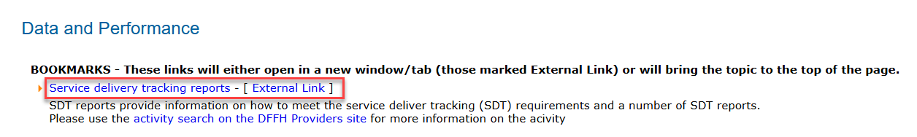

On the Service Delivery Tracking page, you will find all the information you require to complete your Service Delivery Tracking acquittal template.

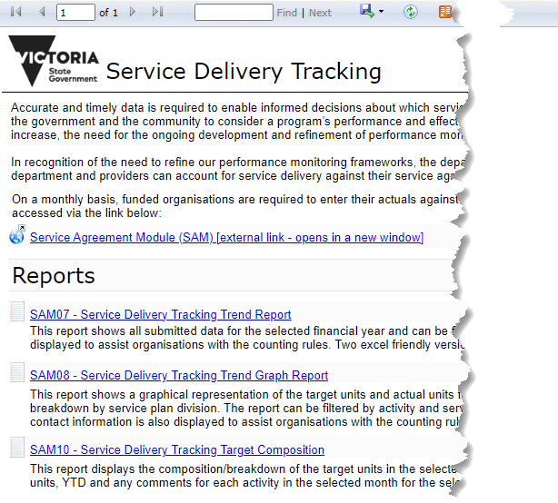

There are links to the Service Agreement Module (SAM), Service Delivery Tracking reports, contacts for assistance in your organisation and the department.

Select the Policy and funding plan you wish to view to open the Word document.

On the Policy and funding plan, hold down the Ctrl key and select Performance Measure 1 for quick access to the Counting Rules.

The counting rules may provide further information to assist you to calculate your actual units for the relevant activity.

To complete the Acquittal template, return to the Service Delivery Tracking page and select the link to the Service Agreement Module on the Acquittal tab.

# Service Agreement Module

1. Log into the Service Agreement Module from My Agency and navigate tab to the Acquittal sub tab

SAM will open in a separate window, defaulting to the Organisations screen.

On the organisations screen, select the organisation name hyperlink (blue text) to open the Organisations tab.

The Organisation screen will open with a series of tabs below the grey section. The Contacts tab will default.

Select the first tab which is Acquittal.

## The Acquittal screen

This screen contains 5 sections: The Organisation details, Actual Responses, Actual Response Details, SDT Commitments and Key Sub-Activities.

### Actual Responses

The second section is where all generated acquittal templates are displayed. The templates are generated on the first day of each month and are due to be completed by the tenth day of that month.

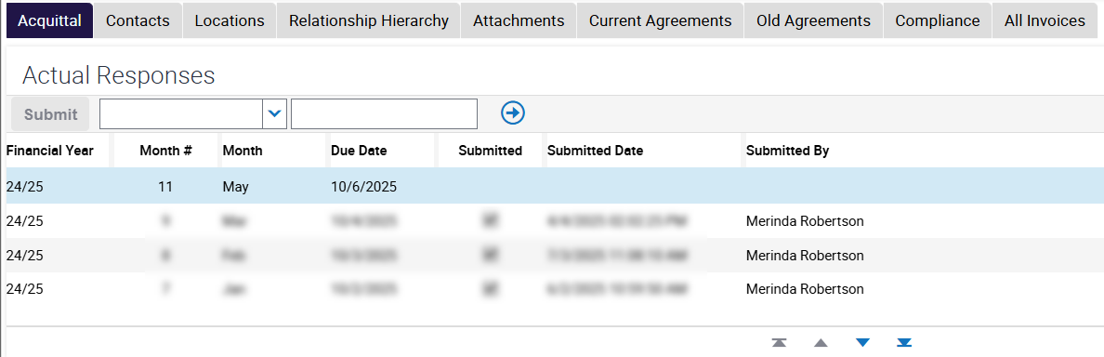

The current month to be submitted will be the first line to display at the top of the section followed by any previous months in descending order. The fields include:

* Financial Year
* Month Number
* Month
* Due Date
* Submitted
* Submitted Date
* Submitted By

The current month will default, but you may complete the acquittal for any un-submitted month. To change to another month, select the arrow on the left side of the screen relevant to that month.

### Actual Response Details

The next section down is the Actual Response Details where each activity that must be acquitted against is listed, together with the Service Plan details relating to that activity. Service plans are unique by the Service Plan Division/Group/Region, Service Plan Area (Introduced July 2025) and Service Plan Name.

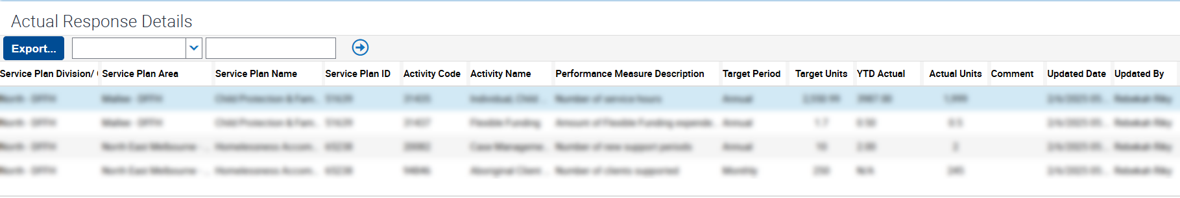

The fields include:

* Service Plan Division Group Region
* Service Plan Area
* Service Plan Name
* Service Plan ID
* Activity Code
* Activity Name
* Performance Measure Description
* Target Period
* Target Units
* YTD Actual
* Actual Units
* Comment
* Updated Date
* Updated By

This section will display up to 100 rows by default (depending on how many commitments the organisation is required to acquit against). This can be reduced by clicking the ‘show less’ button Screenshot of the show less button

And expanded again by clicking the ‘show more’ button

Screenshot of the show more button

### SDT Commitments

The next section down is the SDT Commitments section. This displays the associated commitment Id (as a hyperlink), the Root Start Date, Start Date, End Date, Cost Centre, Area, Funding Type, Event Description, Agreement Id and Agreement Version.

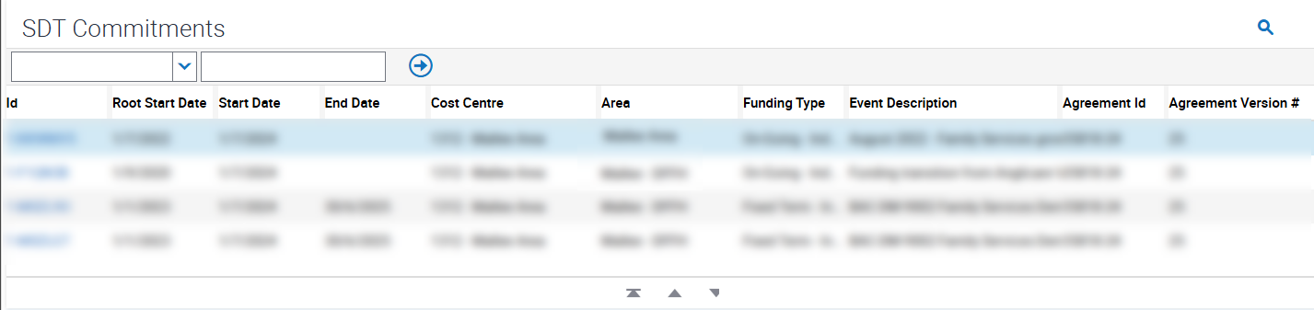

### Key Sub-Activities

The next section down is the Key Sub-Activities, displaying the associated sub activities that make up the targets. The fields displayed are Id, Sub-Activity and Target Units.

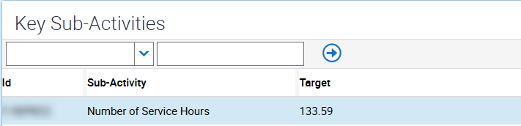

## Completing your organisation’s acquittal

1. There are two types of Target Period:
   1. a monthly target period which is a non-cumulative target. You must enter the number of actual results achieved in the reporting month. The YTD Actual field will display N/A.
   2. an annual target period which is a cumulative target. You must enter the actual result achieved in the month. The YTD actual units are generated in the template and the field cannot be edited. This field provides the sum of the data entered for previous months.

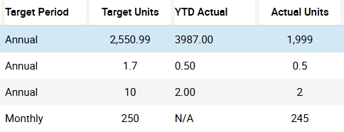

1. Against each activity, enter the actual number of units delivered in the month in the Actual Units field. If you provided services across several divisions and areas, enter only the data relevant to the division and area specified in the Service Plan Division/Group/Region and area fields.
2. You may enter comments up to 1,000 characters in the Comment field. It is advisable to enter summarised comments in the field and it is recommended to limit these to around 255 characters.
3. Comments should include explanations for targets not being met, and remediation strategies, where applicable. To maintain client confidentiality, client details should not be included in your commentary.
4. You can save your progress at any time by pressing the ctrl and S keys.

## Submit the acquittal

1. When all Actual Units have been entered and the data saved, the Submit button will be enabled. Select the Submit button to submit the completed acquittal. Note you cannot submit a partially completed acquittal.

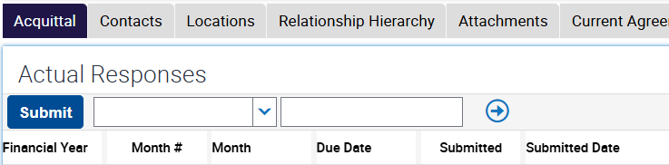

1. Once the acquittal has been submitted, the Submitted field will be checked and the Submitted Date and Submitted By fields against the selected month will be populated.
2. An email will be sent to person who submitted the acquittal.
3. The acquittal for the month is now complete.
4. If you believe that an acquittal has been submitted with incorrect data, please contact your department adviser as displayed in the Service Agreement Module (SAM) for assistance.

# Exporting data to Excel

1. The acquittal form can be exported to Microsoft Excel at any time.
2. To export the data for your records, click the Export button.   
   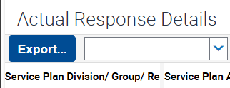
3. A pop-up window opens. You do not need to change the default settings, select the Next button and the data will download in CSV file format.   
   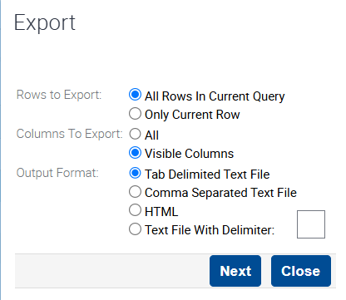
4. You can open the file in Excel (recommended) or other applications supporting CSV format and save it as .xlsx format.
5. When returning from Excel, select Close on the pop-up window in SAM

# Counting rules

Each activity and performance measure in the acquittal has its own counting rules, further information relating to this can be found at <https://providers.dffh.vic.gov.au/families-fairness-housing-health-activity-search> and searching for the activity in question.

|  |
| --- |
| To receive this document in another format, email <[FAC@dffh.vic.gov.au](mailto:FAC@dffh.vic.gov.au)>.  Authorised and published by the Victorian Government, 1 Treasury Place, Melbourne.  © State of Victoria, Australia, Department of Families, Fairness and Housing, June 2025.  Available at [Funded Agency Channel](https://fac.dffh.vic.gov.au/) <https://fac.dffh.vic.gov.au/> |