

|  |
| --- |
| Preparing an eBusiness account for deletion |
|  |
|  |

Contents

Preparing an eBusiness account for deletion 1

Completing the Microsoft eForm 1

No accounts for deletion required 1

Accounts to be deleted. 2

Retrieving User Information: 3

# Preparing an eBusiness account for deletion

When an eBusiness account is no longer required, or an employee who held the account has left your organisation, the Organisation Authority (OA) must take steps to make sure the account is no longer accessible.

This is done by removing the account from membership of the organisation in the Enterprise User Service (EUS) and advising the department to disable the account in preparation for deletion using the Microsoft form <https://forms.office.com/r/HDiUjTamDx> (same as in the email).

Information from the eForm is used in a semi-automated process to complete the deletions, therefore it is important to ensure the data entered is accurate and in the required format. All information needs be sourced from EUS, as other applications do not have all the required details.

# Completing the Microsoft eForm

## No accounts for deletion required

When you receive the quarterly reminder, if you have no outstanding account deletions simply access the form, choose the no option for question one, enter your organization name, and press submit. This allows us to capture that contact details for organisations are up to date and for account management compliance purposes.

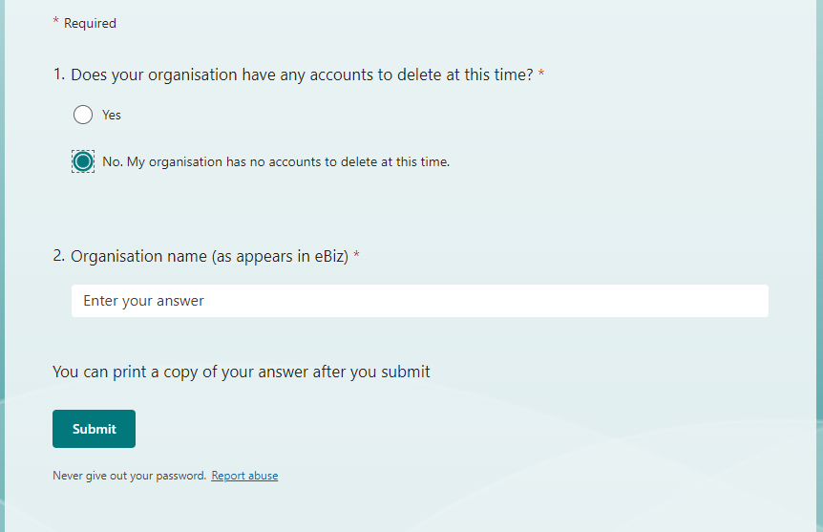

## Accounts to be deleted.

If there are accounts that need to be deleted, the first step is to choose yes for question one. Further options will then be presented for completion.

All the information required for the following questions must be sourced from the Enterprise User Service (EUS). The reminder pertains to the user’s eBiz account, and not individual applications they have access to.

If the user only requires removal from certain applications, but needs to retain their eBiz account, you will need to contact the support teams for those applications as the account does not need to be deleted. Contact details for these teams can be found on either the Department of Health website <https://www.health.vic.gov.au/> or the Department of Families, Fairness and Housing website <https://www.dffh.vic.gov.au/>

To obtain the information required for questions 2 – 6, you will need to access EUS as the Organisation Authority. The steps for this are below the following screenshot which shows an example of how the form should be filled in before submission. Please ensure that you are completing the form BEFORE you delete the organisation role in the below steps as you will no longer be able to access the user’s information afterwards.

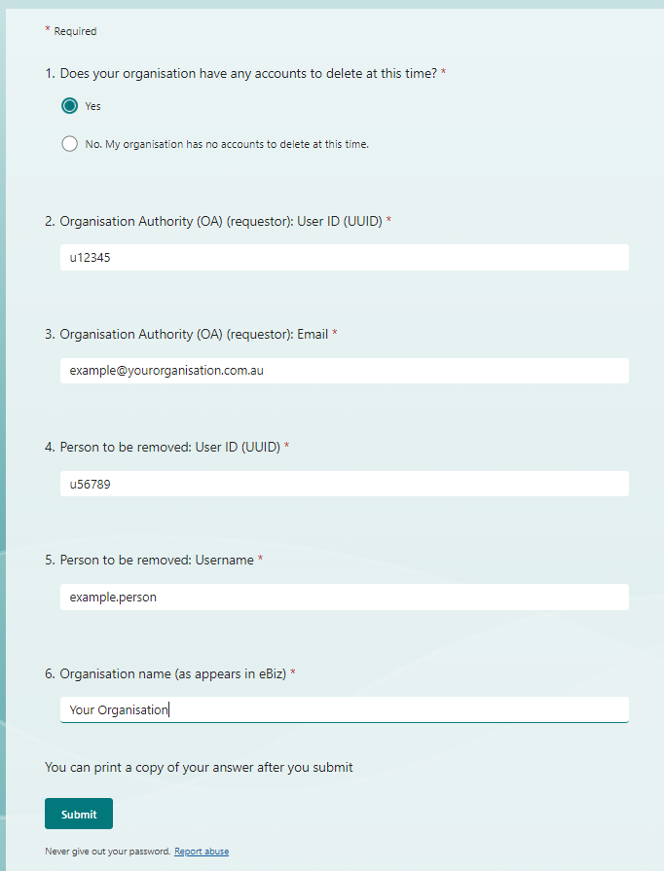

## Retrieving User Information:

1. Under the ‘User Management’ menu option in EUS (<https://hns.dhs.vic.gov.au/EUSAdmin/>), search for the user account you need to prepare for deletion.

**NOTE: to get a list of all users associated with the Organisation, please leave all other fields blank and only populate the Organisation Name and press search.**

**If nothing comes up in the search, please contact** [**ebizreview@support.vic.gov.au**](mailto:ebizreview@support.vic.gov.au) **before continuing with these instructions.**

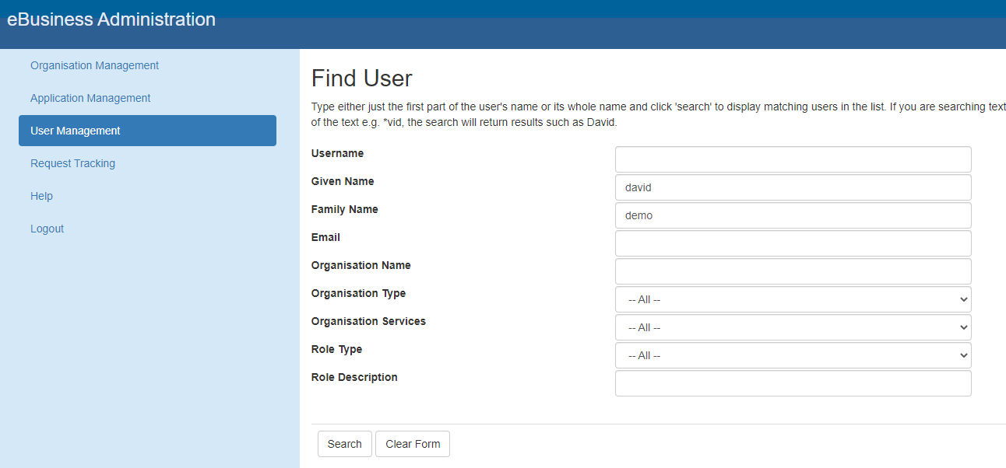

1. Once you have located the desired account, please record the **UUID and Username in the MS e-Form first.** Then, click on the Username to open and edit the account profile.

Screenshot of User 
search Results

1. Scroll down to the **User Organisational Roles** section. This is where you remove the account from the organisation membership.
2. Click on the Org Role ID to open the role.

User Organisation Roles section of the User Details screen


1. Click on the **Delete** button to remove the role (Note: for ‘a’ type accounts, you cannot delete the role).

You will be taken back to the user account profile where you will see the Organisation role has been removed.

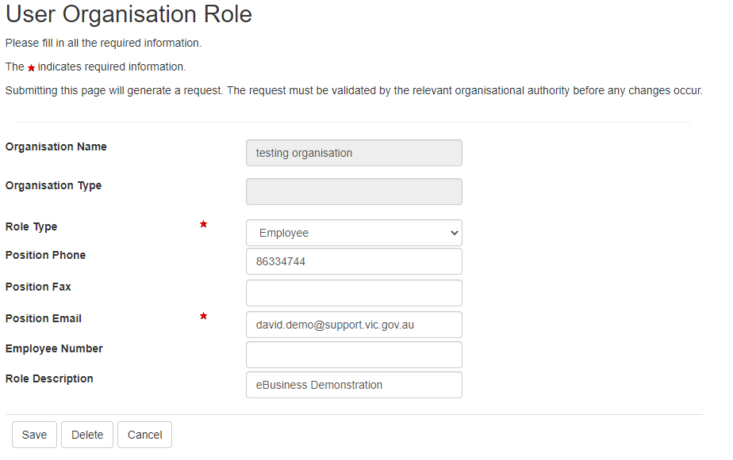

1. Except for ‘a’ type CRISSP accounts, you will be taken back to the user account profile where you will see the Organisation role has been removed.

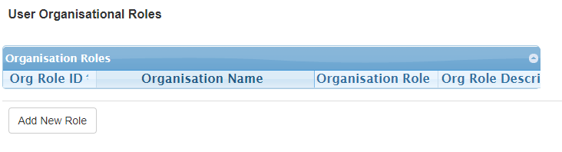

1. You now need to save your changes by clicking on the ‘Save’ button at the top or bottom of the page then confirming the save at the prompt. You will be taken back to the ‘**User Search Results’** list. The account is now ready to submit for deletion.

|  |
| --- |
| To receive this document in another format, email [eBiz@support.vic.gov.au](mailto:eBiz@support.vic.gov.au)  Authorised and published by the Victorian Government, 1 Treasury Place, Melbourne.  © State of Victoria, Australia, Department of Families, Fairness and Housing, June 2025  Available at [Funded Agency Channel](https://fac.dffh.vic.gov.au/) <https://fac.dffh.vic.gov.au/> |