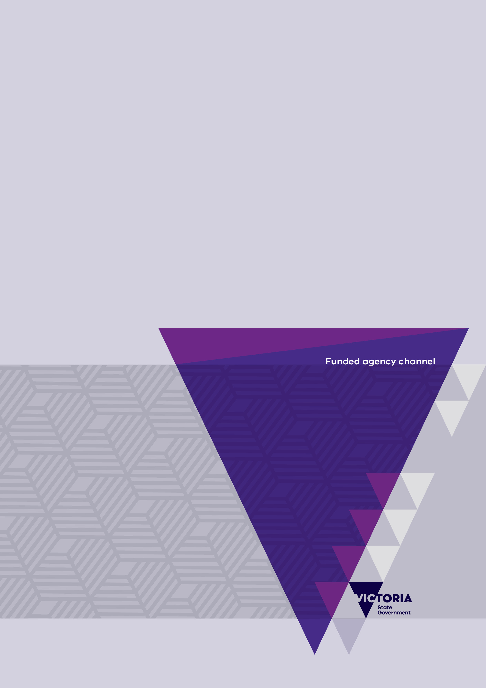

|  |
| --- |
| Introduction to Funded Agency Channel, My Agency and the Service Agreement Module (SAM) |
| A training guide for State Government department staff and funded organisations |
| OFFICIAL |

|  |
| --- |
|  |
| To receive this document in another format, email The Funded Agency Channel [FAC@dffh.vic.gov.au](mailto:FAC@dffh.vic.gov.au)  Authorised and published by the Victorian Government, 1 Treasury Place, Melbourne.  © State of Victoria, Australia, Department of Families, Fairness and Housing, April 2025.  Available at insert web site or web page name and make this the hyperlink and insert full web address (URL) here but do not make it a hyperlink |
|  |

Contents

Introduction 3

Background 4

What is a Service Agreement? 4

How is a Service Agreement structured? 4

View a sample agreement 6

Funded Agency Channel 7

Content 8

User access 8

Target audience 8

Key sections 8

My Agency 9

Content 9

User access 10

Key sections 11

Overview of key reports in My Agency 11

Running reports in My Agency 11

Service Agreement Module 13

Key functions in SAM 13

Access SAM 13

Add or update user details 13

View the list of Department advisers 14

Service Agreement compliance certificate (SACC) 14

Completing your organisation’s acquittal – Service delivery tracking (SDT) 14

Viewing your agreements 14

Accessing contracts 15

Navigating records 15

# Introduction

The purpose of this document is to provide a high-level summary of the key elements of the Funded Agency Channel (FAC) website and its secure area, My Agency. These sites provide users with essential information specific to their Service Agreement with the Department of Families, Fairness and Housing (DFFH), Department of Health (DH), and/or the Department of Education (DE), and the Adult Community and Further Education Board (ACFE).

This workbook is intended to be used as a practical guide to help you navigate the content of both FAC and My Agency. It has been written for use with the desktop version of these sites.

# Background

## What is a Service Agreement?

A Service Agreement is a legal contract between a government department and a funded organisation for the delivery of services to Victorian communities. The Service Agreement sets out the key obligations, objectives, rights, and responsibilities of the organisation delivering services and the department providing funding to the organisation.

## How is a Service Agreement structured?

Knowing how a Service Agreement is structured will assist you to understand the information available in My Agency, its data reports, and the Service Agreement Module.



Figure 1 Diagram of the structure of a service agreement

Moving from the top of Figure 1 to the bottom:

* Each organisation has at least one agreement with one department but may have an agreement with multiple departments. In this example, the Sample organisation have two agreements with DFFH, one with DH and and one with DE.
* Each agreement contains one or more commitments containing the activities which are grouped in services plans under the divisions that fund the activities.
* Each commitment has one or more sub-activities that provide further details of the service to be provided. In this example, the sub activity Community Development Planning & Activity Coordination Hours (KPOM) DFFH indicates that the performance measure is hours, and the target is 1230 hours (units).

## View a sample agreement

You can view a sample agreement by following the link under ‘sample Service Agreements’ on the Tools and resources → Service agreement page [Funded Agency Channel](https://fac.dffh.vic.gov.au/service-agreement)

# Funded Agency Channel

The Funded Agency Channel (FAC) website is a shared service across the Department of Families, Fairness and Housing, Department of Health, Department of Education and the Adult Community and Further Education board.

Launched in 2002, FAC is managed by the Service Agreement Performance team within the Service Agreements and Quality Systems Branch of DFFH.

A screenshot of the Funded Agency Channel website

The Funded Agency Channel website's homepage

Figure 2 The Funded Agency Channel website home page

## Content

FAC provides information, news, policies, and resources to support the business relationship between the departments and funded organisations. It is the primary online communication tool for organisations funded by the departments.

## User access

FAC is a publicly available website open to any user with internet access.

My Agency is the secure section of the FAC website and is only accessible to registered users.

## Target audience

FAC is publicly available, however, the content is targeted at funded organisation and departmental staff, including:

* boards of management
* senior executives
* middle managers
* unit and program managers with management or administrative responsibilities
* staff responsible for meeting performance targets
* relevant departmental managers and staff in divisional, area and central offices.

## Key sections

The FAC homepage links to a wide variety of information relevant to Service Agreement management, including:

**News:** the latest news for funded organisations.

**My Agency:** the secure section of the FAC website, only accessible to registered users.

**Tools and resources:**

**Service Agreement Requirements** is designed to provide funded organisations with guidance on complying with their Service Agreement requirements and also contains the applicable departmental policies that organisations must adhere to.

**Policies and procedures:** information about key policies, procedures and guidelines relating to Service Agreements.

**Incident reporting:** incident management information for funded organisations, including details about the Client incident management system (CIMS) and reporting privacy breaches.

**Data collection:** data collection and reporting tools for funded organisations including Service delivery tracking.

**Systems:** information on useful systems for the funded sector, including Integrated reports and information system (IRIS), Client relationship information system for service providers (CRISSP) and Client relationship information system (CRIS).

**Legislation:** links to Commonwealth and State legislation sources.

**Useful links:** helpful information relevant to Service Agreement management.

**Training:** education and training resources on subjects such as My Agency, CRISSP, IRIS, the L17 Family violence portal, IRIS and the Outcomes Tracking System (OTS).

# My Agency

My Agency is the secure section of the FAC website and is only accessible to registered users.

It provides users with quick and easy access to organisation specific information about Service Agreements.

To be eligible for My Agency access, you must be either a:

* staff member of the departments or of an organisation funded by the departments, or
* member of the board or committee of management of one of the organisations funded by the departments.

## Content

My Agency provides:

* organisation specific Service Agreement information for the current, future and previous financial years
* access to payment schedules, invoices and the progress of Service Agreement variations
* organisation performance reports for funded activities
* access to the Service Agreement Module (SAM)
* links to resources aimed at funded organisations
* a single point of view for information and reporting requirements, as data is gathered from various sources. For example, the Service Agreement management system (SAMS2) or the Health and community care (HACC) minimum data set.

## User access

My Agency is only accessible to registered users.

Internal staff of DFFH or DH can access directly via the department intranet, K-Z systems in the footer of the page.

For users who are from Funded Organisations, Department of Education or the Adult Community and Further Education Board access is via the [eBusiness Portal](https://eus.webapp.dhs.vic.gov.au/)  
< <https://eus.webapp.dhs.vic.gov.au/>>

### eBusiness

Users outside of Department of Families, Fairness and Housing or Department of Health require an eBusiness portal username and password to gain access to My Agency.

While more than one person per organisation can register for eBusiness, you must register yourself.

### Organisation Authority

Each organisation has an Organisation Authority (OA). The OA approves access requests prior to eBusiness access being granted.

### Register for My Agency access in eBusiness

Please follow this guide <https://fac.dffh.vic.gov.au/how-register-my-agency>

Once you have completed the registration process, you should receive your eBusiness login details within three business days. If you do not receive your login by this time, email the [eBusiness support](mailto:eBiz@support.vic.gov.au) <eBiz@support.vic.gov.au>.

### Forgotten eBusiness login

If you are already a registered eBusiness user but have forgotten your details, follow this guide <https://fac.dffh.vic.gov.au/forgotten-ebusiness-username-or-password>

### Help

For further information on how to navigate My Agency, eBusiness registration, username or password issues, visit the User guides section of FAC <https://fac.dffh.vic.gov.au/my-agency-non-dffh-and-dh-staff>

## Key sections

The My Agency homepage links to a variety of resources relevant to Service Agreement management, including:

* **Service Agreement Module (SAM):** provides access to view your organisation’s current service agreements, multi-year funding and payment schedules. Organisations can accept first time agreements, change staff contact details and upload compliance information.
* **Data and performance:** access to a substantial number of reports including current and previous financial year reports, client specific funding reports, compliance reports and the performance against targets.

Departmental staff can also view:

* **Departmental resources:** specialised reports, videos and organisation monitoring information.
* **Desktop Review reports:** monitoring framework reports.

## Overview of key reports in My Agency

My Agency provides users with access to organisation specific information and reports. Please see [My Agency reports fact sheet](https://fac.dffh.vic.gov.au/sites/default/files/Fact%20Sheet%20-%20My%20Agency%20reports%20FINAL.docx) for more information.

## Running reports in My Agency

This section provides step-by-step instructions for running and saving reports.

### Step 1

From the My Agency homepage, select the hyperlink of the report you wish to run. In this example, we will run SAM02b - Current funding report.

Screenshot of SAM02b – Current funding report link


Figure 3 the financial reports in My Agency

For all reports, the first page has information about the report particulars including the number of records, organisation details and time when the report was run. The report’s data is displayed from the second page onwards. Note, the parameters default to “All” and the financial year to the current financial year.

### Step 2

Based on your requirements, select appropriate parameters from the drop-down filters at the top of the screen

1. After selecting your parameters
2. Click the View Report button to refresh the data.
3. Click the forward button to move through the pages

Screenshot of filters and view report button in SAM02b report


Figure 4 The Service Agreement Contract report

### Step 3

To export data, click the arrow next to the export drop-down menu icon and select the format you want to export the data in. In this example, we have selected Excel.

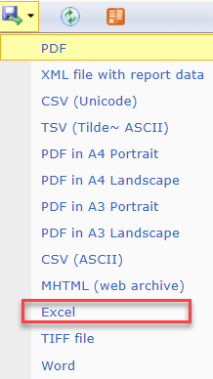

Figure 5 The export report data menu

# Service Agreement Module

The Service Agreement Module (SAM) is the organisation’s view of the departments’ Service Agreement Management System (SAMS2). SAM provides real time Service Agreement information for funded organisations. SAM is accessed via My Agency.

## Key functions in SAM

SAM enables organisations to undertake a number of tasks including:

* change staff member contact details
* submit their Service Agreement compliance certificate along with other compliance documents
* accept first time agreements
* submit monthly acquittals.

## **Access** SAM

To open SAM, click the Service Agreement Module link on the My Agency homepage.

Screenshot of Service Agreement Module (SAM) link on My Agency page


Figure 6 The link to the Service Agreement Module in My Agency

## Add or update user details

When opening SAM, the default view is the Organisation tab.

The Access Controller (AC) can adjust access levels for their organisation’s registered users by ticking/unticking the required role box for each user.

From this screen, the AC can also add a new user or make changes to the details of an existing user. For example, the AC can update a user’s email address or telephone number.

It is important that the AC does not overwrite an existing user’s details with a new user’s detail.

For further information see <https://fac.dffh.vic.gov.au/managing-contacts-service-agreement-module-sam>

## View the list of Department advisers

If you’re unsure about who your department contacts are for your Organisation, you can view this in SAM.

1. Under the organisation tab click on the icon next to the name in the Department Adviser field.



Figure 7 The Organisations screen in the Service Agreement Module (SAM)

1. The department advisers list will be displayed with their name, department, division/region/group, email and phone number. One record is ticked as your primary contact.

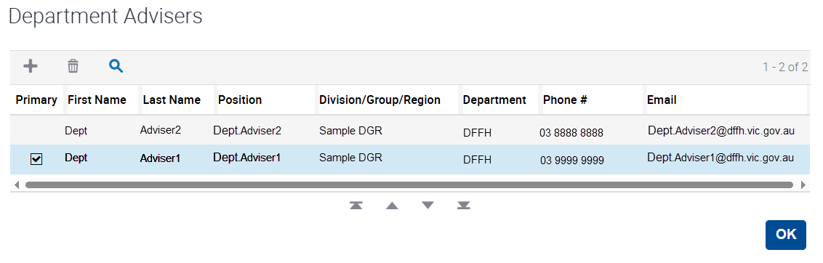

Figure 8 The Department Advisers list

## Service Agreement compliance certificate (SACC)

The SACC is an online questionnaire completed annually by all funded organisations. By submitting the SACC, organisations are making a commitment to the department that they have appropriate systems in place to comply with their Service Agreement requirements. The questions relate to:

* financial management
* risk management
* staff safety screening
* privacy.

The SACC is due 90 days after the end of the organisation’s reporting period. However, if the organisation's annual general meeting (AGM) is after the due date, the organisation can insert the AGM date in SAM. The SACC due date will then automatically update to seven days after the AGM.

For further information about completing your SACC see <https://fac.dffh.vic.gov.au/how-complete-your-sacc-service-agreement-module>

## Completing your organisation’s acquittal – Service delivery tracking (SDT)

SDT supports organisations to manage their progress towards meeting agreed targets and assists the department to manage its reporting commitments. Organisations must submit their monthly service delivery actuals against Service Agreement targets for selected activities, via the Acquittal tab in SAM. For further information see <https://fac.dffh.vic.gov.au/how-complete-your-sdt-acquittal-template-sam>

## Viewing your agreements

Select the Current Agreements tab to access information on current agreements, including details on funding, service plans, activities, commitments and sub-activities.

Select the Old Agreements tab to access information on preceding versions of the agreements, including the initial agreement.

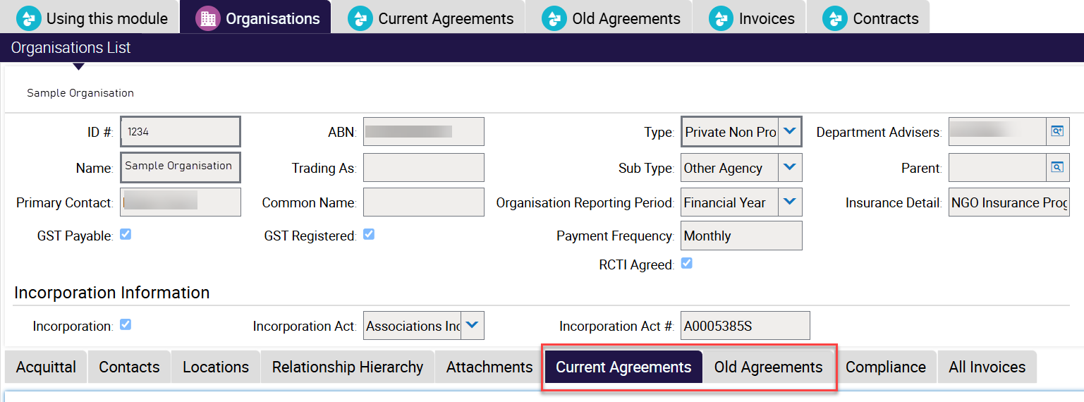

Figure 9 The Organisations screen Agreements subtabs

## Accessing contracts

1. The Contracts tab displays the most recent version of each agreement the organisation holds with the department, as well as the first version of each agreement.
2. Initially, the screen only displays five lines but this can be expended to 20 lines by selecting the Show more/Show less button on the far right hand side of the screen

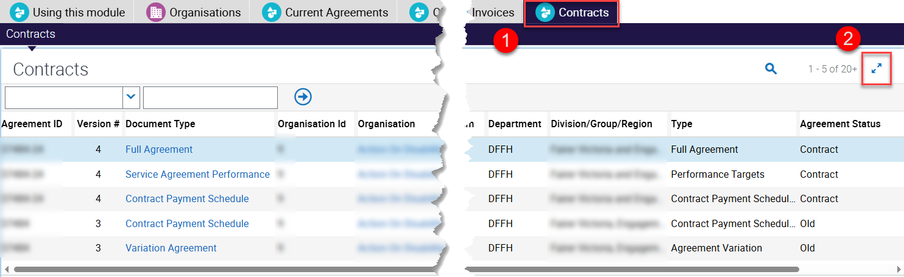

Figure 10 The contracts screen

Each contract version comprises three documents:

1. **Contract Payment Schedule:** details the full payment schedule of the agreement
2. **Service Agreement Performance:** details performance measures, targets and units of measure for each activity within the agreement
3. **Full Agreement or Variation Agreement:** a copy of the full agreement including terms and conditions or a Variation Agreement which is the latest variation to the agreement.

For further information see <https://fac.dffh.vic.gov.au/how-view-your-service-agreement-my-agency>

When a first-time agreement is submitted for approval, its status is shown as Awaiting approval. A pdf version of the agreement is created and can be downloaded by clicking the hyperlink of the Document type. <https://fac.dffh.vic.gov.au/how-view-your-service-agreement-my-agency>

Only the agreement signatory can approve a first-time agreement. Variations, other than version one, are not required to be approved online. For further information see [How to approve a first time agreement in the Service Agreement Module](https://fac.dffh.vic.gov.au/sites/default/files/image_library/How-to-approve-a-first-time-agreement-in-SAM-April-2019.docx)

## Navigating records

### Querying records and exporting data in SAM

SAM provides users with access to large volumes of data. Using the query function makes it easy to search these records. There are a few ways to do this.

1. You can query by using the drop down menu on the top let of the screen, this will give you a number of options to query a single field, for example select the field you wish to query
2. Enter the criteria
3. Click to go button

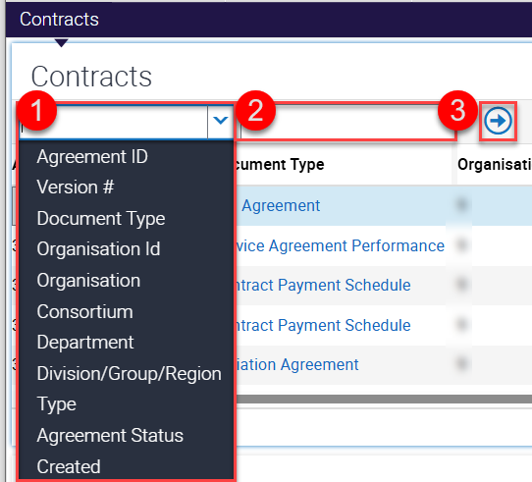

Figure 11 sample search box

You can also click on the on the query button on the right hand side of the screen The query button, this will display further buttons. In order, the go button (arrow), the cancel button (cross) and the query assistant. The go, cancel and query assistant button

You can enter criteria you are searching for directly in any of the fields and click go or invoke the query assistant where you can select several fields with different conditions and criteria for each.

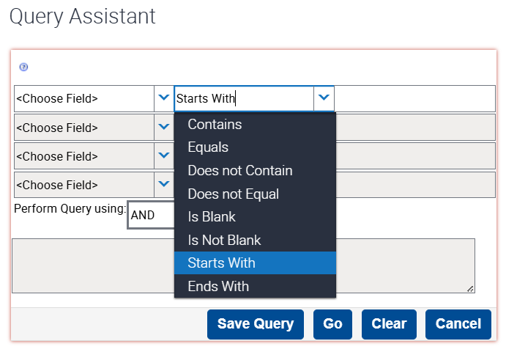

Figure 12 The query assistant

Some screens allow you to export data in various formats, these are:

* The invoice→Activity Line Items, Remittance Advice, Commitment Details
* The Aquittal→Actual Response Details

These screens will display the export button screenshot of the export button

You will then have the following options to select from, generally the default settings work will to opn the data in excel.

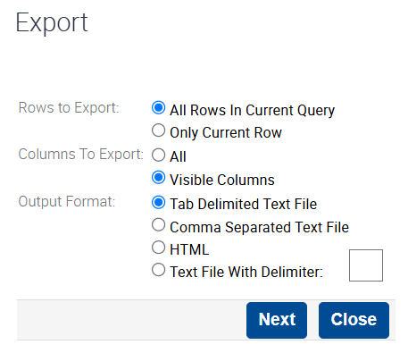

Figure 13 Export data options

# Appendix

## List of acronyms

The following is a list of commonly used acronyms relating to Service Agreement systems and reports.

You may find it useful to keep this list on hand.

|  |  |
| --- | --- |
| AC | Access controller |
| ACCO | Aboriginal community-controlled organisation |
| ACFE | Adult, Community and Further Education Board |
| APSS | Agency Performance & System Support |
| AQR | Agency Quality Review |
| CAMS | Chart of Accounts Management |
| CIMS | Client incident management system |
| CRIS | Client relationship information system |
| CRISSP | Client relationship information system for service providers |
| DE | Department of Education |
| DFFH | Department of Families, Fairness and Housing |
| DH | Department of Health |
| DTR | Desktop review |
| FAC | Funded Agency Channel |
| FAR | Financial accountability requirements |
| IRIS | Integrated reports and information system |
| KIM | Kindergarten Information Management System |
| NDA | National disability agreement |
| NDIS | National Disability Insurance Scheme |
| OA | Organisation authority (an eBusiness role) |
| PFG | Policy and funding guidelines |
| QDC | Quarterly data collection |
| SABRG | Service Agreement business rules and guidelines |
| SACC | Service Agreement compliance certification |
| SAM | Service Agreement Module (organisation view) |
| SAMS2 | Service Agreement management system (department view) |
| SDT | Service delivery tracking |
| SSR | Social Services Regulator |