

|  |
| --- |
| How to view your Service Agreement via My Agency |
|  |
|  |

Contents

Logging into My Agency 1

Opening the Agreement 2

Navigation tips 2

### Logging into My Agency

Go to the **Funded Agency Channel** website: <https://fac.dffh.vic.gov.au>

Scroll down and click on [**https://fac.dffh.vic.gov.au/my-agency-non-dffh-and-dh-staff**](https://fac.dffh.vic.gov.au/my-agency-non-dffh-and-dh-staff)

[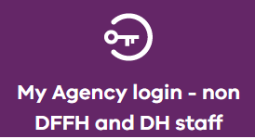](https://hns.dhs.vic.gov.au/facadmin/home.aspx)

Log into the eBusiness portal using the credentials received when you registered for access.

Should you need to reset your password, please contact eBusiness on 1300 799 470 (option 1 then 4).

Click on the **Funded Agency Channel** under **My Applications**

You are now in **My Agency.** Click on the **Service Agreement Module** link (as per below)

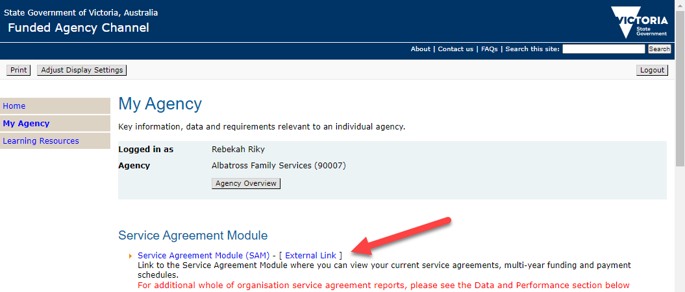

Click on your organisation’s name.

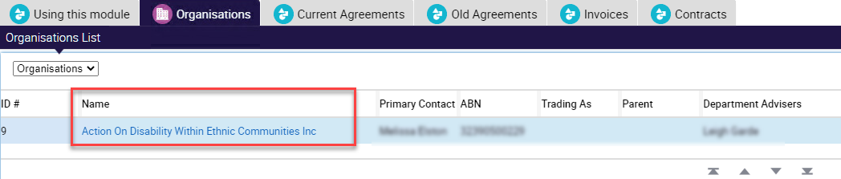

### Opening the Agreement

Go to the **Contracts tab** and click on the Document Type hyperlink to download/open the document (action performed is browser dependant).

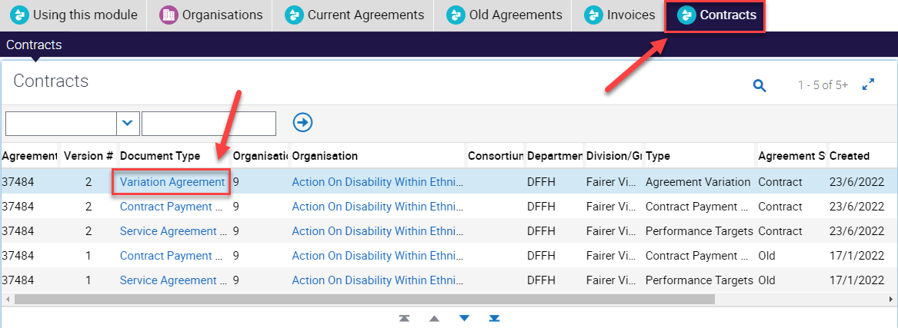

### Navigation tips

Clicking on the right side of **'Version #'** will display the sort control to enable you to sort by Version #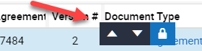

If there are more than five records on this screen, you can view further screens by using the down arrows, or you can click on the Show More/Show Less control to expand the view to twenty records. 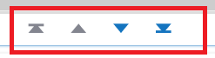 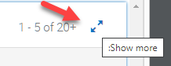

|  |
| --- |
| To receive this publication in another format, email: [fac@dffh.vic.gov.au](mailto:fac@dffh.vic.gov.au)  Authorised and published by the Victorian Government, 1 Treasury Place, Melbourne.  © State of Victoria, Department of Families, Fairness and Housing, March 2025  Available on the [Funded Agency Channel](https://fac.dffh.vic.gov.au/my-agency-non-dffh-and-dh-staffhttps:/fac.dffh.vic.gov.au/my-agency-non-dffh-and-dh-staff) <https://fac.dffh.vic.gov.au/my-agency-non-dffh-and-dh-staff> |