

|  |
| --- |
| Forgotten eBusiness username or password |
|  |

# About eBusiness

For users outside of the Department of Health and Department of Families Fairness and Housing, My Agency, the Service Agreement Module (SAM) and other applications are accessed via the eBusiness Portal.

# Forgotten eBusiness login details

If you have forgotten your eBusiness password or username, you can email [ebiz@support.vic.gov.au](mailto:ebiz@support.vic.gov.au) or phone 1300 799 470, select Option 1, then Option 4.

Alternatively, you can reset your password using the security question on your account.

1. Go to the [**eBusiness login**](https://eus.webapp.dhs.vic.gov.au/EUSPortal/)page<https://eus.webapp.dhs.vic.gov.au/EUSPortal/>

On the **eBusiness Login** page, select the **I forgot my login details** link on the right-hand side of the page.

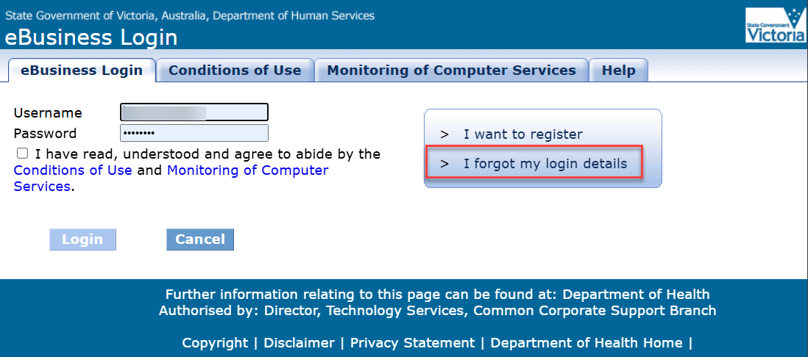

Figure 1 The eBusiness login page

You will be presented with the Reset password request form. Complete all fields and press Request password. (Note: your email address in eBusiness must be correct for you to receive notification)

The new password you enter in this form is a temporary password only, you will have to change it once you log in successfully.

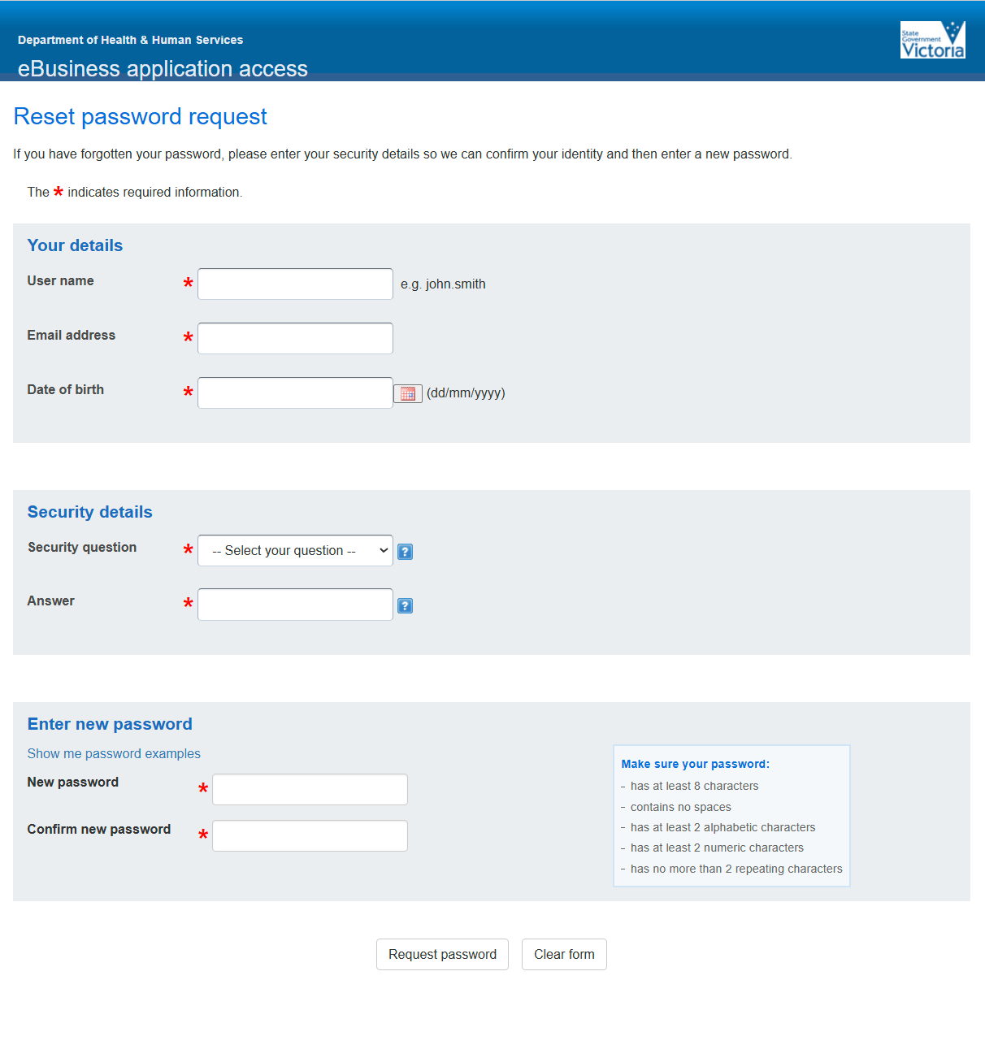

Figure 2 the Reset password requests online form

Confirmation of the password reset request

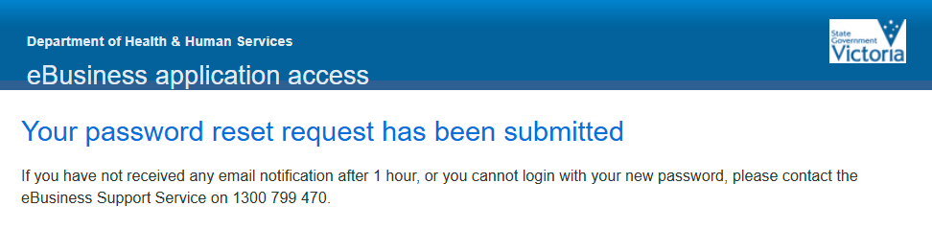

Figure 3 Acknowledgement of request

Incorrect information rejection email

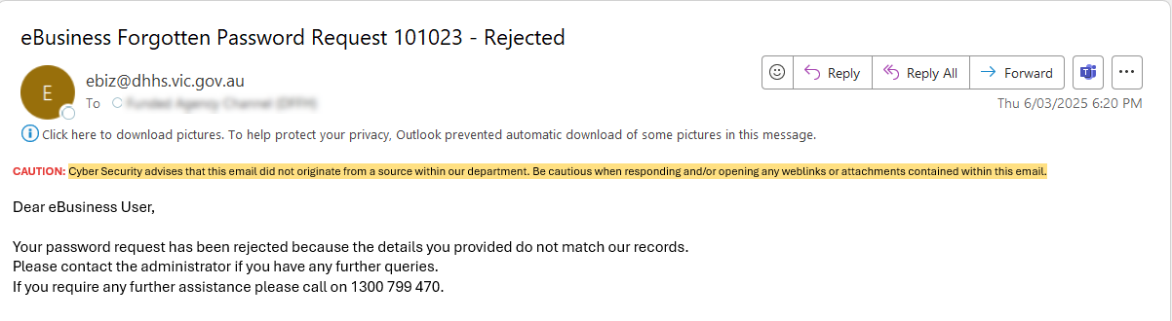

Figure 4 request rejected email

Successful request confirmation email

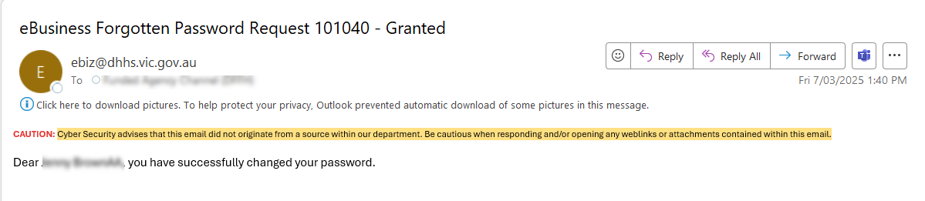

Figure 5 eBusiness Forgotten Password Request - Granted email.

Log in with temporary password

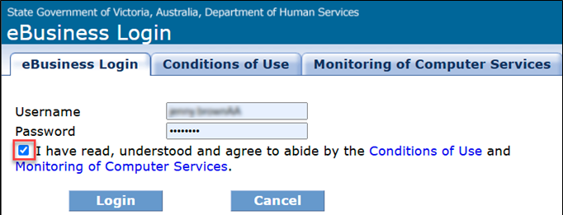

Figure 6 eBusiness log in screen

Enter the temporary password, then a new password twice. (Note: this can be the same as your temporary password)

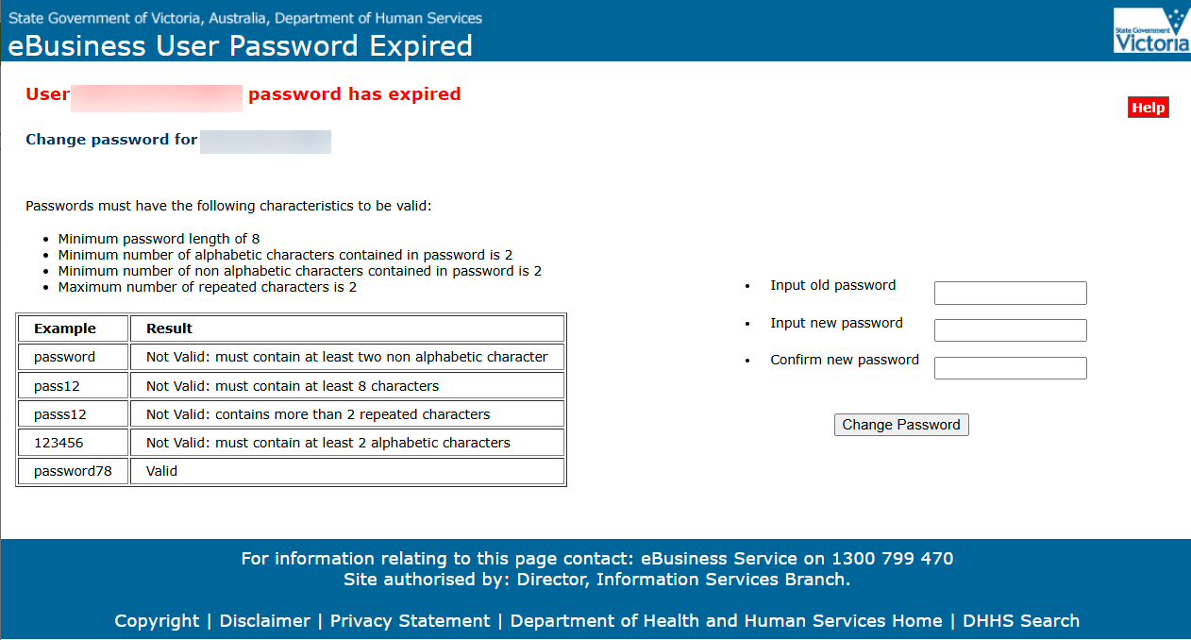

Figure 7 eBusiness Password Expired screen

|  |
| --- |
| To receive this publication in another format, email: [fac@dffh.vic.gov.au](mailto:fac@dffh.vic.gov.au)  Authorised and published by the Victorian Government, 1 Treasury Place, Melbourne.  © State of Victoria, Department of Families, Fairness and Housing, March 2025  Available on the [Funded Agency Channel](https://fac.dffh.vic.gov.au/my-agency-non-dffh-and-dh-staffhttps:/fac.dffh.vic.gov.au/my-agency-non-dffh-and-dh-staff) <https://fac.dffh.vic.gov.au/my-agency-non-dffh-and-dh-staff> |