

|  |
| --- |
| Changing your eBusiness  password |
|  |

# About eBusiness

For users outside of the Department of Health and Department of Families Fairness and Housing, My Agency, the Service Agreement Module (SAM) and other applications are accessed via the eBusiness Portal.

# Changing your eBusiness password

To change your eBusiness password, you need to know your current password.

If you have forgotten your password, visit the [**eBusiness login**](https://eus.webapp.dhs.vic.gov.au/EUSPortal/)page<https://eus.webapp.dhs.vic.gov.au/EUSPortal/>  
and select [**I forgot my login details**](https://eus.webapp.dhs.vic.gov.au/EUSPublic/forgottenPassword) on the right-hand side of the page. See <https://fac.dffh.vic.gov.au/forgotten-ebusiness-username-or-password>

1. Log into the eBusiness Portal at <https://eus.webapp.dhs.vic.gov.au/EUSPortal/> 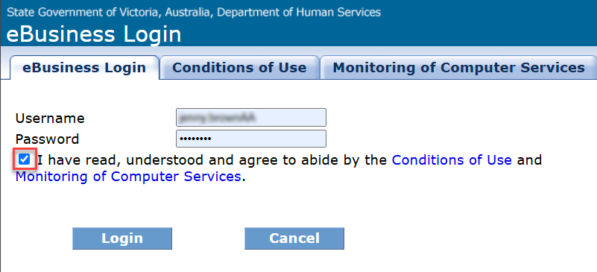

Figure 1 The eBusiness login screen

1. Select **Change Password** at the top of the screen

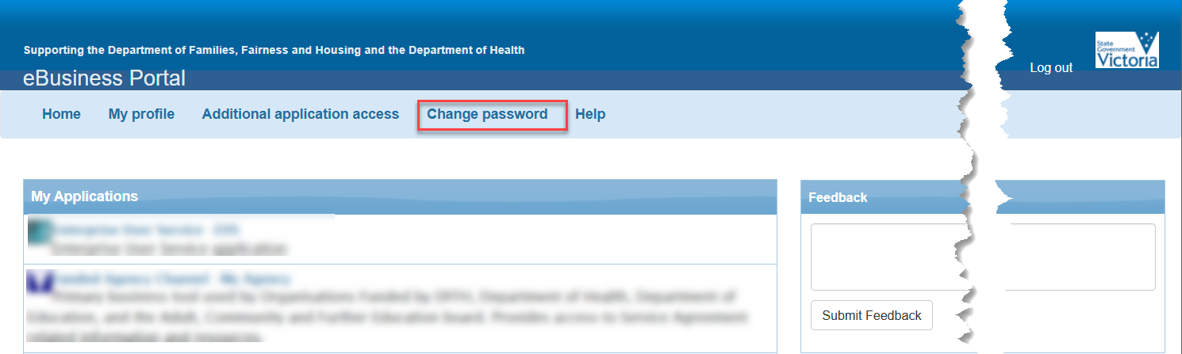

Figure 2 The eBusiness home page

1. The **Change Password** screen displays. On the right-hand side of the screen in the fields provided, **enter** your current password and choose a new password. **Enter** your new password for again in the **Confirm new password** field. Click the **Change Password** button to proceed.

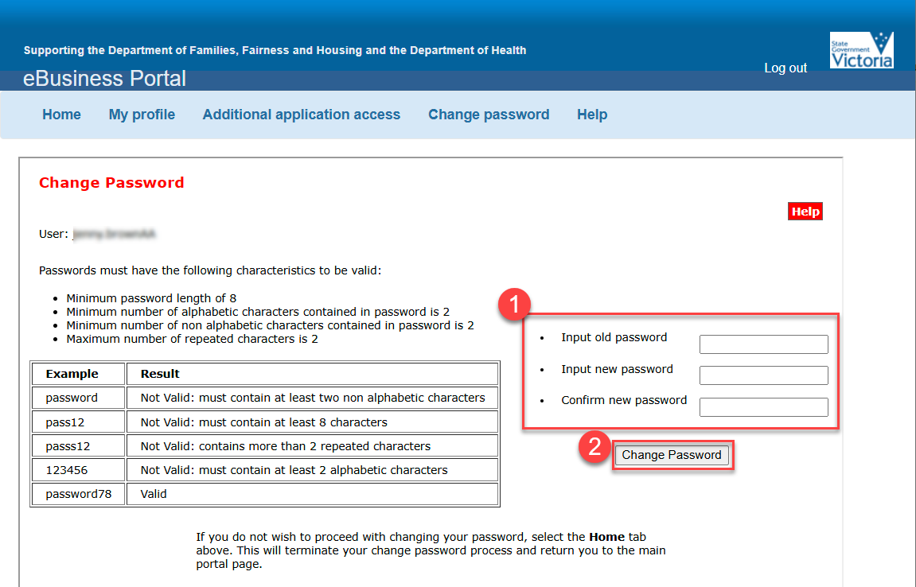

Figure 3 The change password screen

1. Acknowledgment of your **Change Password** displays.

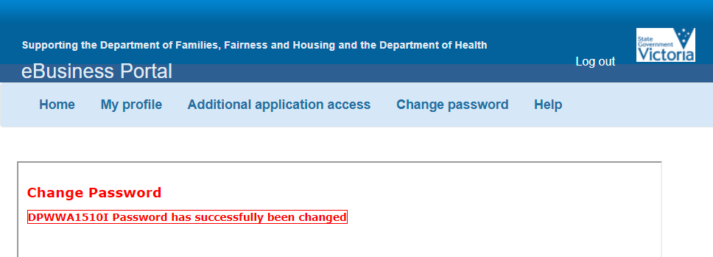

1. Select the **Home** tab to return to the eBusiness Portal page or select **Log out** to end the session.

## Help

If you experience any difficulties with changing your password, please contact eBusiness support on 1300 799 470. Select option 1, then option 4.

|  |
| --- |
| To receive this publication in another format, email: [fac@dffh.vic.gov.au](mailto:fac@dffh.vic.gov.au)  Authorised and published by the Victorian Government, 1 Treasury Place, Melbourne.  © State of Victoria, Department of Families, Fairness and Housing, March 2025  Available on the [Funded Agency Channel](https://fac.dffh.vic.gov.au/my-agency-non-dffh-and-dh-staffhttps:/fac.dffh.vic.gov.au/my-agency-non-dffh-and-dh-staff) <https://fac.dffh.vic.gov.au/my-agency-non-dffh-and-dh-staff> |