

|  |
| --- |
| L17 Family Violence Portal |
| Privacy impact assessment report  Phase 4 |
|  |

# Document Version History

|  |  |  |  |
| --- | --- | --- | --- |
| Version | Date finalised | Reviewed by | Purpose of version |
| PIA Phase 4 | 10/9/2024 | **Abhendra Singh**, Principal Cyber Security Lead, DFFH/DH  **James Melville**, Managing Principal Solicitor, Public Law and Privacy, Legal Services Branch  **Alicia Houlihan**, Director Service Delivery Support, SAQs, COPL, DFFH | Overview of all user groups, current and proposed with incorporation of Correctional Community Service (CCS) users and access to L17 portal via Ebusiness  Removal of references to Services Australia’s proposed access. The assessment for access is dependent on Services Australia updating the Service Agreement, which is yet to occur. Additionally, assessment for their access will be subject to a separate PIA. |
| PIA Phase 3A | 13 May 2024 | **Alicia Houlihan**, Director Service Delivery Support, SAQs, COPL, DFFH **James Melville,** Managing Principal Solicitor, Public Law and Privacy, Legal Services Branch  Abhendra Singh, Principal Cyber Security Lead, DFFH/DH | Additional Functionality included since Phase 3, fuzzy search. |
| PIA Phase 3 | 9 February 2024 | **Alicia Houlihan**, Director Service Delivery Support, SAQs, COPL, DFFH **James Melville**, Managing Principal Solicitor, Public Law and Privacy, Legal Services Branch  **Lipy Sahini,** A/Program Manager, Information Digital Solutions, DFFH  **Abhendra Singh**, Principal Cyber Security Lead, DFFH/DH | Implementation of recommendations made in Phase 2. |
| PIA Phase 2 | 1 May 2018 | **Tony Newman,** Director Service Implementation and Support, DHHS  **Sean Morrison**, Assistant Director, Legal Services, DHHS | Address Royal Commission recommendations with legal review. |
| PIA Phase 1 | 17 December 2016 | **Tony Newman,** Director Service Implementation and Support, DHHS | Development of the PIA |

Contents

Document Version History 2

Summary of assessment 5

Description of the project 6

Scope of the assessment 8

Roles in the assessment 8

Information elements 8

Personal information 8

Health information 8

Sensitive information 9

Information Access 9

L17 Fuzzy Search 9

New user group to access L17 Portal 11

Roles in the assessment 11

Information elements 12

Personal information 12

Health information 12

Sensitive information 12

Information flow 13

Fuzzy Search – information flow 14

Privacy analysis 15

Access Groups 15

Privacy principles 19

Privacy risk mitigation 24

Appendix 26

Appendix 1 – VPSAFvR Form 26

Appendix 2 – L17 Portal Privacy Impact Assessment Phase 1 26

Appendix 3 - L17 Portal Privacy Impact Assessment Phase 2 26

Appendix 4 - L17 Portal Privacy Impact Assessment Phase 3A 26

Appendix 5 - L17 Portal PIA Phase 2 Recommendations Acquitted 26

Appendix 6 – Community Correction Services Business Case 26

Appendix 7 – Youth Justice Business Case 27

Appendix 8 – Minutes approving Youth Justice Access 27

# Summary of assessment

The L17 Portal Privacy Impact Assessment (PIA) was developed in three phases.

Phase one of the PIA was developed to capture the functionality built in the L17 Family Violence portal that was ultimately delivered in December 2016.

Phase two of the PIA outlines additional functionality proposed to be built to fulfil; the recommendations of the Royal Commission into family violence, integration of the portal with the Orange Door CRM and legal services recommendations provided on 11 May 2018.

Phase three of the PIA outlines functionality built as outlined in the phase two PIA.

Phase three A of the PIA outlines extended search functionality to assist in more exact matches first time for service users.

Phase four of the PIA outlines the existing user groups who access the L17 portal and new request of users by Community Correctional Services (CCS) for practitioners in Department of Justice and Community Safety (DJCS) to access the portal to support people who have received a community corrections order, parole order or sentence order involved in family violence.

|  |  |  |
| --- | --- | --- |
| Abhendra Singh  Cyber Security Lead | Alicia Houlihan  Director Service Delivery Support | James Melville  Managing Principal Solicitor, Information Privacy Law, Legal Services Branch |
| Contact: [Abhendra.singh@health.vic.gov.au](mailto:Abhendra.singh@health.vic.gov.au) | Contact: [Alicia.houlihan@dffh.vic.gov.au](mailto:Alicia.houlihan@dffh.vic.gov.au) | Contact: [james.melville@dffh.vic.gov.au](mailto:james.melville@dffh.vic.gov.au) |
| Signature:  Date: 20/06/ 2024 | Signature:    Date: 10 / 09 / 2024 | Signature:  Date: 10/ 09 / 2024 |

## Description of the project

**Background**

To provide improvements to the L17 process, which involves the capacity to share information, to improve client outcomes and safety, together with a need for integrated multi-disciplinary approaches that provide the broad strategic context for the L17 Family Violence Information Portal project, which forms part of a whole of Victorian government strategy to address family violence. It supports some of the recommendations of the Royal Commission into Family Violence. The Royal Commission identified better information-sharing as critical to keep victims safe and make perpetrators accountable for their actions.

In 2015-16, Victoria Police attended more than 78,000 family violence incidents and referred more than:

* 66,000 people who have experienced family violence to support services for assistance.
* 58,000 perpetrators of family violence for assistance in addressing their violent behaviour
* 2,000 children to Child FIRST
* 12,000 reports to child protection.

**Reporting system**

When Victoria Police attend a callout and it is determined to be a family violence incident Victoria Police use the Victorian Police Risk Assessment and Risk Management Report ‘L17’, as a mechanism to make referrals to community-based Family Violence service providers and/or reports to Child Protection about a family violence incident that they have attended. The L17 report is also copied into the police system LEAP, where it is used by police for their own operational purposes.

Police assess the risk of the situation and depending on the risk factors will provide information to the victim (known as an ‘informal referral’) and/or provide a formal referral to a Family Violence service provider for the victim to receive support. A referral is also created for the perpetrator to be referred to a relevant support provider. Where children are involved, police will make a report to Child Protection within Department of Families, Fairness and Housing (DFFH)) and/or a Child FIRST community support provider. All formal referrals by police use the L17 referral process.

**Advantages**

By replacing the old fax-based system, the new L17 portal has saved frontline workers time and effort on collating received referrals, thus freeing up time for following up family violence incidents with the family members. The L17 portal has also enhanced the security and accuracy of L17s in transmission from Victoria Police to Family Violence service providers.

Since 6 December 2016, all formal referrals have been transmitted through the DFFH L17 portal. From 6 December 2016 to 24 August 2017 for example, more than 120,000 formal referrals were made through the portal, arising from 48,000 incidents attended by police. (One incident can generate multiple referrals, such as one for each party involved.)

Information entered in Victoria Police’s existing IT system LEDR, electronically transfers to the L17 Family Violence Information Portal in real time. L17 details transferred to the Family Violence Information Portal are stored in the portal which is a Siebel system maintained by DFFH. The portal incorporates business routing rules to determine to which Family Violence service provider/s the referral should be allocated. The system can send an email message to the recipient organisation/s to notify that there is a new referral which requires their action. That email does not contain any personal information. The recipient Family Violence service provider/s then logs in to the portal to retrieve the specific details relating to that referral.

The exceptions to this rule are Child Protection and The Orange Doors within DFFH (further details below), and the Victims Support Agency operated by the Department of Justice & Community Safety, which receives referrals for male Affected Family Members (AFMs).

The personal information collected and reported by police includes details of the incident, affected family members, children, perpetrators and their history of violence and a risk assessment and management strategy. The personal information include:

* name,
* date of birth,
* address
* phone number!
* email address!
* sensitive information, eg: criminal history
* Identifies as Aboriginal and/or Torres Strait Islander
* Ethnic Appearance
* Country of Birth
* Preferred Language
* Accessibility Needs
* Relationship
* Identification as LGBTIQA+
* health information

Not all information is sent to all service providers.

## Scope of the assessment

The information provided in the L17 Portal where referrals are made to Child Protection, is sent from the portal into the department’s child protection system, ICCMS. Child Protection practices including use and storage of the information provided through the L17 Portal must be in line with legislation.

This PIA does not cover the collection, storage, use or disclosure of information once it has been received by a Family Violence service provider for their investigation and action., The collection, storage, use and disclosure of the information provided via the portal to Family Violence service providers must be in line with their contractual agreements and legislated privacy obligations (including their own privacy requirements), as contracted service providers to DFFH.

PIA Phase Three A will address the inclusion of the a “Fuzzy Search” function on statewide and historic incidents within the L17 Portal.

## Roles in the assessment

This assessment has been prepared by the Service Delivery Solutions team, Service Delivery Support Branch, COPL, with advice from Legal Services, Information Technology Solutions, DFFH

### Information Security Team

A revised security assessment was completed in July 2021 due to changes with the L17 application. There was no change in the Information Security Classification, which remained at a rating of PROTECTED as initially completed in 2017. This rating was based on the highest level of classification among the individual data sets, with a business impact severity level of HIGH. Noting that there has been no change to the portal or the highest level of classification among the individual data sets, the rating remains PROTECTED, and a new Information Security Classification was not completed.

# Information elements

Informational elements changed when Victoria Police updated their Family Violence Assessment form to the VPSAF-VR Risk Assessment form.

Appendix 1 provides a copy of the Victoria Police VPSAFvR form used to inform L17 Family Violence Referrals.

## Personal information

No change since the Phase Three PIA assessment.

## Health information

No change since the Phase Three PIA assessment.

## Sensitive information

No change since the Phase Three PIA assessment.

# Information Access

Information within the L17 Portal is accessed in various ways, these have been addressed in previous versions of PIAs. This section aims to address functionality introduced since the Phase Three PIA.

## L17 Fuzzy Search

### Purpose

The implementation of the L17 Fuzzy Search allows users an additional pathway to find the information they need within the L17 Family Violence Portal. By allowing approved users access to broader search capability, this reduces the need for multiple searches, guessing alternative spellings of names and delays when waiting for confirmation of name spellings recorded in police systems.

### User Access

The Fuzzy Search function has been designed to be a “responsibility” with the portal. This is a function that can be added to users individually – not assigned to a set role – allowing access to be allowed or restricted as needed and approved by L17 Portal Governance.

### Benefits

Broadening search results will reduce the number of searches a user is required to undertake before finding their client or related person/s improving time it takes for users to find the information required for their investigations.

Although the search results show a wider range of results, limited information is available to a user to assist in identifying the correct person before revealing further identifiable information.

The Fuzzy Search performs its search on the same information as the L17 Search tab. Users will follow the same processes for using the L17 Fuzzy Search tab and L17 Search Tab.

By creating extra capacity for broader search results, the risk of accessing unrelated persons information is reduced. With the Fuzzy Search, in a single view users will be able to see and compare results to identify the best match and be confident that all persons in the L17 Portal with similar names have been presented to them for their assessment.

### Function Explained

A user with the “Fuzzy Search” responsibility assigned, can access the “L17 Fuzzy Search Tab” within the L17 Portal.

Following the same process as the current L17 Search tab; a user must record the reason they are conducting the search “Search is Related to Client”, their approval to undertake the search by selecting a checkbox that aligns to reasons under the Family Violence Information Sharing Scheme (FVISS), Child Information Sharing Scheme (CISS) or as authorised under an Orange Door as well as a persons’ First and Last names.

The L17 Portal Fuzzy Search will bring back search results that sound the same or similar to the search criteria entered. For example, for search criteria “Rob Smyth” the results will include “Bob Smith”, “Rob Smithe” or “Robb Smyth”.

In addition, the new search allows for a search using an ‘or’ operation. Search results will return results with a first name sounding like the criteria entered or a last name sounding like the criteria entered. This function broadens search capabilities and is expected to assist greatly when searching for linked persons of concern where users are not as familiar with the unknown person.

Although the search results show a wider range of results, limited information is available to a user to assist in identifying the correct person. A user will select one of these results to see further information about a person and related incident details.

When a person’s details are known the L17 Search Tab can be used for future searches where required.

The L17 Fuzzy Search tab shows the same disclaimer as the current L17 Search tab.

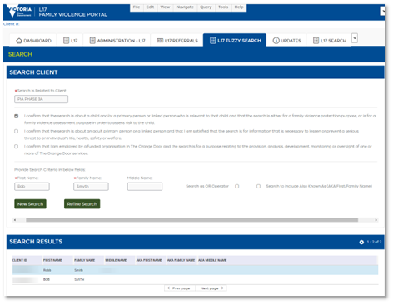

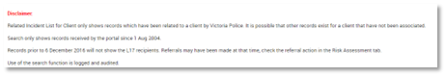

## New user group to access L17 Portal

### Community Correctional Services

It is proposed that around 704 Community Correctional Services (CCS) staff be provided with access the L17 Portal to enable these practitioners to access information regarding people who have received a community-based disposition (Community Corrections Order, Parole Order or Post Sentence Order) as part of their court ordered sentencing to reduce a person’s risk of reoffending.

CCS is prescribed under the Multi-Agency Risk Assessment and Management (MARAM) Framework and the Family Violence Information Sharing Scheme (FVISS), and as such, have a legislative responsibility to appropriately assess and manage family violence risk of both victim survivors and adults using family violence (AUFV). In addition, CCS is also required to manage associated risks to the broader community.

CCS will greatly benefit from having access to the portal as it will:

* Allow CCS staff to assess and manage family violence related risk in real time more appropriately.
* Reduce the need follow up with Victoria Police and The Orange Door regarding family violence incident narratives via the FVISS thus reducing pressure on systems and services.
* Reduce the number of FVISS requests to Victoria Police to request L17 history and incident narrative.
* Allow for more consistent processes across CCS locations to not only assess and manage family violence risk but also obtain specific information regarding family violence incidents.
* A recent coronial inquest identified the need for CCS staff to have access to the incident narrative information in the L17 Portal to provide quick response times and early intervention to clients to reduce the risk of reoffending.

The business case for CCS to gain access the L17 Portal is attached as Appendix 5.

## Roles in the assessment

This assessment has been prepared by the Service Delivery Solutions team, Service Delivery Support Branch, COPL, with advice from Legal Services, Information Technology Solutions, DFFH and the departments Information security.

### Information Security Team

A revised security assessment was completed in July 2021 due to changes with the L17 application. There was no change in the Information Security Classification, which remained at a rating of PROTECTED as initially completed in 2017. This rating was based on the highest level of classification among the individual data sets, with a business impact severity level of HIGH. Noting that there has been no change to the portal or the highest level of classification among the individual data sets, the rating remains PROTECTED, and a new Information Security Classification was not completed.

# Information elements

Informational elements changed when Victoria Police updated their Family Violence Assessment form to the VPSAF-VR Risk Assessment form.

Appendix 1 provides a copy of the Victoria Police VPSAFvR form used to inform L17 Family Violence Referrals.

## Personal information

No change since the Phase Three PIA assessment.

## Health information

No change since the Phase Three PIA assessment.

## Sensitive information

No change since the Phase Three PIA assessment.

.

## Information flow

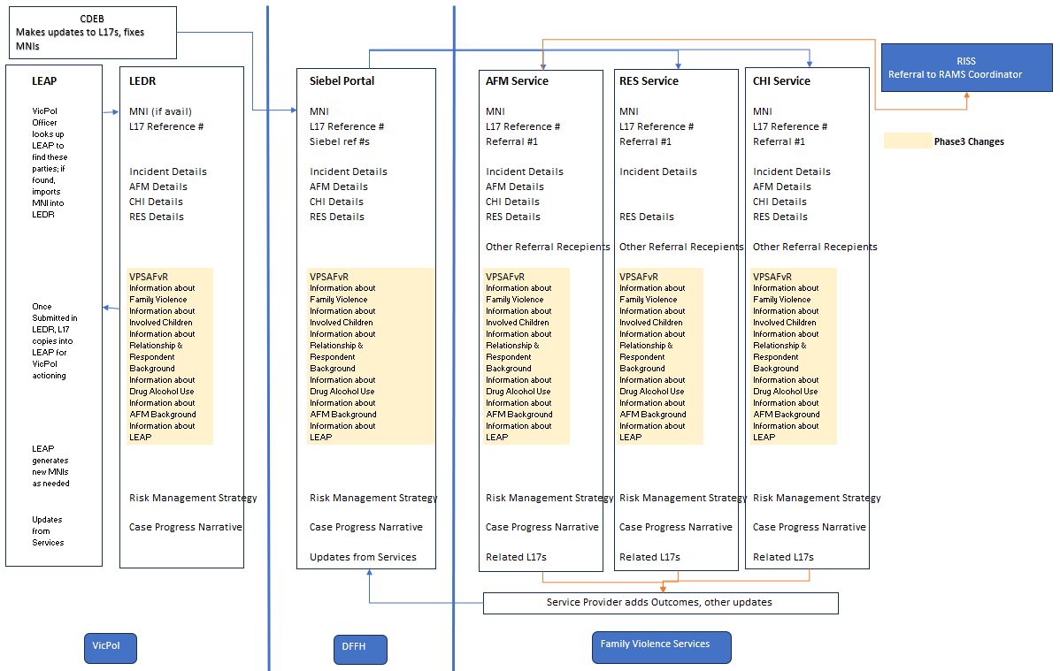

## Fuzzy Search – information flow

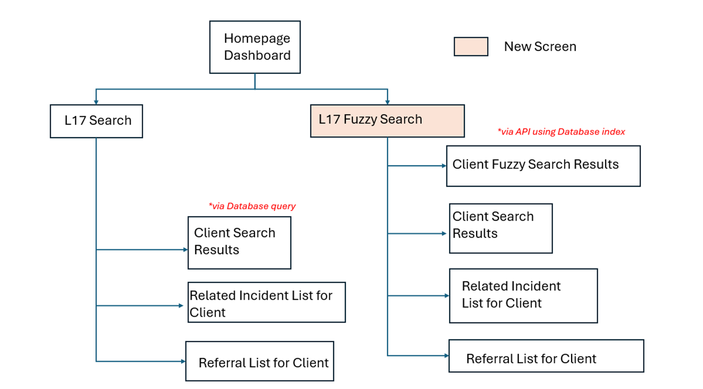

# Privacy analysis

## Access Groups

|  |  |  |  |
| --- | --- | --- | --- |
| User Group | Access Method | Purpose | Authorisation |
| Child Protection Intake | Single Sign On | To assess risk to children, register an Intake report and determine if further intervention is needed. View referrals made to Child Protection and undertake Statewide Historical Search. | Legislativerequirement to respond to reports to Child Protection.  Prescribed under: the :   * (MARAM) Framework, * (FVISS); * and Child Information Sharing Scheme (CISS). |
| All other Child Protection Practitioners | Single Sign On | Undertake Statewide Historical Search. | L17 Portal Project Control Group, Royal Commission into Family Violence Recommendation.  Prescribed under the:   * Multi-Agency Risk Assessment and Management (MARAM) Framework, * Family Violence Information Sharing Scheme (FVISS) and; * Child Information Sharing Scheme (CISS). |
| Family Safety Victoria | Single Sign On | Orange Door Managers Only. View all Orange Door users for an area and report on referrals made to the Orange Door. Prescribed under the MARAM Framework, the (FVISS) and (CISS). |  |
| Orange Doors | eBusiness Portal | View referrals made to Orange Doors and undertake Statewide Historical Search. | Prescribed under the;   * Multi-Agency Risk Assessment and Management (MARAM) Framework; * and the Family Violence Information Sharing Scheme (FVISS). |
| Victoria Police | eBusiness Portal | View outcomes of referrals | L17 Portal Project Control Group, Coroners recommendation to Victoria Police and Youth Justice, business case attached refer to appendix 7 & 8 |
| Youth Justice | eBusiness portal | Conducts historical searches in the L17 portal for events involving young people under Youth Justice supervision to inform risk assessments and screens as appropriate | L17 Portal Project Control Group approved based on the Coroners recommendation to Victoria Police and department that Youth Justice get access to the L17portal in November 2021  Youth Justice users access the L17 portal in the same way as other agencies. It is planned for these users to move to eBusiness sign in by October 2024. |
| Proposed: Community Correctional Services (CCS) | eBusiness Portal | Conduct historical searches in the L17 portal for events involving adults and young people who are being assessed for a community-based disposition to inform risk assessments and manage family violence risk. | The Family Violence Protection Act 2008 (The Act), more specifically Family Violence Information Sharing Scheme (FVISS) provisions under The Act provides the required legislative framework to support information sharing with DJCS through the portal (noting that Corrections and Justice services within Department of Justice Community Safety, are a prescribed Information Sharing Entity under FVISS, Further sharing of information from the portal with relevant service providers will occur as is allowed under the FVISS and other legislative requirements pertaining to privacy and confidentiality.  It is proposed that the access by CCS users will follow the process of other external agencies. Access will include the standard L17 Search Tab and results, as well as the incident narrative.  Subject to DFFH/DH information security assessment, it is proposed that the access to the L17 portal by CCS users will be via eBusiness.  The L17 portal for external agencies is via ebusiness, noting DFFH/DH are progressively moving system applications off ebusiness to another Departmental User Onboarding Program (DUOP2), which is a more secure multi factor authenticated system targeted to occur in 2024/25. |
| Safe Steps | eBusiness Portal | Respond to urgent AFM Referrals. Conducts historical searches in the L17 portal for events involving young people under Youth Justice supervision to inform risk assessments and screens as appropriate. | Prescribed under the MARAM Framework and the FVISS. |
| Men’s Referral Service | eBusiness Portal | Conducts historical searches in the L17 portal for events involving young people under Youth Justice supervision to inform risk assessments and screens as appropriate. | Respond to Male respondent referrals on non-business days. Prescribed under the MARAM Framework and the FVISS. |
| Services Australia | eBusiness Portal | Undertake Statewide Search to support the timely assessment of Family Violence Crisis Payments. | Not yet provisioned and is subject to a separate PIA. |
| Portal Administrators - Technical – Program Delivery Unit, Enterprise Technology Branch (ETB), eHealth Division | Single Sign On | Provide essential support to the operation of the L17 Family Violence Portal. |  |
| Portal Administrators - User Access - Workspace Support, Technology Services Unit | Single Sign On | Provide onboarding and access support to L17 Portal users. | User Administration Access only. No access to incident information. This role has been implemented in June 2024. |
| Portal Administrators - Business Support – Service Delivery Support, Service Agreement and Quality Systems | Single Sign On | Provide business support to operate the L17 Family Violence Portal. | Undertake business administration of the portal involving adding additional referrals as requested by Victoria Police, undertake audits and fulfilling requests to the department by the coroner. |

## Privacy principles

| Questions – what is the risk? | Further information | Yes / No | Detailed response |
| --- | --- | --- | --- |
| **Collection:** Is all the information collected necessary for the project? | IPP 1 and HPP 1  Privacy team | Yes | All information collected to make formal referrals to service providers is necessary for risk assessments to be undertaken to inform the provision of services to people involved in family violence.  Information collected as part of an informal referral has no immediate use and may never have a further use. Informal referrals have potential future use if a person is involved in further family violence incidents.  History of informal referrals collected as a part of this project will further provide information for the service provider’s risk assessment.  If a person is involved in a family violence incident and there is only an informal referral, with no further family violence incidents, then this is the only scenario where information collected would have no further use. In this case this information would not be shown to any user. |
| **Notice:** Have all reasonable steps been taken to inform the individual that their information is being collected and why, by whom, how they can access, to whom it will be disclosed? | IPP 1 and HPP 1  [Fact sheet on developing a collection notice](https://dhhsvicgovau.sharepoint.com/:w:/r/sites/health/Forms/Privacy/Developing%20a%20Collection%20Notice%20for%20Personal%20or%20Health%20Information.docx?d=w8e5322b296fd4738b31f67bee5e1d512&csf=1&web=1&e=Tp1MDu) <https://DHHSvicgovau.sharepoint.com/sites/health/SitePages/Privacy.aspx#privacy-related-resources-on-the-intranet>  Privacy team | Yes | Victoria Police have advised that they will inform individuals about how their information will be used as part of the referral process.  Information is collected directly from Victoria Police systems. The L17 Portal is a means of transferring incident/referral information to service providers. There is no means of the L17 Portal or administration team to contact persons involved.  The Victoria Police Code of Practice for the Investigation of Family Violence (available online) advises of the referral process including when and with who information can be shared.  Victoria Police Code of Practice for investigation of Family Violence: https://www.police.vic.gov.au/code-practice-investigation-family-violence |
| **Direct collection:** Is all information being collected directly from the individual? | IPP 1 and HPP 1  Privacy team | No | All information in the portal is collected from parties working directly with individuals.  Information collected by these parties including Victoria Police may not always come directly from the individual for practical and safety reasons. Information may be collected from a person reporting the family violence incident or children involved or witnessing the incident. |
| **Identifiers:** Will this project assign a unique identifier or use a unique identifier of another organisation? | IPP 7 and HPP 7  Privacy team | Yes | The Victoria Police Master Name Index (MNI) number has been adopted to link individuals to their previous related incidents. Adopting this identifier is critical to maintain synchronicity between the police systems and the portal, critical for maintaining police as the single source of truth.  It is important to Victoria Police that the MNI is not shared widely. As a result, the portal creates a unique client ID based on the MNI so that portal users can be sure that a client with the same name and details are or are not the same person according to Victoria Police. |
| **Anonymity:** Can individuals remain anonymous for the purpose of the project? | IPP 8 and HPP 8  Privacy team | No | The portal collects personal information for the purpose of contacting an individual to provide service. It is not practical for individuals to remain anonymous for the purpose of a referral to provide service.  It is not practical for individuals to remain anonymous for the purpose of a referral to provide service, and for the purpose of assessment and determination for Commonwealth crisis payment. |
| **Sensitive information:** Will this project collect sensitive information? | IPP 10  Privacy team | Yes | As part of the referral and to assist services to engage with the client in an appropriate way, Victoria Police collect sensitive information from the individual directly or the reporting person. |
| **Data security:** Are reasonable steps being taken to protect the information collected from misuse, loss, and unauthorised access, modification or disclosure? | IPP 4 and HPP 4  Projects MUST engage the Cyber Security team to arrange assessment/s | Yes | The L17 Family Violence Portal is hosted on a secure cloud platform backed up by a regularly refreshed disaster recovery environment. The L17 Portal was built by the Enterprise Technology Branch (ETB) - eHealth Division and meets the department's security requirements. Multi-Factor Authentication (MFA) and Geo-Factor is implemented for access to the L17 Portal for internal departmental users.  User access to the L17 Portal is managed via secure portals. Access to the portal by a user is determined by whether they are a DFFH employee with access to the Workspace Portal or if they are an external service provider or statutory body. These users will access the portal via eBusiness. Access via both pathways is managed by DFFH portal administrators. Team Managers of external services with access to the portal can also remove their users' access. Access via Workspace is also removed when a person is removed from a department's system. Access via eBusiness can also be removed should an eBusiness account be removed.  The L17 Portal is audited in line with the L17 Portal Audit Plan. Warnings are shown to users throughout the portal that their use is logged and audited. Prior to using the portal, all users must accept the Privacy Agreement and Terms of Use of the L17 Portal. An audit log is available in the portal to monitor user access.  CSU recommends that the process should be similar to how the Youth Justice staff (who are also part of DJCS) were onboarded to L17 FVP. They currently use Workspace/Citrix to connect to L17 FVP, and authentication is via single sign-on. It should be cut over to ISVA with User Authentication applied with Multi-Factor Authentication. |
| **Use and disclosure:** Will the information only be used or disclosed for the primary purpose identified? | IPP 2 and HPP 2  Privacy team | Yes | In addition to the referral purpose, information about previous incidents since August 2004 can be accessed to inform risk assessments.  The information is used for the purpose of information sharing to inform risk assessment, client safety and service or payment provision.  The data about the referrals e.g., number of referrals may also be used for service reporting purposes. |
| **Information sharing:** Will the information be shared with other agencies for service delivery, data matching or analytics? | IPP 2 and HPP 2  Privacy team | Yes | The purpose of collecting the information is to share with other organisations for service delivery only. |
| **Transborder data flows:** Will the project transfer the information to an organisation or person outside of Victoria? | IPP 9 and HPP 9  Projects MUST engage the Cyber Security team to arrange assessment/s | Yes | Access to the L17 portal is logged, capturing user credentials, timestamp, and accessed resources for security and auditing purposes.  The L17 referral is generally within Victoria, however on rare occasions a referral may be triggered by Victoria police for an incident that occurred interstate, and one or more party resides in Victoria.  The L17 data resides in Azure data centres in Australia.  Primary data centre resides in Melbourne – Victoria and secondary data centre is in Sydney – NSW in case of any failures at primary data centre.  Access to the L17 portal must be successfully logged, capturing user credentials, timestamp, and accessed resources for security and auditing purposes. |
| 1. **Data quality:** Are reasonable steps being taken to ensure that the information collected, used or disclosed will be accurate, complete and up to date? | IPP 3 and HPP 3  Privacy team  Information and Data Management | Yes | Referral information is collected directly from Victoria Police which also obtain the information from individuals involved. Victoria Police systems can send updated information to the portal for certain periods of time depending on the information sent. This means that referral information is up to date as is relates to the referral purpose.  The L17 portal Client ID numbers can continue to be updated indefinitely should police identify duplicate clients within the system. |
| 1. **Access and correction:** Are there any restrictions that would prevent individuals from accessing or correcting their information? | Freedom of Information team  Privacy policy | Yes | Information recorded within the portal is accurate according to police record. Most of the information cannot be updated by portal administrators or users, only through the Victoria Police updates process.  Individuals cannot access the L17 Portal directly, any changes to an individual’s contact details must be made by a service user or via the Police updates process.  Freedom of Information requests can be made to the FOI team within DFFH. |
| 1. **Destruction:** Will reasonable steps be taken to destroy or de-identify the information if it is no longer needed? (note this does not apply to a health service provider) | IPP 4  *Public Records Act 1973*  Records management team | Yes | When the L17 Portal is no longer required, the system information will be destroyed when no longer required.  While the portal is live and being used, all information – unless removed for a specific reason – will remain in the portal and accessible for the purpose of the Statewide Historical search used to inform users risk assessment and other approved reasons. |
| 1. **Re-identification:** Will the project involve de-identified information that may be re-identified through the linking of data or other information? | Privacy team | No | The L17 Portal contains information so that a person can be identified for the purpose of receiving a service. |
| 1. **Information held by third parties:** Will the project involve information being transferred to or collected by other parties (for example, cloud service providers or collection of information via third party platforms)? | Information Security team  Records management team | Yes | Information is sent to and collected by third parties from the portal for the purpose of providing a service. These service providers will retain documents and information in line with the agreed upon terms with department services agreements. |

# Privacy risk mitigation

Consequence and likelihood matrix[1]

|  |  |  |  |  |  |
| --- | --- | --- | --- | --- | --- |
| Likelihood | Negligible | Minor | Moderate | Major | Extreme |
| **Almost Certain**  (Once per week)  (90%) | **Medium** | **High** | **High** | **Critical** | **Critical** |
| **Likely**  (Once per month)  (70%) | **Medium** | **Medium** | **High** | **High** | **Critical** |
| **Possible**  (Once a year)  (50%) | **Low** | **Medium** | **Medium** | **High** | **High** |
| **Unlikely**  (Once in 3 years)  (30%) | **Low** | **Low** | **Medium** | **Medium** | **High** |
| **Rare**  (Once in over 3 years)  (10%) | **Low** | **Low** | **Low** | **Medium** | **Medium** |

|  |  |  |  |  |  |  |  |  |  |  |  |  |
| --- | --- | --- | --- | --- | --- | --- | --- | --- | --- | --- | --- | --- |
|  | | Description of the risk | Consequence rating | | Likelihood | Risk rating | Accept risk | Risk management strategy | Residual consequence rating | Residual likelihood rating | Residual risk rating | Risk owner  [Name, title and position] |
|  | Disclosure –  Risk of personal information being disclosed by DFFH portal beyond what is authorised by law (i.e. the tests for which user type can see what, under ss.144N-144NC of the FVP Act).  This impacts on portal features 5 (visibility of RES details), 7 (linking Related Referrals), 8 (backload historic formal referrals), 9 (add all informal referrals), 10 (search functionality), 11 (refine access controls, i.e. Suppression function), and 12 (support Hubs). | | Moderate | Likely | | High | Yes | Users to confirm their authority to access information.  Message on the screen advising use of the portal is logged and audited.  Training  Guides available on information sharing  Auditing | Moderate | Possible | Medium | Alicia Houlihan, Director, Service Delivery Support Branch |
|  | Unnecessary collection of information -  Risk that information collected as part of an informal referral will have no future use of that person is not involved in a future family violence incident | | Minor | Almost Certain | | High | Yes | Although, not known at the time of collection, collection of information may be unnecessary if the person/s recorded in an incident are not referred to a service in the first instance (called an informal referral) and/or never involved in a future family violence incident or only receive informal referrals in future incidents. | Negligible | Almost Certain | Medium | Alicia Houlihan, Director, Service Delivery Support Branch |
|  | Indirect collection –  Information sent to the portal has been collected by Victoria Police and sometimes by Family Violence services. These services will collect information from various parties involved in the incident and information may be collected about individuals not present when police arrive. | | Moderate | Likely | | High | Yes | Information stored within the portal is in line with information sent by Victoria Police.  Some involved person/client information can be amended by service users and notes and additional information can be recorded in the portal if the client advises of a different record. | Minor | Likely | Medium | Victoria Police |
|  | Collection of sensitive information – Sensitive information is collected by Victoria Police to inform their investigation, risk assessment and referral. This information is sent to the portal and then shared with other services. | | Moderate | Almost Certain | | High | Yes | Collection of sensitive information is unavoidable as it is required by services to inform risk assessment.  This information will only be displayed to services that provide a service to that particular client. | Negligible | Almost Certain | Medium | Victoria Police |
|  | Use and disclosure of Information remains within the portal that can be accessed after the primary purpose has been concluded. | | Moderate | Almost Certain | | High | Yes | Information will continue to be stored in the portal after the referral has been closed as it will be relied upon for reporting and if the client is involved in future family violence incidents to inform risk assessment.  The data stored is protected data and only accessible by authorised users approved to search and view historical information. | Negligible | Almost Certain | Medium | Alicia Houlihan, Director, Service Delivery Support Branch |
|  | Information collected and stored by third parties | | Moderate | Almost Certain | | High | Yes | Information is sent and stored in third party client managements systems | Minor | Almost Certain | High | Service Providers |

# Appendix

## Appendix 1 – VPSAFvR Form



## Appendix 2 – L17 Portal Privacy Impact Assessment Phase 1



## Appendix 3 - L17 Portal Privacy Impact Assessment Phase 2



## Appendix 4 - L17 Portal Privacy Impact Assessment Phase 3A

## 

## Appendix 5 - L17 Portal PIA Phase 2 Recommendations Acquitted



## Appendix 6 – Community Correction Services Business Case



## Appendix 7 – Youth Justice Business Case



## Appendix 8 – Minutes approving Youth Justice Access





.

To receive this document in another format, please [email the Information Sharing and Privacy Team](mailto:privacy@dffh.vic.gov.au) <privacy@dffh.vic.gov.au>.

Authorised and published by the Victorian Government, 1 Treasury Place, Melbourne.

© State of Victoria, Australia, Department of Families, Fairness and Housing, May 2024.

Available at <https://DFFHvicgovau.sharepoint.com/sites/dffh/SitePages/Privacy.aspx>

1. Reference, the department’s [*Risk management policy and framework*](https://intranet.dhhs.vic.gov.au/risk-management-policy-and-framework)