

|  |
| --- |
| L17 Family Violence Portal  User Guide |
| For Family Violence and Child FIRST services, Child Protection, and The Orange Door services  February 2025 |
|  |

|  |
| --- |
| L17 Family Violence Portal  User Guide  For Family Violence and Child FIRST services, Child Protection, and The Orange Door services  February 2025 |
|  |

|  |
| --- |
|  |
| To receive this document in another format, [email Service Delivery Solutions](mailto:L17Portal@dffh.vic.gov.au?subject=eBusiness%20Registration%20Guide) <L17Portal@dffh.vic.gov.au>  Authorised and published by the Victorian Government, 1 Treasury Place, Melbourne.  © State of Victoria, Australia, Department of Families, Fairness and Housing, February 2025.  Available at L17 Family Violence Portal user guide on the Funded Agency Channel <https://fac.dffh.vic.gov.au/l17-family-violence-portal-user-guide-1> |
|  |

Contents

Document information 7

Changes made 7

1. Welcome 8

Audience 8

Related documents 8

About the L17 Family Violence Portal 8

2. Overview 9

3. Information Privacy 10

Access via the E-Business L17 Portal 10

Login time-out 10

Information privacy and security 10

Electronic Privacy Agreement 12

Information visibility 13

Disclosing information to others 14

4. Icons & Keyboard Tools 14

5. Portal Structure & Navigation functions 16

Navigating the Portal 16

Editable fields 19

Sorting columns 23

Accessing additional information 24

Save functions 25

Search functions 27

Reopen function 41

6. Homepage Dashboard 44

Service Snapshot 45

Referral status 45

7. Service L17 List 46

Screen Overview 46

L17 List 46

Referral Details 49

8. My L17 List 52

Accessing My L17 List 52

Screen Overview 53

9. Assigning & Triaging Functions 54

Location of assigning & triaging functions 54

Assign to a worker 55

Enter a Service Priority 56

Enter a Next Action 56

Enter a Service Classification 57

Change Records: Updating multiple values in the L17 List at once 59

10. Referral Record 61

Accessing the Referral Record 61

Screen Overview 61

Information sharing within the Referral Record 62

Referral # hyperlink 62

Summary Banner 64

L17 Recipients Table 64

Make a referral 65

Generate Updated PDF 69

Incident Details tab 69

Affected Family Member (AFM) tab 70

Children tab 73

Respondent tab 77

Risk Assessment tab 80

Actions and Attachments tab 88

11. Restricting User access to a referral record 101

To restrict user access 101

12. Manage users 103

Editable information 103

To edit user information 103

13. Automatic deactivation of inactive users 104

14. Extracts for reporting 104

To extract a full list of referrals: 104

15. Glossary of Terms & Acronyms 106

# Document information

This document has been prepared by the Service Delivery Support Branch, Community Operations and Practice Leadership Division.

|  |  |
| --- | --- |
| **Criteria** | **Details** |
| **Document title** | L17 Family Violence Portal User Guide |
| **Document owner** | Executive Director, Service Agreement and Quality Systems, Community Operations and Practice Leadership Division |
| **Document custodian** | Director, Service Delivery Support, Service Agreement and Quality Systems, Community Operations and Practice Leadership Division |
| **Version** | V9 |
| **Issue date** | February 2025 |

# Changes made

|  |  |  |
| --- | --- | --- |
| Published date | Sections amended | Description of amendment |
| December 2016 | Not Applicable | First version of User Guide |
| February 2017 | Throughout refer to description | Referred by included in the L17 Portal and Victoria Police included to access the Portal |
| October 2017 | Throughout refer to description | New columns in the list view, new fields in L17 record, Send comments when making a referral to another service, Make a referral and close your referral at the same time, Record final outcome secondary reason, See other service's outcome, Team manager can restrict users from viewing L17s, Improved system performance |
| February 2018 | L17 Search Tab, Final Outcomes and Referred by Field | A new L17 Search Tab, Changes to action types including Final Outcomes, Referred By field in the L17 PDF |
| August 2018 | Throughout refer to description | Changes to save functions and Client Outcomes |
| November 2018 | Throughout refer to description | Document updated to meet accessibility guidelines |
| October 2019 | Throughout refer to description | Changes in the Affected Family Member, Respondent and Children risk assessment tabs to meet the new Victoria Police Risk Assessment and Information, Online Privacy Agreement, Changes to ‘Reopen’ a closed referral, Editable Fields, Make a Referral, Highlights and L17 Search Tab |
| January 2020 | Throughout refer to description | Referral updates from Victoria Police, Statewide Search Results, Automatic offboarding of inactive users, Team Managers can edit user details and revoke access, Quick access to list of L17’s open more than 90 days, New related L17 incident flag, Change to statewide search checkboxes and text |
| February 2025 | Throughout refer to description | L17 Portal Fuzzy Search, Child Protection Intake name update from DHHS to DFFH |

# Welcome

## Audience

This user guide contains step-by-step “How-to” guidance for commonly used functions in the L17 Family Violence Portal (the Portal).

This user guide has been developed specifically for services using the Portal, including nominated Child Protection staff, Child FIRST/Integrated Family Services, specialist family violence services and The Orange Doors (Hubs) and Department of Justice and Community Services.

The Department of Families, Fairness and Housing may update the user guide, as deemed necessary, to reflect any changes to the operation of the Portal.

## Related documents

This guide should be read in conjunction with the L17 Family Violence Portal - Operations Manual which provides guidelines, procedures and protocols to users to effectively operate the Portal.

## About the L17 Family Violence Portal

Family violence referrals from Victoria Police are made through the Victorian Police Risk Assessment and Risk Management Report ‘L17’ and are the mechanism by which Police who attend family violence incidents can make referrals to community agencies and/or reports to Child Protection.

The Portal provides an electronic means for Victoria Police to make referrals and reports and in December 2016 it ended the practice of sending and receiving faxes. It is a web-based Siebel application that is used by Child Protection staff, The Orange Doors and services funded by the Department of Families, Fairness and Housing to deliver family violence support.

The Portal receives a referral incident from police, identifies which services should receive the referral and sends the referral/report to the service.

Access to the Portal is through the internet and the Department of Families, Fairness and Housing hosts the Portal.

The Portal is not a case management system but a means of receiving family violence referrals.

**Note:** That the L17 Family Violence Portal only receives Family Violence Reports, No other Victoria Police reports types (Example. Missing Persons Report) are received or triaged by this portal. Any non-Family Violence related referrals must be made outside of the portal as per Victoria Police procedures.

# Overview

The Portal functions include:

* Service can see all family violence referrals made to their service.
* Ability to triage referrals.
* Ability to assign a referral to an individual worker.
* An individual can view all referrals assigned to them.
* Ability for the service to monitor and manage referrals.
* Visibility of other services who have received a referral for the incident.
* Service can assign the referral to another Service where it has been referred to an incorrect location.
* Ability to edit client contact information for safety purposes.
* Record actions taken on the referral.
* Record the outcome of a referral for each client.
* An audit trail will show who has actioned the referral details.
* Generate a PDF.
* Ability for services to copy information into their existing case management systems.
* Updated information from Victoria Police and other service users.
* Integration with other case management systems.
* Undertake name-based searches for incident records.

# Information Privacy

## Access via the E-Business L17 Portal

Each user will need a secure eBusiness login and access to the Family Violence Application in eBusiness to access the Portal. For more information, see the L17 Family Violence Portal – Operations Manual.

## Login time-out

The Portal will time out after 15 minutes of inactivity and take users back to the Homepage Dashboard. For eBusiness users, the Portal will require you to re-login after two hours for security reasons.

## Information privacy and security

Users must not use or disclose information within or outside of the Portal except in line with current privacy and information sharing legislation.

Current referral protocols remain in place and should be followed when making referrals between services.

Table 1. Legislative instruments, protocols & partnerships relevant to the L17 process

| Legislation |
| --- |
| * Privacy Act 1988 (Cth) |
| * Health Records Act 2001 (Vic) |
| * Privacy and Data Protection Act 2014 (Vic) |
| * Children, Youth and Families Act 2005 (Vic) |
| * Child Wellbeing and Safety Act 2005 |
| * Family Violence Protection Act 2008 (Vic) |
| Protocols and partnership agreements |
| * Privacy Impact Assessment on the L17 Family Violence Information Portal – Phase 1 |
| * Family Violence Referral Protocol (Department of Families, Fairness and Housing, Family Safety Victoria, Department of Justice and Regulation and Victoria Police) |
| * Procedural Guidelines for Referral and Consultation (Child Protection & Child FIRST) |
| * Family Violence Information Sharing Guidelines |
| * Child Information Sharing Scheme |
| * Memorandum of Understanding between Department of Families, Fairness and Housing and Victoria Police |
| * Any regional-specific protocols and partnership agreements |

Auditing captures user activity including name searches, changes to any of the fields and actions recorded. Some of the audit trail will be visible at the bottom of the relevant tab, while some auditing will be recorded and visible only to Department of Families, Fairness and Housing Services Administrators.

## Electronic Privacy Agreement

Upon first logging in to the Portal, users will be required to read and agree to a privacy agreement before being allowed access to the Portal itself. A window will automatically display, presenting the terms and conditions of the L17 Family Violence Portal, prompting the user to read and accept the agreement.

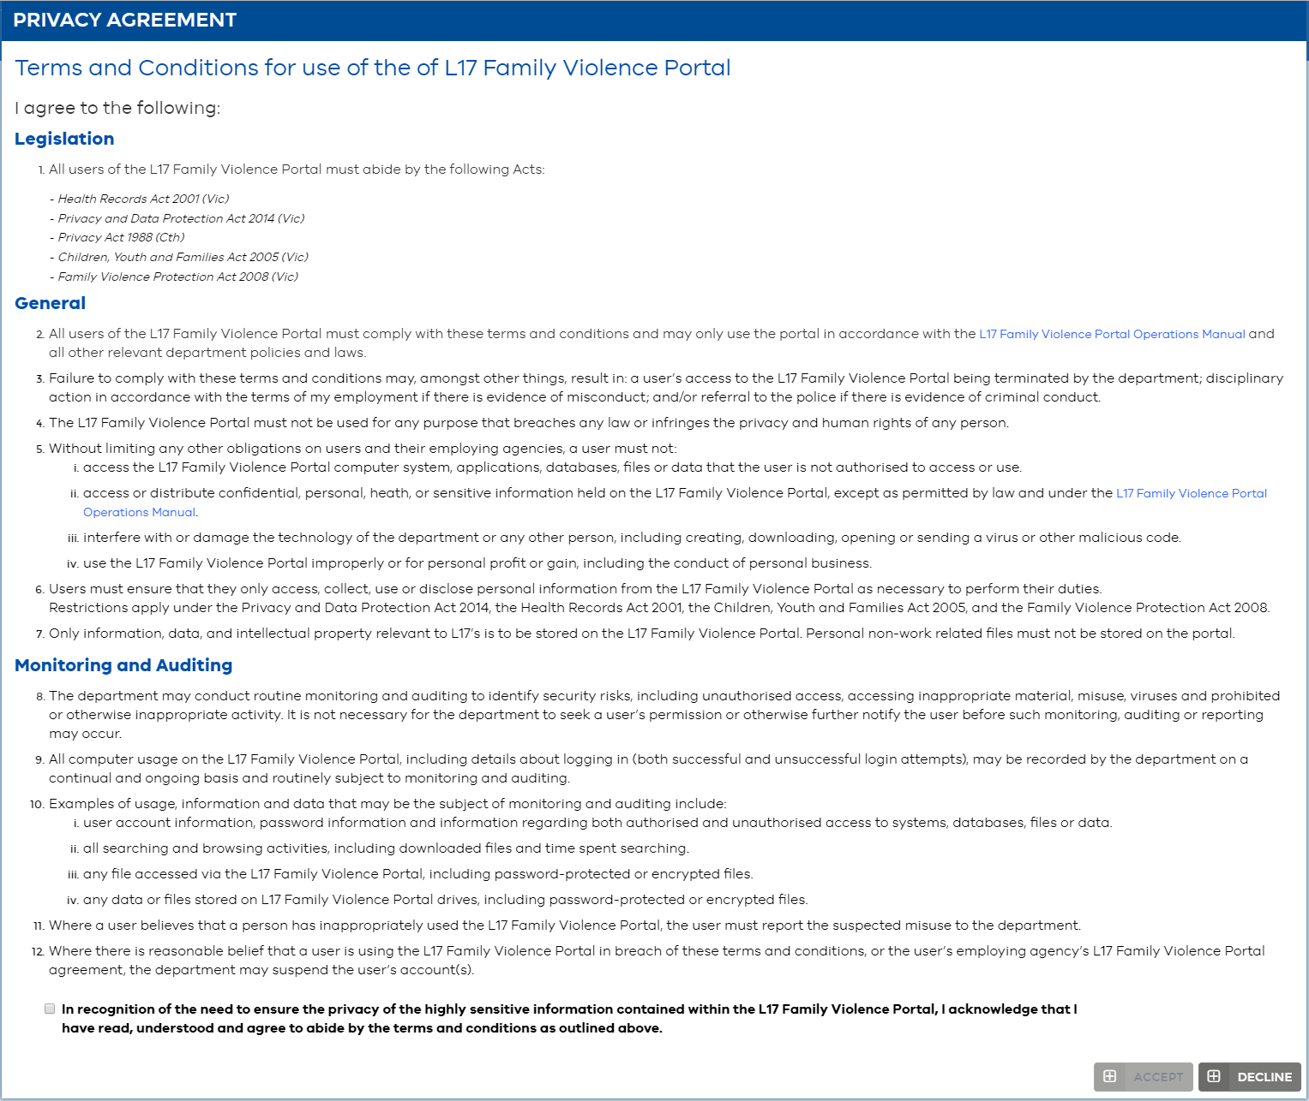

The agreement also contains hyperlinks which will load to a page where users can view the L17 Family Violence Portal Operations Manual.

At the bottom of the window, the user will be asked to check a box to confirm that they have read, understood and agreed to the conditions outlined in the agreement.



Once checked, the option to select the ‘Accept’ will become available at the bottom of the agreement. If the box above is not checked, then the option to accept the agreement will remain greyed out and unavailable.

Screenshot of the Accept and Decline options present at the bottom of the agreement. This screenshot shows a greyed out Accept option, as the necessary checkbox had not been ticked. 

Should a user wish to reject the conditions outlined in the Privacy Agreement, then they may select the ‘Decline’ option, which will automatically load to a page that reads ‘Logout Successful’.

**IMPORTANT:** Access to the Portal requires that the Privacy Agreement be accepted.

Once the box has been checked, and the ‘Accept’ option selected, the page will load to the L17 Portal Homepage Dashboard.

The process of accepting the electronic Privacy Agreement is required for users during their first log in to the Portal. Subsequent log ins via an account which has accepted the agreement will load directly to the L17 Portal Homepage Dashboard.

If the Terms and Conditions for use of the L17 Family Violence Portal are updated the Electronic Privacy Agreement will appear again upon next log in and users will be required to accept the updated terms and conditions.

## Information visibility

The Portal will display only data relevant to your service. Depending on the referral type, some fields will appear blank and some tabs will contain no data with a statement “Information withheld” displayed.

Table 2. Visibility of information within L17 Portal

|  |  |
| --- | --- |
| Referral type | Visible information |
| **AFM Referral** | AFM, Child and Respondent information |
| **Respondent Referral** | Respondent information |
| **Child Protection and Child First** | Child, AFM and Respondent information |
| **HUB** | Child, AFM and Respondent information |

The below notification will be displayed where information is withheld:

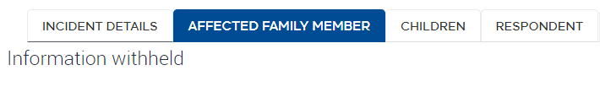

## Disclosing information to others

The Portal has been designed to provide greater security to the L17 referral process.

The Portal has capacity to send the family violence referral within the Portal from any service to any service this ensures that services can share information as necessary.

|  |  |
| --- | --- |
| Note  Note symbol | Where a Hub has commenced service in an area, any service can send referrals to that Hub if an on-referral is required. Similarly, a Hub can on-refer to an AFM, RESPONDENT or CHILDREN (Child FIRST) service if required. |
| Note  Note symbol | Sending L17 referrals via non-encrypted email is not a secure form of transmission. Referrals should always be sent using a secure form of communication (e.g. via the Portal or using encrypted email). |

# Icons & Keyboard Tools

Table 4. Icons & Keyboard tools

| Icon | Icon Name | Function |
| --- | --- | --- |
| Add icon | Add | Add a comment or create an L17 Record action. |
| Calendar icon | Calendar date | Select to enter a date. |
| Down arrow icon | Down arrow | Select to show drop-down list.  Expand the History (audit trail) section. |
| Edit field icon | Edit field | Select the pencil icon to display items to edit field. |
| Keyboard esc key image | Escape key (keyboard) | Cancel loading or exit an incomplete function (for example, when creating a new comment or new action). |
| Expand icon | Expand | Select to display a maximum of 20 records. |
| Field search icon | Field Search | Perform a field search on any field. |
| Go arrow icon | Go | Select this button after entering data in Search fields. |
| Next page buttonPrevious page button | **Next/Previous page buttons** | Use these buttons to navigate between pages on the screen. |
| Shows the previous and next record icons, indicating which record is currently displaying (e.g. 2 of 10) | **Next/Previous record buttons** | Use these buttons to navigate between records as listed in the List View sitting behind the record.  Indicates which record in List is currently displaying (e.g. 2 of 10+ means the second record in a list of 10 or more records is displayed). |
| Preferences icon | Preferences (“the Gear”) | Preferences and advanced functions including:   * + 1. **Save Record** (an alternative to the “Step Off” function)     2. **Change Records** to change multiple fields on a referral at once     3. **Export** column data to Microsoft Excel (available to Team Managers only)     4. Customise the **Columns Displayed** in the List View     5. Perform an **Advanced Sort** |
| Referral number hyperlink icon | Referral # hyperlink | Use the referral # hyperlink to return to the List view (Service L17 List or the My L17 List) you entered the referral from. The same referral will be highlighted. |
| Search (magnifying glass) icon**then**Go arrow icon | Refresh | The L17 Referrals List and sections in the Portal will need to be refreshed to display the most update-to-date information. To refresh the List or a section:   * + 1. Select the magnifying glass icon; then     2. Select the go button |
| Reopen icon | Reopen | Use the reopen button to reopen a closed referral and set the status back to Working. |
| Green Save icon | Save | The Portal is built with the intelligence to save data as you enter it. When a change is made, the section you are working in and save button will turn green to indicate new information has been entered and needs to be saved. To save, you must “step off” the section you are working in.  There is also an optional Save button. Alternatively, you can click the save button.  The section and the save button will return to grey indicating that the data has been saved. |
| **\*** | Wildcard (keyboard) | In search fields, the wild card is an asterisk *. A wildcard is a character that may be used in a search term to represent zero, or one or more other (unknown) characters. It can be used at the beginning, middle or end of a search term. For example, to search by Family Name of the AFM, type * in the First Name field then the Family Name. This indicates that the First Name is missing, and the search engine should replace the asterisk with anything it can find. |

# Portal Structure & Navigation functions

|  |  |
| --- | --- |
| Overview | This section provides an overview of the structure of the Portal and general navigation functions within the Portal. There is also Portal support information. |

## Navigating the Portal

There are four sections of the Portal:

1. **Homepage Dashboard:** Displays service statistics and important information

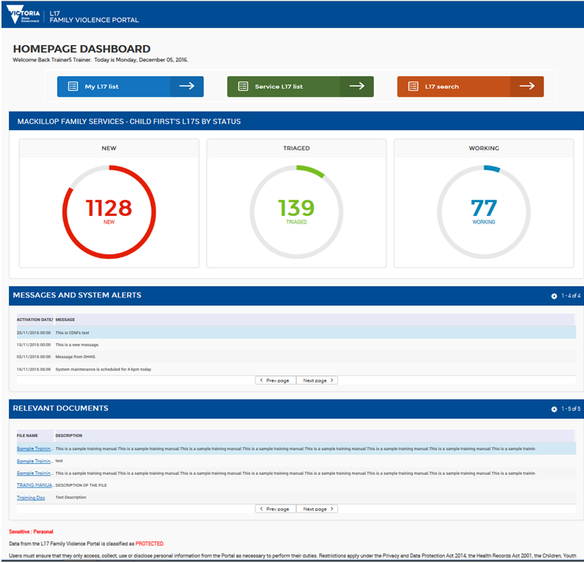

1. **The List view**
   1. **Service L17 List:** Displays all referrals for the service.

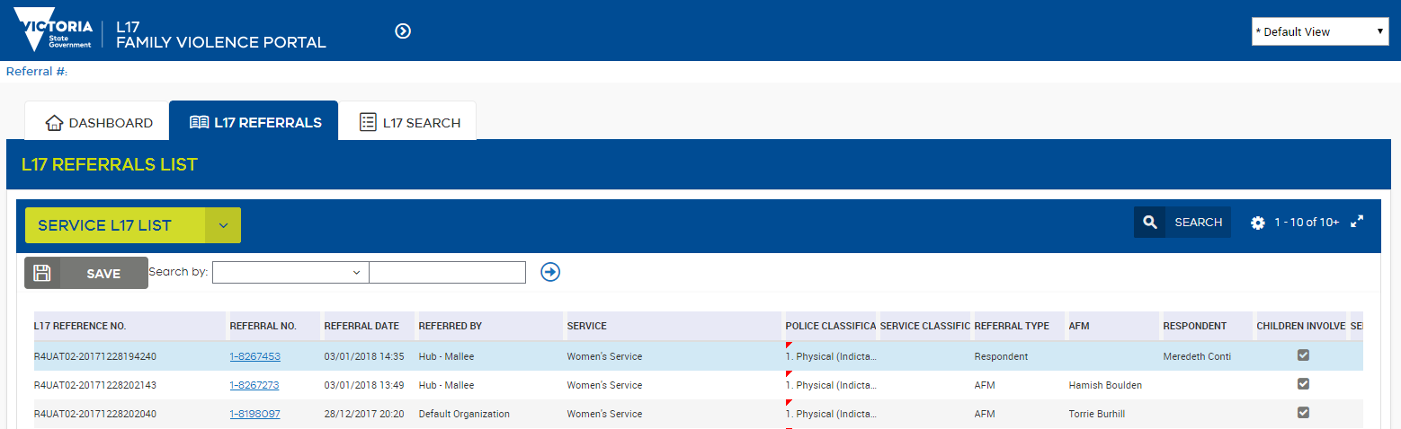

* 1. **My L17 List:** Displays all referrals assigned to a worker.

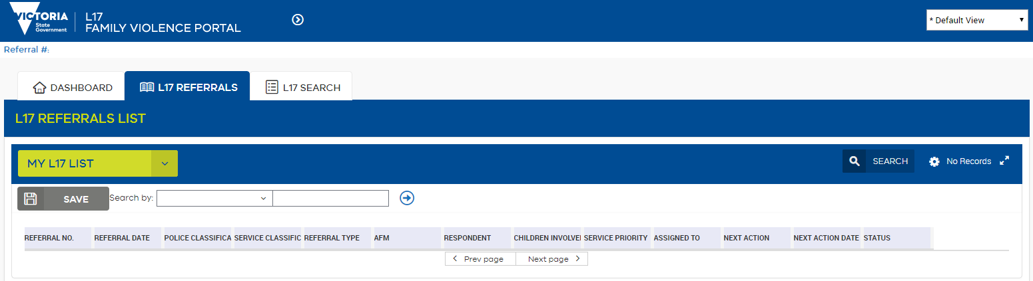

1. **The L17 Record:** A detailed view of the referral

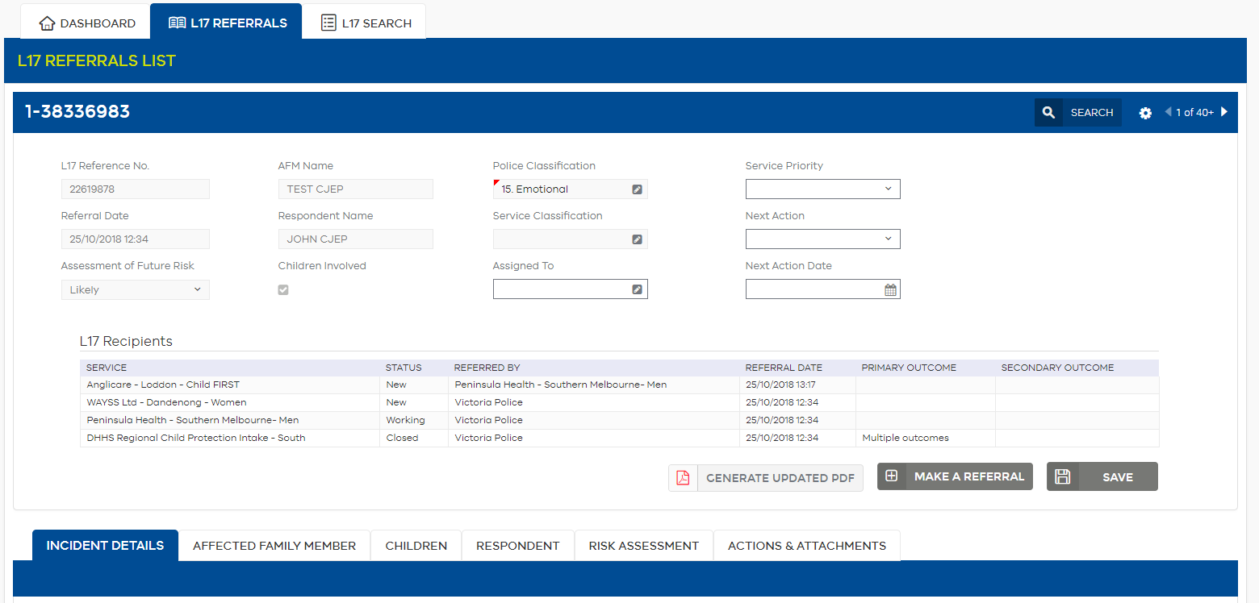

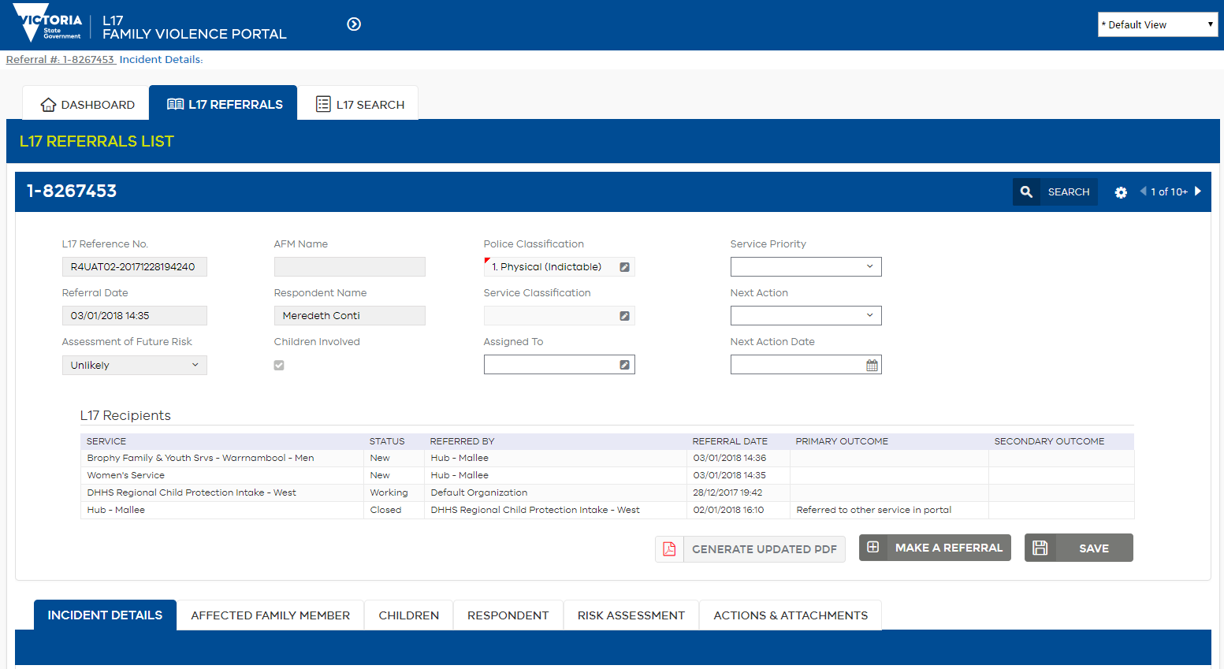

1. **The** **L17 Search**: A client-based search that allows search on name and date of birth.

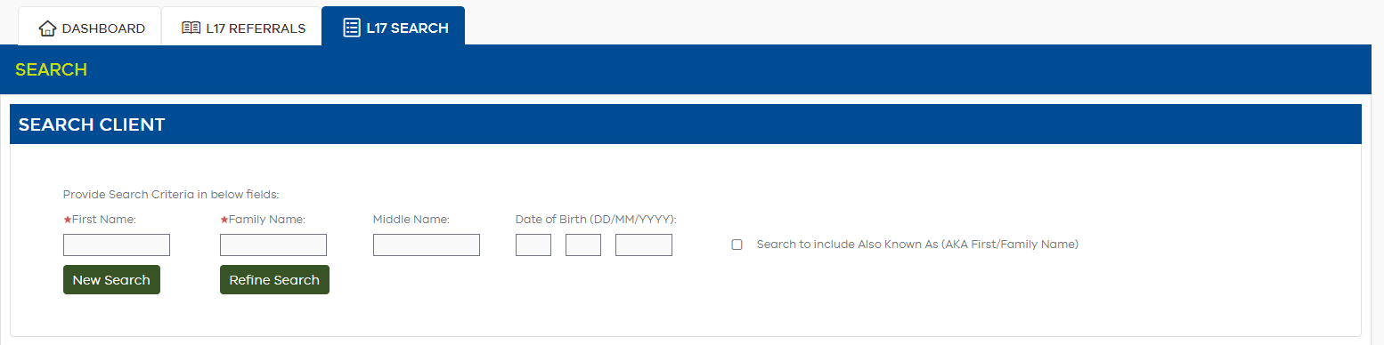

Each part of the Portal contains several sections, some with multiple tabs.

1. **The** **L17 Fuzzy Search**: A client-based search that allows search on names that sound similar and date of birth.

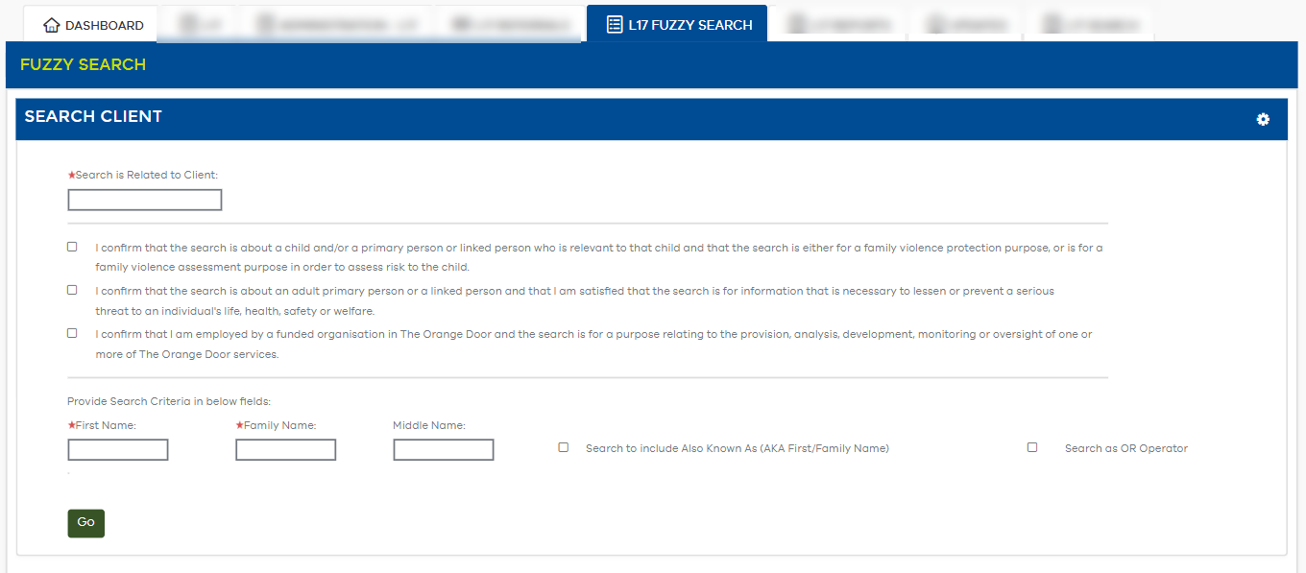

**To navigate back to the Homepage Dashboard at any time:**

Select the **Dashboard** tab on the top left-hand side of the screen.

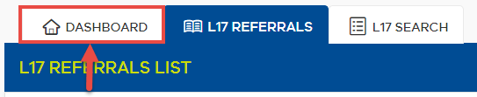

**To navigate back to the Service L17 List at any time:**

Select **L17 Referrals** tab on the top left-hand side of the screen.

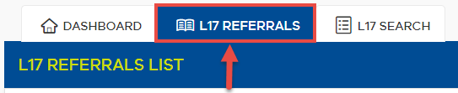

**To navigate back to My L17 List at any time:**

Select **L17 Referrals** on the top left-hand side of the screen, below the Dashboard, in the banner.

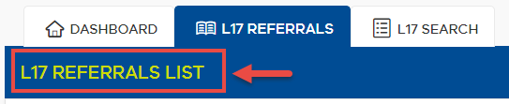

## Editable fields

Most fields within the Portal are non-editable as they contain law enforcement data. However, some fields have editing enabled in order to triage and support information sharing for the purposes of client safety.

* **Greyed out fields:** View only information. Most of this information is law enforcement data which cannot be amended.
* **White fields:** Fields are active (not greyed out). Examples of editable fields include assigning and triaging functions, as well as limited client details such as phone number and address – these are fields that are deemed important to have accurate information for the safety of the client.

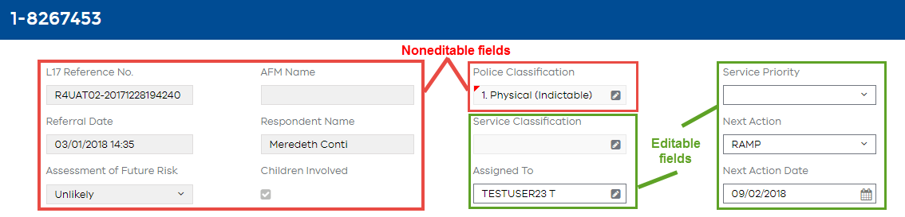

|  |  |
| --- | --- |
| Note  Note icon | Any changes made to fields in the AFM, Children or Respondent tab will be **visible across all services who have access to that tab**, including Comments and the History (Audit trail). See Information sharing within the L17 Record for more information. |

### Shared Information Updated by a Service

Where a user from a family violence/children’s service changes information in a shared editable field in the referral, that change will be underlined in orange in the Portal.

Indication of Updated Field

Screen-shot of indication of a field that has been updated or altered by a portal user. A field with altered information is indicated by an orange underline.

If another service has also received a referral for the same incident, they will also be able to see these changes. The orange underline will make it easier for servcies to identify where original Victoria Police information has been changed by a service.

The following are list of fields that can be updated and viewed by another service that has received a referral for the same incident:

|  |  |  |
| --- | --- | --- |
| AFM and Respondent Tabs | * Also known as name fields  (Family, First and Middle) * Identified as Respondent/ AFM * Date of Birth * DOB Unconfirmed * Gender * Identifies as Aboriginal and/or Torres Straight Islander (T.S.I.) * ATSI (only) referral preference * Interpreter Required and Language * Country of Birth | * Email (Home, Business and Other) * Contact numbers (Mobile, Home, Work and Other) * Preferred contact method * Preferred cotact time (including ‘Between certain hours’ options) * Social Media (Facebook and Twitter) * Accessability needs * Address * Address Withheld |
| Children Tab | * Also known as name fields  (Family, First and Middle) * DOB * DOB unconfirmed * Present at incident * Gender * ATSI descent * Country of Birth * Normally resides with | * Email (Home, Business and Other) * Contact numbers (Mobile, Home, Work and Other) * Social Media (Facebook and Twitter) * Address * Address Withheld * Newly Added Child/ren |

Services can also continue to check the History section (audit trail) for any changes that may have been made by their own or another service.

### Information Updated by Victoria Police

Where Victoria Police change information from the original referral, that change will be underlined in blue in the Portal. Any part of the L17 Family Violence Report can be updated by Victoria Police.

Indication of Updated Field

Screen-shot of indication of a field that has been updated or altered by Victoria Police. A field with information altered by Victoria Police is indicated by an blue underline.

The blue underline will make it easier for servcies to identify where Victoria Police has changed information from the original referral.

All changes will be recoreded in the History section (audit trail).

#### Case narrative

When the **Case Progress Narrative** (or **FVIU reason** on the **Risk Assessment** tab) is updated:

1. Click on **Multiple Records**

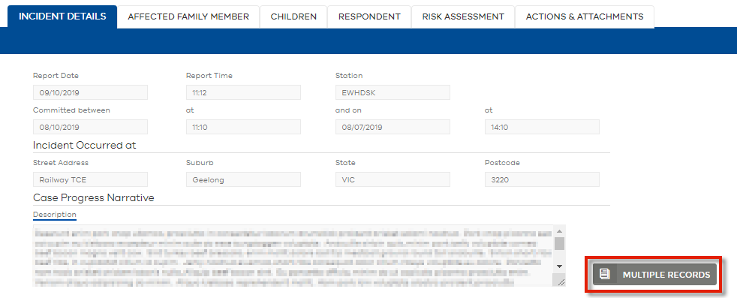

1. Click on **Previous Narrative** and **Next Narrative** to view case narrative history.

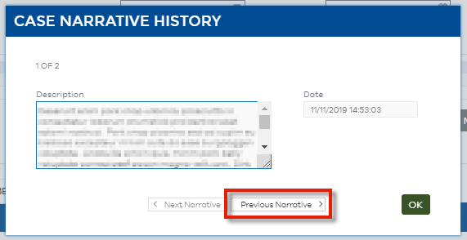

### Updated Information in the Updated PDF

When information is changed by a service user or Victoria Police, it will be reflected in the Updated PDF by a green highlight. This is to indicate that referral information was changed since the original referral. The source of the change can be identified in the History section of each tab within the portal.

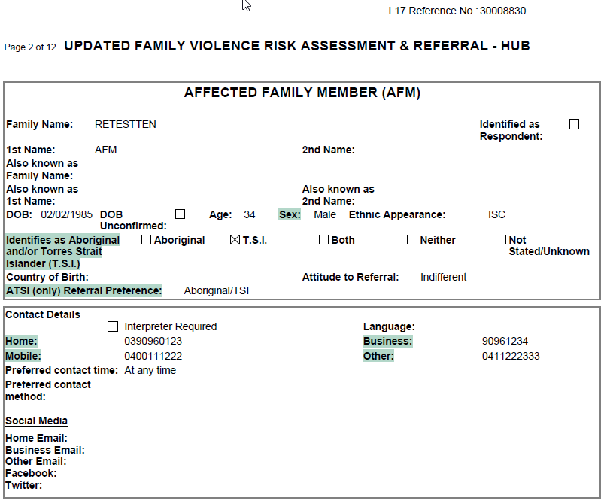

Sorting columns

#### To sort column by descending order:

1. Select the column header.
2. Click **Sort**.

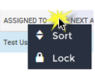

|  |  |
| --- | --- |
| Note  Note icon | The Sort button will be grey when it is not possible to sort on a column. |

#### To perform an advanced sort:

1. Click the **Preferences** icon Preferences icon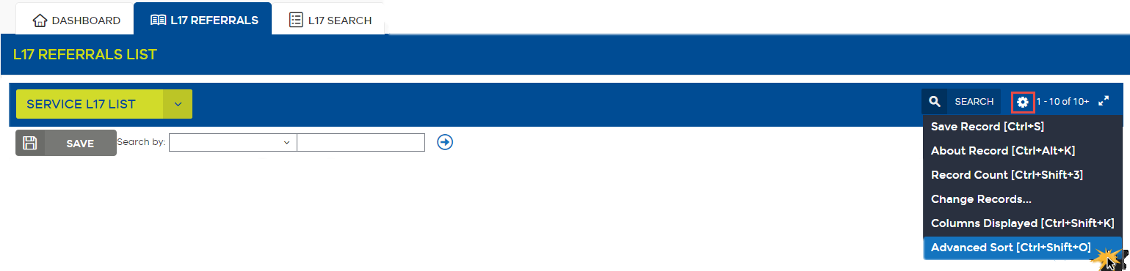
2. Select Advanced Sort.

*Advanced Sort dialogue box appears.*

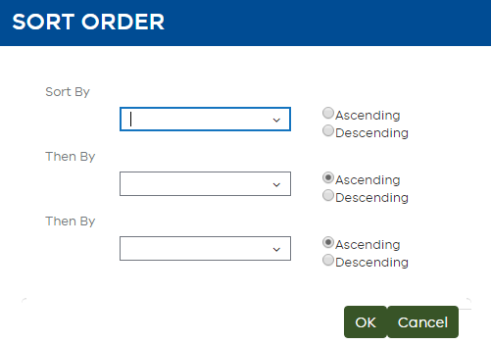

1. Using the down arrow Down arrow icon, select the first column you would like to sort by.

For example, select the **AFM** Name.

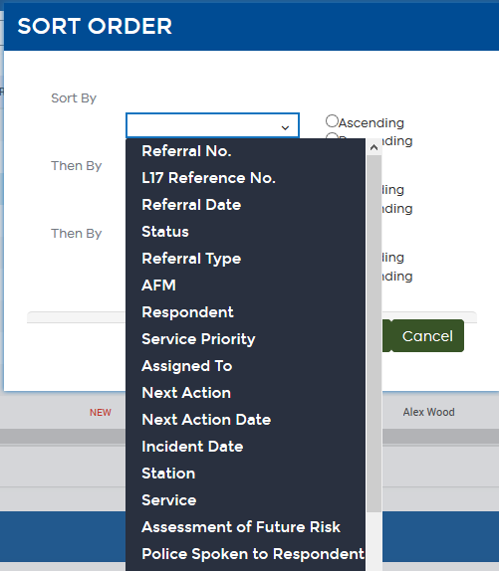

1. Select whether to sort in Ascending or Descending order using the radio buttons.  
    Sorting options - Ascending or Descending
2. Repeat column selection for **Then By** to enter additional sort categories.   
   For example, select the Referral Date.
3. Repeat for the third **Then By** if a third sort category is required.

The above example will sort the list alphabetically by AFM name, then within each AFM name referrals will be listed by Referral Date.

## Accessing additional information

A red triangle in the top left-hand corner indicates multiple values are present in that field (e.g. in the Police Classification column, there may be more than one classification assigned to the referral).

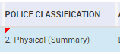

### To view additional information:

1. Select the field and then click the pencil icon Edit pencil icon to view multiple values. A dialogue box will appear to display the additional information. 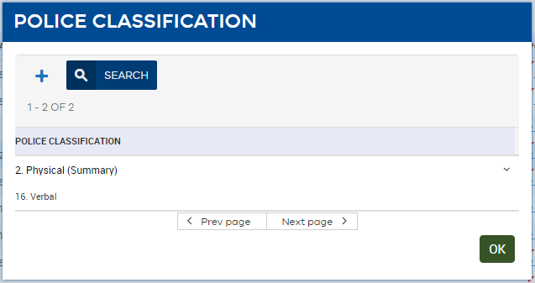

## Save functions

The Portal provides two alternative ways to save changes:

1. Save button.
2. Step off function.

|  |  |
| --- | --- |
| Note  Note icon | The red triangle notification will only display if you have the following columns included in your L17 List view:   * **Police Count** * **Police Risk Rating Count** * **Service Risk Rating Count** |

### Save button:

1. After altering data, the Save button will turn green to indicate changes have been made, but not yet saved. Click the Save button.

Green Save icon

1. The Save button will turn grey to indicate changes have been saved.

Gray Save button

#### Step off function:

You can also save changes by “stepping off” into a different section. 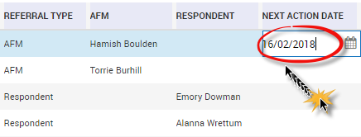

1. Update the value in the field you wish to change.
2. Click on another section.

*The changes will save and the section you are working in and the Save button will turn grey.*

|  |  |
| --- | --- |
| Tip  Tip icon | When the save button turns green this means you have made changes that are not yet saved. Click the green Save button to save your changes. The Save button will turn grey to indicate the changes have now been saved.  Green Save icon |

## Search functions

There are five ways to search in the Portal:

1. **Search by** drop down
2. **Search** button (field search)
3. **Query** assist (complex searches)
4. **Default view** (saved queries)
5. **L17 Search** tab (client search)

### Search by drop down:

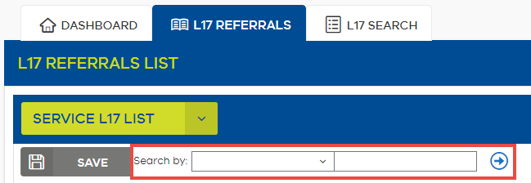

1. Select a category using the **Search by** drop down field.

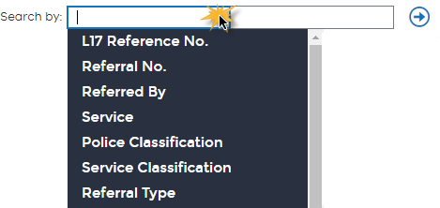

|  |  |
| --- | --- |
| Tip  Tip icon | To search by all fields, leave this field blank.  *Please note, leaving blank will slow down the time taken for the search to return results.* |

1. Enter the search terms in the free text field.
2. Click the **Go** button Go Icon

*Search results populate in the list below.* 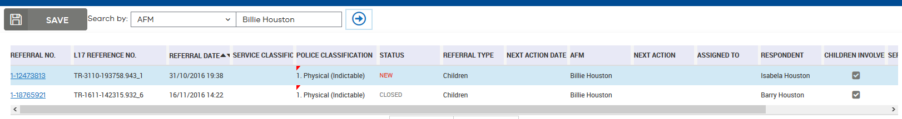

|  |  |
| --- | --- |
| Note  Note icon | Search filters will continue to apply in the List view until the List is refreshed, even if you have navigated away from the List view. Always refresh your List view to ensure you are viewing the full list of referrals, without any Search filters applied, and to include any referrals that may have recently arrived. |
| Reminder  Reminder icon | In search fields, the wild card is an asterix *. A wildcard is a character that may be used in a search term to represent zero, or one or more other (unknown) characters. It can be used at the beginning, middle or end of a search term. |
| Tip  Tip icon | To search by **Family Name** select the **AFM** or **Respondent** category from the drop down list. Then use a wildcard (asterix, * ) in the free text field before the **Family Name**. |
| Tip  Tip icon | To search by Date Range, use the syntax: e.g. >01/01/2016 AND <31/01/2016 in the date column |

### Search button (field search):

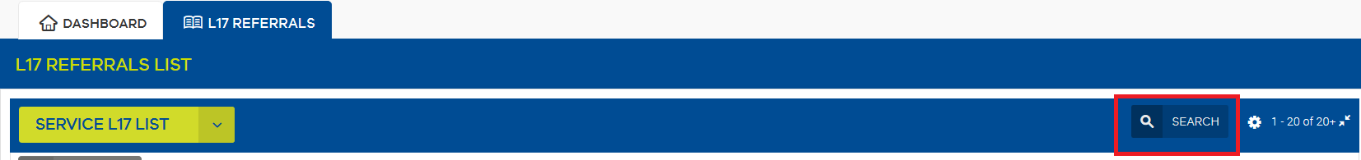

1. Select the Field search icon icon.   
   *All fields in the list will clear. The list and fields in the L17 Referral Details below may now be used for specifying search parameters.*

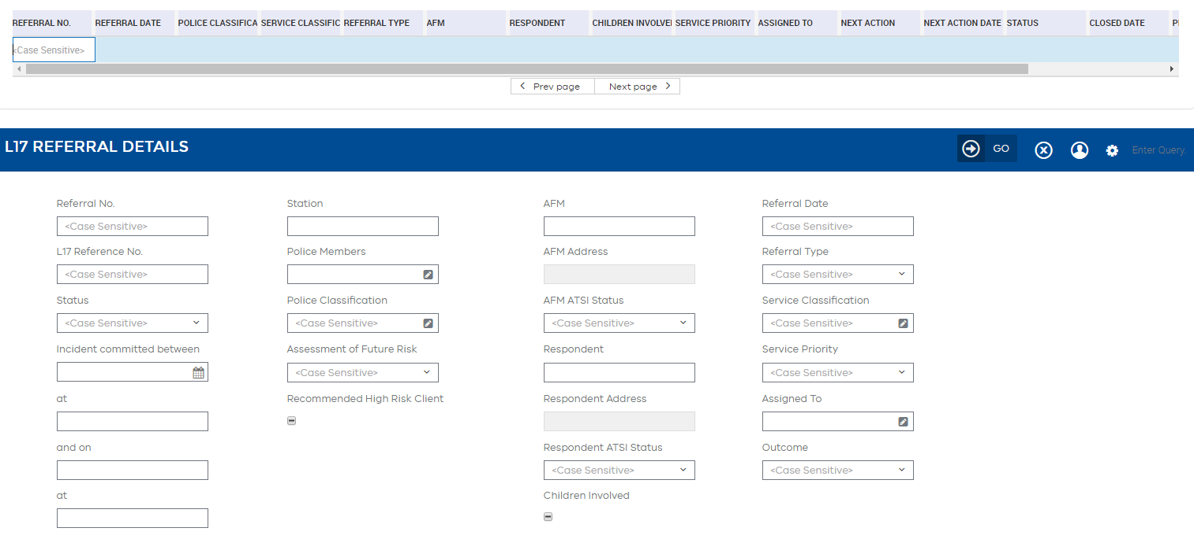This screen allows you to perform a similar search as above using the actual table of referrals; you can also use the screen to perform a multiple field search. For example, you might search for referrals with a particular Respondent name from a particular Station.

|  |  |
| --- | --- |
| Note  Note icon | Search parameters available will change depending on the type of data (e.g. the column) you are searching for. For example, some will be free-text and others will require you to select a date, a tick-box, or another pre-defined value by selecting the Edit Edit iconicon. Some fields are case-sensitive. |
| Tip  Tip icon | When entering search terms, do not click the column heading (this will provide sort options only). Instead click into the cell beneath the relevant column to enter your search term. |

1. Enter relevant search parameters by clicking on the desired field and entering the search query.

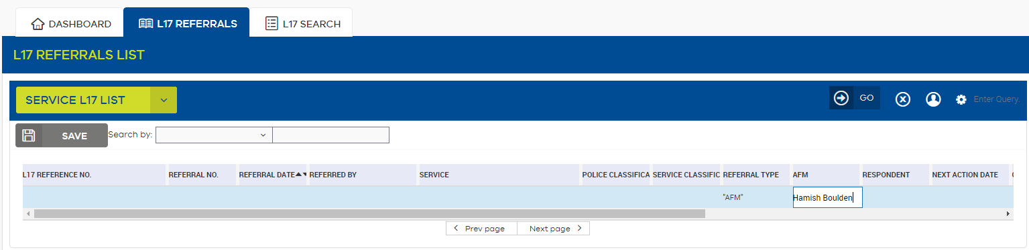

1. Select Go Go icon

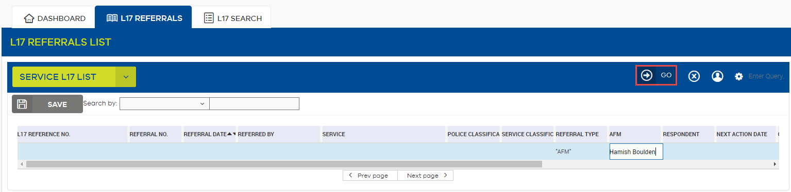

*Search results display in the L17 List.*

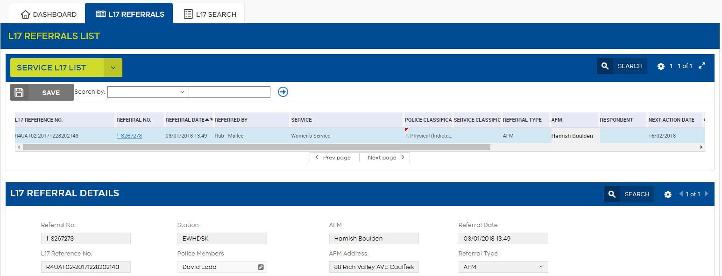

### Query Assist

1. Select the Field search icon icon.

*All fields in the list will clear.*

1. Click on the Application Menu in the Portal header.

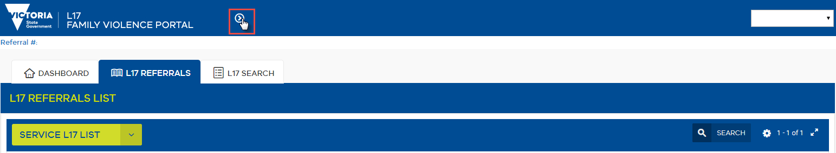

1. Click on Query and select Query Assistant.

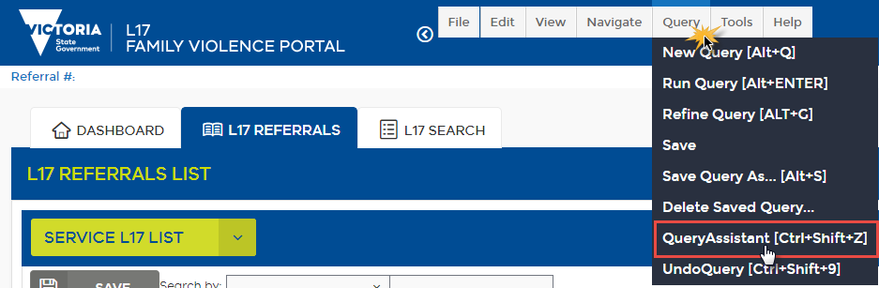

*Query Assistant dialogue box appears.* 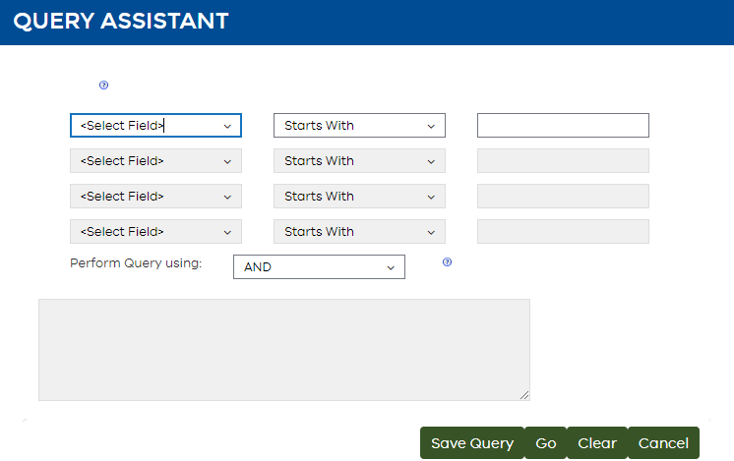

1. Using the down arrow Down arrow icon, select the first column you would like to query.

For example, select the **Status.**

A drop down box in first field in the Query Assistant dialogue box. 
From here you can select a number of options to narrow down your query. 

1. Select text filter.

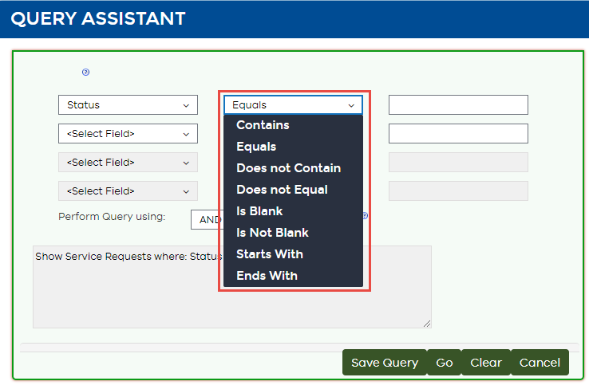

1. Enter your search value.

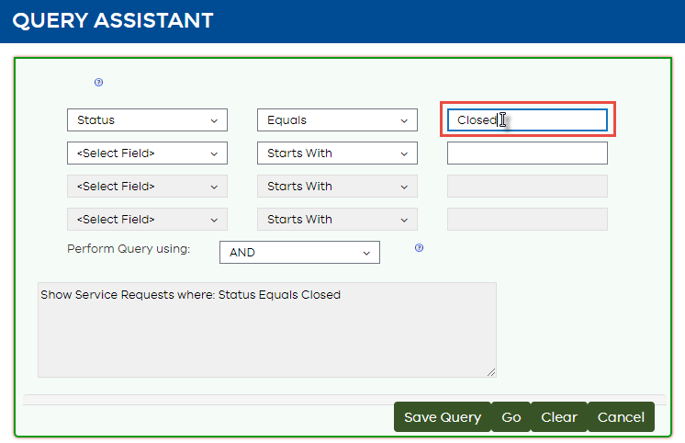

1. Repeat entering information for additional search values.   
   For example, Referred by Does not Equal Victoria Police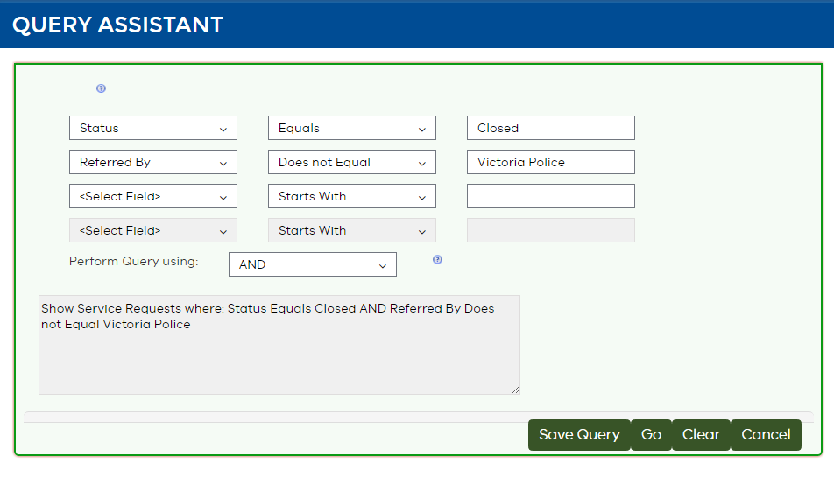
2. Select Perform Query using.

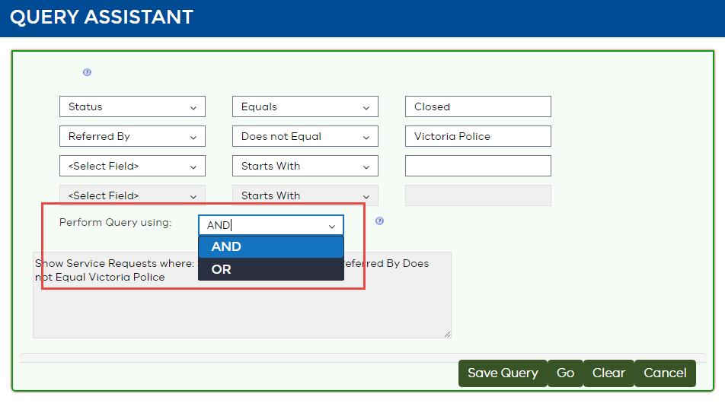

1. Click the Go button Go icon

This example will result in a list of all referrals that have a status of Closed and were referred to your service by another service - not Victoria Police.

|  |  |
| --- | --- |
| Note  Note icon | You can save your query by clicking the Save Query button. Give it a name and the query will be available to you from the **Default view** drop down options. |

### Default view saved queries

1. Click on *Default view in the Portal header.

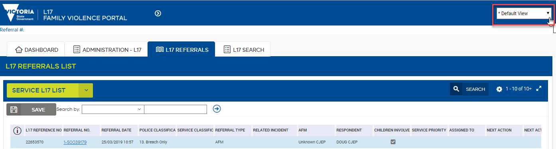

1. Select from a number of saved searches

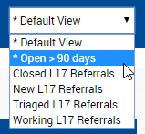

1. After selecting a query the L17 List view will automatically be updated to display results matching the search.

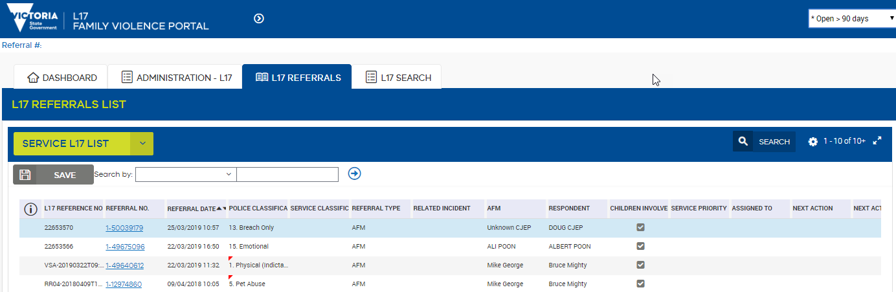

### L17 Search and L17 Fuzzy Search Tabs

The **L17 Search** and **L17 Fuzzy Search** tabs are designed to search for a client based on name and date of birth. The search will return a client regardless of their role in an incident.

The **L17 Fuzzy Search** tab will return results that sound similar to the search criteria.

The **L17 Search** tab will return results that match search criteria.

The more specific the search is the faster results will return. Use of the Also Known As search and a wildcard (*) will significantly slow down the Portal.

|  |  |
| --- | --- |
| Tip  Tip icon | Use the **L17 Search** and L17 Fuzzy Search tabs to search for a child. These tabs **are** the only method of search that will allow searches on a child’s name. |

#### Search Client for L17 Portal Users:

#### Screenshot of search screen available to Child Protection and Orange Door workers.

1. Click the **L17 search** button on the Homepage dashboard

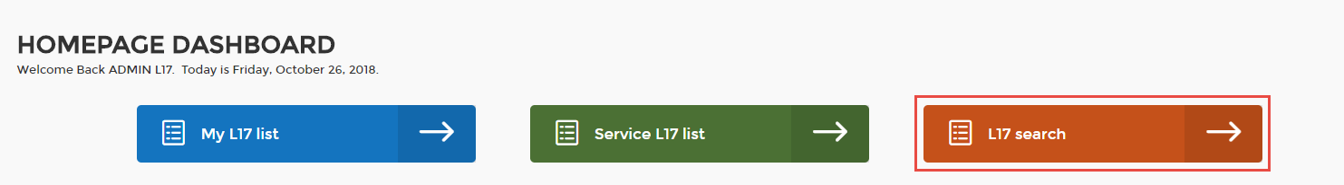

Or

Select the **L17 Search** tab  
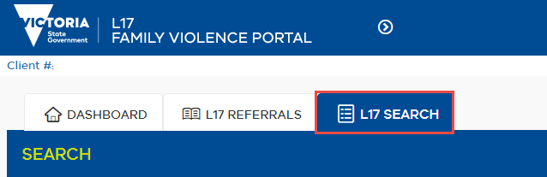

1. For Child Protection, Child FIRST and workers in The Orange Door only, select the relevant checkbox to confirm your search authority aligns with the lawful collection of information from historical L17 searches.
2. Enter the First Name and Family Name of the client  
     
   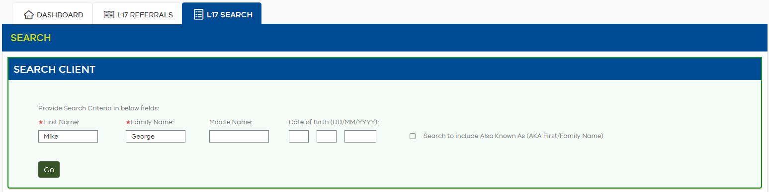
3. Enter Middle Name, Date of Birth if known.   
   *If the full date of birth is not known you are able to search on day only, month only, year only or any combination (day & month / day & year / month & year).*
4. You can also search Also Known As First Name or Family Name. This can be useful if your service knows the client by another name and has been entered in previous referrals or the data received from Victoria Police was misspelled and the correct spelling was recorded by your service in the AKA fields.

|  |  |
| --- | --- |
| Reminder  Reminder icon | Using the Also Known As First Name or Family Name will slow the time taken for the search to return results. |

1. Once all search criteria has been entered click the GO button.   
   *Pressing the “Enter” key will not perform the search.*

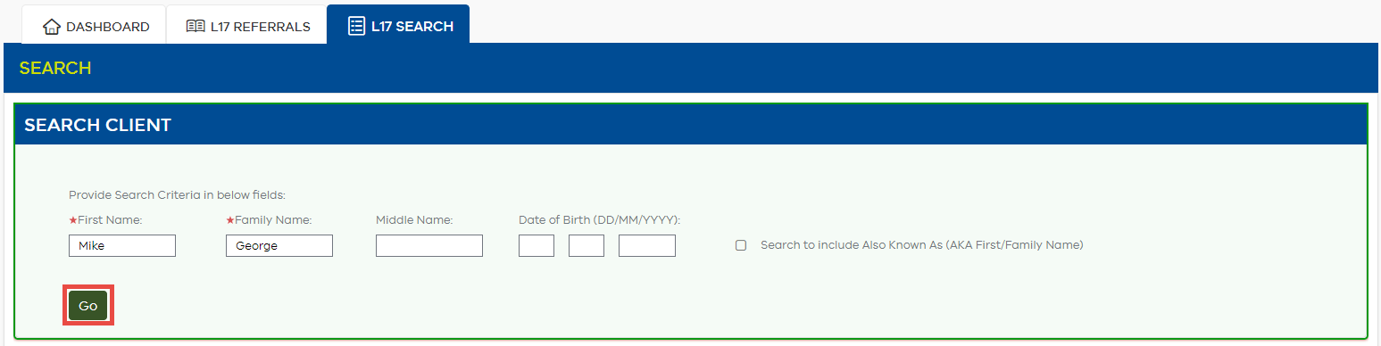

|  |  |
| --- | --- |
| Reminder  Reminder icon | Upon clicking **Go** the search criteria will be logged as a part of the audit process. |

1. Once the search is completed the Go button will be replaced by **New Search** and **Refine Search**. **New Search** will clear all search criteria and results allowing for a search on a new client.   
   **Refine Search will allow** edits to search criteria, for example a name was spelt wrong or the date of birth was incorrect.
2. **Client Search Result** list is grouped by Client ID. This is a unique identifying number that is generated based on information sent by Victoria Police. If “Unknown” appears as the Client ID, that particular client is not linked with any other incidents or referrals. Possible reasons for an unknown Client ID may be that the client was not within Victoria Police’s systems or was not identified at the time of making the report. 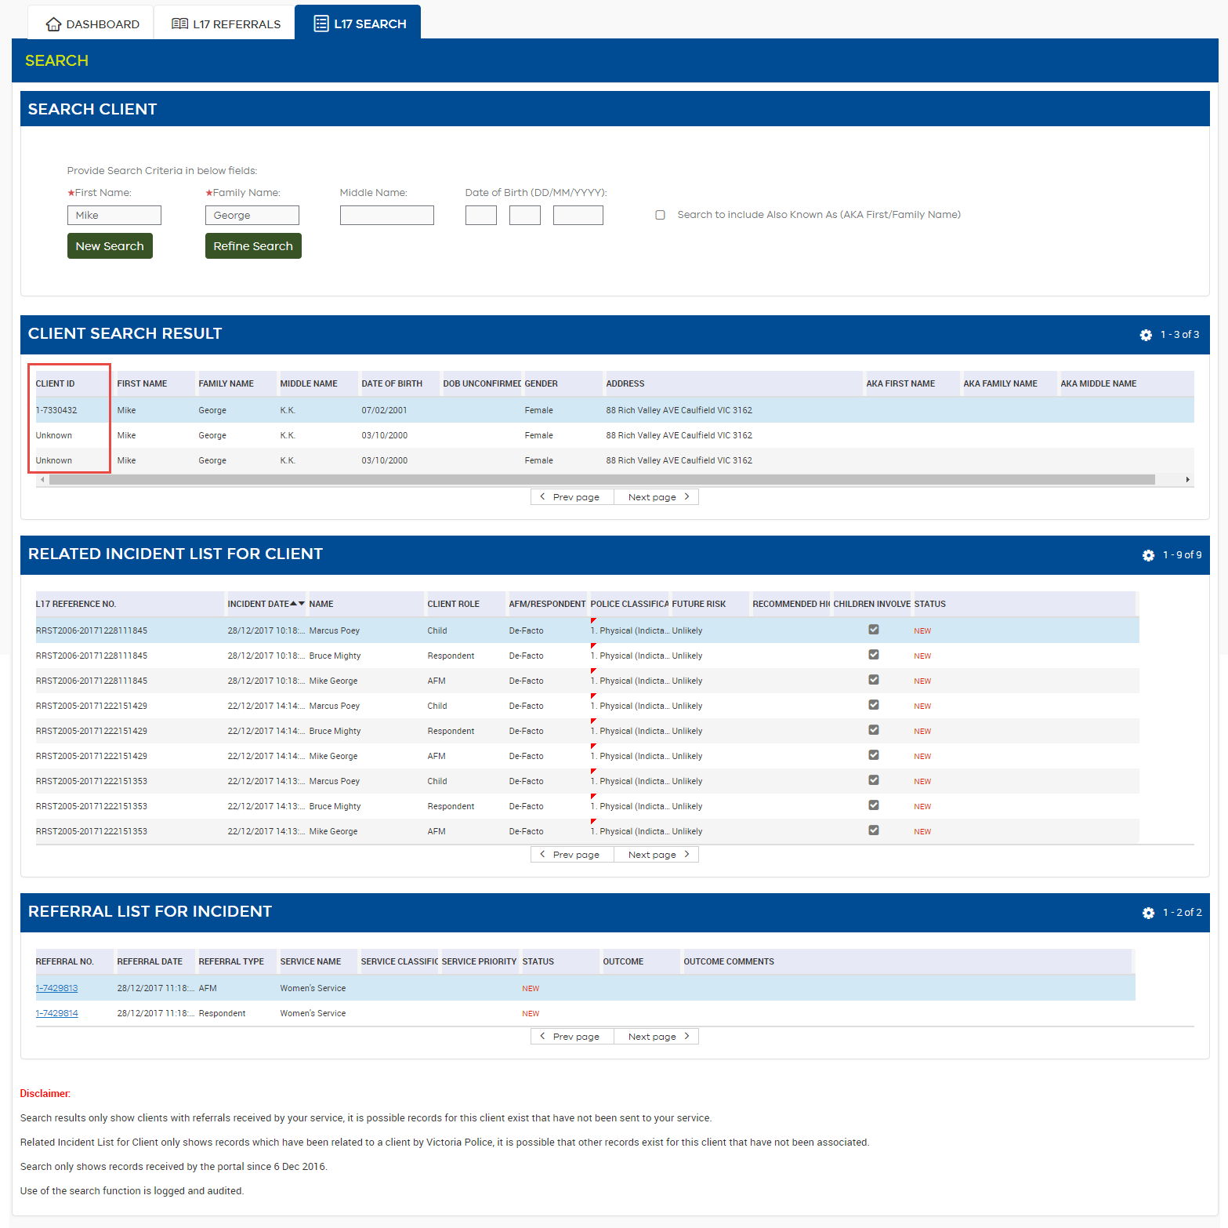

|  |  |
| --- | --- |
| Note  Note icon | The name displayed in **Client Search Result** is the name recorded in the most recent incident sent to the Portal.  It is possible the name displayed is different to the search criteria. To appear in the **Client Search Result** the client name used in the search criteria **must** have matched the name in a previous incident.  Previous names will appear in the **Related Incident List for Client**. |

1. **Related Incident List for Client** displays basic details for all incidents your service has received referrals for, for the highlighted client.

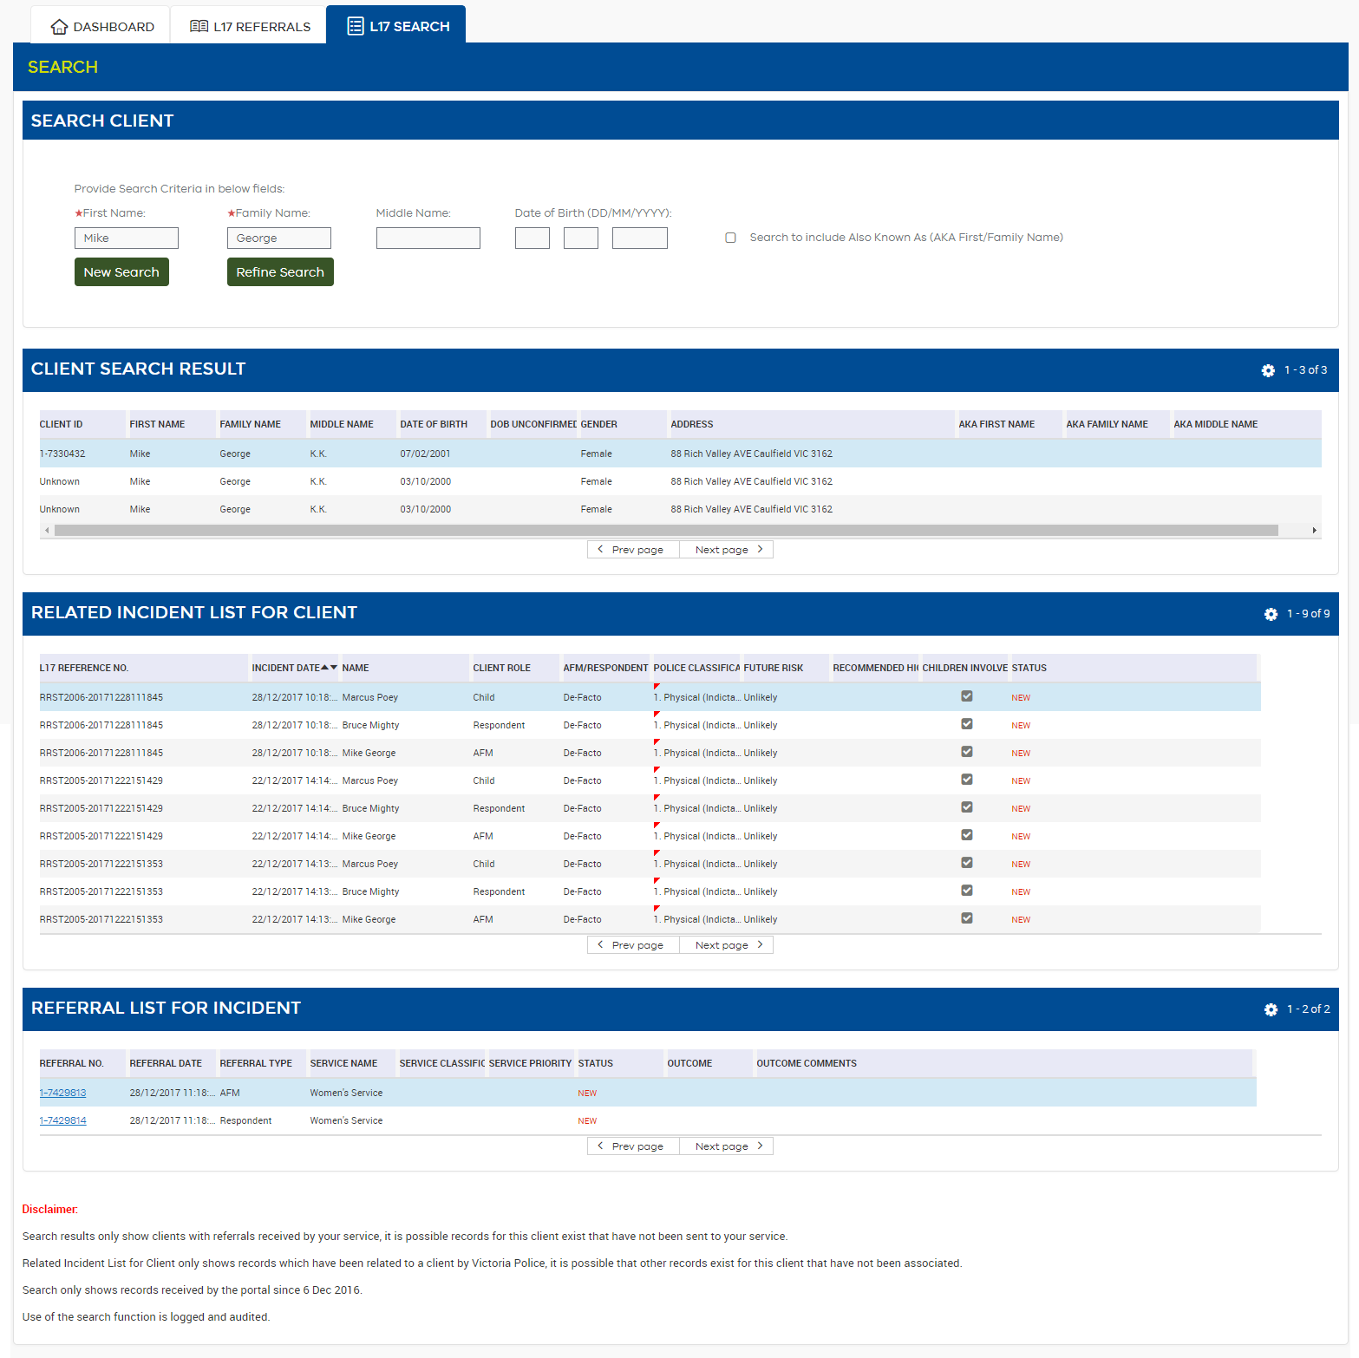

|  |  |
| --- | --- |
| Note  Note icon | The **Name** column shows the name recorded by Victoria Police for each incident. Names in this column may be different to your search criteria however all incidents were related based on the Victoria Police identifying information. |
| Reminder  Reminder icon | **Related Incident List for Client** only shows incidents for which referrals were sent to your service. It is possible other incidents for the client exist for which referrals were not sent to your service. |
| Reminder  Reminder icon | **Related Incident List for Client** only shows incidents that were related by Victoria Police. It is possible other incidents for the client exist that have not been related. |

1. **Referral List For Incident** shows the referral/s your service has received for this client for the highlighted incident.

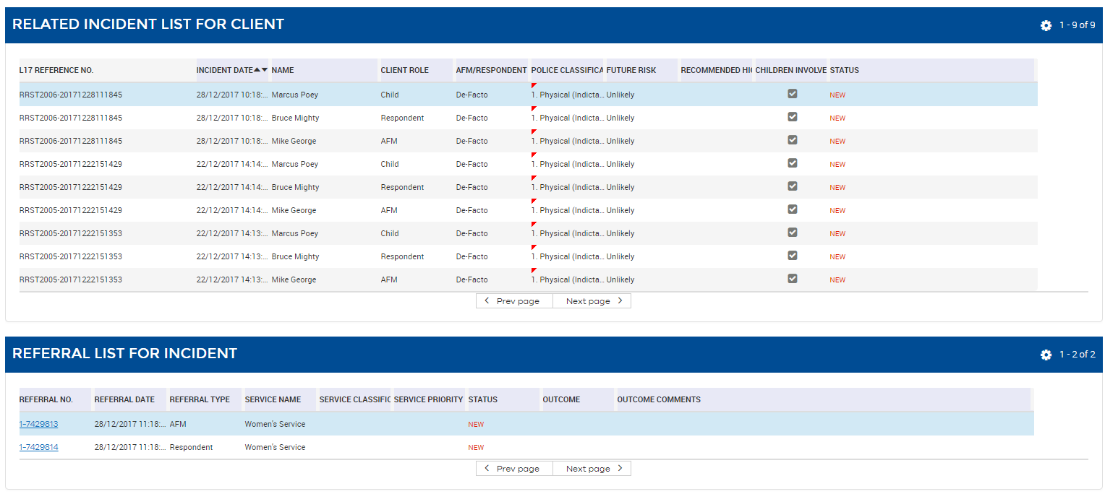

1. Using the **Referral #** hyperlink you are able to drill into referrals, make changes and notes as required.
2. By clicking the **Client #** hyperlink in the referral view, you will be returned back to the search screen with your search results intact.

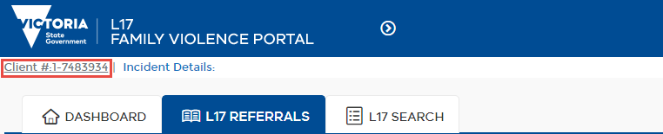

### How to Save a Query

1. Click the Gear (preferences) icon**Preferences** icon and select Advanced Sort

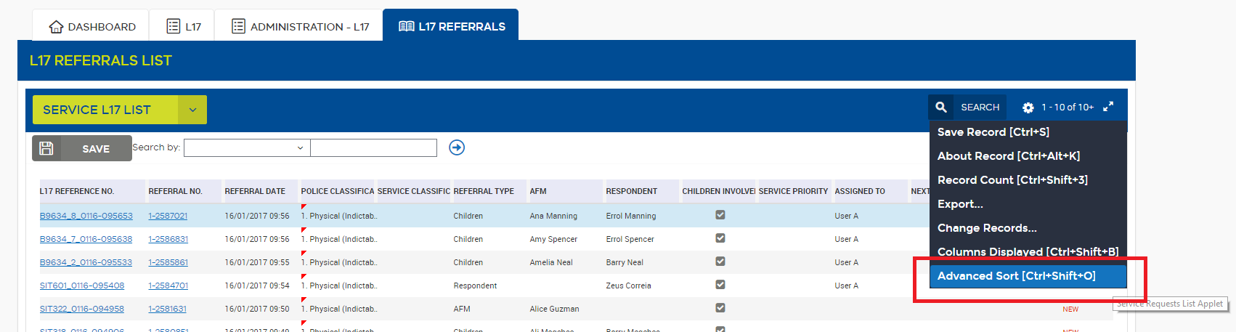

1. Enter the query you would like to save and click OK e.g. Referral Date Ascending

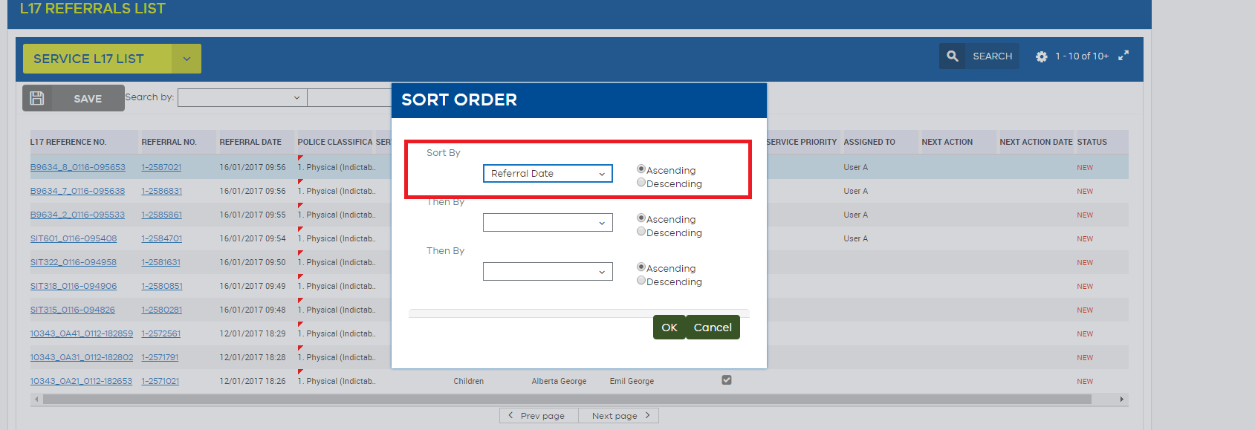

1. Click the arrow in the header to expand options

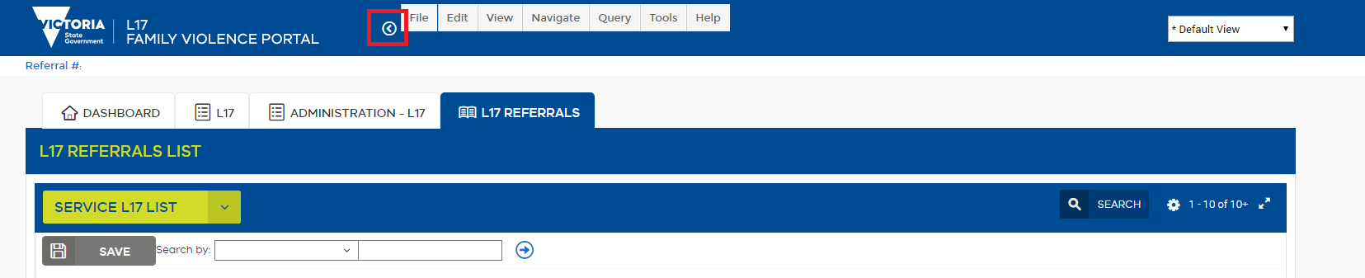

1. Select Save Query As

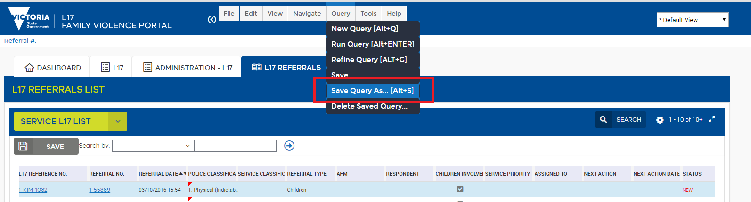

1. Enter a query name in the Save Query As pop-up.

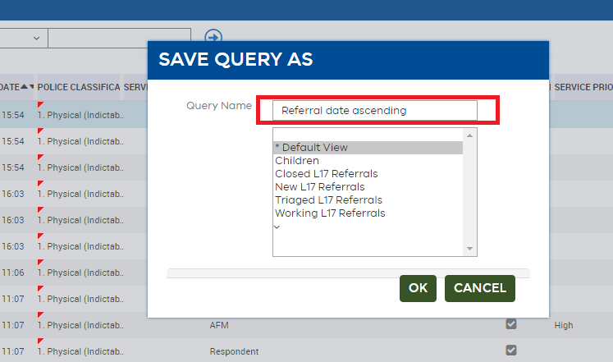

1. This query will now appear in your drop-down box of saved queries and can be accessed quickly at any time

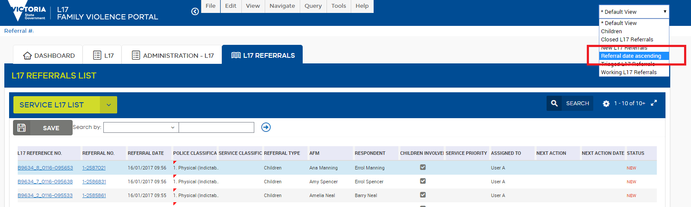

## Reopen function

A referral can be reopened within the Portal.

There are two methods of reopening referrals; the first can be done via the L17 Referrals tab when viewing closed referrals in the Referrals List, and the second is through options available when viewing the incident details of the referral.

### To reopen referrals via the L17 Referrals Tab:

1. Click on the closed referral from the **Service L17 List** or the **My L17 List**.
2. The Save button is replaced with a Reopen button.

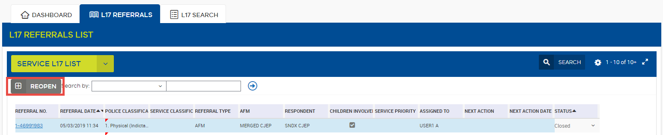

1. Click the Reopen button and a pop-up will appear asking the user to enter comments.

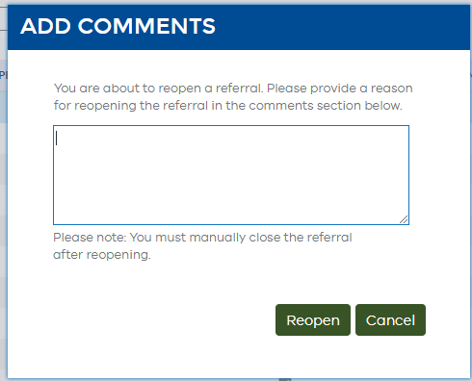

1. Enter the comments, select Reopen and the referral status will be set back to **Working**.



1. The referral is now editable and further updates can be made.

### To reopen a referral from within the Incident Details:

1. Click on the referral no. of the closed referral you would like to reopen.



1. At the bottom of the L17 Record you will find the Reopen button. Select this to reopen the referral.

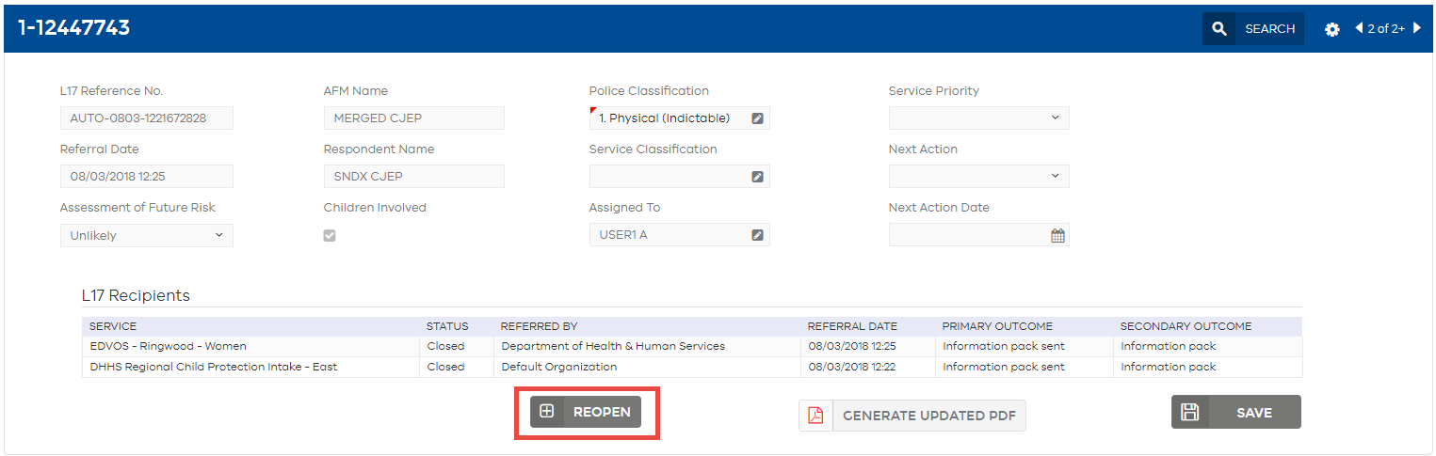

1. The Add Comments box will appear. Enter the comments you would like to add and select Reopen.

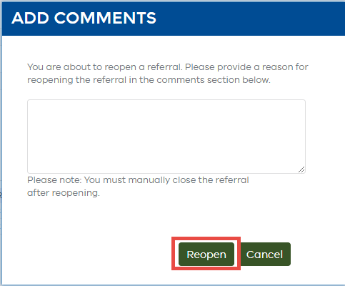

### User reopen comments:

1. Navigate to the Actions & Attachments tab with the L17 Record view. Here you will see the action ‘Reopened’, along with the date, time, and comment previously entered when the referral was reopened.

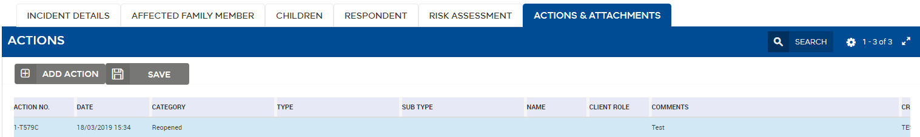

### Closing a reopened referral:

1. To close the referral. Open the referral to the L17 Record view. You will notice that the Reopen option has been replaced with a Close Referral option.
2. Click the Close Referral button after you have made your updates.

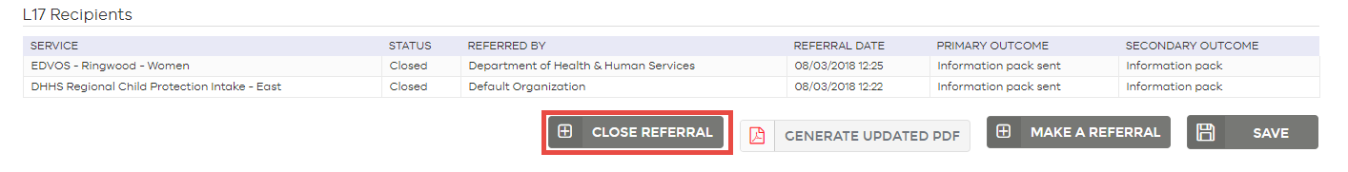

|  |  |
| --- | --- |
| Note  Note icon | If you reopen a referral that was closed prior to 16 August 2018 (that is, prior to the introduction of client level outcomes) you will be required to enter the outcome for the primary client/s to close the referral. A warning pop up will appear if an outcome is missing for the primary client/s and you will not be able to close the referral. |

# Homepage Dashboard

|  |  |
| --- | --- |
| Overview | The **Dashboard** is where you can:  Link to **My L17 List**  Link to **Service L17 List**  Link to **L17 search**  View the Service Snapshot  View the Privacy Disclaimer  Link to the User Guide  Link to Portal support |

The **Homepage** **Dashboard** is divided into four sections.

1. Links to **My L17 List** tab, **Service L17 List** tab and the **L17 search** tab
2. Snapshot of status of current referrals
3. Message and system alerts (where present)
4. Privacy disclaimer, and links to support, protocols and training resources

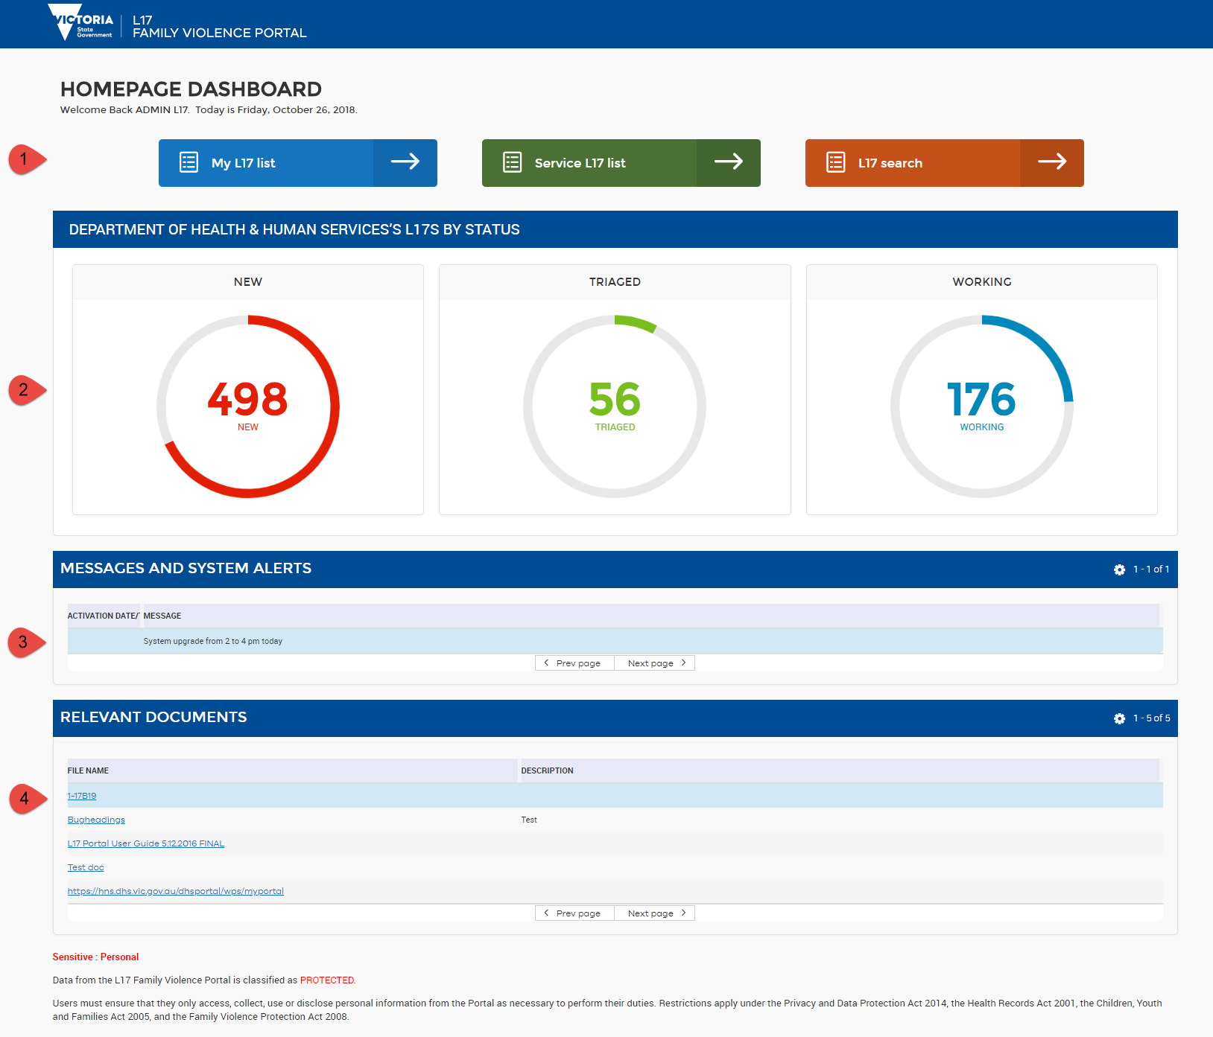

## Service Snapshot

The **Service Snapshot** provides an infographic with a count of your service’s current referrals, divided into status of the referrals.

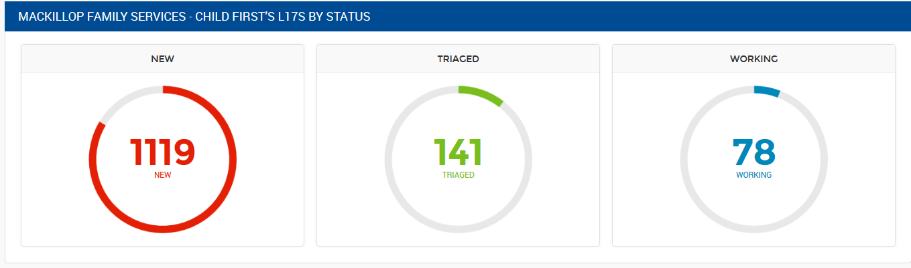

## Referral status

There are four different statuses within the system: new, triaged, working, and closed. Statuses are automatically triggered when specific functions are performed in the Portal.

Table 5. Definitions of L17 Record Status

|  |  |
| --- | --- |
| Status | Definition |
| New | Newly received referral from Victoria Police or another service in the Portal |
| Triaged | Status will change to **Triaged** when you change a triage field: that is, enter a **Service Classification** or a **Service Priority** |
| Working | Status will change to **Working** when you have made a change in the **Record** screen: **Make a Referral**, create an **Action,** edit any client details, **Generate a PDF** or enter any **Comments**. |
| Closed | Status will change to **Closed** when an **outcome for all primary clients** have been recorded in the **Actions and Attachments** tab. This means the family violence referral has been processed. A service may still be working with the client, wherein they will continue to manage the client record via their client management system. |

|  |  |
| --- | --- |
| Reminder  Reminder icon | **Where a referral is Closed, a service may still be working with that client. This simply means that the service has completed their work with the L17 Referral. The service can still view closed L17 records and generate L17 PDF files.** |

# Service L17 List

|  |  |
| --- | --- |
| Overview | The **Service L17 List** tab is where you can:  Monitor all referrals sent to your service in one list  View select details of the referral (including status of new, working, triaged, or closed)  Manage referrals by **triaging** or **assigning** to other workers  Search and filter referrals that have not been actioned or have been overlooked |

## Screen Overview

The **Service L17 List** is divided into two sections.

1. The **L17 List** section
2. The **L17 Referral Details** sub-section

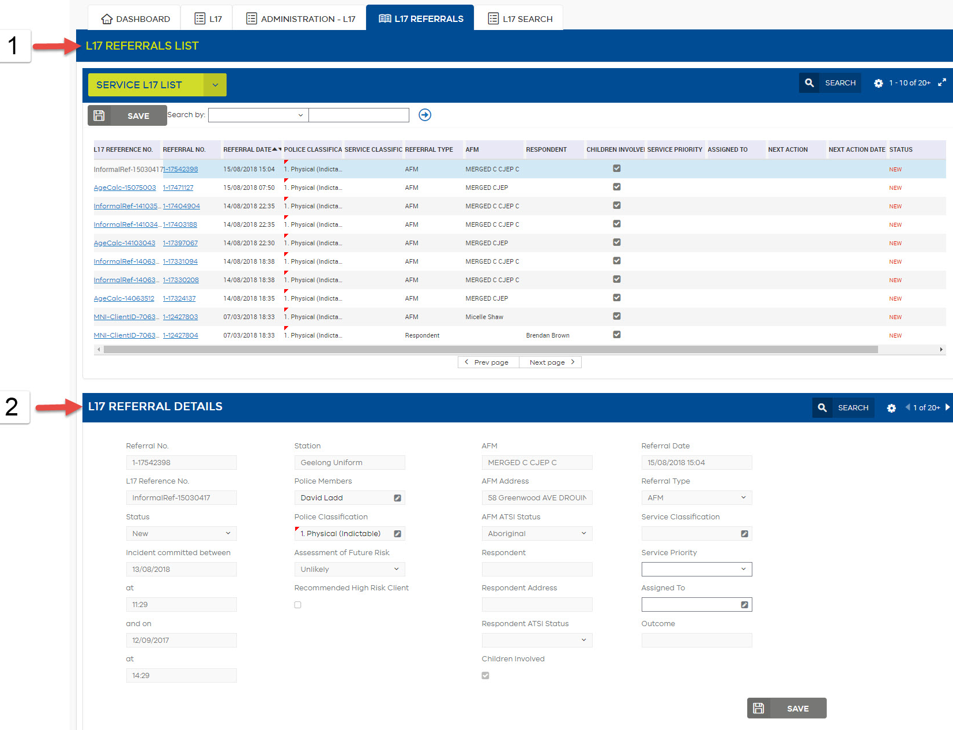

## L17 List

The L17 List contains a list of all family violence referrals that have come into the service. There are a number of columns across the top, which can be customised to suit the needs of the service. Editable fields can be edited directly from the List View, for example, you can **Assign to** a worker by selecting in the relevant record **Assign to** field.

### Default Order of L17s

The system default display for the **Service L17 List** shows open L17s for your service, in order of:

1. **Status** in the following order: New – Triaged – Working.
2. **Date** and **Time** order (**Referral Date** column). The most recent referrals will display at the top.

### Display More Records

The list displays 10 records at a time. It can be expanded to display 20 records, by clicking the **Expand** Expand iconicon.

### Filter by Status

You can filter the **L17** **List** by status.

#### To filter the list by status:

1. In the top right-hand corner of the screen, select the Default view box.



The drop-down box will appear with the six different filtering options:   
Default view; Open > 90 days; Closed L17 Referrals; New L17 Referrals; Triaged L17 Referrals; and Working L17 Referrals.

### Customise the Columns Displayed in L17 List

The Portal has been designed to accommodate over 48 different services, all with different processes. As a result, it has been built with the ability to customise the list to your services’ needs.

#### To re-order columns:

1. Click on the column, hold and drag to the desired position in the table.

#### To add a column:

1. Click the Gear (preferences) icon**Preferences** icon

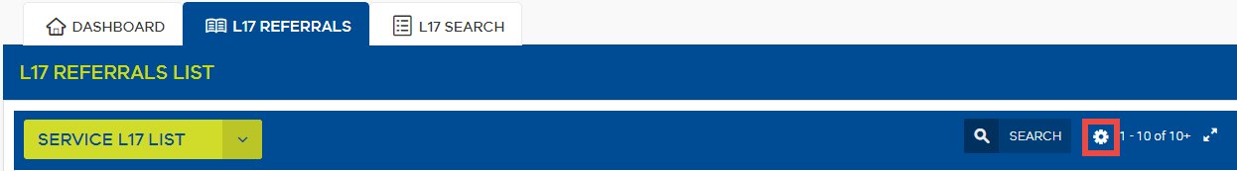

1. Select “**Columns Displayed**”

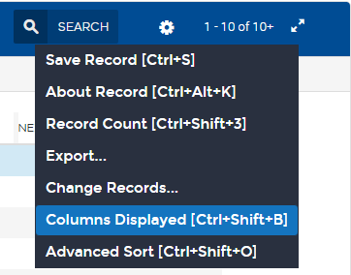

1. Columns Displayed box displays. The **Available Columns** section on the left displays all possible columns that may be added to your L17 List view. The **Selected Columns** section on the right displays all columns already in your L17 List view.

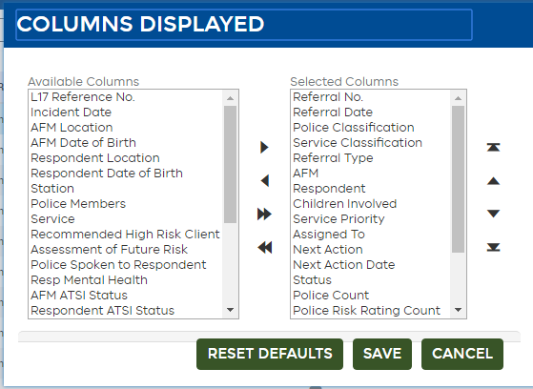

1. Select the name of the column you wish to add from the **Available Columns** section.
2. Click the **right pointing arrow** to move the selected column from **Available Columns** into the **Selected Columns** section
3. In the **Selected Columns** section, highlight an item and use the up or down arrows to change the order of the columns
4. Click the **Save** button – the column and information should now appear in the **List**.

#### To remove a column:

Follow steps 1 to 3 above (how to add columns), then:

1. Click the **left pointing arrow** to move the selected column from **Selected Columns** into the **Available Columns** box.
2. Click the Save button – the column should now be removed from the **List**.

#### To restore to default column list:

1. Click the Gear (preferences) icon**Preferences** icon and select “**Column Displayed**”
2. Click the **Reset default** button
3. Clive the **Save** button – the columns should now revert to the original settings.

|  |  |
| --- | --- |
| Note  Note icon | **L17 List column customisations must be set in each user profile.**  **You can customise different columns to display in your Service L17 List and in your My L17 List.**  **Once you have customised your required columns, they will appear each time you log in to the Portal.** |

## Referral Details

When you select an item from the **L17 List** above, a summary of its contents is displayed in the **L17 Referral details** below.

### To select an L17 Record to display in the L17 Referral Details section:

1. Click on the referral record in the list in any field – except the Referral No. hyperlink.

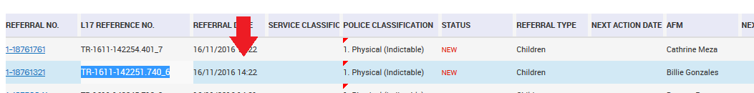

*The selected record will be highlighted in blue, and the details of that record will display in the L17 Referral Details sub-section below.*

This view contains additional information and is primarily used as an alternative to viewing the **L17 List** above. You are able to add information such as **Service Priority** and **Assigned To** from here as well.

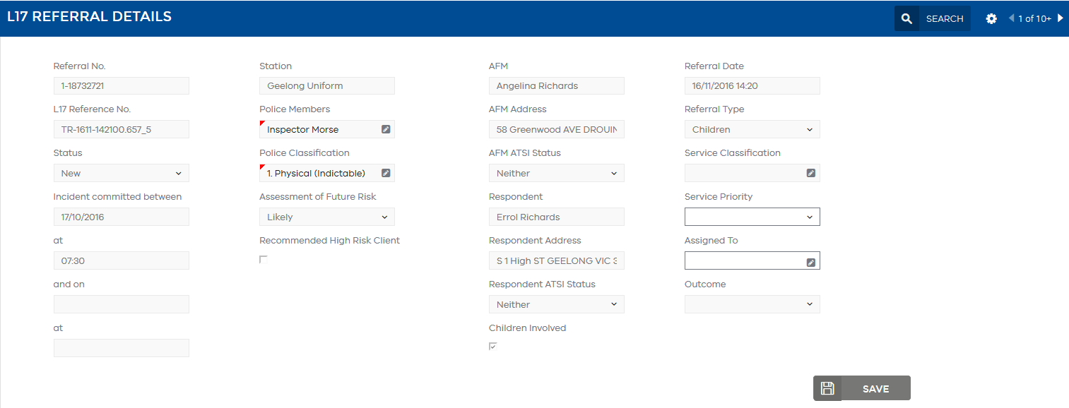

Table 6. Fields available in the L17 List View

| Available fields for L17 list | Field content |
| --- | --- |
| Information symbol. | Updates to L17 referral from Victoria Police (currently not used) |
| AFM | Name of Affected Family Member (AFM), showing first and last name together. |
| AFM Date of Birth | Date of Birth of AFM. When an incomplete date of birth is received into the Portal it will automatically populate the missing fields, day and/or month with 01 (year is always supplied by Victoria Police). |
| AFM Address | Permanent Address of AFM (not to be confused with current temporary address). |
| AFM ATSI Status | Aboriginal and Torres Strait Islander status of AFM. |
| AFM DOB Unconfirmed | Check-box to indicate Victoria Police have sent an incomplete Date of Birth (DOB) for the AFM. |
| AFM/Respondent Relationship | Relationship between AFM & Respondent. |
| Assessment of Future Risk | Police assessment of likelihood of future risk. |
| Assigned To | Optional editable field. Some services may choose to assign the referral to a worker as part of triaging and managing the referral. This field indicates the Worker the referral has been assigned to. |
| Children Involved | Check-box to indicate whether children were involved in the family violence incident. |
| Closed Date | The date a **Final Outcome** was entered. |
| First Court Date | The date the matter is to be seen in Civil and/or Criminal Court as indicated in Court Information in the **Risk Assessment** tab. |
| Incident date | Date that the family violence incident occurred. |
| L17 Reference Number | The Victoria Police L17 Referral reference number. This referral number will be the same across services.  This is different to the **Referral Number** which will be different for every service. |
| Next Action | The next action required for the referral. |
| Next Action Date | The date the next action is required. |
| Outcome | The Final Outcome (primary and secondary concatenated) recorded by your service in the **L17 Record** tab. |
| Outcome Comments | Comments recorded when the Final Outcome was made. |
| Police Classification | The 1 - 20 classification that Victoria Police has given the family violence incident. |
| Police Count | In order for the multi-value indicator functionality (i.e. the red triangle notifications) to work for the **Police Members** columns, you must have **Police Count** selected in Columns Displayed. |
| Police Members | The name/s of the police member/s who attended the incident and prepared the family violence report. |
| Police Risk Rating Count | In order for the multi-value indicator functionality (i.e. the red triangle notifications) to work for the **Police Classification** columns, you must have **Police Risk Rating Count** selected in Columns Displayed. |
| Police Spoken to Respondent | Check-box to indicate whether Victoria Police have spoken to the Respondent. |
| Pregnancy/New Birth | Indication as per **Risk Assessment** tab if a person involved is pregnant or recently given birth. |
| Recommended High Risk Client | Recommendation by Victoria Police to consider client for High Risk management. Not currently sent by Victoria Police. |
| Referral Date | The date and time that the referral has been received by the L17 Family Violence Portal from Victoria Police. |
| Referral Number | This is the unique identifier assigned to a referral by the Portal. This is service specific, that is, the Referral Number will be different for each service receiving a referral for the same incident.  The **Referral Number** links to the **L17 Record**. |
| Referral Type | Victoria Police identify which type of service should receive the referral i.e. AFM, Respondent, or Children. You will only be able to see referrals that your service receives.  Referrals sent to Hubs, regardless of whom the referral is made for, will be a ‘Hub’ referral type. Hubs can find out more information about the referral type by referring to the Referral Actions table in the Risk Assessment section. |
| Referred By | Who made the referral. This is Victoria Police or any service operating within the Portal who has made a referral to another service. |
| Related Incident | Check-box to indicate where one or more clients within the referral is related to a previous L17 incident in the portal. In the case of Respondent referrals, the column will only be ticked if the Respondent is related to a previous L17 incident. |
| Reopened | Check-box to indicate the referral has been reopened. |
| Respondent DOB Unconfirmed | Check-box to indicate Victoria Police have sent an incomplete Date of Birth (DOB) for the Respondent. |
| Respondent | Name of Respondent, showing first and last name together. |
| Respondent Address | Permanent address of Respondent (not to be confused with current temporary address of Respondent). |
| Respondent ATSI Status | Aboriginal and Torres Strait Islander status of Respondent. |
| Respondent Date of Birth | Date of Birth for Respondent. When an incomplete date of birth is received into the portal it will automatically populate the missing fields, day and/or month with 01 (year is always supplied by Victoria Police). |
| Respondent Mental Health | Check-box to indicate whether Respondent has a Depression/Mental Health issue. |
| Service | The service that has received the referral. |
| Service Classification | Optional editable field. The service can add their own classification at any time if they believe it may be different from the police classification given the information they receive from the client. |
| Service Priority | Optional editable field. Some services operate with a priority rating. This field provides a triage tool with the ability to give the referral a High, Medium or Low priority. |
| Service Risk Rating Count | In order for the multi-value indicator functionality (i.e. the red triangle notifications) to work for the **Service Classification** columns, you must have **Service Risk Rating Count** selected in Columns Displayed. |
| Station | The Police Station that attended the incident and where the referral has been sent from. |
| Status | The **Status** of the referral. See Referral status, for more information on the meaning of each **Status**. |

|  |  |
| --- | --- |
| Note | **The above fields can be exported by Team Managers. See** Extracts for reporting**.** |

# My L17 List

|  |  |
| --- | --- |
| Overview | **My L17 List** tab is where you can:  View referrals that have been assigned to you  View select details of the referral (including status of new, working, triaged, or closed)  Referrals can be managed by **triaging** or **assigning** to other workers from this screen |

## Accessing My L17 List

Use the drop down to toggle between the **L17 List** (all referrals in the service) and **My L17 List** (those referrals assigned just to you).

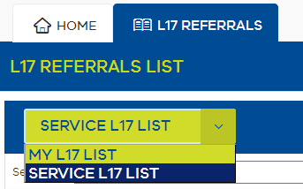

**My L17 List** can also be accessed from the **Homepage**.

## Screen Overview

The **My L17 List** is divided into two sections.

1. **My L17 List** section
2. The **L17 Referral Details** sub-section

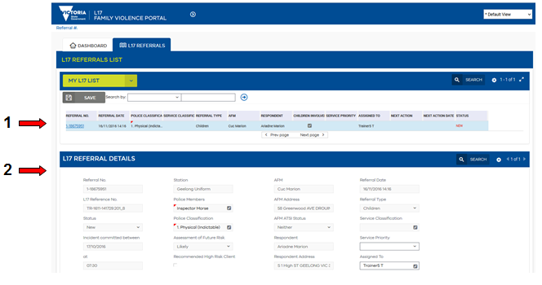

|  |  |
| --- | --- |
| Note  Note icon | **My L17 List can be filtered and customised in the same way as the L17 List.**  The column customisations are specific to each List view. This means that the **My L17 List** and the **L17 List** can have different columns displayed. Once set, **column customisations selected in the previous session will re-appear upon next login** |
| Note  Note icon | **Referrals will appear in a worker’s My L17 List when that referral has been assigned to them. Assigned referrals will still be visible in the Service L17 List.** |

# Assigning & Triaging Functions

|  |  |
| --- | --- |
| Overview | Assigning and Triaging functions include:  **Assigning to** a worker  Entering a **Service Classification**  Entering a **Service Priority**  Entering a **Next Action** and **Next Action Date** |

## Location of assigning & triaging functions

**Assigning** & **triaging** can be completed from three places:

1. The List views (**Service L17 List** & **My L17 List**) where these columns are selected to display



1. The **L17 Referral Details** summary sub-section in the List views

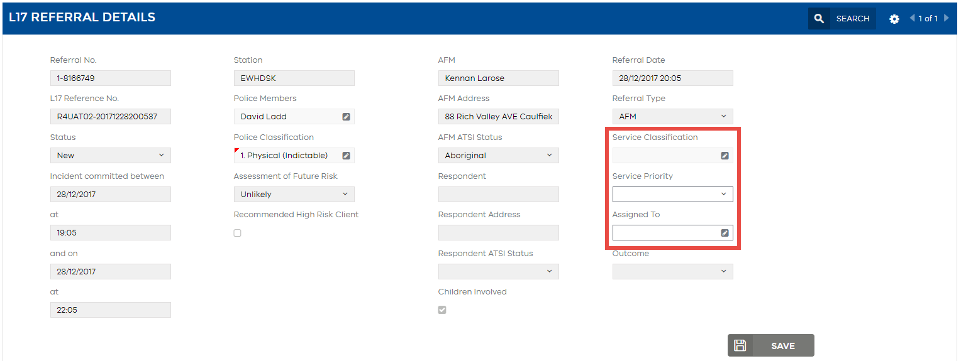

1. The **L17 Record** – **Summary Banner**

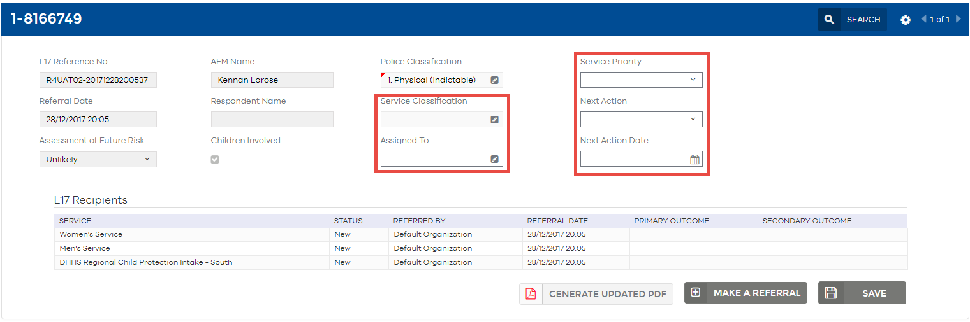

## Assign to a worker

You can assign the referral to a worker within your service. Each service may decide if and how they utilise this feature. Assigned referrals appear in the individual worker’s My L17 List view.

### To assign an L17 using the worker list:

1. Select the Edit pencil icon button in the relevant **Assigned to** field

*Assign Worker window opens*

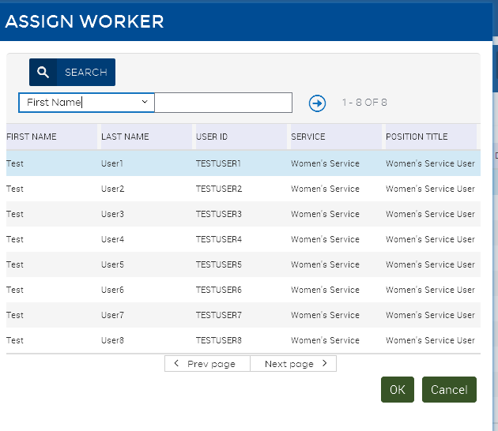

1. Select the worker you wish to assign the referral to. This will contain a list of workers in your organisation.
2. Click OK.
3. Step off to save or alternatively click the Save button.

The referral will now appear in the worker’s **My L17 List**.

|  |  |
| --- | --- |
| Note  Note icon | When working from the **My L17 List**, changing the **Assigned to** field should be the **last action** performed. If the Assigned to field is changed or cleared while still working on the referral, the next action performed will cause the referral to be removed from the users view and the My L17 List, however changes will be saved. To find the referral again a user can search the Service L17 List. |
| Note  Note icon | When a referral is assigned to a Worker, a Team Manager will not be able to restrict the view of the referral to that user. The referral will need to be unassigned before restricting. |
| Reminder  Reminder icon | **When a referral is assigned to a worker, it will not disappear from the Service L17 List view, it will merely be added to the worker’s My L17 List view.**  **Assigning a referral to a worker will not change the status of the record.** |

## Enter a Service Priority

Some services operate with a **Service Priority** rating. This field provides a triage tool with the ability to give the referral a High, Medium or Low priority.

### To assign the referral with a Service Priority:

1. From the L17 List, select the drop down Down arrowbutton in the relevant **Service Priority** field.
2. Choose the **Priority Rating** from the drop-down box.
3. Step off to save or alternatively click the Save button.

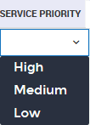

|  |  |
| --- | --- |
| Reminder  Reminder icon | **When a referral is given a Service Priority, the referral Status will change to Triaged.** |

## Enter a Next Action

**Next Action** categories were developed in consultation with service leaders and workers as a way to flag the referral with brief information regarding the Next Action required.

Enter a follow up action in **Next Action** field and **Next Action Date**.

### To enter a Next Action and/or Next Action date:

1. Select the Down arrowbutton in the **Next Action** field.
2. Choose the **Next Action** from the drop-down box.
3. Step off to save or alternatively click the Save button

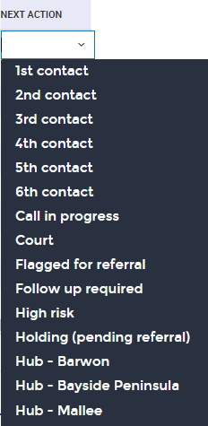

**Next Action Dates** are optional, however are useful for filtering from the L17 List view. For example, the **Next Action** can be used to record the number of contact attempts (e.g. use the “**2nd contact attempt**” option, and **Next Action Date** to indicate that contact is required tomorrow). Use the **Sort** function to sort by date to filter for all actions on the date you selected.

|  |  |
| --- | --- |
| Tip  Tip icon | **When you need to make a referral to a Hub (e.g. you received a referral that is out of your catchment area) however the Hub has received another referral for the same incident and the referral is still open, you will not be able to make a duplicate referral. The Next Action can be used to flag the referral was sent to a Hub. This information will then show when you export the column data. See** Extracts for reporting **for more information.** |

## Enter a Service Classification

In the incident, Victoria Police enters a Police Classification. This classification is read only in the Portal. Some services may wish to enter their own additional family violence classification.

### To enter a Service Classification:

1. Select the pencil icon Edit pencil icon in the relevant **Service Classification** field.

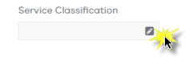

*Service Classification dialogue box appears.*

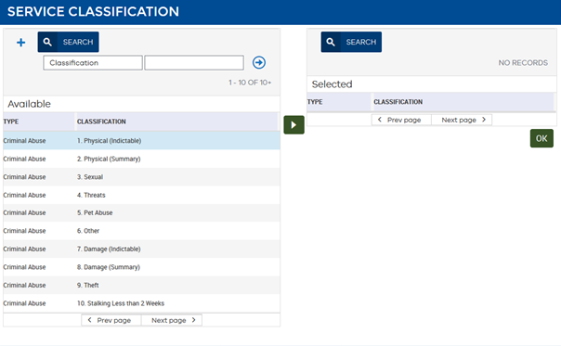

1. From the **Available** section on the left, select the **Classifications** you wish to add to your list view. Use the green right arrow to push the classification over to the **Selected** section on the right.
2. To remove a Classification, select the left arrow to move the Classification back from Selected to Available.

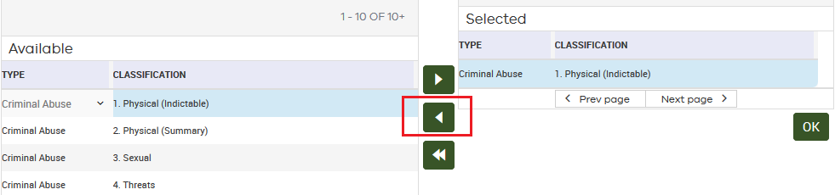

1. Once all relevant Classifications have been selected, click OK.
2. Step off to save or alternatively click the Save button
3. The Service Classifications will be saved in the record you selected. Where there are multiple values, the highest ranked Classification will appear first, with a small red triangle indicating that there is more than one value selected.

Service Classification field showing red triangle, which indicates additional information is available

## Change Records: Updating multiple values in the L17 List at once

From the List View, you can change multiple fields on a referral at once.

### To change multiple fields in a record at once:

1. In the list, highlight the referral you wish to change multiple values for (highlight in blue)



1. From the List view (**My L17 List** or **Service L17 List**), select the Gear (preferences) icon **Preferences** icon

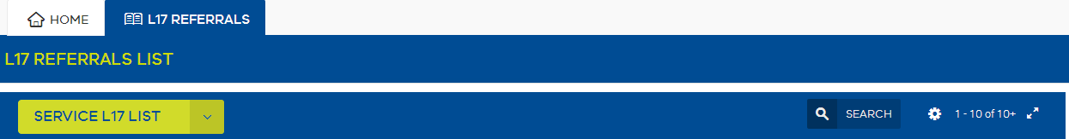

1. Choose **Change Records** from the drop-down list.

***Change Records*** *dialogue box appears.*

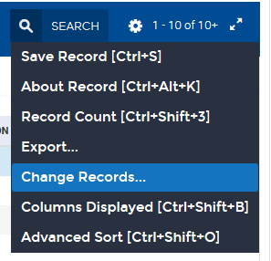Chang records dialogue box, showing sections: 1st field to change, with Field and Value; 2nd field to change, with Field and Value; Third Field to Change, with Field and Value; 4th Field to change, with Field and Value


1. There are four fields that can be changed using the multiple field change function in **Change Records**: **Assigned To**, **Service Priority**, **Next Action** and **Next Action Date.**
2. Select the **1st field** to change from the drop down box, and then enter the value in the **Value** field. The system will search available values and if it finds the value, it will populate the field for the record you have selected.

For example, Select **Assigned To** in the Field, then type a worker’s name in the **Value** field.

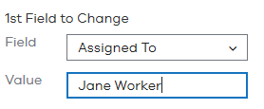

1. Continue for each additional field you wish to change.
2. Select **OK**.
3. Where the system has been able to find the values entered, they will be populated into that L17 Referral.

# Referral Record

|  |  |
| --- | --- |
| Overview | The Referral Record tab is where you can:  View full details of the family violence referral  Referrals can be managed by **triaging** or **assigning** to other workers from this screen  Download the original L17 PDF, or **generate** an updated PDF to download  Enter overall **Actions** as well as recording a **Final Outcome**  View other recipients of a referral |

## Accessing the Referral Record

You can access the **referral record** itself from either the **My L17 List** or **Service L17 List**, using the hyperlinked **Referral number**.

Referral no. hyperlink - screenshot

## Screen Overview

The **Referral Record** tab is divided into two sections with additional sub-tabs:

1. Referral # hyperlink
2. The Summary Banner
3. Referral Record details which contains the following sub-tabs:
   1. Incident Details
   2. Affected Family Member
   3. Children
   4. Respondent
   5. Risk Assessment
   6. Actions & Attachments

The **Referral Record** tab contains the same fields visible in the **L17 List** (and **L17 Referral Details)** view, as well as all remaining information contained in the L17. It is the most complete view of the L17 Referral.

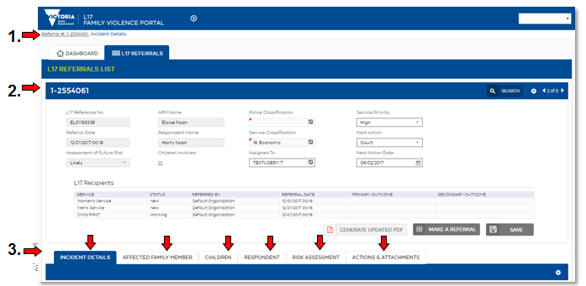

## Information sharing within the Referral Record

Certain fields within the Referral Record are editable. Any changes made to fields in the **AFM**, **Children** or **Respondent** tab will be **visible across all services who have access to that tab**, including Comments and the History (Audit trail). See the Information visibility section for which services are able to see which tabs.

**For example:** if a service identifies that the contact telephone number for the AFM is incorrect, they can update the number. This will then be visible to all other services who have access to that tab (i.e. any other AFM, Children’s or Hub services).

Mobile number field displaying example text entry - screenshot

For information security purposes, services must always enter a comment to explain why it has been changed. When entering comments, services must use the established naming conventions (e.g. “AFM”, “Children” or “Respondent” rather than individual names).

**For example:** Where a service has updated the comments to explain why a number has been changed, they might write: *“AFM has advised that number provided by Victoria Police is linked to Respondent’s business account, and is therefore unsafe to use. Please use the new number provided to contact the AFM”*

## Referral # hyperlink

The Referral # hyperlink allows users to return to the Service L17 List or the My L17 List view, dependant on which list the user entered the referral from, with the same referral highlighted.

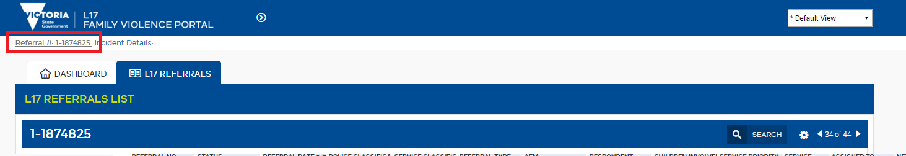

|  |  |
| --- | --- |
| Note  Note icon | If the status is updated while in the L17 referral, when the Referral # hyperlink is clicked to return to the list view, the user will be returned to the list at the new position **according to status.** |
| Tip  Tip icon | **If the status is updated and you wish to return to the original list view at the next record, rather than the same L17 referral you had just updated with a new status, click the arrow in the summary banner** Next record icon **followed by the Referral # hyperlink and you will be returned to your original place in the list.** |

## Summary Banner

The Summary Banner contains:

A snapshot of law enforcement data

Triage & assigning functions, including **Assigned To, Service Classification**, **Service Priority**, **Next Action** & **Next Action Date**

Functions to Generate Updated PDF, Make a Referral and Save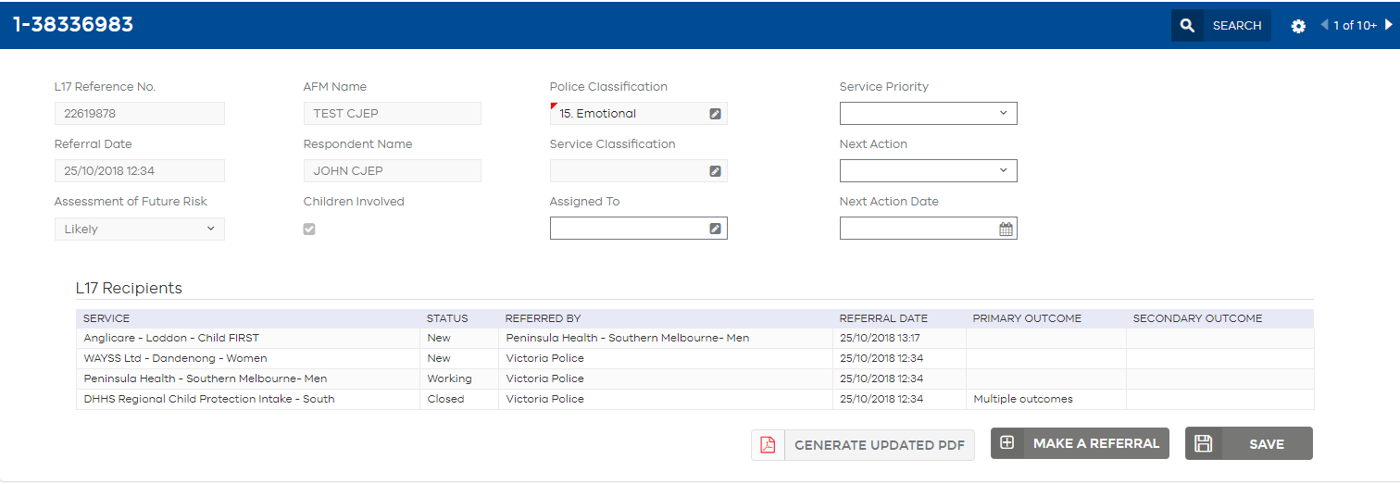

## L17 Recipients Table

The L17 Recipients tables shows all services who have received a referral. It will show who made the referral to that service (Victoria Police in the first instance, or another service where it has been on-referred) and also the **Status** of the referral. See the Referral status section for more information on the meaning of each **Status**. If the **Status** of the referral is **Closed** the L17 Recipients table will also show the **Primary Outcome** and **Secondary Outcome** if applicable.

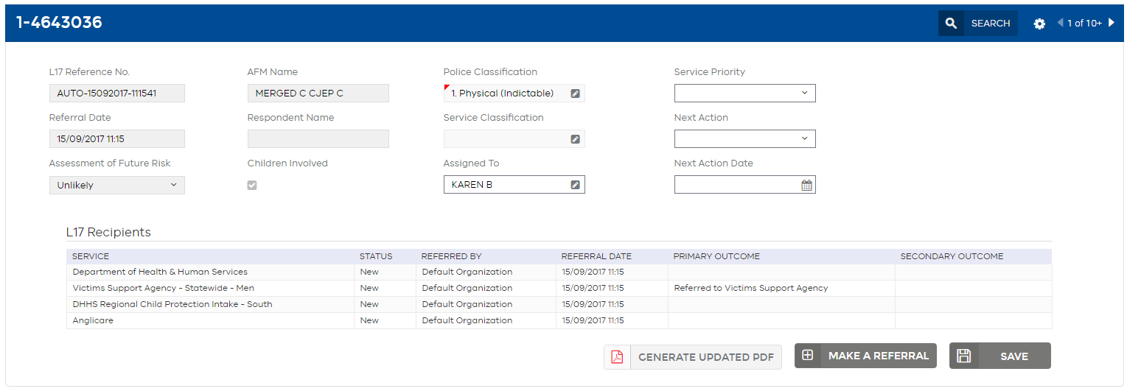

|  |  |
| --- | --- |
| Reminder  Reminder icon | **Where an L17 is Closed, a service may still be working with that client. This simply means that the service has completed their work with the referral.** |

### To refresh the L17 Recipients table:

1. Switch into another tab e.g. Risk Assessment tab. This will refresh the **L17 Recipients table.**

|  |  |
| --- | --- |
| Note  Note icon | Do not perform the ‘Search & Go’ refresh function as this will refresh the list that sits behind the L17 Record, and you will be returned to the first L17 Record on the List (which may be a different client). |

## Make a referral

Services can refer the incident on to other services within the Portal.

*See* *Disclosing information to others* *for more information.*

### To refer the incident to another service:

1. Identify the referral type/s required
2. Click the **Make A Referral** button Make a Referral icon

***Make a Referral*** *dialogue box displays.*

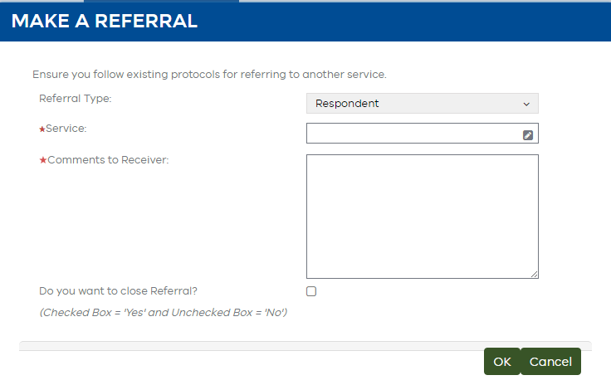

1. Select the ‘Referral type’ required. The referral type you select should always refer to the role of the ‘primary person’ you are referring. This can be determined by the tab.

For example, if you want to refer an AFM, an ‘AFM’ referral type should be selected. This still applies if the AFM is a child, the ‘AFM’ referral type should be selected as that is the role of the child.

If you have received an AFM referral, however wish to refer the children listed in the Children tab ‘Children’ referral type should be selected.

**Reminder** - If no children are listed within the incident, always add a child before making a ‘Children’ referral – even if this means adding ‘Unknown’ ‘Unknown’ as the child’s name.

#### Respondent services - If you have received a ‘Respondent’ referral, however wish to refer the children involved, you will now be able to select ‘Children’ referral type to make the referral. You will be able to identify if police have listed the children involved through the ‘Children Involved’ checkbox.

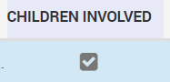

**Clients who are misidentified** - If you receive a ‘Respondent’ referral and believe your client has been misidentified, the ‘Respondent’ referral type must still be selected when referring on. In order to notify the new service you believe your client has been misidentified tick the ‘Identified as AFM’ check box in the ‘Respondent’ tab and make a comment.

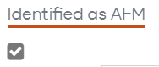

If you receive an ‘AFM’ referral and believe your client has been misidentified, the ‘AFM’ referral type must still be selected when referring on. In order to notify the new service you believe your client has been misidentified tick the ‘Identified as Respondent’ check box in the ‘AFM’ tab and make a comment.

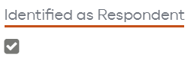

**Note -** Ticking the ‘Identified as …’ check box will not change who is listed within the relevant tabs, the referral should continue to be made based on the person listed within the tab even if you/your service believes the client has been misidentified.

1. Type in the name of the service you wish to refer to and select Tab on the keyboard.
2. Alternatively, click the edit Edit pencil icon button to search.

***Pick Service*** *box displays.*

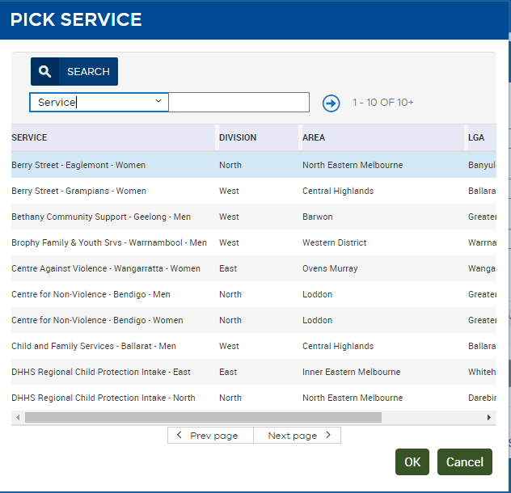

1. Use the drop-down box to select the field you would like to search by: **Service**, **Division, Area** or **LGA**. Then type any keywords in the search field, and select Go Go icon. Note that searches in the Make a Referral box are **case sensitive**. This will return a list of services (search results display in the table).
2. Alternatively, you can browse through services using the **Prev page** and **Next page** buttons.
3. Select the correct service and click **OK**.
4. You must complete **Comments to Receiver**. This can be used to explain to the receiving service why you are making the referral or what actions you have taken. Your comments will appear in the receiving service’s **Actions** section. Your comments will also appear as a note in your referral **Actions** section.
5. Click **OK** - the referral will be made to your selected service. Your referral will remain open and you can continue to work on the referral. To make multiple referrals repeat this process without closing the referral.

*The L17 recipients table in the summary banner will update with details of the new referral/s.*

The receiving service will be able to view the relevant tabs for the type of referral you have selected:

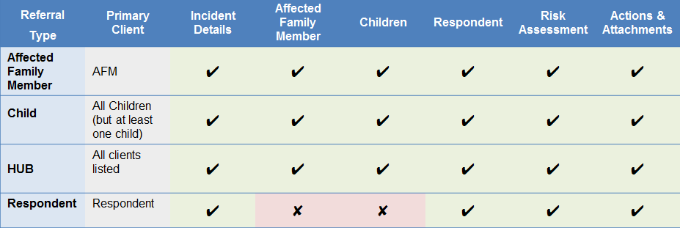

1. ***Alternatively*** you may wish to enter a client outcome. You can select the checkbox “Do you want to close the Referral?”

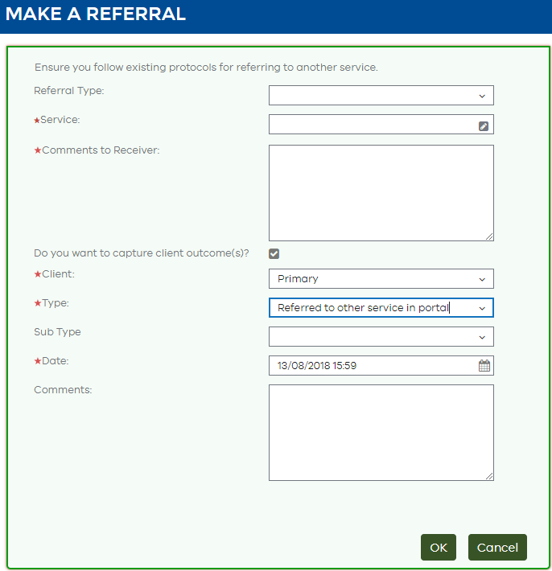

1. The **Make a Referral** section will expand to allow a **Client Outcome** to be entered**.** Complete this section to enter an outcome. Refer to Referral Outcomes for more information about the new changes to outcomes, and how to enter a client level outcome.

|  |  |
| --- | --- |
| Tip  Tip icon | If you have completed all required actions in relation to the referral and wish to close the referral, and if the outcome is the same for all primary clients, select ‘primary’ clients in the ‘Client’ dropdown to quickly enter an outcome for primary clients. An action of Final Outcome for each primary client will automatically be created in the **Actions** section. |
| Note  Note icon | **The system will automatically populate the field if you search for a Service and it only finds one matching result.** |
| Note  Note icon | **Making a Referral will change the status of the referral to Working.**  **Entering an outcome for all primary clients via Make a Referral will change the status of the referral to Closed.** |
| Note  Note icon | “Referred to other service in Portal” is the default entry type when closing a referral through the **Make a Referral** process. This can be changed to any other primary/secondary **Outcome**. |

### Duplicate referrals

Where a service already has an open referral of that type, the Portal will not allow another referral of the same type to be sent to that service.

A warning pop-up will appear if an attempt is made.

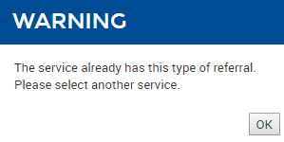

|  |  |
| --- | --- |
| Note  Note icon | As Hubs receive all referrals as ‘HUB’ referral type, if a Hub has an open referral for that incident, you will not be able to make another referral to the Hub, regardless of who you are making the referral for.  You will need to on-refer to the Hub via alternative means outside the Portal.  Do not assume that as the Hub has already received the ‘HUB’ referral they are working with all persons listed in the referral. |

### Children referrals

Children outcomes are required for services receiving a child referral. Before making a referral, children must now be listed in the children tab. A prompt will be displayed when attempting to make a referral where children are not recorded.

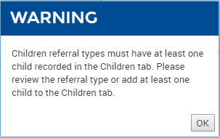

See page 64, To add children, on how to add children

## Generate Updated PDF

Use the **Generate Updated PDF button** to capture a PDF version of the entire record including all updates made by services.

Generate Updated PDF icon

Some services may add this to a client file or case management system.

The generated PDF will appear in the **Actions & Attachments tab**, in the **Attachments** section. See Attachments section, for more information.

## Incident Details tab

### Incident section

This subtab provides read only information from the Police about the incident. Details include time, date and location of incident, and the **Case Progress Narrative** from Police.

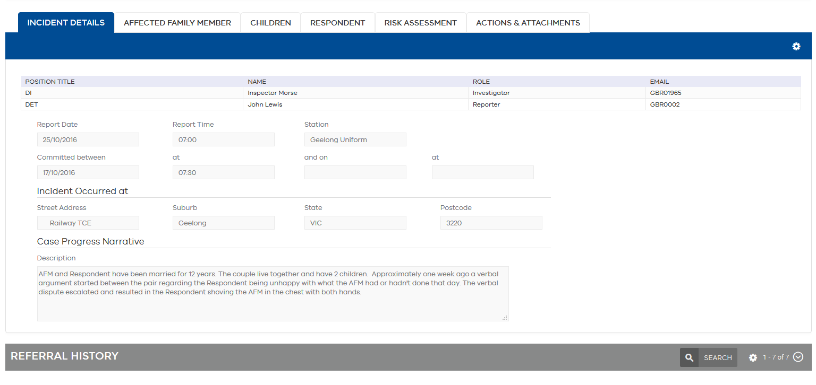

|  |  |
| --- | --- |
| Note  Note icon | **Any text in the Portal, including the Case Progress Narrative, can be copied and pasted into a service’s own case management system if required, using CTRL+C on the keyboard or the browser menu, or by dragging and dropping the text to another screen.** |

### Referral History section

The Referral History is read only and shows all changes that have been made to the overall Referral (e.g. changes to status, assigning and triaging functions). When an editable field is updated a new audit trail record is created. Each record will display both the previous value and new value. By default the Referral History section will be collapsed.

#### To see the Referral History:

1. Click the Down arrow icon button.
2. A history of changes made to the Referral will be displayed with the most recent changes displayed at the top of the list.
3. You may need to refresh the History to see the latest changes by using Field search icon & Go icon.

## Affected Family Member (AFM) tab

### Affected Family Member (AFM) section

The first section contains the AFM details. Most fields are editable, however some fields are non-editable, including:

* AFM Name
* System generated unique client identifier
* Related Incident Count- where applicable will be displayed for each client on the referral. Where the count is 0, the field will not be displayed. The count is calculated based on the number of previous related incidents present in the L17 portal, this is not a field sent by Victoria Police. An example of how the count is calculated:
  + First incident – **Related Incident Count** will not be displayed
  + Second incident – **Related Incident Count** = 1
  + Third incident – **Related Incident Count** = 2.
* Age
* Attitude to referral
* Language
* Ethnic appearance
* Date of Birth- Victoria Police will always send a year, but may not always send day and month. When an incomplete date of birth is sent by Victoria Police the Portal will automatically populate the missing fields with 01 and tick the DOB Unconfirmed Flag. For example if Victoria Police send only the year 1990, the Portal will automatically populate the missing fields and the date of birth will appear as 01/01/1990. The date of birth received by Victoria Police will be visible in the Original L17 PDF e.g. //1990. The date of birth as populated by the Portal will be visable in the Updated PDF e.g. 01/01/1990.

Rules for editable fields include:

* Also Known As- allows one Alias or name correction to be entered.
* Telephone- do not use spaces when entering telephone numbers
* Address and temporary address, and option to withhold address for safety reasons
* There is also an option to tick that the AFM has been **Identified as Respondent**, in cases where the worker has determined that in their professional opinion, the client was misidentified as the victim in this incident where they were in fact the person using violence. This does not then enable any additional functionality in the Portal; it is for information purposes only.

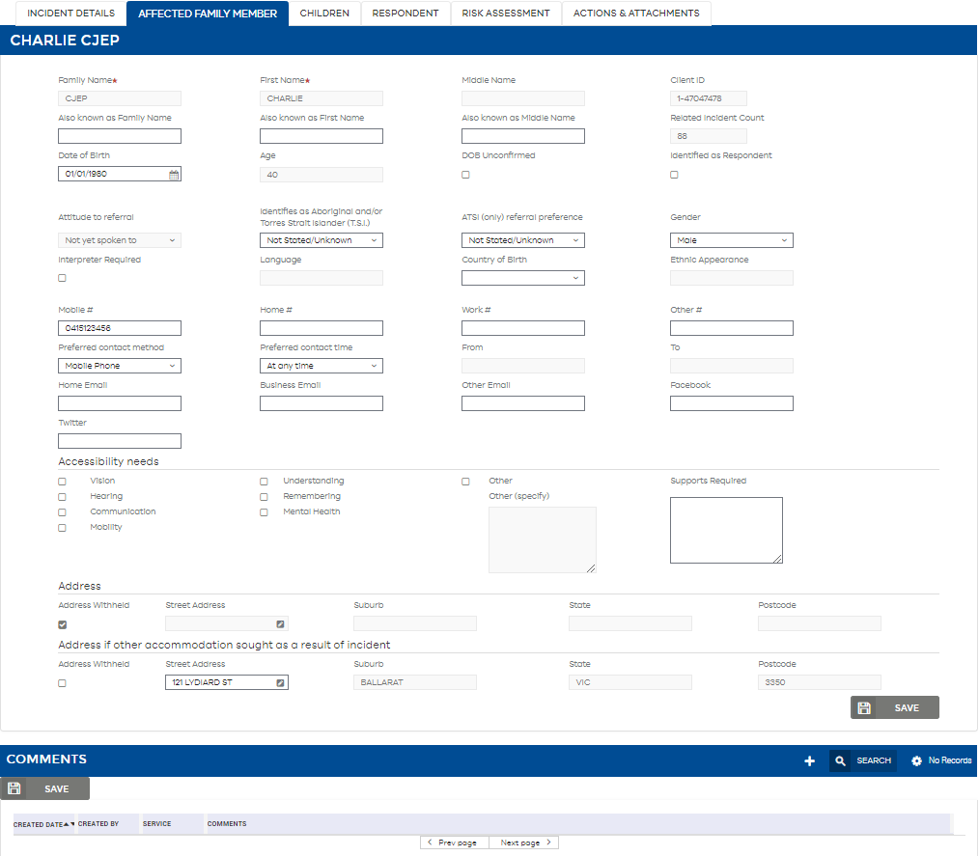

|  |  |
| --- | --- |
| Note  Note icon | Use the Save button as an alternative to the Step Off function if desired. It will turn grey once saved**.** |
| Note  Note icon | Any changes made to fields should be accompanied by a comment to explain the change. |

### Comments section

This section is only to be used to add safety and/or contact related notes (e.g. “Please only contact using mobile number”). This section is not for detailed case notes.

#### To add a comment:

1. Click the Add icon button.
2. Enter your comment in the comments box.
3. Step off to save or alternatively click the Save button.

|  |  |
| --- | --- |
| Reminder  Reminder icon | Never refer to individuals on other tabs by name in this system since the data can be viewed by other services. It is a good idea to follow the police protocol when referring to individuals e.g. use the terms “AFM”, “Respondent” or “Child” |
| Tip  Tip icon | **If you start to make a Comment and wish to un-do the Comment, simply select Esc on the keyboard and it will cancel the action.** |

### AFM History section

The AFM History is read only and shows all changes that have taken place in this subtab only. When an editable field is updated a new audit trail record is created. Each record will display both the previous value and new value. By default the AFM History section will be collapsed.

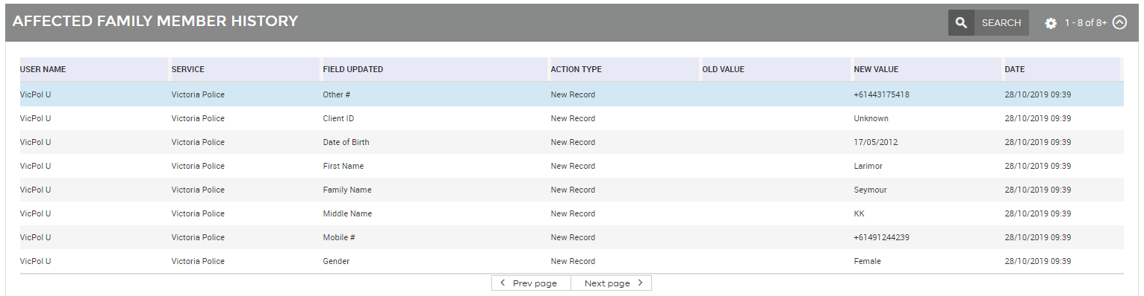

#### To see the AFM History:

1. Click the Down arrow icon button.
2. A history of changes made in this subtab will be displayed with the most recent changes displayed at the top of the list.
3. You may need to refresh the History to see the latest changes by using Field serach icon & Go icon

|  |  |
| --- | --- |
| Note  Note icon | **Making changes or adding comments on the AFM tab will change the status of the Referral to Working.** |

## Children tab

### Children section

The first section lists any children Victoria Police have identified who normally or regularly reside, or have regular contact with either party and who have been present at / witness to / exposed to / or otherwise affected by family violence. It also enables you to select between each of the children involved in the incident, allowing you to view their full details within the tab separately from each other.

The list section contains details of Children in table format with the following fields:

* Removed by Police – A field that indicates Victoria Police have notified this child was not affected by this incident
* Name
* Client ID – A system generated unique client identifier
* Date of Birth, Date of Birth Unconfirmed Flag and Age
* Related Incident
* Whether child was present at incident
* Gender
* ATSI descent
* Where the Child normally resides
* Also Known As (allows one Alias or name correction to be entered) – hidden by default

|  |  |
| --- | --- |
| Note  Note icon | **Removed by Police will not be received by the portal until updates are sent by Victoria Police. This field is available in preparation for this to occur.**  **Related Incident Count** where applicable will be displayed for each client on the referral. Where the count is 0, the field will not be displayed. The count is calculated based on the number of previous related incidents present in the L17 portal, this is not a field sent by Victoria Police. An example of how the count is calculated:   * First incident – **Related Incident Count** will not be displayed * Second incident – **Related Incident Count** = 1 * Third incident – **Related Incident Count** = 2. |

The second section provides the expanded details of the child selected in the first section. These detials include detailed contact information, as well as address and alternative address details. Boxes which are not greyed out allow the user to update the information.

Most fields are editable, excluding;

* Name
* Client ID

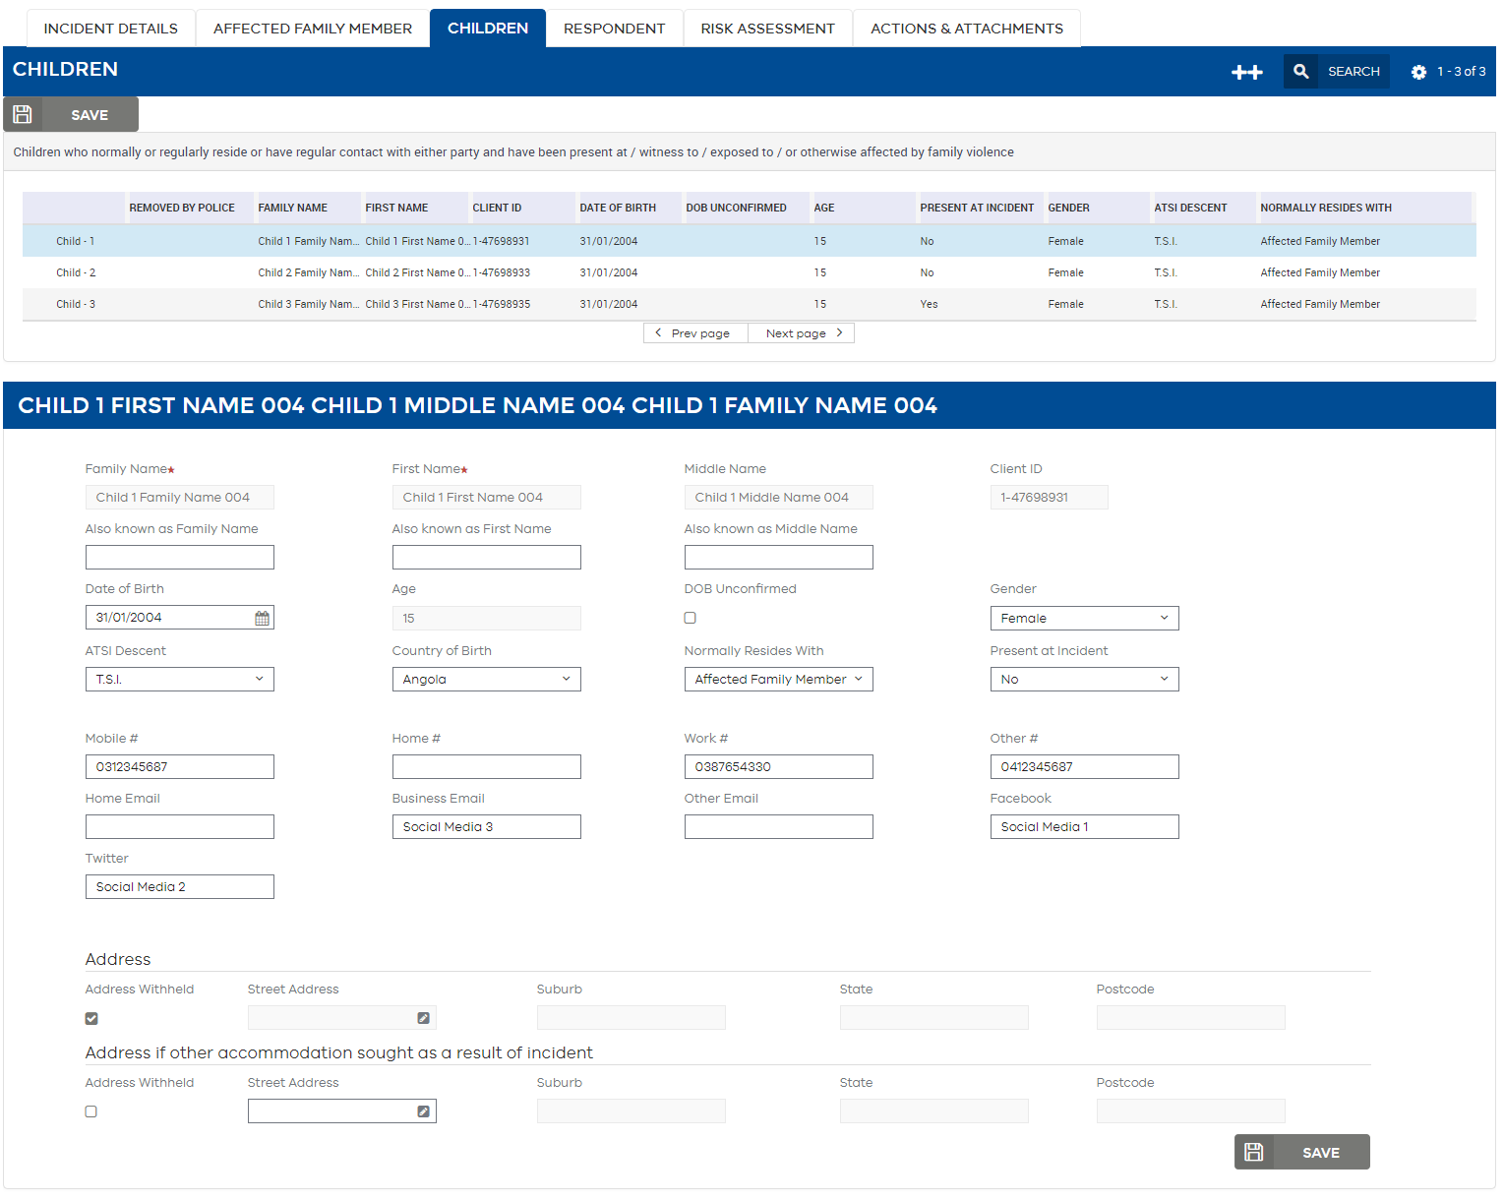

|  |  |
| --- | --- |
| Reminder  Reminder icon | Use the Save button as an additional alternative to the Step Off function if desired. It will turn grey once saved**.** |

Children can also be added by services where additional child/ren have been identified who normally or regularly reside, or have regular contact with either party and who have been present at / witness to / exposed to / or otherwise affected by family violence.

#### To add children:

1. Click the button.



1. Enter the relevant details.
2. Step off to save or alternatively click the Save button.

|  |  |
| --- | --- |
| Tip  Tip icon | **If you start to add a new child and wish to un-do the added child, simply select Esc on the keyboard and it will cancel the action.** |
| Tip  Tip icon | To indicate **Unborn Children:** Enter the word “**unborn**” in both the **First name** and **surname** fields with no date of birth. You can add the expected due date in the comments for the unborn child and tick the DOB unconfirmed check-box. |

### Comments section

This section can be used to add notes about the child/ren. It is only to be used to add safety and/or contact related notes. This section is not for detailed case notes.

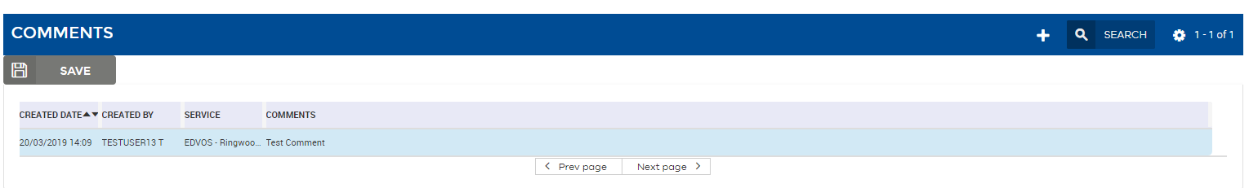

Where there are multiple children involved, you will need to select (highlight in blue) the child’s name from the **Children section** to display comments relevant to that child only.

If you have added a child, you will need to refresh Field search icon& Go icon the **Children section** before you can enter **Comments** about the new child.

#### To add a comment:

1. Click the add iconbutton.
2. Enter your comment in the comments box.
3. Step off to save or alternatively click the Save button.

|  |  |
| --- | --- |
| Reminder  Reminder icon | Never refer to individuals on other tabs by name in this system since the data can be viewed by other services. It is a good idea to follow the police protocol when referring to individuals e.g. use the terms “AFM”, “Respondent” or “Child” |
| Reminder  Reminder icon | The Children tab is made up of three sections being the Children, Comments and Child History sections. Ensure you perform the ‘Search and Go’ refresh function in the correct section where required. |
| Tip  Tip icon | **If you start to make a Comment and wish to un-do the Comment, simply select Esc on the keyboard and it will cancel the action.** |

### Child History section

The Child History is read only and shows all changes that have taken place in this subtab only. When an editable field is updated a new audit trail record is created. Each record will display both the previous value and new value. By default, the Child History section will be collapsed.

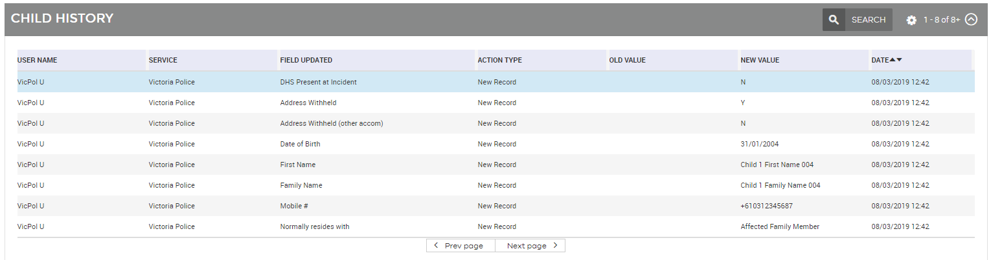

#### To see the Child History:

1. Select the child you would like to see the Child History for from the first section (this can be done in any order e.g. after the Child History has been expanded).
2. Click the Down arrow icon button.
3. A history of changes made in this subtab for the selected child will be displayed with the most recent changes displayed at the top of the list.
4. You may need to refresh the History to see the latest changes by using Field search icon & Go icon.

|  |  |
| --- | --- |
| Note  Note icon | **Making changes, adding children or adding comments on the Children tab will change the status of the referral to Working.** |

## Respondent tab

### Respondent section

The first section contains the Respondent details. Most fields are editable, however some fields are non-editable including:

* Respondent Name
* System generated unique identifier
* Related Incident Count- where applicable will be displayed for each client on the referral. Where the count is 0, the field will not be displayed. The count is calculated based on the number of previous related incidents present in the L17 portal, this is not a field sent by Victoria Police. An example of how the count is calculated:
* First incident – **Related Incident Count** will not be displayed
* Second incident – **Related Incident Count** = 1
* Third incident – **Related Incident Count = 2.**
* Age
* Attitidue to referral
* Lannguage
* Ethnic appearance
* Date of Birth- Victoria Police will always send a year, but may not always send day and month. When an incomplete date of birth is sent by Victoria Police the Portal will automatically populate the missing fields with 01 and tick the DOB Unconfirmed Flag. For example if Victoria Police send only the year 1990, the Portal will automatically populate the missing fields and the date of birth will appear as 01/01/1990. The date of birth received by Victoria Police will be visible in the Original L17 PDF e.g. //1990. The date of birth as populated by the Portal will be visable in the Updated PDF e.g. 01/01/1990.

Rules for editable fields include:

* Also Known As (allows one Alias or name correction to be entered)
* Telephone- do not use spaces when entering telephone numbersAddress and temporary address, and option to withhold address for safety reasons
* There is also an option to tick that the Respondent has been **Identified as AFM**, in cases where the worker has determined that in their professional opinion, the client was mis-identified as the primary aggressor in this incident where they are in fact experiencing violence themselves. This does not then enable any additional functionality in the Portal; it is for information purposes only.

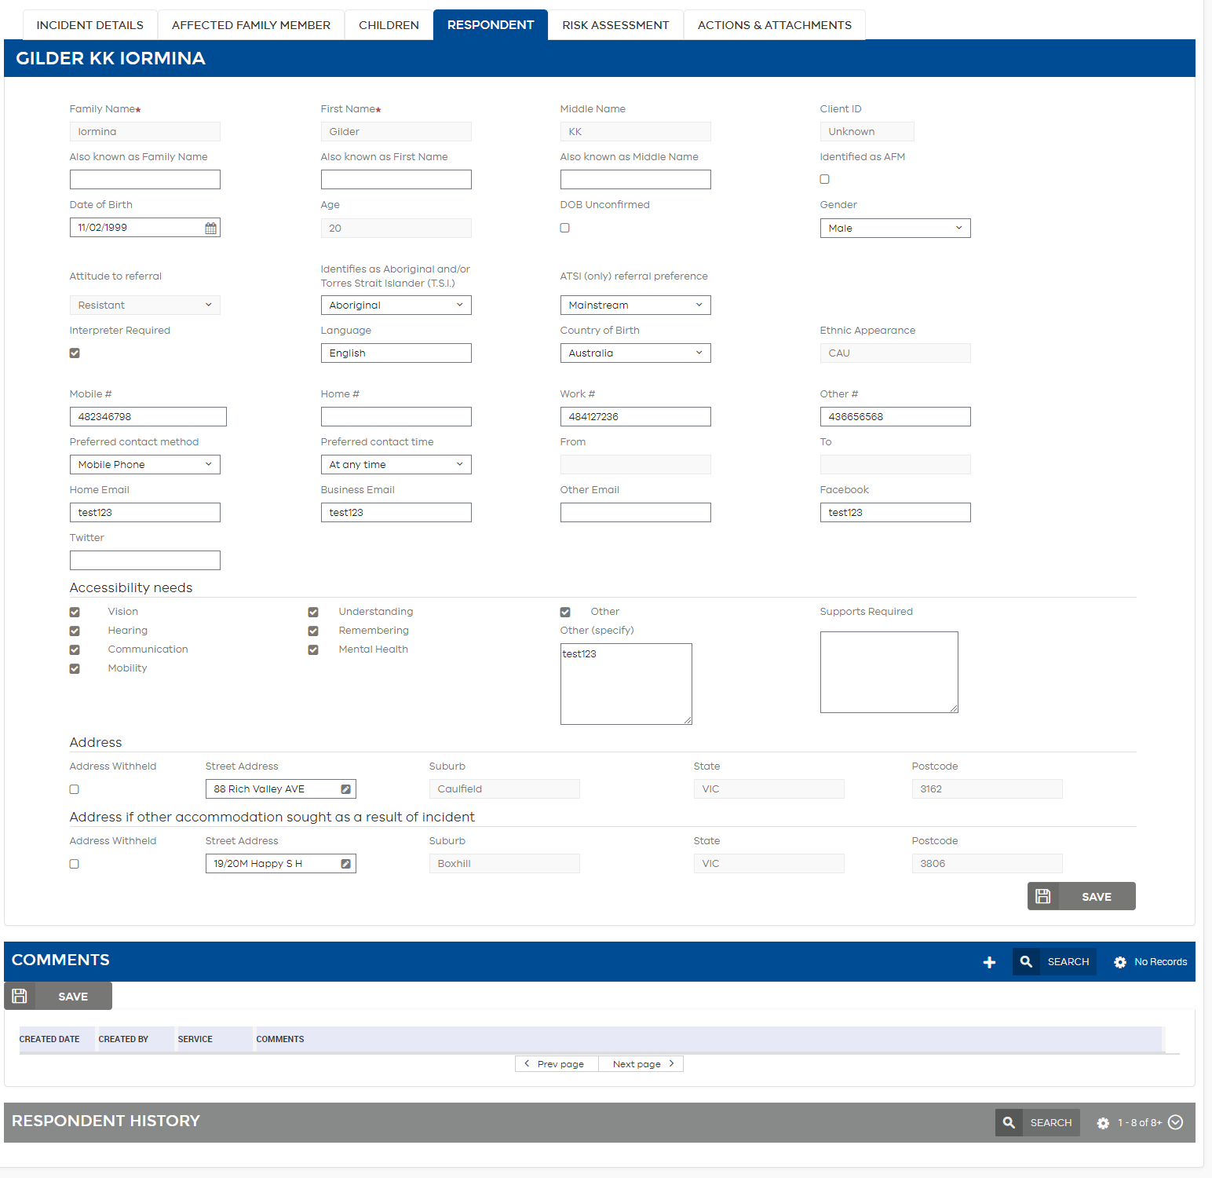

|  |  |
| --- | --- |
| Reminder  Reminder icon | Use the Save button as an additional alternative to the Step Off function if desired. It will turn grey once saved**.** |

### Comments section

This section is only to be used to add safety and/or contact related notes (e.g. “Please only contact using mobile number”). This section is not for detailed case notes.

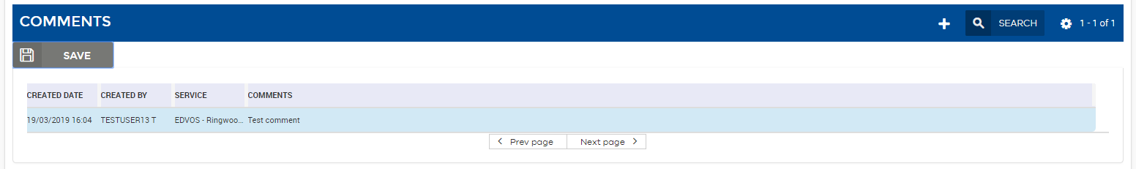

#### To add a comment:

1. Click the Add icon button.
2. Enter your comment in the comments box.
3. Step off to save or alternatively click the Save button.

|  |  |
| --- | --- |
| Reminder  Reminder icon | Never refer to individuals on other tabs by name in this system since the data can be viewed by other services. It is a good idea to follow the police protocol when referring to individuals e.g. use the terms; “AFM”, “Respondent” or “Child” |
| Tip  Tip icon | **If you start to make a Comment and wish to un-do the Comment, simply select Esc on the keyboard and it will cancel the action.** |

### Respondent History

The Respondent History is read only and shows all changes that have taken place in this subtab only. When an editable field is updated a new audit trail record is created. Each record will display both the previous value and new value. By default the Respondent History section will be collapsed.

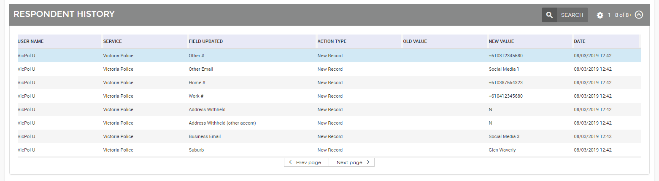

#### To see the Respondent History:

1. Click the Down arrow icon button.
2. A history of changes made in this subtab will be displayed with the most recent changes displayed at the top of the list.
3. You may need to refresh the History to see the latest changes by using Field search icon & go icon.

|  |  |
| --- | --- |
| Note  Note icon | **Making changes or adding comments on the Respondent tab will change the status of the referral to Working.** |

## Risk Assessment tab

**IMPORTANT:**

Over time Victoria Police Risk Assessment forms have changed as a result, the portal may display multiple versions of the Victoria Police risk assessment, depending on the date received and area it was sent.

The below section will cover both versions of the risk assessment that the user may access. The first will be the risk assessment used between December 2016 and June 2019. Below this will be the details of the updated risk assessment.

This tab provides read only information from the Police about the Risk Factors identified, court information and actions taken to manage risks.

* **Police classification:** details include Police classification, AFM/Respondent relationship, whether Police have spoken to the Respondent/Other Party about the current incident, any intervention orders, and risk of future violence.
* **Court information**: details listed include upcoming Civil or Criminal court dates, and Interpreter information for AFM and Respondent
* **Risk vulnerability and other factors:** this includes the pre-existing checkboxes for risks relating to the Respondent including Respondent mental health. Other information may include details of any weapons present, AFM mental health and substance use, and whether Respondent usually resides with AFM.
* **History of violence:** provides information regarding the types of and frequency of violent behaviour.
* **Risk management strategy:** shows actions taken to protect AFM including Criminal, Civil (including whether a FVSN has been placed), Referral Action or Other Action.

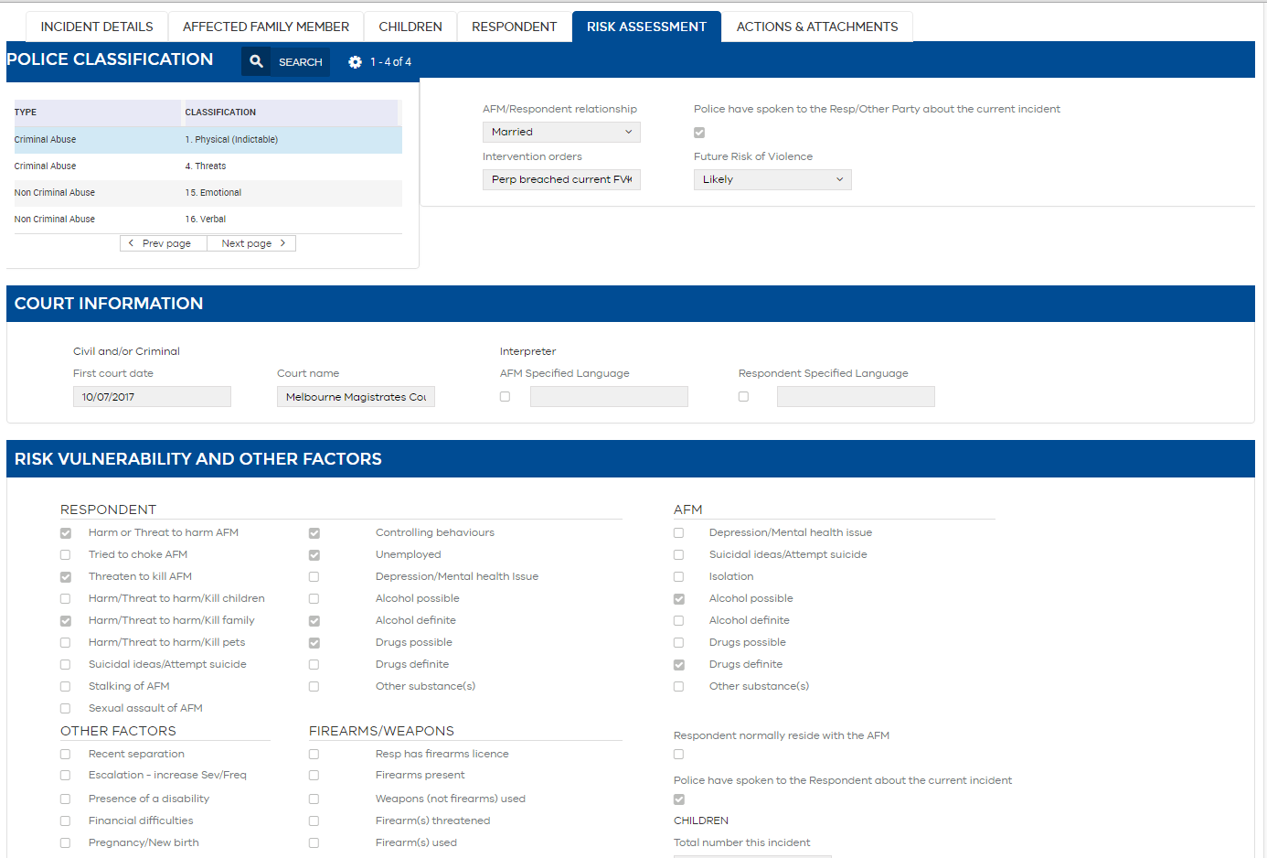

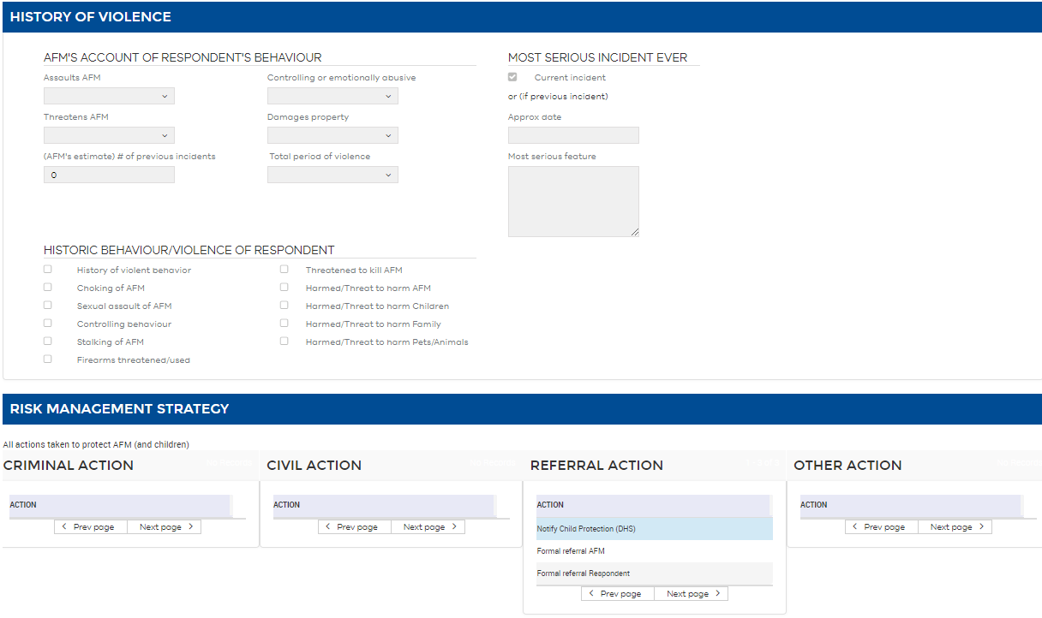

**IMPORTANT:**

The below section relates to the updated risk assessment, which was used in some areas from April 2019 and statewide from June 2019.

* **Police classification:** details include Police classification, and the Police classification history.

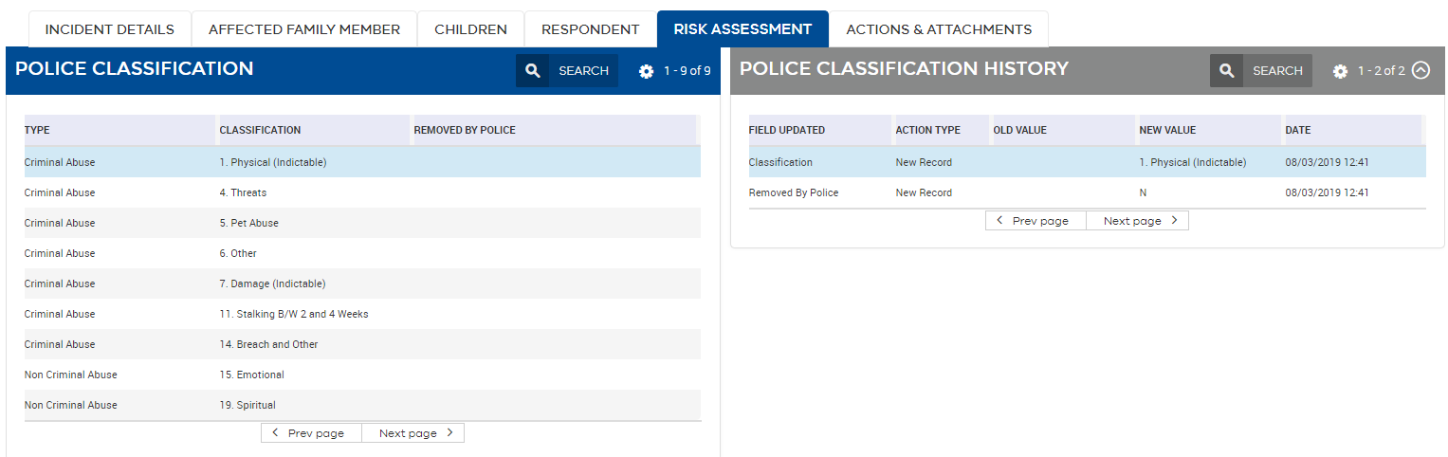

* **Court information**: details listed include upcoming Civil or Criminal court dates.

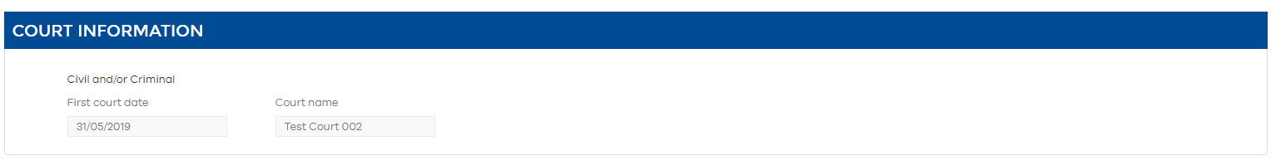

* **Other factors:** this includes the AFM and Respondent relationship status, alternative residence after incident (if not current address), notifications of firearms or weapons present, and an indication of if Police have communicated with the Respondent.

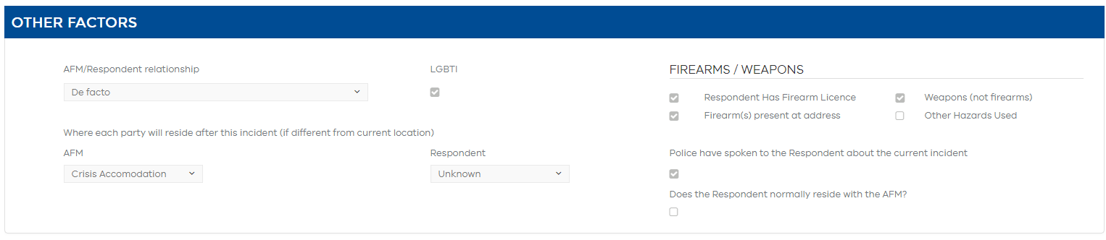

* **Victoria Police risk assessment:** this presents the scoring given to this incident by Victoria Police, as well as an indication of if the score had been overridden by a member to send to the Victoria Police Family Violence Intervention Unit.

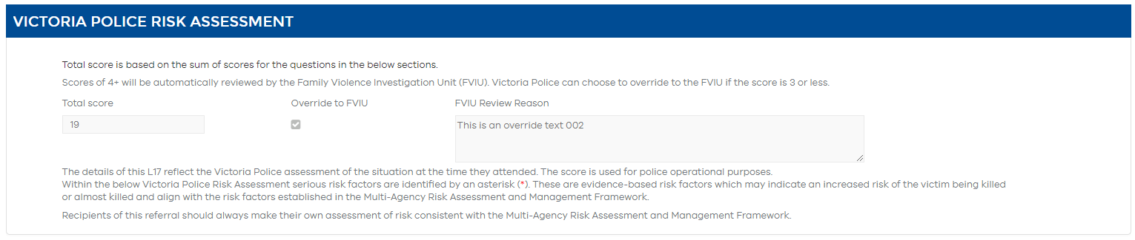

* **Court information/Other factors/Victoria Police risk assessment history:** this details the history of changes made to the above sections through updates sent by Victoria Police.

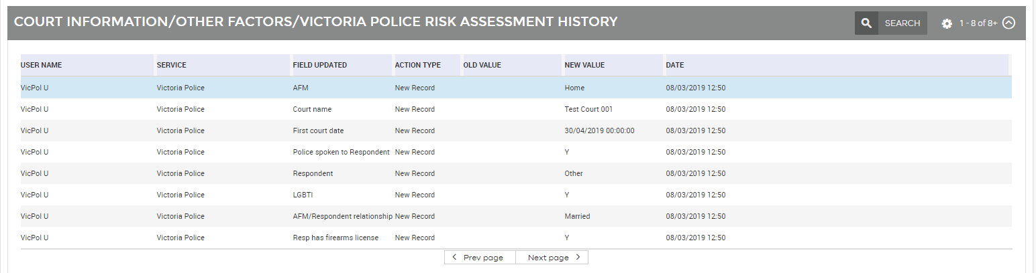

|  |  |
| --- | --- |
| Note  Note icon | The next few sections cover the questions which contribute to the Victoria Police risk assessment score. The scoring is evaluated from interviews and/or observations of the AFM, Respondent or relevant parties made by Victoria Police. |

|  |  |
| --- | --- |
| Note  Note icon | Each of the below sections is followed by related History sections, depicting the changes made to each of the relevant fields. The history sections are included in the below screen captures. |

* **Information about family violence:** this includes 14 questions relating to the possible presence of family violence.

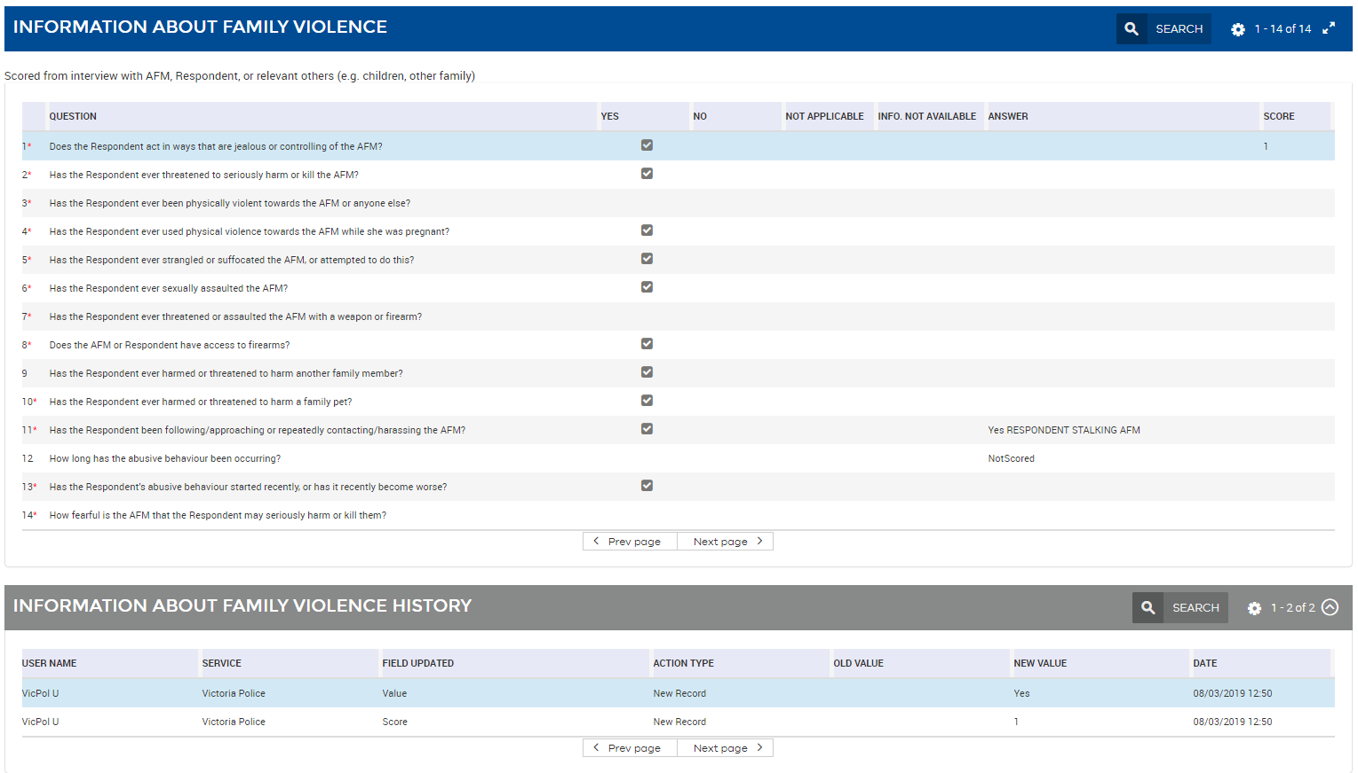

* **Information about involved children:** this includes questions 15 to 21 which relate to the potential involvement of children in this incident or acts of family violence.

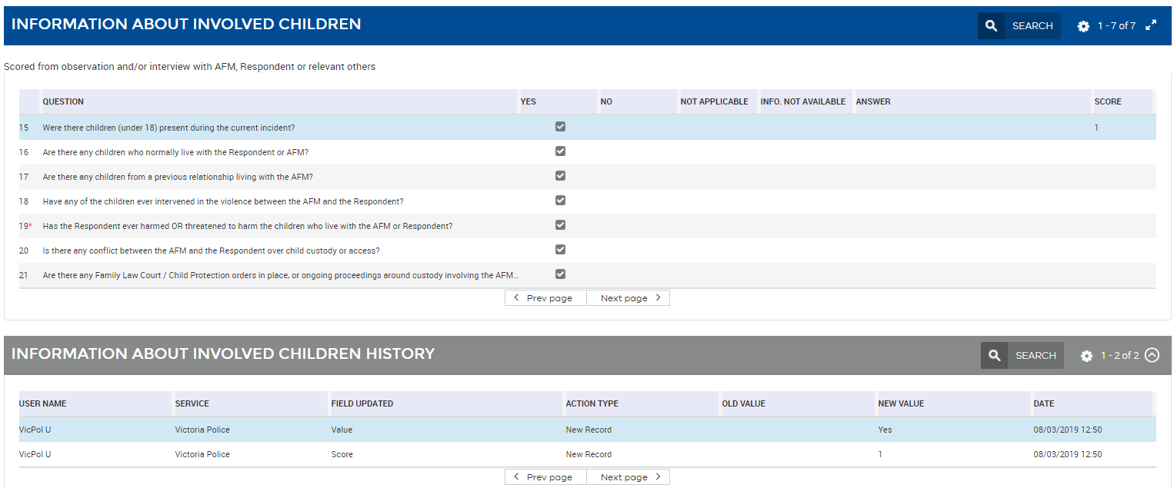

|  |  |
| --- | --- |
| Note  Note icon | If the answer to question 16 is “NO” question 17 to 21 are not asked and will not appear in the risk assessment. |

* **Information about the relationship and Respondent background:** this includes questions 22 to 28 relating to the relationship background of the AFM and Respondent.

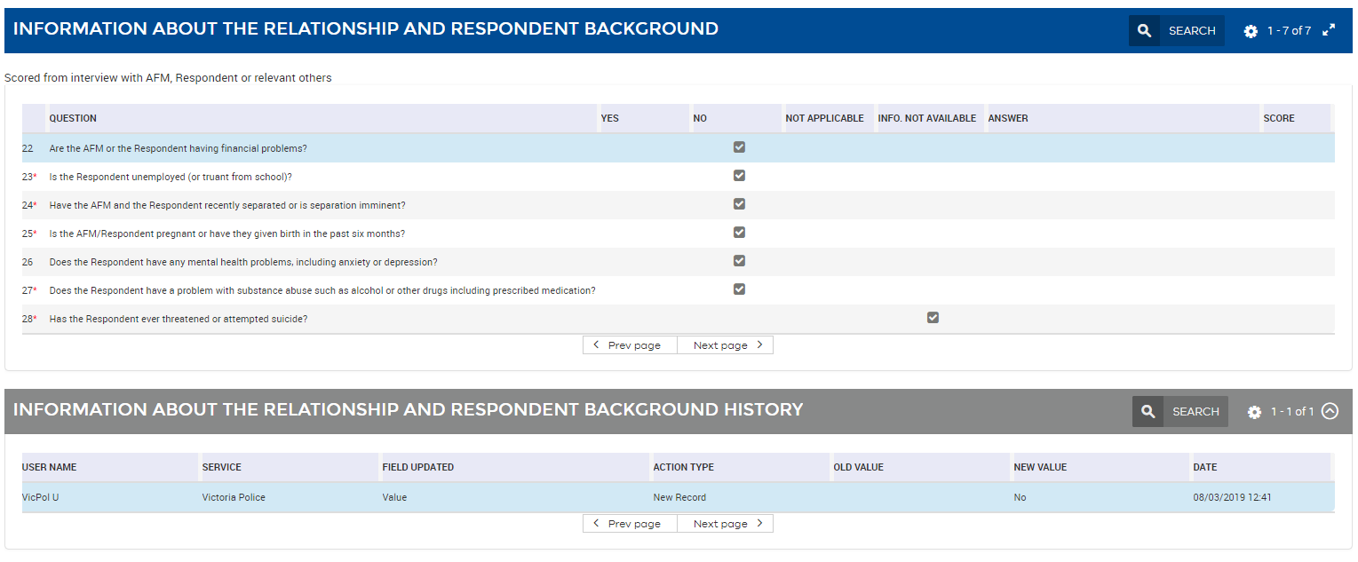

* **Information about drug and alcohol use:** this includes questions 29 and 30 relating to possible drug and alcohol use by the AFM, Respondent or relevant parties.

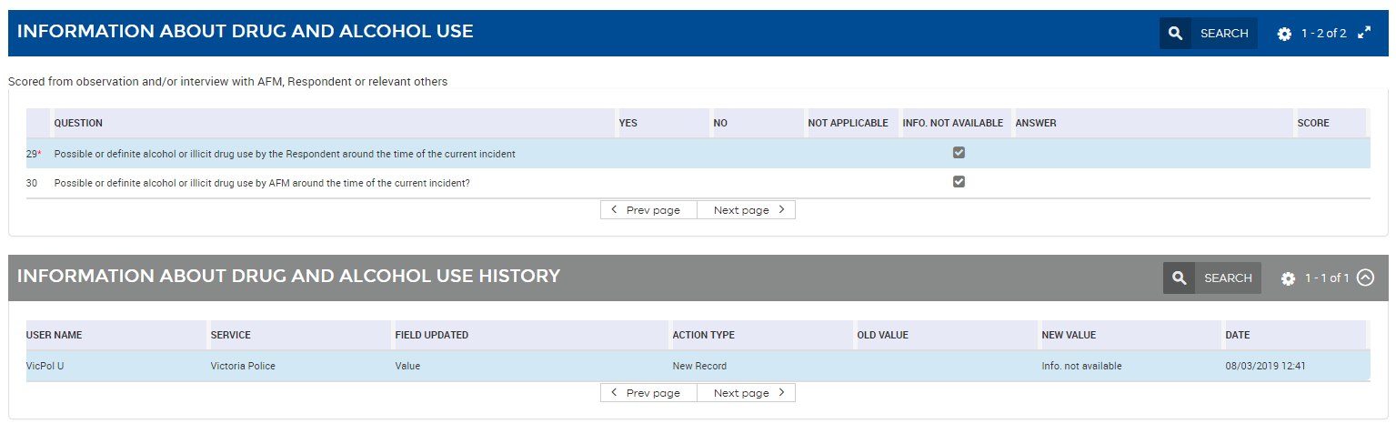

* **Information about AFM background:** this includes questions 31 to 34, relating to the background of the AFM. This is scored **ONLY** from the interview with the AFM.

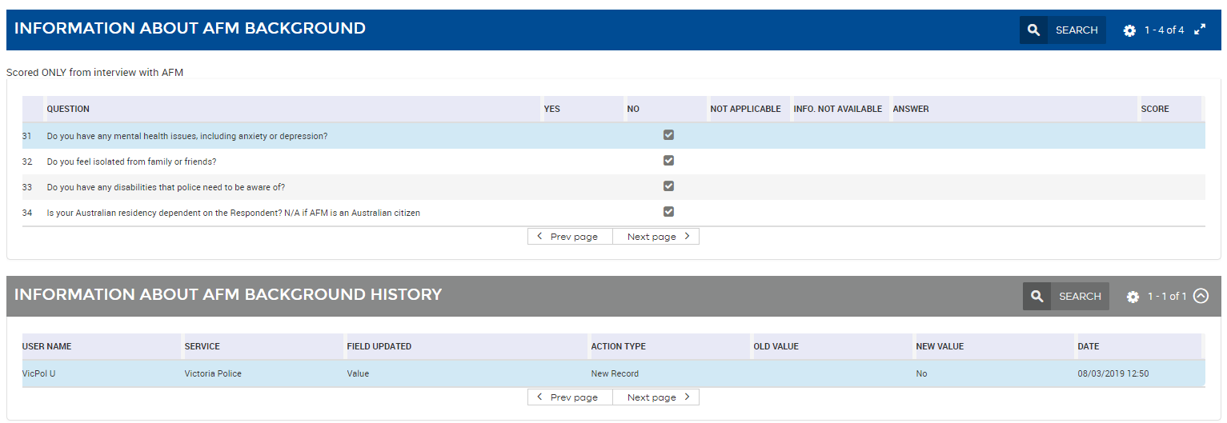

* **Information from LEAP:** this includes questions 35 to 39 (the last of the scored questions).



* **Risk management strategy:** this includes details of both civil and criminal actions taken to protect the AFM and any involved children.

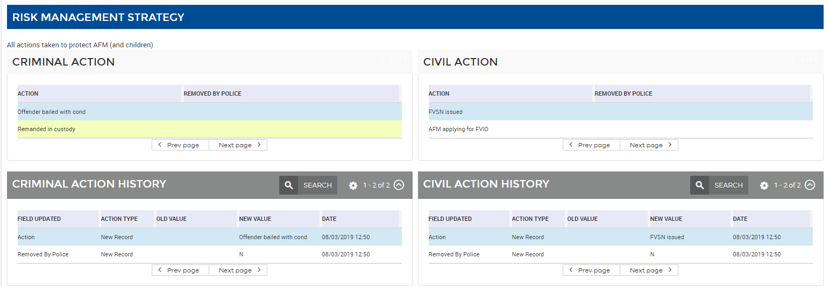

* **Referral action & Other action:** this depicts referral actions made by Victoria Police, as well as any additional non-referral actions made, such as weapons seized, or Firearm/s licence revoked.

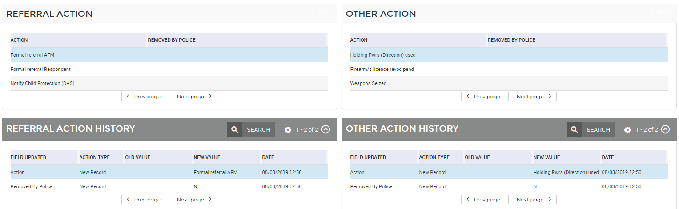

|  |  |
| --- | --- |
| Note  Note icon | **Removed by Police will not be received by the portal until updates are sent by Victoria Police. This field is available in preparation for this to occur.** |

Table 7: Referral Action Definitions

| Available fields for L17 list | Field content |
| --- | --- |
| Formal Referral AFM | Present when Victoria Police have selected a Formal Referral for the AFM. This action is chosen to make a formal referral for the AFM regardless of the age of the AFM. Therefore, when a Formal Referral AFM is present it may be sent to either an adult service, Child FIRST, Child Protection or a Hub. |
| Safe Steps immediate assist | Present when Victoria Police have selected an immediate assist referral for the AFM. This referral action may be sent to either a Hub or Safe Steps. |
| Formal Referral Respondent | Present when Victoria Police have selected a Formal Referral for the Respondent. This action is chosen to make a formal referral for the Respondent regardless of the age of the Respondent. Therefore, when a Formal Referral Respondent is present it may be sent to either an adult service, Child Protection or a Hub. |
| Notify Child Protection (DFFH) | Present when Victoria Police have selected Notify Child Protection for the Children present at the incident. This referral action is always sent to Child Protection. |
| Child FIRST | Present when Victoria Police have selected Child FIRST for the Children present at the incident. This referral action may be sent to either Child FIRST or a Hub. |

## Actions and Attachments tab

This tab allows service users to add Referral Record actions and upload attachments.

It is separated into an **Actions** section and an **Attachments** section, each with a corresponding history section.

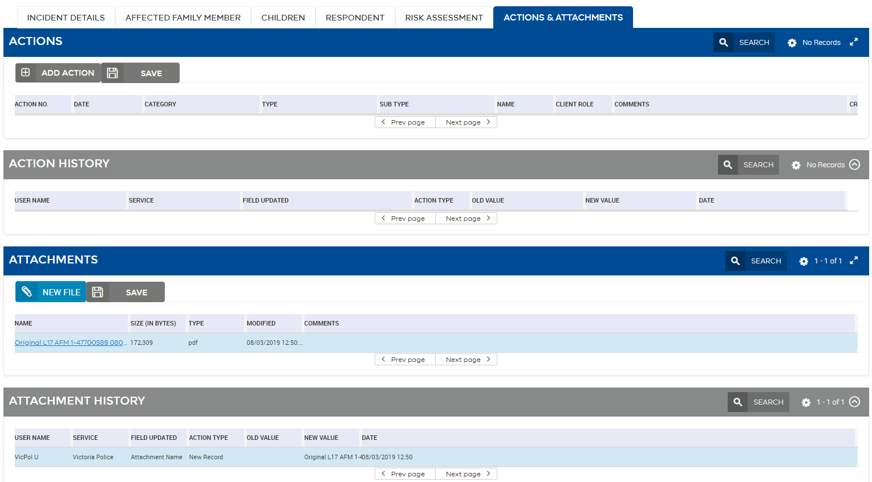

### Actions section

The Actions section can be used to enter brief notes to support the intake and triage process. All Actions require a Category and Type. When entering a Final Outcome, for some types a subtype may also be entered.

There are four **Action categories** that can be entered:

1. **Contact (Successful)**
2. **Contact (Unsuccessful)**
3. **Note**
4. **Client Outcome**

#### Contact – Successful and Unsuccessful

You can enter an action category of Contact Successful or Unsuccessful to indicate that contact has been made or attempted but unsuccessful. For Successful and Unsuccessful contacts, you will need to enter a Type indicating who was contacted:

* Hub
* AFM
* Respondent
* Agency
* Police
* Child Protection
* Child FIRST
* Other

#### File Note

This action category can be used to record additional information.

|  |  |  |
| --- | --- | --- |
| Note  Note icon | **Actions and Attachments** entered in this tab are only visible to your service. However, it is important that you continue to record details about your client and any contacts made in your client management system. This section should be used to record broad-level notes that support the intake and triage process. | |
| Note  Note icon | | **Adding an Action that is a Contact (Successful), Contact (Unsuccessful) or File Note on the Actions & Attachments tab will change the status of the referral to Working.** |
| Tip  Tip icon | | **If you start to create an Action and wish to un-do the Action, simply select Esc on the keyboard and it will cancel the action.** |

#### To add an Action:

1. In the **Actions & Attachments** tab, in the **Action** section, click the **ADD ACTION** button.

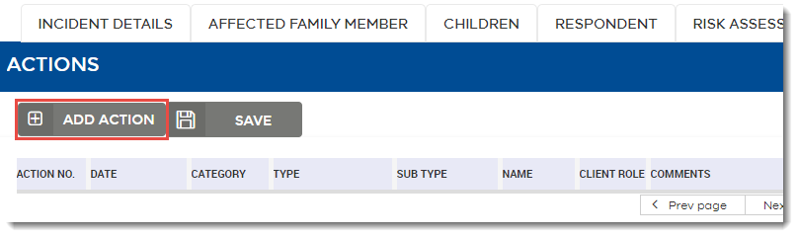

1. Select the type of Action you wish to capture:

Client Outcome – to add an outcome for all or selected clients.

Other – to add a Contact (Successful/Unsuccessful) or Note

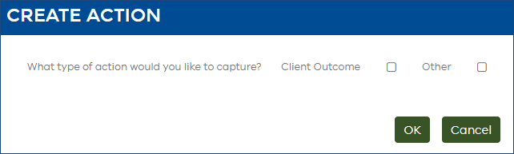

1. If you select **Other** the Create Action pop up will expand. Enter a category, Type and Comments.

Refer below to Referral Outcomes for information about entering client level outcomes.

1. Click the OK button to save your Contact or Note.

### Referral Outcomes

Prior to 16 August 2018 one referral outcome was entered to close a referral.

As of 16 August 2018, outcomes are captured on the **client level**. This means when you enter an outcome, it will now accurately reflect the *outcome* *of the referral for* *the selected person*.

For example, Victoria Police send an AFM referral to an AFM service. The referral consists of the AFM and two children. The service commences case management with the family however also makes a referral in the Portal to Child FIRST for the two children. The outcomes for each person will be:

|  |  |
| --- | --- |
| **Client** | **Outcome** |
| AFM | Client engaged with service |
| Child one | Referred to other service in portal |
| Child two | Referred to other service in portal |

This new way of entering outcomes means data will be more accurate – you can enter an outcome that is relevant to the client. This is especially important for services that work with all persons (AFM, Children and Respondent) such as The Orange Door services, or for children’s services where one referral may have multiple children.

Where one referral has multiple client outcomes, the L17 Recipients table will show “Multiple Outcomes”. See page 73, *Display of Multiple Client Outcomes in the L17 Recipients Table* for more information.

The L17 Family Violence Portal User Guide has also been updated to reflect the new way outcomes are entered in the Portal. The L17 online training will be updated shortly.

#### Client Types: Primary and Optional

Client level outcomes are only required for the **primary** client/s. The primary client is the client for whom your service received a referral. For example, if an AFM referral is received, you only need to enter an outcome for the AFM client, regardless of whether there is a respondent or children listed on the referral.

For a children referral, outcomes only need to be entered for all children listed in the Children’s tab (refer to *Table 8: Primary and optional client/s by referral type* for the exception).

For a respondent referral, outcomes only need to be entered for the Respondent.

For an Orange Door service, an outcome is required for all persons listed in the Hub referral.

It is advised that you discuss the new outcomes process with your manager to determine best practice. For example, to improve data quality, AFM services may consider adding outcomes for all children listed on the referral as routine practice.

Refer to *Table 8: Primary and optional client/s by referral type* to determine which client roles are considered primary for your service. The primary client is identified in the Portal by the referral type.

Table 8: Primary and optional client/s by referral type

|  |  |  |  |
| --- | --- | --- | --- |
| **Referral Type** | **Primary** | **Optional** | **Exceptions** |
| **AFM** | AFM | Child/ren, Respondent | Where a child service receives an AFM referral for an adult AFM, the child service must enter the outcomes for the children in the **Children’s tab** first to ensure outcomes are captured for the service’s actual target client group.  Respondents are listed as ‘Optional’ clients. An outcome against a respondent does not need to be recorded if the service has not worked with the client in response to this referral.  An outcome must then be entered for the AFM to close the referral. The children’s service may wish to select ‘Not eligible for service’ as the outcome. |
| **Children** | Child/ren | AFM, Respondent |  |
| **Respondent** | Respondent | NA |  |
| **HUB** | AFM, Child/ren, Respondent | NA |  |

#### To close a referral

Every referral will require an outcome to be entered for the primary client/s in order to close the referral. The status will automatically change to ‘closed’ when an outcome has been entered for **all** **primary** clients.

If outcomes are entered for optional clients first, the referral will not close. It will remain at working status.

Refer to *Table 8: Primary and optional client/s by referral type* for list of primary clients.

|  |  |
| --- | --- |
| Note  Note icon | Where a children’s service receives an AFM referral type, the Portal identifies the AFM as the primary client. This means to close the referral an outcome must be entered for the AFM after all children outcomes have been entered in the Children’s tab. |

#### To change an outcome

Open referrals

If the referral is still open, you can update an outcome for any person, noting that once an outcome has been entered for all primary clients the referral will automatically close.

Closed referrals

If the referral is closed, you will need to reopen the referral to change an outcome.

Once you have changed the outcome and finished making updates, click the “Close Referral” button to close the referral. Reopened referrals will not close automatically.

|  |  |
| --- | --- |
| Note  Note icon | If you reopen a referral that was closed prior to 16 August 2018 (i.e.prior to the new client level outcomes functionality) you will be required to enter the outcome for the primary client to close the referral. A warning pop up will appear if an outcome is missing for the primary client. |

#### Table 9: Final Outcomes and Definitions

|  |  |  |
| --- | --- | --- |
| L17 Final Outcome (Type) | L17 Secondary Outcome (Sub-type) | Definition |
| **Client declined to engage with service** | Not Applicable | Client was successfully contacted but did not want support from service. |
| **Client engaged with service** | Advice provided, no further action  Case management/program  Assessment pending | Client was successfully contacted and advice was provided with no need for follow up action.  Client was successfully contacted and is now being case managed/is part of a support program within your service.  Client was successfully contacted and is now awaiting assessment for next action. |
| **Existing case open** | Not Applicable | Client is a current client and current workers have been updated with new referral details. |
| **Repeat referral** | Not Applicable | Family Violence referral is a repeat referral, meaning that the same client currently has another open referral that your service is managing. |
| **Information pack sent** | Text message  Information pack | Information has been sent to client. |
| **Unable to contact** | Phone number disconnected  Phone number incorrect  Maximum attempts reached/Did not return calls  Text message sent  Information pack sent  Client un-contactable (e.g. in hospital, in remand) | Client could not be contacted. |
| **Referral incomplete/missing information** | No contact details  No parent contact details | Referral that was received did not have adequate information to contact the client. |
| **Police not spoken to Respondent** | Not Applicable | Police had not spoken to Respondent about referral and therefore client could not be contacted. |
| **Not eligible for service** | Not family violence  Does not meet service eligibility criteria  Client resides interstate | Client is not eligible for service due to; the incident not being family violence, the client does not meet service eligibility criteria, the client resides interstate. |
| **Referred to other service in Portal** | Out of area  Redirected to Child Protection | The incident has been referred to another service using the Make A Referral Portal function (i.e. referral to a service within the Portal). |
| **Referred to other service outside of Portal** | Not Applicable | Client was referred to service external to the Portal. |
| **Registered Child Protection Intake** | Not Applicable | Client has been registered for intake by Child Protection (Child Protection use only). |
| **Referred to Victims Support Agency** | Not Applicable | Client has been referred to Victims Support Agency external to the Portal. |

#### To record a client level outcome:

1. In the Actions section, click ‘ADD ACTION’ button.
2. Select “Client Outcome” and the Create Action will expand.
3. In ‘Client’ dropdown, select the client type you wish to enter an outcome for.

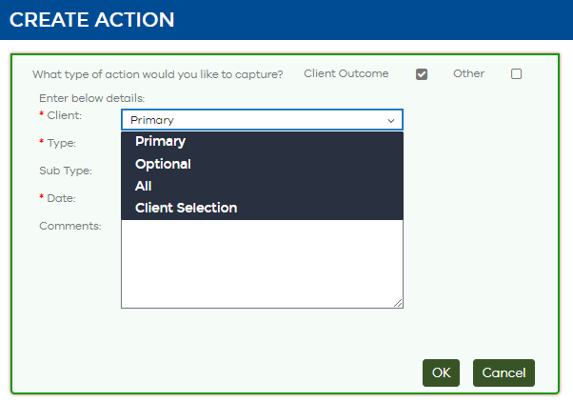

**Primary** – Select ‘Primary’ if you want to add an outcome for your primary client. If you have more than one primary client it will enter the outcome against all primary clients. The referral will close.

**Optional** – Select ‘Optional’ if you want to enter the same outcome for all optional clients. The referral will remain open.

**All** – Select ‘All’ if you want to enter the same outcome for every person on the referral including primary and optional clients. The referral will close.

**Client Selection** – Select ‘Client Selection’ to add an outcome for one client at a time. The referral will close once an outcome has been added for all primary clients.

3.1 If Client Selection is selected, the field ‘Select Client’ will appear.

Click the pencil icon in the ‘Select Client’ field to show a list of clients.

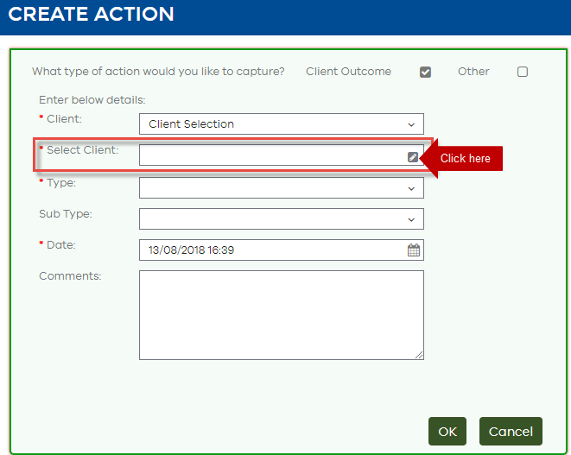

3.2 Highlight the client you wish to enter an outcome for and click OK.

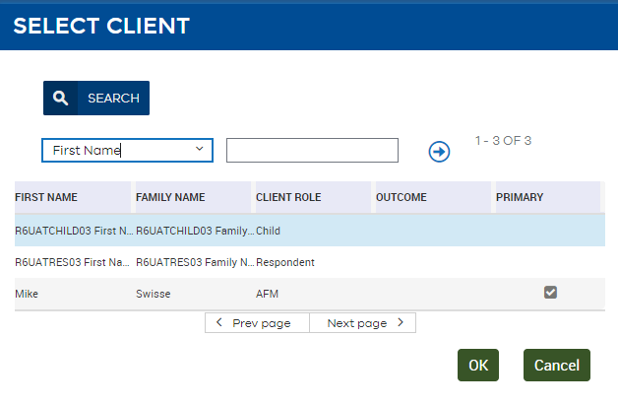

Note: the primary client/s is indicated by a tick.

1. In ‘Type’ dropdown, select the primary outcome.

4.1 Select the Sub Type if applicable.

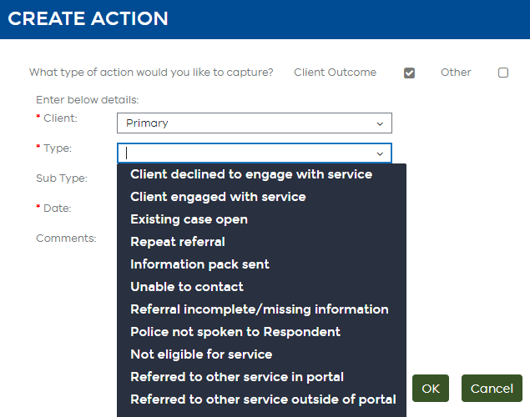

1. Enter comments in the comments text box.
2. Click OK to save.

Once you save an outcome for **all** **primary** **clients** the Referral Record will be **Closed**. This will mean no fields can be edited, however, you can still generate and download PDFs.

Check that your Referral has changed status to Closed by refreshing the **L17 Recipients table** in the **Summary Banner.**

The **Type** and **Subtype** will now be the **Primary** and **Secondary** outcomes respectively.

|  |  |
| --- | --- |
| Reminder  Reminder icon | The Client Outcome should reflect the outcome/service your organisation provided. The outcome entered should be the outcome of the *referral for the selected client*, not the outcome of working with the client. |

**To refresh the L17 Recipients table:**

1. Switch into another tab e.g. Risk Assessment tab. This will refresh the **L17 Recipients table.**

|  |  |
| --- | --- |
| Note  Note icon | Do not use Search & Go at the top of the referral, as this will refresh the list that sits behind the Referral Record, and will then return you to the first record on the List (which may be a different client). |

#### Display of multiple client level outcomes in the L17 Recipients table

If one referral has multiple outcomes, it will be displayed according to the following scenarios:

|  |  |  |  |
| --- | --- | --- | --- |
| **Same Primary Outcome** | **Same Secondary Outcome** | **L17 Recipients Table Display** | |
|  |  | **PRIMARY OUTCOME** | **SECONDARY OUTCOME** |
| Y | Y | Primary outcome value | Secondary outcome value |
| Y | N | Primary outcome value | “Multiple secondary outcomes” |
| N | N (or not applicable) | “Multiple outcomes” |  |

Where values are the same, the Portal will display that value. However where values are different, th Portal will display the text “Multiple outcomes”. This also applies when the outcomes column is shown in the List View.

For example, the following three clients have the same Primary Outcomes but different Secondary Outcomes:

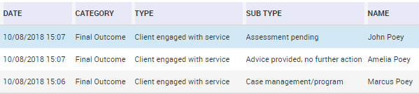

The L17 Recipients table will display:

Screenshot of the L17 Recipients table

#### Search or Refresh Actions

The Actions section also provides search and refresh functions

#### To search the Actions table:

1. Click the Search icon (magnifying glass)button.
2. Enter your search text.
3. Click the go iconbutton.

#### Action History

The Action History is read only and shows all changes that have taken place in this subtab only. When an editable field is updated or an action added, a new audit trail record is created. Each record will display both the previous value and new value. By default the Action History section will be collapsed.

Where there are multiple Actions recorded you will need to select the Action entry from the **Action table** above to display the history relevant to that entry only.

**To see the Action History:**

1. Select the Action entry you would like to see the Action History for from the **Action table** above (this can be done in any order e.g. after the Action History has been expanded).
2. Click the Down arrow icon button.
3. A history of changes made in this section of the tab for the selected Action will be displayed with the most recent changes displayed at the top of the list.
4. You may need to refresh the History to see the latest changes by using Search icon & Go icon.

### Outcomes received via integration

Outcomes can also be recorded in the L17 Family Violence Portal via integration with a connected system. Currently, the only connected systems able to send outcomes to the Portal are Child Protection CRIS and The Orange Door CRM.

When referrals are received through one of the above, and they are actioned within that system, an outcome will automatically be sent through to the L17 Family Violence Portal to be recorded. This means users will not need to log onto the L17 Portal to record an outcome separately to the one processed in the connected system used.

### Attachments section

This section will always contain a PDF version of the original L17 submitted by Police pinned to the top. You can also generate an updated PDF after changes have been made. There is also capability to upload attachments if required.

|  |  |
| --- | --- |
| Note  Note icon | The Original L17 PDF will always retain the **L17 Recipient** and **Referred By** fields. For example if Victoria Police make a referral to Service A, the Original L17 PDF will always show the **L17 Recipient** as Service A and **Referred By** as Victoria Police, even if Service A redirects the referral to Service B. |

#### Generate Updated PDF

Use the **Generate Updated PDF button** whenever you wish to generate a PDF version of the entire record and all its current updates made by services.

#### To generate an updated PDF:

1. Click the Generate Updated PDF Icon button in the **Summary Banner**.
2. The PDF file will be generated and saved under the Original L17 PDF.

#### Open or download Original or Updated PDF

#### To open or download the original or updated PDF:

1. Select the hyperlink for the PDF you wish to open or download.
2. The following Information Privacy alert will display:

*Data from the L17 Family Violence Portal is classified as PROTECTED.  
Users must ensure that they only access, collect, use or disclose personal information from the Portal as necessary to perform their duties. Restrictions apply under the Privacy and Data Protection Act 2014, the Health Records Act 2001, the Children, Youth and Families Act 2005, and the Family Violence Protection Act 2008.  
  
You are downloading the file 'Updated L17 XXXX.pdf'. Would you like to edit the file directly or download it to your computer?*

1. The PDF will begin downloading. Once it has downloaded, double-click to open, or right-click to save.
2. To upload into your Client Management System, you will need to save it to your computer first, and then browse to upload to your computer.

|  |  |
| --- | --- |
| Note  Note icon | **Related Incident Count**, where present, will be displayed on the **Updated PDF**. |

#### To add a file:

1. Click the New File icon button.
2. Locate your file on your computer and upload.
3. To add a comment click on the **Comments** field in the **Attachment table**.

|  |  |
| --- | --- |
| Tip  Tip icon | **It is recommended that files uploaded to the Portal are less than 15MB.** |

#### Attachment history

The Attachment History is read only and shows all changes that have taken place in this subtab only. When an editable field is updated or an attachment added, a new audit trail record is created. Each record will display both the previous value and new value. By default the Attachment History section will be collapsed.

Where there are multiple Attachments recorded you will need to select the Attachment from the **Attachment table** above to display the history relevant to that entry only.

**To see the Attachment History:**

1. Select the Attachment entry you would like to see the Attachment History for from the **Attachment table** above (this can be done in any order e.g. after the Attachment History has been expanded).
2. Click the Down arrow icon button.
3. A history of changes made in this section of the tab for the selected Attachment will be displayed with the most recent changes displayed at the top of the list.
4. You may need to refresh the History to see the latest changes by using Field search icon & Go icon.

# Restricting User access to a referral record

|  |  |
| --- | --- |
| Overview | **Team Managers** have access to the **Administration – L17** Tab.  From this tab Team Managers will be able to **Restrict** access to referrals their service has received  Team Managers will have the ability to restrict any user from their service. |

## To restrict user access

1. Select the **Administration L17** Tab and click on **Restrictions**.

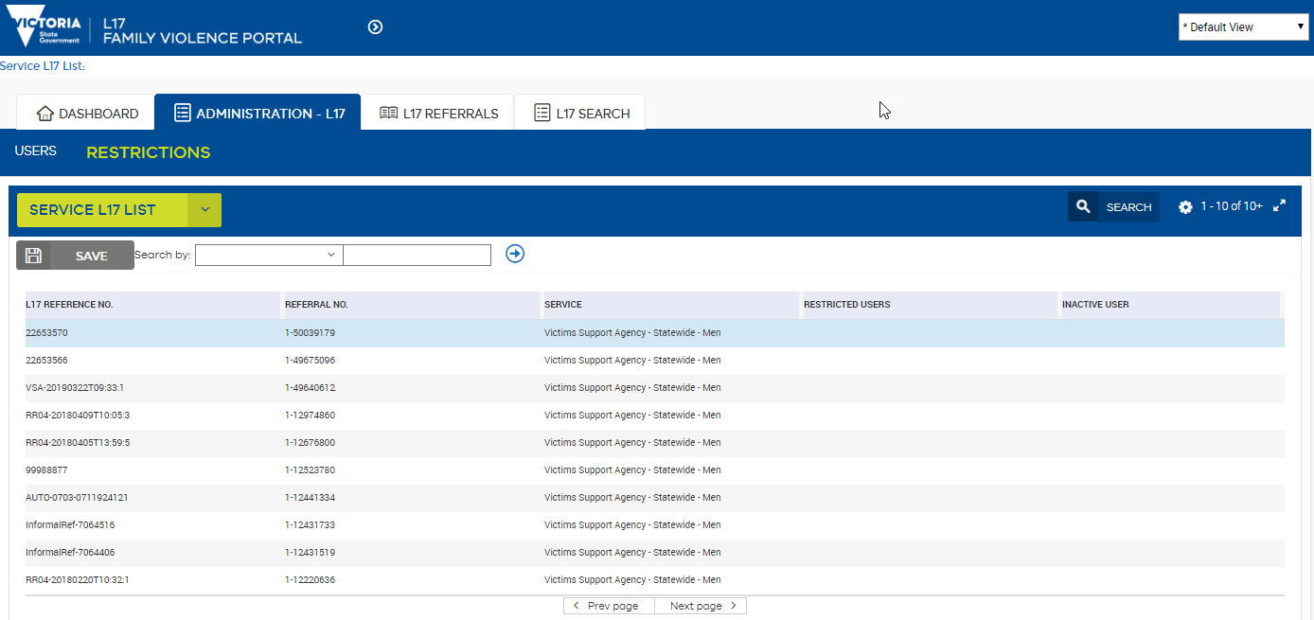

1. Search for the referral via the L17 Reference Number or Referral Number.
2. When the referral to be restricted is selected, click in the Restricted users field then the Edit pencil iconbutton.
3. The **Users** pop up will display showing all users available to be restricted from the referral to the left and all users who are unable to see the referral on the right.

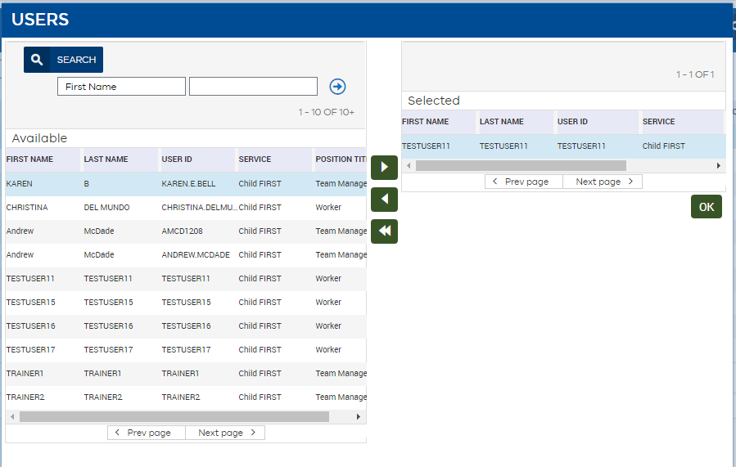

1. To restrict a user, search for the user's name, highlight that user and select Move user Arrow Icon
   1. To select multiple users grouped together in the list, select the first user in the list, hold the ‘Shift’ key and select the last user in the list then select the across arrow.
   2. To select multiple users not grouped together in the list, hold the ‘Ctrl’ select all users then click the across arrow.
2. Once all users to be restricted are in the right side of the screen, select **OK.**
3. Save the changes by clicking the **SAVE** button or ‘Stepping Off’.

### To remove a restriction from a user

1. From the **Users** pop-up, select users from the right, select Single Move User Icon  to remove a single user or Move all users icon to remove all restricted users.
2. Select **OK**
3. Click **SAVE** or ‘step off’

|  |  |
| --- | --- |
| Note  Note icon | When a referral is assigned to a Worker, the Team Manager will not be able to restrict the view of the referral to that user. The referral will need to be unassigned before restricting.  A tick in the inactive user column indicates that the user is no longer provisioned as a user in the Portal for the service. |

# Manage users

|  |  |
| --- | --- |
| Overview | **Team Managers** have access to the **Administration – L17** Tab.  From this tab Team Managers are able to **Manage users** access to referrals their service has received  Team Managers can edit user information or revoke L17 portal access for any user from their service. |

## Editable information

The following information is editable on the **Users** tab:

* First Name
* Last Name
* Phone Number
* Mobile Number
* Email
* Status - can only be changed from ‘Active’ to 'Inactive'.

## To edit user information

1. Select the **Administration L17** Tab and click on **Users**.

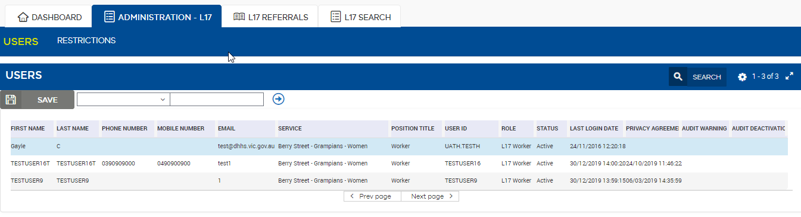

1. Search for the user, if required.
2. Highlight the relevant cell to make edits.
3. Step off the cell.
4. Click **Save**.

### To deactivate a user

1. Select the **Administration - L17** > **Users** tab.
2. Search for the user, if required and change **Status** to **Inactive**.

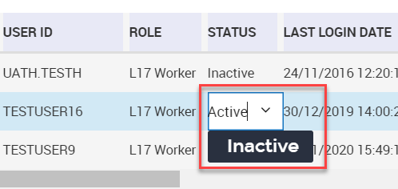

1. Click **SAVE.**

|  |  |
| --- | --- |
| Note  Note icon | ‘X’ or ‘_1-1234’ at the end of the **User ID** is present when **Status** is **Inactive**, indicating that the user no longer has access to the portal.  If access to the portal has been revoked but is still required, please email [L17portal@dffh.vic.gov.au](mailto:L17portal@dffh.vic.gov.au) |

# Automatic deactivation of inactive users

|  |  |
| --- | --- |
| Overview | The L17 portal will automatically detect and offboard inactive users. |

Users who have not logged in to the L17 portal for 45 days will automatically be detected by the system and will receive a warning email advising that their account will be deactivated if the account remains inactive for 60 days. In order to avoid deactivation, users must log into the L17 portal.

If the account remains inactive for 60 days, the account will be automatically deactivated and an email notification will be sent.

If your access is revoked and you require access to the L17 portal, please email L17portal@dffh.vic.gov.au.

# Extracts for reporting

Data within the Portal can be extracted into Microsoft Excel as either.csv or.xls files by those with Team Manager level access to the Portal.

## To extract a full list of referrals:

1. In the **Service L17 List,** refresh the list (Field search icon& Go icon) to ensure all Search terms are cleared.
2. Click the **Preferences** icon

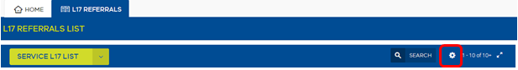

1. Select “**Export**”

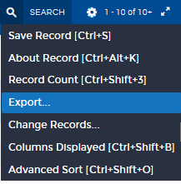

*Export dialogue box appears.*

Export dialogue box, including options to select: 
Rows to Export: All rows in current query, or Only current row
Columns to Export: All, or Visible Columns
Output Formate: Tab delimited Text File, Comma Separated Text File, HTML, Text file with Delimiter (includes free text field) 

1. Select **All Rows In Current Query**, **Visible Columns**, and the Output format you wish to use.
2. This will generate a list of all referrals in the Service, with the fields as available in the List view (see Table 1. Fields available in the L17 List for Available Columns and their definitions).

|  |  |
| --- | --- |
| Note  Note icon | * Future improvements to the Portal will include reporting functions. * Extracting functions are limited to those with Team Manager access to the Portal. |

# Glossary of Terms & Acronyms

| Term | Definition |
| --- | --- |
| **AFM** | Affected Family Member - defined in s.4 *Family Violence Protection Act* and means the family member whose person or property is the subject of an application for an order. Within the referral context, it is an interchangeable term for the person identified as the victim (of crime), regardless of whether a family violence intervention order has been sought or granted. |
| **ATSI** | Aboriginal and/or Torres Strait Islander. |
| **Children** | Person/s who are under the age of 18 who normally or regularly reside or have regular contact with either party in a family violence incident and have been present at / witness to / exposed to / or otherwise affected by family violence. Note that unaccompanied children, or children using violence, may be alternatively recorded as the primary AFM or Respondent. |
| **Closed** | Status will change to **Closed** when a Final Outcome has been recorded in the Actions and Attachments tab. This means the referral has been processed. The agency may still be working with the client, wherein they will continue to manage the client record via their client management system. |
| **L17** | Victorian Police Risk Assessment and Risk Management Report “L17”. |
| **LGA** | Local Government Area. |
| **New** | Status of newly received referral from Victoria Police or another service in the Portal. |
| **Respondent** | Defined in s.4 of the *Family Violence Protection Act* and means the person against whom an application for an intervention order has been made, an intervention order has been made against or a family violence safety notice has been issued. Within the referral context, it is an interchangeable term for the person identified as the primary aggressor in the family violence incident, regardless of whether a family violence intervention order has been sought or granted. |
| **Service** | An organisation that provides specialist family violence services, child specific services or community support, including Department of Families, Fairness and Housing – Child Protection and Support and Safety Hub. |
| **Service List** | A view within the Portal which displays all referrals received by your service. |
| **Triaged** | Status will change to **Triaged** when a user changes a triage field: that is, if they enter a Service Classification, or enters a Service Priority. |
| **Working** | Status will change to **Working** when a user has made a change in the Referral Record: Make a Referral, create an L17 Action, edit any client details, or enter any Comments. |