

|  |
| --- |
| Viewing your remittance advice in the Service Agreement Module (SAM) |
|  |
|  |

Contents

Log into My Agency 1

The Service Agreement Module 2

All Invoices for an Organisation 3

Exporting data 4

Top level invoices tab 6

Reports 7

## Log into My Agency

1. Log into the [eBusiness portal](https://eus.webapp.dhs.vic.gov.au/EUSPortal/) and under My Applications, click on Funded Agency Channel - My Agency.

Screenshot of the eBusiness Portal once logged in with a red box around the
Funded Agency Channel - My Agency hyperlinkFigure 1 Funded Agency Channel - My Agency in the eBusiness Portal

If you have forgotten your eBusiness username or password, select [request username](https://hns.dhs.vic.gov.au/EUSPublic/forgottenUsername.action) <https://hns.dhs.vic.gov.au/EUSPublic/forgottenUsername.action> or [reset password request](https://hns.dhs.vic.gov.au/EUSPublic/forgottenPassword.action) <https://hns.dhs.vic.gov.au/EUSPublic/forgottenPassword.action> links on the eBusiness Login page, or you can contact **eBusiness on 1300 799 470 (option 1 then 4). You will be provided with a temporary password that you will need to manually change.**

## ****The Service Agreement Module****

The Service Agreement Module (SAM) is the organisation’s view of the departments’ Service Agreement Management System (SAMS2). SAM provides real time Service Agreement information for funded organisations.

**From the My Agency home page, click on the Service Agreement Module (SAM) hyperlink.**

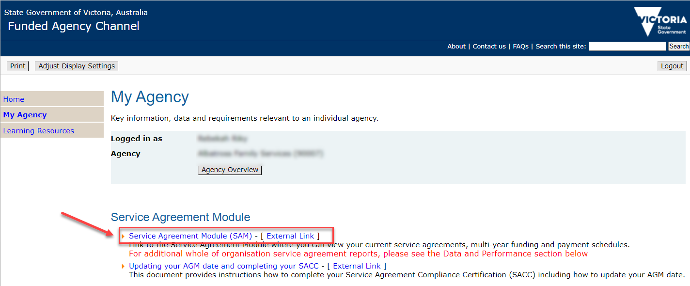

Figure 2 Link to SAM on the My Agency page

**Once in SAM, click on the name of the organisation you are wanting to view.**

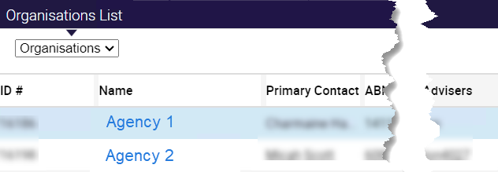

Figure 3 Organisation list in SAM

The organisation details are displayed with several subtabs visible depending on the level of access you have.

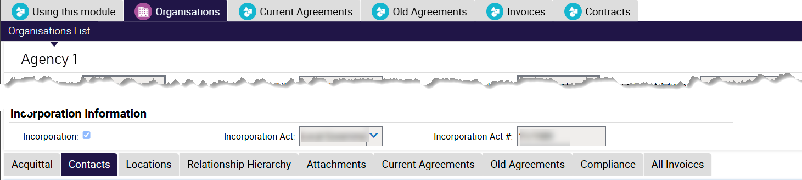

Figure 4 Organisations screen

## All Invoices for an Organisation

On the organisations screen, click on the All Invoices subtab, then view the Invoice number field.

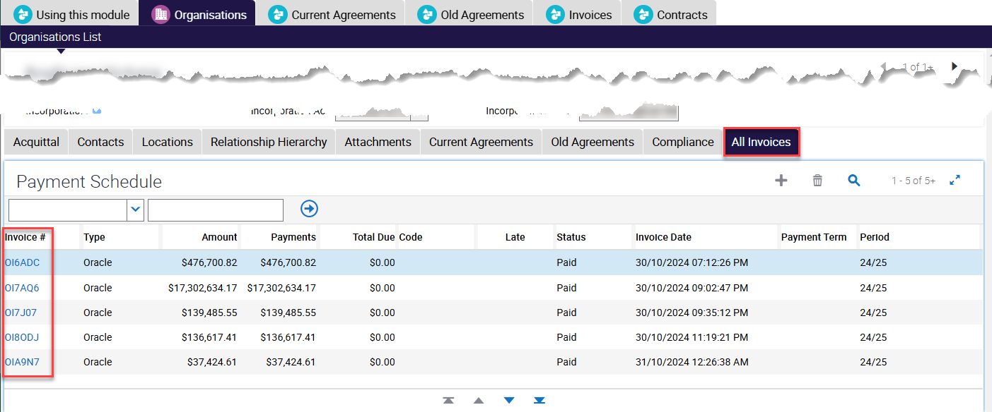

Figure 5 screenshot of the All invoices view

The list of invoices is returned including paid and unpaid, displaying the payment schedule for the invoices. You can drill into the details of any paid invoice, by clicking on the Invoice ID.

This will default to the Actual Payments subtab. Other views are the Activity Line Items, Remittance Advice and Commitment Details.

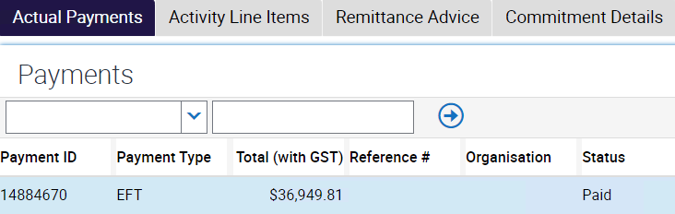

Figure 6 the Actual Payments view

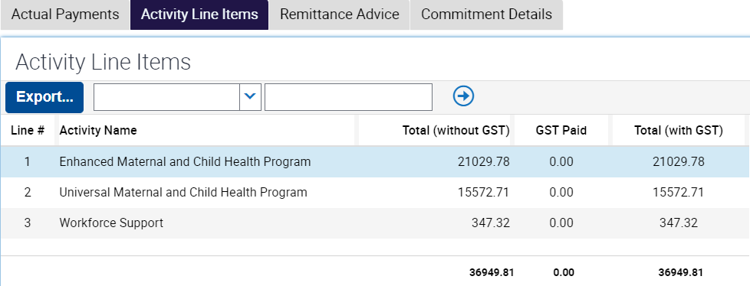

Figure 7 Activity Line Descriptions

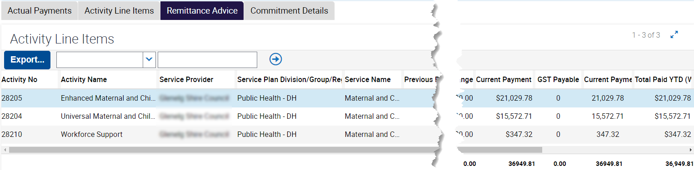

Figure 8 Remittance Advice

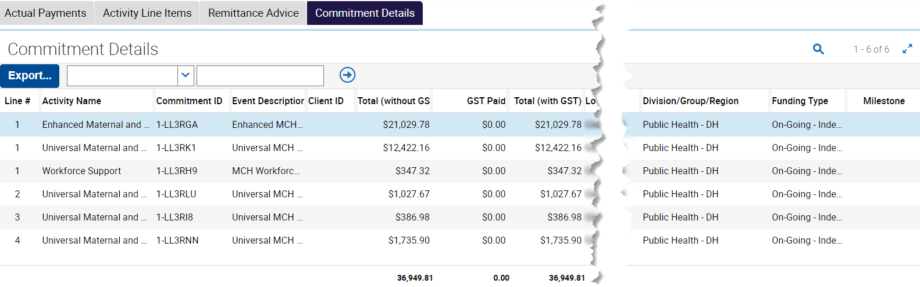

Figure 9 Commitment Details

## Exporting data

Activity Line Descriptions, Remittance Advice and Commitment details data can all be exported, **by clicking on the export button then the Next button, the default settings are usually the most suitable.**

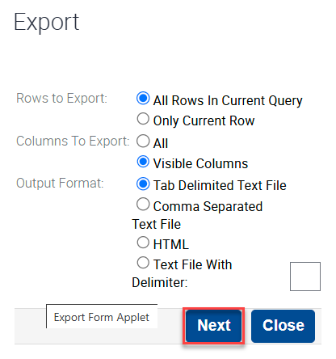

Figure 10 the export dialogue box

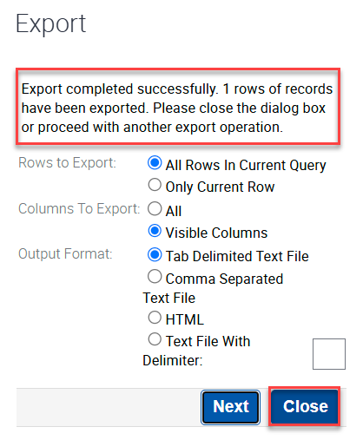

Figure 11 confirmation message and close button

The exported file will be in your browsers downloaded files

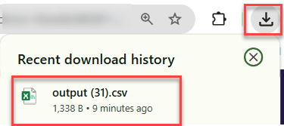

Figure 12 example downloaded files in Chrome browser

## ****Top level invoices tab****

You can also view invoices via the top level tab, which displays some additional information.

1. Click on the invoices tab
2. then the drop down arrow on the search box
3. select the field you wish to query by, in this example Agreement is selected, it could be any of the other fields.
4. enter the value in the search criteria text box
5. click the Go button.

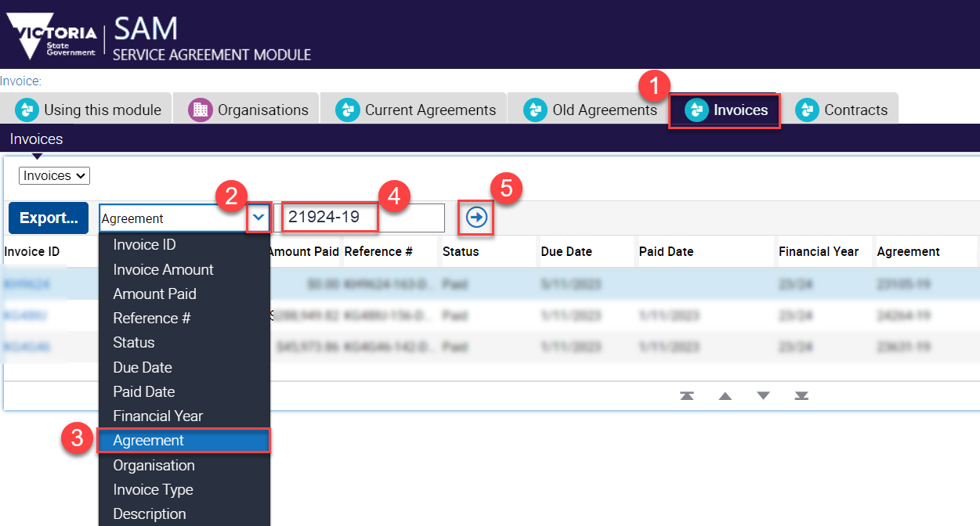

Figure 13 the invoices screen in SAM

1. The list of invoices is returned including paid and unpaid.
2. You can drill into the details of the invoice, by clicking on the Invoice ID.

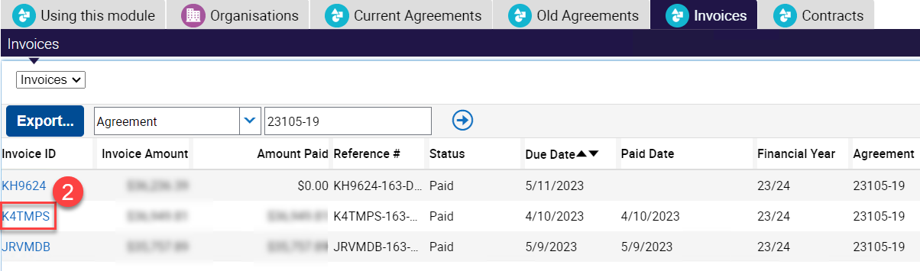

Figure 14 Invoice ID

## Reports

1. In My Agency, you can view several reports, including the SAMS03 – Invoices report by clicking on the hyperlink to open it. The SAM03 Invoice report displays all invoices paid to the organisation. Payment details are displayed at agreement, service plan, activity and commitment level.

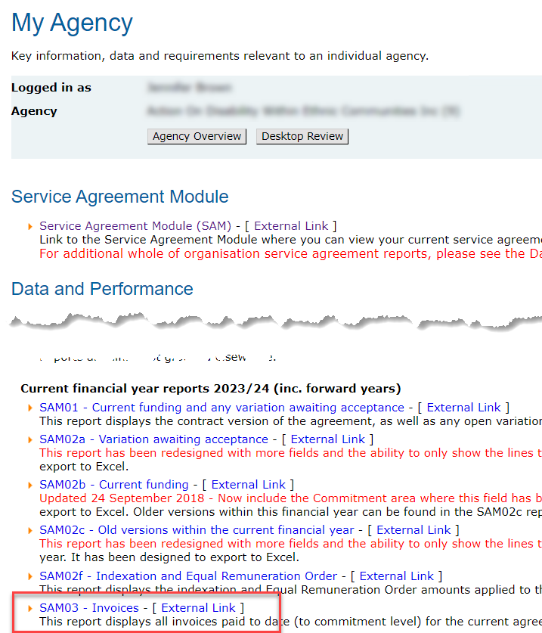

Figure 15 Invoices report in My Agency

1. Refine your criteria

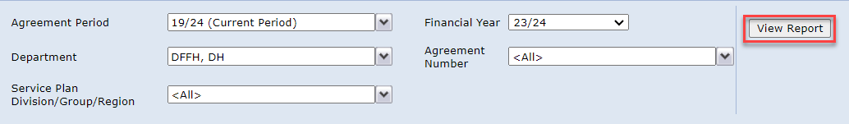

Figure 16 report criteria selection

1. Once the data has loaded, you will see a summary worksheet. You can export the report into various format, however, excel is often the most useful.

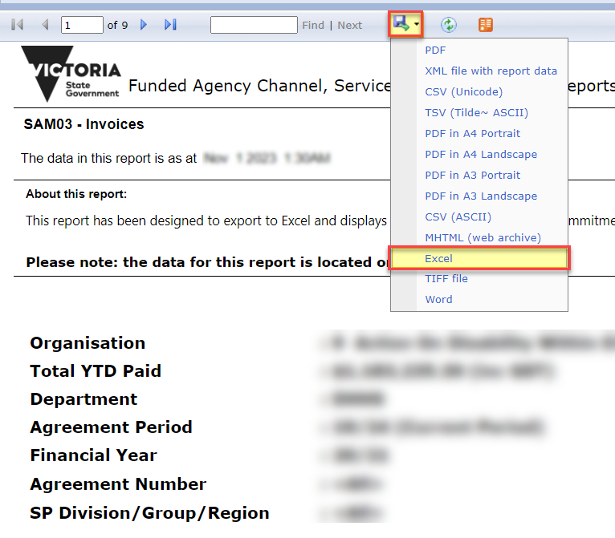

Figure 17 export report data

|  |
| --- |
| To receive this document in another format, [email the Funded Agency Channel](mailto:FAC@dffh.vic.gov.au) <FAC@dffh.vic.gov.au>  Authorised and published by the Victorian Government, 1 Treasury Place, Melbourne.  © State of Victoria, Australia, Department of Families, Fairness and Housing, December 2024  Available at [Funded Agency Channel](https://fac.dffh.vic.gov.au/) <https://fac.dffh.vic.gov.au/> |