

|  |
| --- |
| Managing contacts in the Service Agreement Module (SAM) |
|  |
|  |

Contents

Introduction 1

The role of the Access Controller 2

Viewing organisation users in My Agency 2

Viewing organisation contacts in SAM 2

How to add a new contact to the Contacts list 4

Registration of a new user for My Agency and SAM 4

Permissions and functions 5

Updating Contact details and permissions in SAM 5

What cannot be updated in SAM 5

The Signatory of your service agreement 5

Your eBusiness account details 6

What contact details can be updated in SAM? 6

Edit a contact’s details 6

Edit a contact’s permissions 6

Making a user inactive 7

## Introduction

Only organisation contacts with Service Agreement Module (SAM) access and the Access Controller permission can make changes to contacts within SAM.

The Access Controller for an Organisation can be found in SAM under the contacts tab. There can be multiple Access Controllers ticked for an organisation.

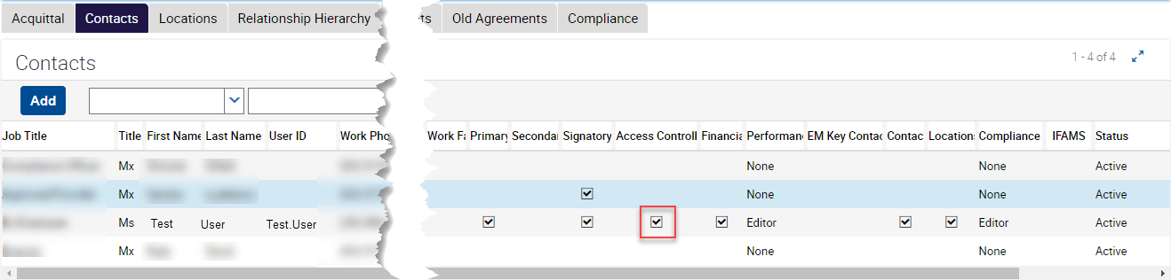

Figure 1 screenshot of the contacts in SAM

### The role of the Access Controller

* Access Controllers must be registered for My Agency Access in eBusiness.
* Every Organisation must appoint at least one registered user with Access Controller permissions. This position can update the permissions and details on other ‘Active’ contacts.
* The Organisation’s Access Controller(s) can change a user’s access which determines what each user can see and do in SAM and My Agency.
* Access Controllers can add new contacts and appoint other organisation users as Access Controllers or primary and secondary contacts.
* Access Controllers are responsible for ensuring that active user details are correct and up to date.
* Access controllers are responsible for ensuring that contacts no longer requiring access to SAM have their status amended to ‘Old’ and provision of advice to the FAC helpdesk for cessation of My Agency privileges
* All fields in the contacts tab are editable by the Access Controller except the signatory field, and the User ID field.
* Access controllers can make updates to the contact name fields but cannot change them to a new user, doing so creates log in issues and is a breach of the eBusiness access agreement between the organisation and the department/s.
* The Access Controller is a role within SAM used to maintain contact details and the information they can view. While this may be the same user as the Authority (OA) role within eBusiness they are separate roles and functions.

## Viewing organisation users in My Agency

To view what users have access to SAM within an organisation and the types of information visible, go to the organisation report via <https://rsamseb.ace.webapp.dhs.vic.gov.au/RSAMS/app/FACSSO/enu>

Scroll down the page until you see the User Details heading.

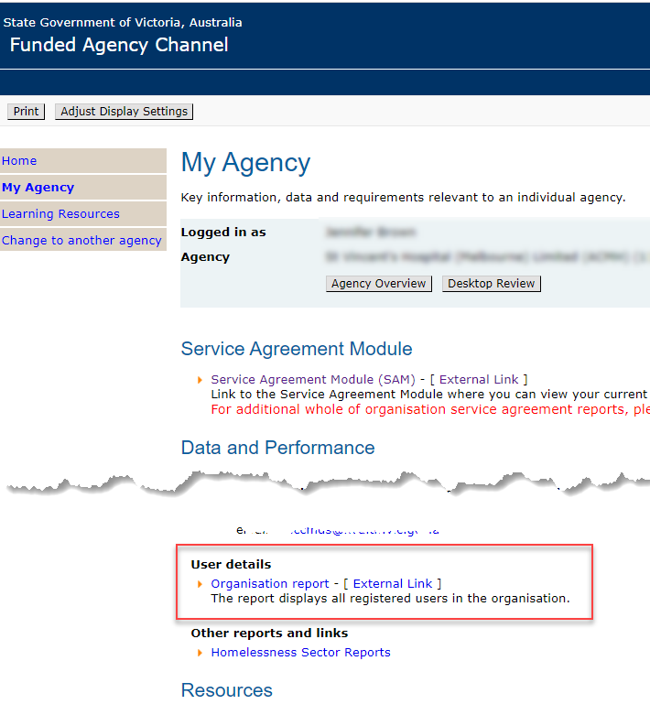

Figure 2 Organisation report on My Agency

Click on the hyperlink to open the report.

If there are any contacts you would like removed, contact the Funded Agency Channel Helpdesk [fac@dffh.vic.gov.au](mailto:fac@dffh.vic.gov.au) listing the old contact(s).

## Viewing organisation contacts in SAM

Log into the Service Agreement Module (SAM).

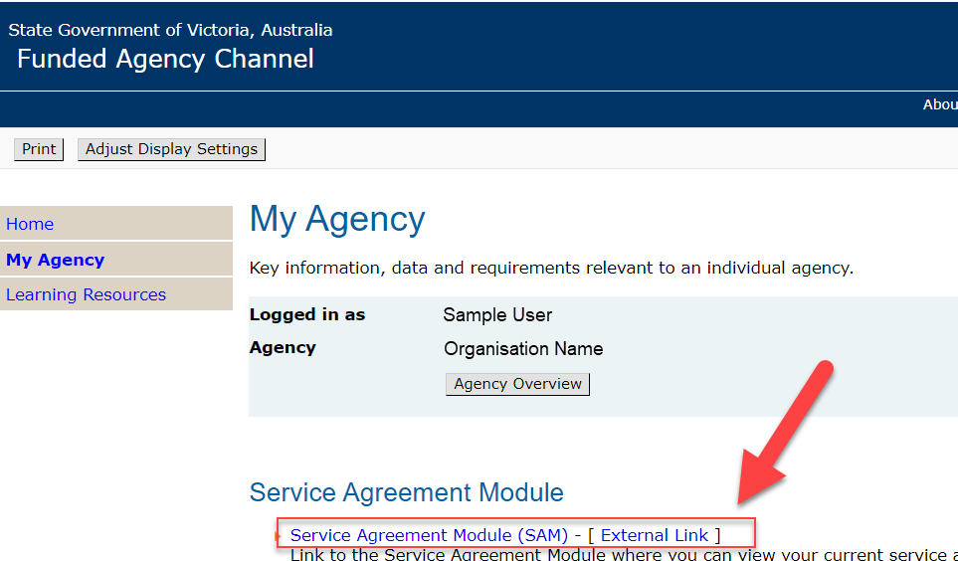

Figure 3 My Agency SAM link

A separate window will open, and SAM will display the “Organisations” tab showing a list of Organisations available to access.  
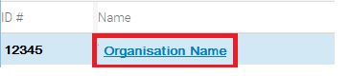

Figure 4 Organisation name hyperlink

Click on the name of the organisation to access. A series of sub-tabs will be displayed, with the Contacts sub-tab selected by default.

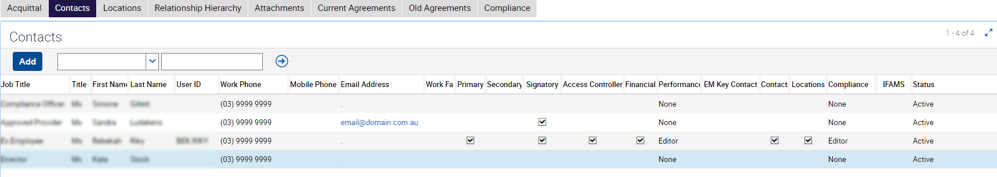

Figure 5 Contacts sub-tab in SAM

The Access Controller has this permission ticked for the organisation. This can be sorted by clicking on the arrows on the heading label.

Contact permissions can be seen by hovering over the permission field, a tooltip with a brief description of the access provided is displayed.

* An organisation member who **does not** have a User ID does not have access to My Agency. They are listed as a contact only.
* An organisation member who has _X, _XX or an _XXX at the end of their user ID has had their access to My Agency removed.
* ‘Old’ contacts remain in the contacts list for auditing purposes and are visible only to the Access Controller.

## How to add a new contact to the Contacts list

**Please note: Adding a new user does not provide access to My Agency or SAM**. Each user must register for eBusiness themselves. By adding the user prior to their registration, the Access Controller can determine what additional permissions the user will have once access is granted, for example: EM Key Contact. See Permissions and Functions for more information.

Ensure that the person is not already a contact by scrolling through the contact names using the down arrow under the contacts list.

Click on the Add button and the Add Contacts box is displayed

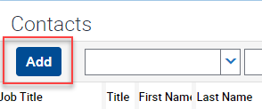

Figure 6 Contacts Add button

Click on the Plus symbol.

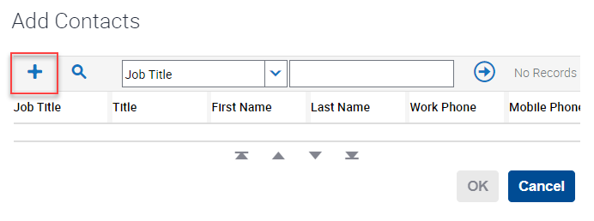

Figure 7 Add Contacts pop up box

A new row will appear. User details can be entered. The User ID is system generated when a user’s access is approved by FAC. Scrolling to the right half of the contacts screen will show user permissions.

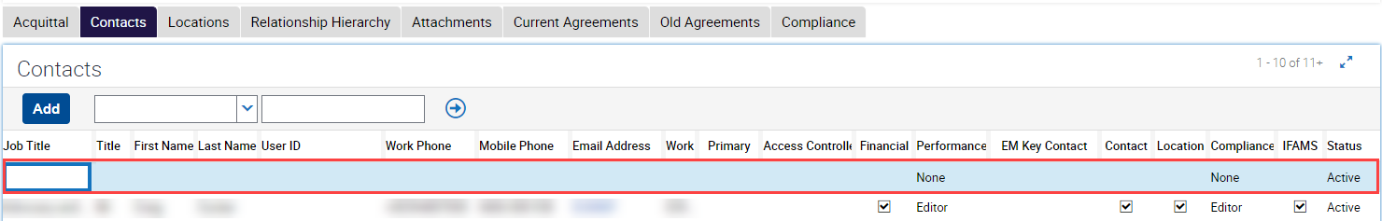

Figure 8 New blank record in the Contacts screen

Enter the Job Title, Title, First Name, Last Name, Work Phone and email address.

**Note**: The contact will not have access to SAM or My Agency until they register for access, at which point they will receive a User ID and be added to My Agency by the FAC team.

### Registration of a new user for My Agency and SAM

Instructions on how a new user can register for access to FAC and SAM can be found in the document titled “How to register for My Agency” at <https://fac.dffh.vic.gov.au/how-register-my-agency>.

## Permissions and functions

|  |  |  |  |
| --- | --- | --- | --- |
| Permission | Associated tabs in SAM | Editable fields | Associated reports in My Agency / Purpose |
| Primary |  |  | Primary contact for the organisation, will receive system generated emails. Can only be one |
| Secondary |  |  | Secondary contact/s for the organisation, will receive system generated emails. Can be multiple. |
| Signatory |  |  | Is the authorised organisation signatory for Agreements, is required to accept first time agreements. |
| Access Controller | All | Update permissions and contact details | All |
| EM Key Contact |  |  | For organisations in scope for Emergency Management attestation. This contact will receive system generated emails regarding EM compliance requirements. |
| Financial | Current agreements |  | Current financial year reports |
| Previous agreements |  | Previous agreement version reports |
| Invoices |  | All structured reports |
| Contracts |  |  |
| Performance: Read only | Acquittal |  | Service delivery tracking Health reports - performance against targets |
| Performance: Edit | Acquittal | Update and submit acquittal | Service delivery tracking Health reports - performance against targets |
| Contact | Contacts |  | User details |
| Location | Locations |  | No location reports |
| Compliance: Read only | Compliance |  | Compliance reports |
| Compliance: Edit | Compliance | Upload and submit SACC | Compliance reports |
| IFAMS |  |  | Client specific funding reports |

## Updating Contact details and permissions in SAM

### What cannot be updated in SAM

#### The Signatory of your service agreement

If the signatory of the service agreement requires updating, please contact the relevant departmental advisor, or email FAC@dffh.vic.gov.au.

#### Your eBusiness account details

An eBusiness account profile can only be updated by the account holder. A separate ‘how to’ guide detailing how to update an eBusiness account can be found in the document titled ‘[Change your eBusiness profile details](https://fac.dffh.vic.gov.au/change-your-ebusiness-profile-details-fact-sheet)’ at <https://fac.dffh.vic.gov.au/change-your-ebusiness-profile-details-fact-sheet>

### What contact details can be updated in SAM?

The access controller can edit all fields in the Contacts tab except the User ID field and Signatory checkbox.

The text fields that can be updated are Job Title, Title, First Name, Last Name, Work Phone, Mobile Phone, Work Fax, Email Address.

There are several checkboxes and drop-down lists for each record that grant different permissions and views in the Service Agreement Module (SAM).

* Primary: this mandatory check box indicates the main contact for an organisation. Email and mail correspondence from the department to an organisation is addressed to the primary contact. There can only be one primary contact. The Primary contact is also copied into emails regarding service agreements available to view, awaiting acceptance and accepted by all parties.
* Secondary: this checkbox enables one or more secondary contacts to receive system emails in addition to the primary contact. Where ticked, the secondary contact will be copied into correspondence regarding Insurance compliance, Emergency Management compliance (where applicable), SACC compliance, and Desktop Review completion.
* Signatory: is a read only field.
* EM Key Contact is the person nominated by the Organisation (for in-scope organisations only) to complete the annual Emergency Management attestation.
* Status (Active or Old drop-down menu) please note that if employee is set to old, the Funded Agency Channel help desk (fac@dffh.vic.gov.au) must be contacted to ensure the users’ access is revoked.

### Edit a contact’s details

1. To edit a contact’s details, select anywhere in the relevant user row. Please note that each row is unique to the user, not the job title. Do not update one person’s record with another person’s details.
2. Once the user row is selected, all the fields except User ID and signatory will become editable. Changes are saved when another row is selected or by pressing Ctrl+S.

### Edit a contact’s permissions

1. To edit a contact’s permissions, select anywhere in the relevant contact row. The permissions are located on the right half of the contacts screen.

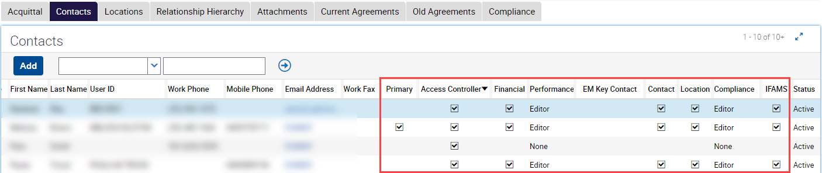

Figure 9 Contacts screen

1. Please refer to the Table of permissions and functions before editing permissions.
2. The user will either gain or lose access based on whether a permission is added or removed. Changing permissions will generate a system email notifying the user of the change. The person who made the changes, being either the Access Controller, department adviser or FAC helpdesk member will also receive a confirmation email.
3. Note that permissions are organisation specific, meaning that if a user has access to more than one organisation (Multi-Organisation access), then changes made are specific to that organisation only.

## Making a user inactive

1. The Access Controller can change the status of a user when they no longer require access or work for the organisation. Changing status will remove permissions except the Primary contact, which needs to be assigned to another user first.

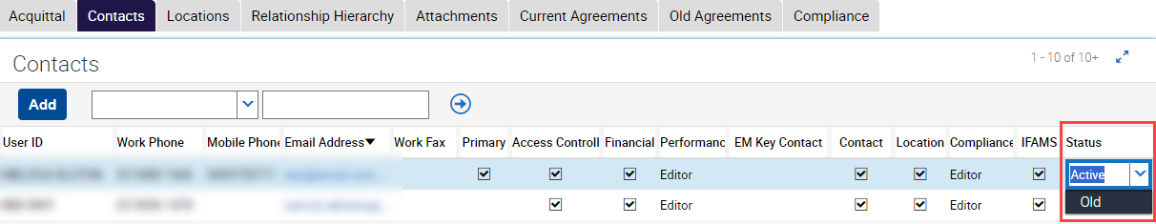

Figure 10 Changing the status of a user.

1. Select the contact record to be made ‘Old’. Scroll across to the status column and click into the field. A drop-down arrow is displayed which when enables the selection of the status ‘Old’.
2. Changes are saved when you either select another user row or Press Ctrl+S.
3. If the record is not ticked as the primary contact or the only access controller, all the permissions will be removed.
4. Note, if the person has left your organisation, you are also required to advise [FAC@dffh.vic.gov.au](mailto:FAC@dffh.vic.gov.au) to enable access to be revoked across My Agency and eBusiness as well, if required.

**Note**: Access controllers only can still see the ‘Old’ users within the contacts screen.

|  |
| --- |
| To receive this publication in another format, email: the [Funded Agency Channel](mailto:fac@dffh.vic.gov.au) <fac@dffh.vic.gov.au>  Authorised and published by the Victorian Government, 1 Treasury Place, Melbourne.  © State of Victoria, Department of Families, Fairness and Housing, December 2024  Available on the [Funded Agency Channel](https://fac.dffh.vic.gov.au/my-agency-non-dffh-and-dh-staffhttps:/fac.dffh.vic.gov.au/my-agency-non-dffh-and-dh-staff) <https://fac.dffh.vic.gov.au/my-agency-non-dffh-and-dh-staff> |