

How to register for My Agency

About this document
Access to My Agency is via the eBusiness Portal. To access the eBusiness Portal, users need to first complete an online registration form. Users can register to access My Agency if they are either a:
- Staff member of one of the organisations funded by the Department of Families, Fairness and Housing (DFFH), Department of Health (DH), the Department of Education (DE) or the Adult Community and Further Education Board (ACFE) (the Departments).
- Member of the board or committee of management of one of the organisations funded by the Departments
Registering for My Agency will provide users with access to the following organisation specific information:
- Service agreements and variations
- Funding and payments information
- Performance targets
- Service Standards and Guidelines
- Data collection requirements
- Program data reports
- Financial Accountability Requirements

Registering to access My Agency via the eBusiness Portal
Go to https://eus.webapp.dhs.vic.gov.au/EUSPortal/
And select I want to register
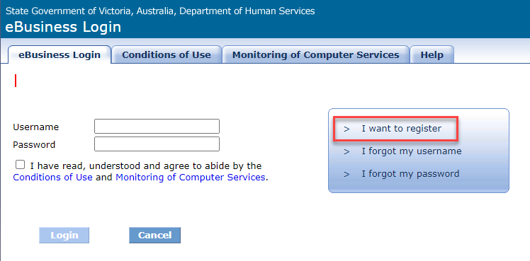
Figure 1 Screenshot of eBusiness login page

The eBusiness Application Registration screen is displayed. From the Application Catalogue, either search by typing Funded Agency Channel or selecting Funded Agency Channel – My Agency (1.0.0) from the list.
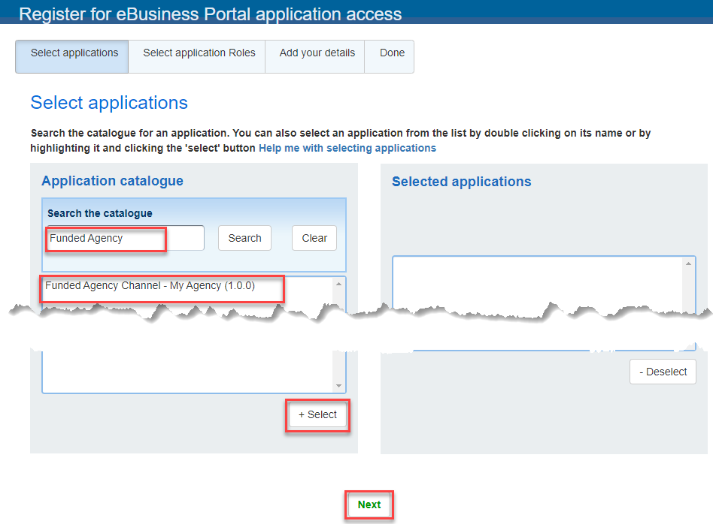
Figure 2 screenshot of Select application screen
Choose the Select button to move your selection to the Selected Applications box (on the right of the screen). Select the Next button.
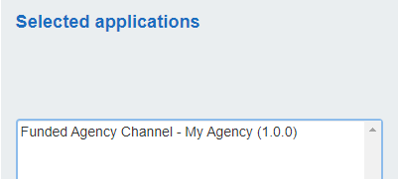
Figure 3 screenshot of Selected Applications screen

The Select application roles screen displays. Select the application roles checkbox. Select the Next button.
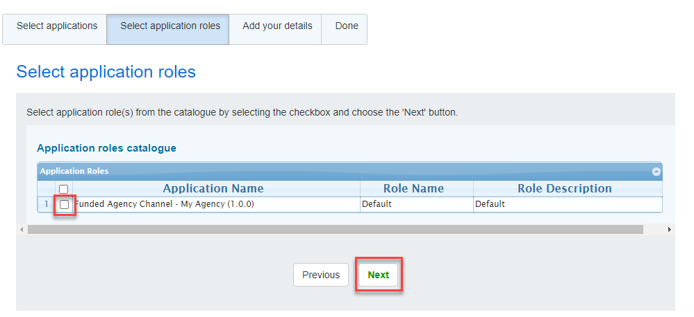
Figure 4 Screenshot of Select applications screen.
The Add your details screen displays. Proceed to complete the Contact details section, ensuring all mandatory fields are completed.
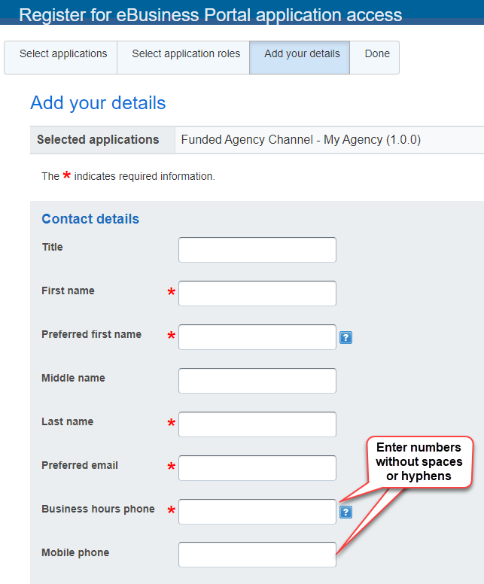
Figure 5 Screenshot of Add your details screen.

Proceed to Organisation details
Find your Organisation by typing the organisation name then choosing search. The results of the search will appear below in the Organisations found box. Choose your organisation and then choose the select button.
Your organisation will appear in the Organisation name box. Select an organisation role and optional Role description. Eg. Centre Manager

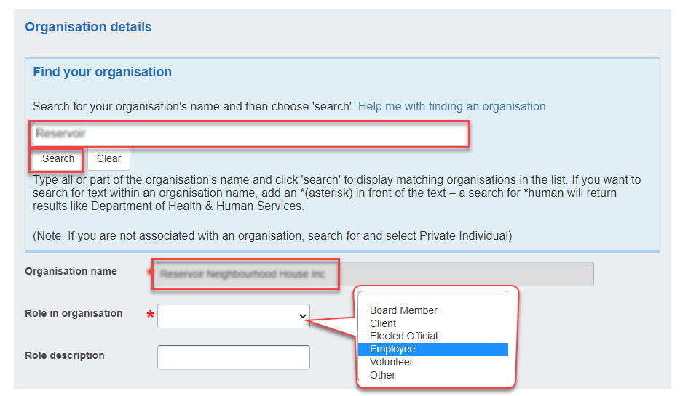
Figure 6 Screenshot of Organisational details screen

Proceed to complete the Security details section, ensuring all mandatory fields are completed.
Note: Ensure you remember the selected secret question and answer. You will need to re-enter this information if you forget your username or password (in the future).
Note: You must select the Agree box (Conditions of Use) to enable your registration to be processed. Please ensure that you read and understand the Conditions of Use prior to completing your request for registration.
Then click on register to complete your request.
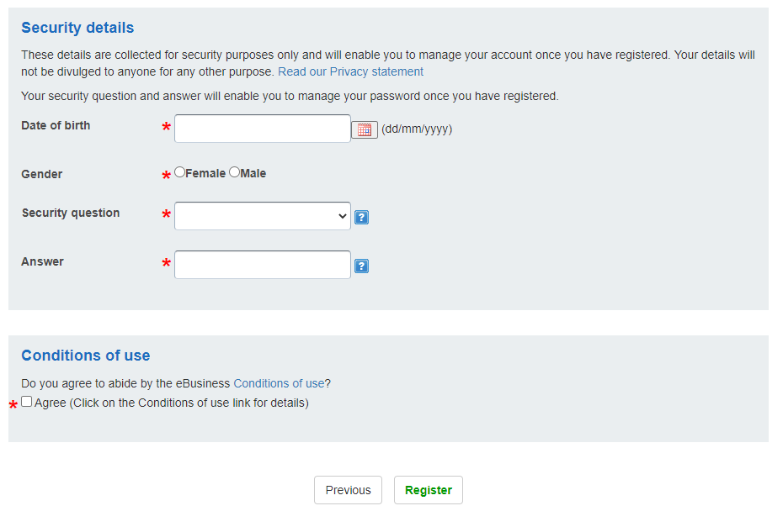
Figure 7 Screenshot of Security details screen and Conditions of Use checkbox
Post Registration
The Organisation Authority (OA) will receive an automated email from eBusiness to validate their staff member’s request.
The OA should log into their eBusiness account and access the Enterprise User Service application to validate eBusiness/application requests. If the request is not validated in a timely manner, it will time out and be automatically cancelled. The User will then need to resubmit
It is the organisation’s responsibility to advise eBusiness if an OA has left the organisation and to designate a new OA.
If approved, your request will then be forwarded to the Application Administrator (My Agency) to grant or deny access and an automated email, from eBusiness, will then be sent to your nominated email address providing your username and password.
Please ensure your username and password are kept in a secure location and are not shared with other users.

Troubleshooting
There are several steps in the registration process that can cause registration delays. The information below provides advice on how to overcome the most common registration issues.

My request for eBusiness access, or access to the application, is not being actioned.
The Organisation Authority (OA) within an organisation must validate all requests related to eBusiness. There are several reasons why the request may be delayed from the organisation’s side:

- The OA no longer works for the agency and therefore cannot approve the eBusiness request.
- The OA is on leave and has not approved the eBusiness request.
- The OA does not know the staff member and cannot confirm their identity.
- The staff member selected the wrong organisation name and therefore the request has been sent to the wrong OA.

If the OA no longer works for the organisation, a new OA will need to be appointed. The Organisation Authority nomination form must be completed prior to staff applying for eBusiness. This form also allows an organisation to nominate a secondary OA who will be able to action requests when the primary OA is on leave.
To obtain an Organisation Authority nomination form, please contact the eBusiness helpdesk on 1300 799 470 select option 1 then option 4. or email ebiz@support.vic.gov.au
My organisation’s OA has approved my request, but I haven’t received confirmation of my access.
Possible reasons why you may not have been notified of access include:
- An incorrect email address was provided in the eBusiness registration request, therefore the confirmation email bounced.
- The automated email confirming registration was recognised as SPAM and filtered into your email Trash/Junk folder.
- You entered a yahoo or hotmail email account. Your work email address must be used when registering.
To check your access, please email FAC@dffh.vic.gov.au

I received a confirmation email of my access however when I login it says access denied/invalid username and password.
Possible reasons why you may receive an error message include:
- Activation of eBusiness accounts and access to the application can take up to 24 hours.
- You have attempted to reset your password several times and the account has been locked. Contact the eBusiness helpdesk on 1300 799 470 select option 1 then option 4, to reset the account.

Logging in once registered
Go to https://fac.dffh.vic.gov.au/ and click on the ‘tile’ My Agency login – non DFFH and DH staff https://faceb.ace.webapp.dhs.vic.gov.au/facadmin
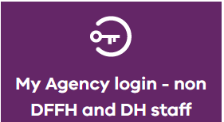
This will take you to the Security verification page, enter the eBusiness credentials you registered with and the My Agency page will then load.

- To receive this document in another format, email FAC@dffh.vic.gov.au <FAC@dffh.vic.gov.au>.
- Authorised and published by the Victorian Government, 1 Treasury Place, Melbourne.
- © State of Victoria, Australia, Department of Families, Fairness and Housing, July 2024

