

|  |
| --- |
| Change your eBusiness profile details |
|  |

Contents

What is eBusiness? 1

What is my eBusiness profile? 1

How to change your business profile details 1

Help 5

## What is eBusiness?

For all users other than Department of Health and Department of Families, Fairness and Housing employees the eBusiness Portal is the entry point to many applications including My Agency.

## What is my eBusiness profile?

Your eBusiness profile contains your personal information and is created when you register for eBusiness. If you wish to change your profile details, you can do so via the eBusiness Portal. Profile details that can be changed include your:

• Email address

• Business phone number

• Mobile phone number

• Security question and answer (labelled personal question and personal answer)

## How to change your business profile details

1. Log into the eBusiness Portal via <https://eus.webapp.dhs.vic.gov.au/EUSPortal/>
2. On the **eBusiness Login** page, enter your **username** and **password**. Select the **Login** button.

**Note**: You must select the check box stating you have read, understood and agree to abide by the Conditions of Use and Monitoring of Computer Services to proceed. Please ensure that you have read and understood them. A copy can be found by clicking on the hyperlinks or selecting the Conditions of Use or Monitoring of Computer Services tabs at the top of the screen.

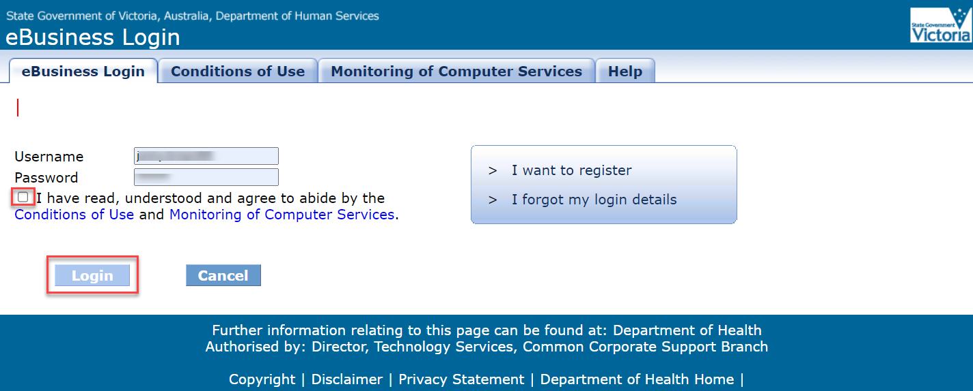

Figure 1 Screenshot of the eBusiness Login page

1. The **eBusiness Portal** screen displays. Select **My Profile**.

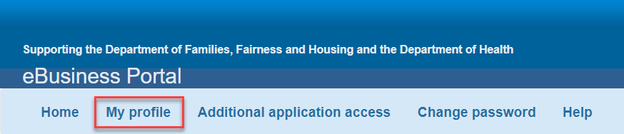

Figure 2 Screenshot of eBusiness Portal page

1. The **My Profile** screen displays, with your current registered details shown. Change the fields you wish to update, ensuring all mandatory fields, indicated by a red star, are completed.

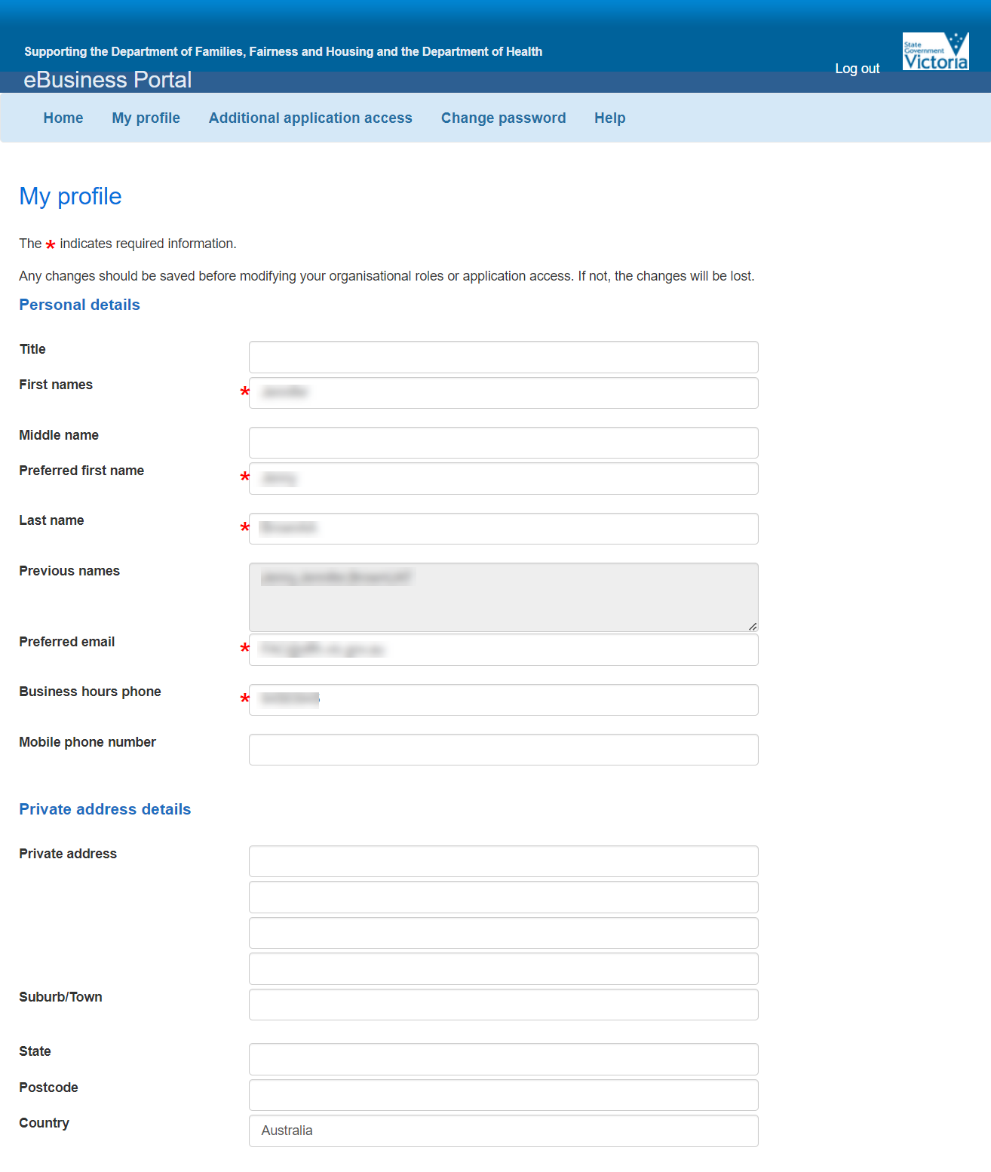

Figure 3 Screenshot of 1st half of the My profile screen

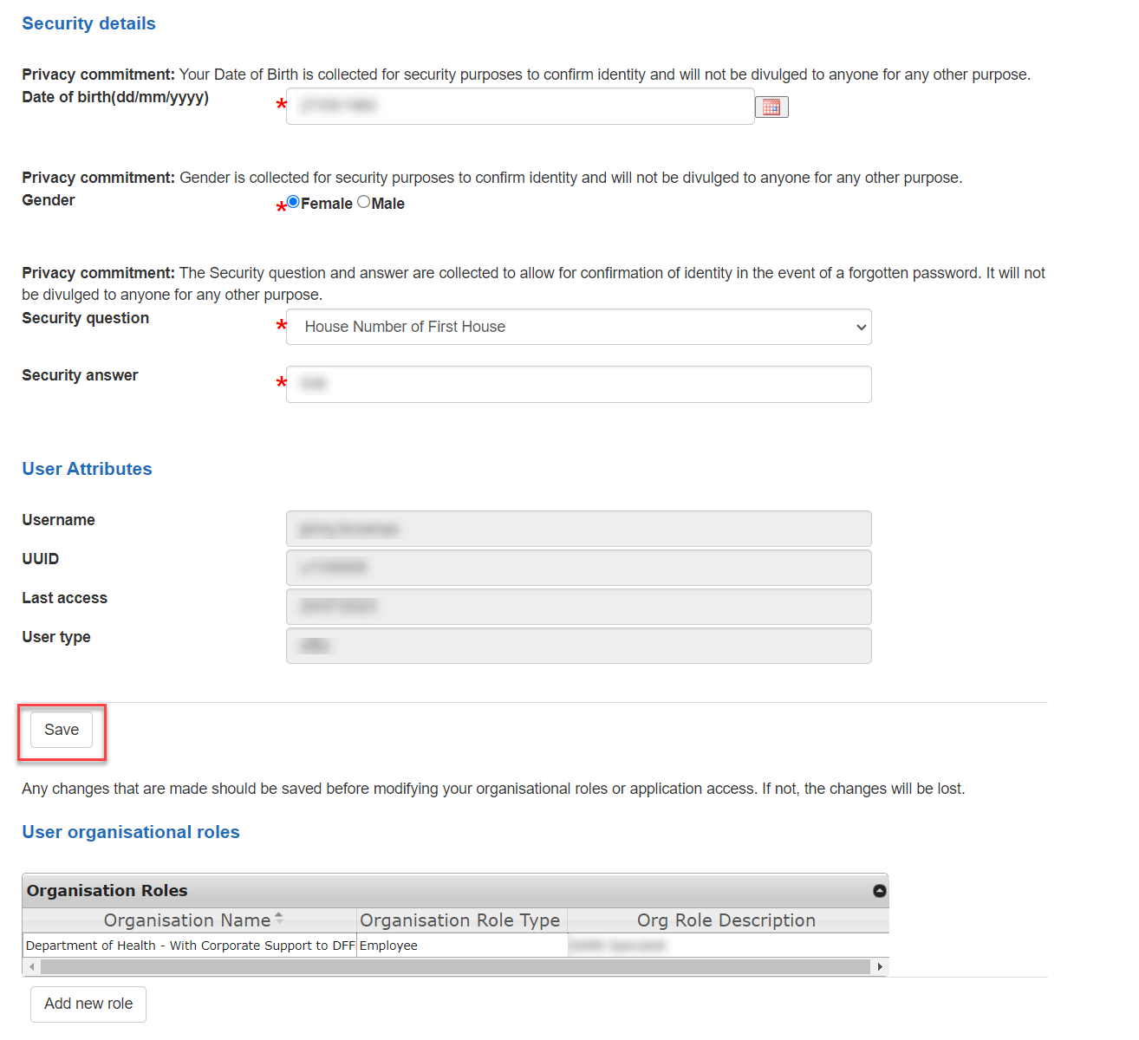

Figure 4 Screenshot of the 2nd half of the My profile screen

1. Press the **Save** button.
2. The Confirm your profile updates screen displays. Check that the changed details are correct. If yes, select the Confirm button. If no, select the Cancel button to start again. 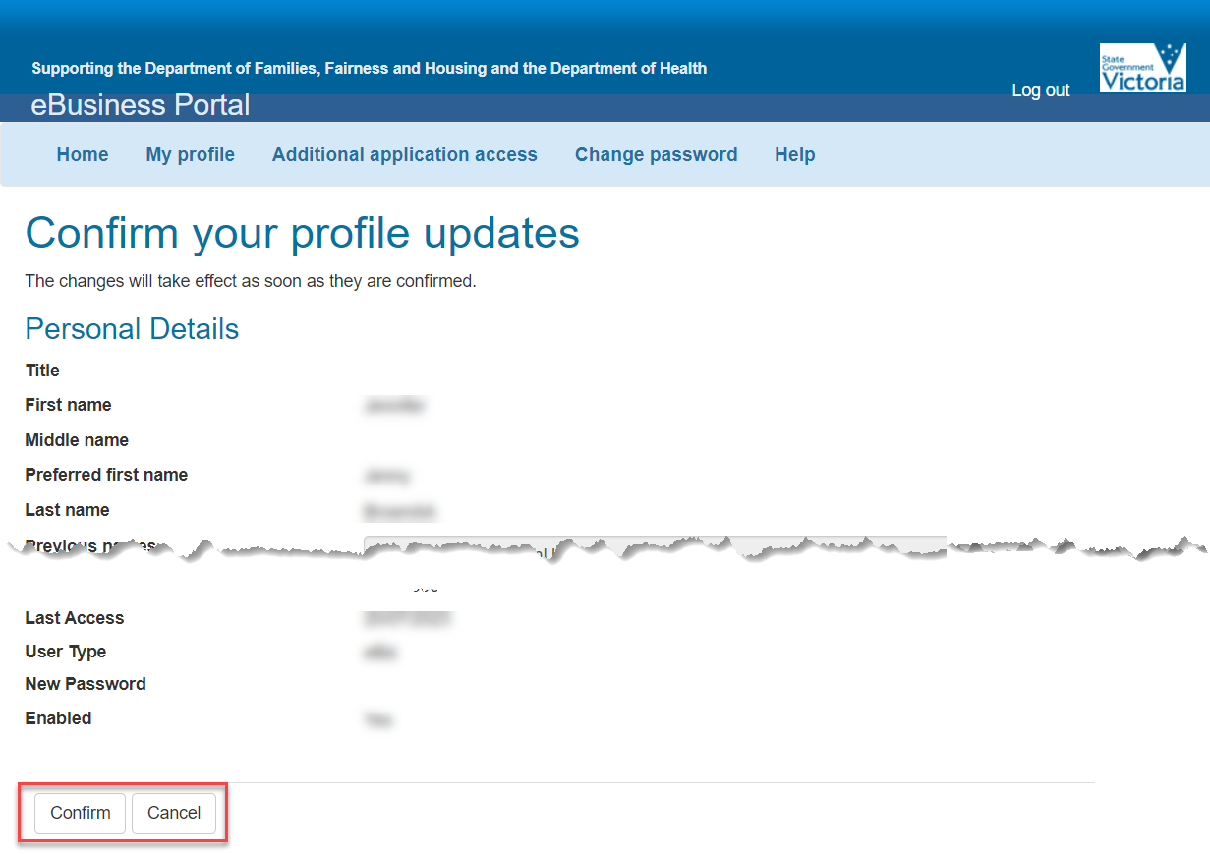

Figure 5 Screenshot of Confirm your profile screen

1. Confirmation message displays.

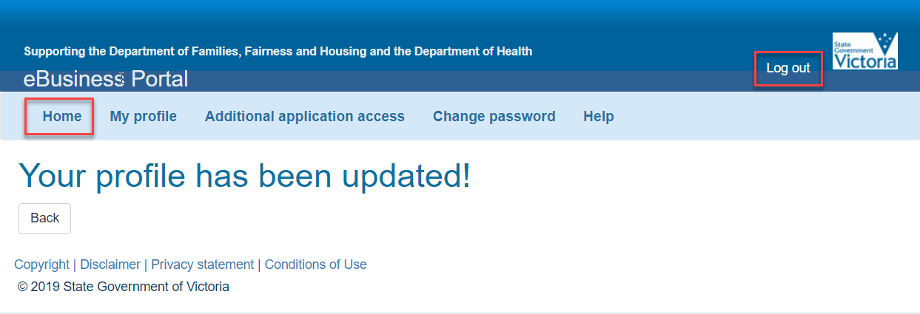

Figure 6 screenshot of the confirmation of your request updated

Select the Home tab to return to the eBusiness Portal page or select Log out to end the session.

## Help

If you experience any difficulties updating your profile, please contact the eBusiness helpdesk on 1300 799 470. Select option 1, then option 4.

|  |
| --- |
| To receive this publication in another format, email: the [Funded Agency Channel](mailto:fac@dffh.vic.gov.au) <fac@dffh.vic.gov.au>  Authorised and published by the Victorian Government, 1 Treasury Place, Melbourne.  © State of Victoria, Department of Families, Fairness and Housing, August 2024  Available on the [Funded Agency Channel](https://fac.dffh.vic.gov.au/my-agency-non-dffh-and-dh-staffhttps:/fac.dffh.vic.gov.au/my-agency-non-dffh-and-dh-staff) <https://fac.dffh.vic.gov.au/my-agency-non-dffh-and-dh-staff> |