

|  |
| --- |
| Client Recording Info System (CRIS/SP) enhancements |
| Guidance on how to use ‘Statement of Recognition’ case note category |
|  |

Contents

Purpose 1

Overview 1

Statement of Recognition Act 2023 1

Changes to CRIS/SP 1

CRIS/SP Guidance 2

# Purpose

Advise DFFH staff, Community Service Organisation and Aboriginal Community-Controlled Organisation staff of the changes in the Client Relationship Information System (CRIS/SP). Guidance is provided on how to use the ‘Statement of Recognition’ case note category to record the recognition principles (s. 7E) when working with Aboriginal children and their families.

# Overview

## Statement of Recognition Act 2023

As of 1 July 2024, the *Children and Health Legislation Amendment (Statement of Recognition, Aboriginal Self-determination and Other Matters) Act 2023* (Statement of Recognition Act 2023) amends the *Children, Youth and Families 2005* (CYFA) to embed the Victorian Government’s commitment to Aboriginal self-determination.

This includes the introduction of recognition principles (s. 7E) and further principles for placement of Aboriginal child (s.14) for staff to consider at all points of child protection involvement.

Child Protection are required to demonstrate to the Children’s Court how regard has been given to the recognition principles (s. 7E) when working with an Aboriginal child and their family.

## Changes to CRIS/SP

CRIS/SP has been updated to include a new ‘Statement of Recognition’ case note category.

The purpose of the ‘Statement of Recognition’ case note category is to allow for accurate recording of actions and services delivered by DFFH and community service organisations which support Aboriginal self-determination. The case note allows for the ability to audit and share information regarding how the recognition principles (s. 7E) were considered when working with Aboriginal children and families.

# CRIS/SP Guidance

### Create a new CRIS/SP case note

1. Open the child’s 360 Page and select the child’s ‘Current CP Case’
2. Select the ‘Notes & Documents’ tab
3. Select ‘Go’ under Create New Note or Document

**Note**: Do not use the ‘Quick Note’ function.

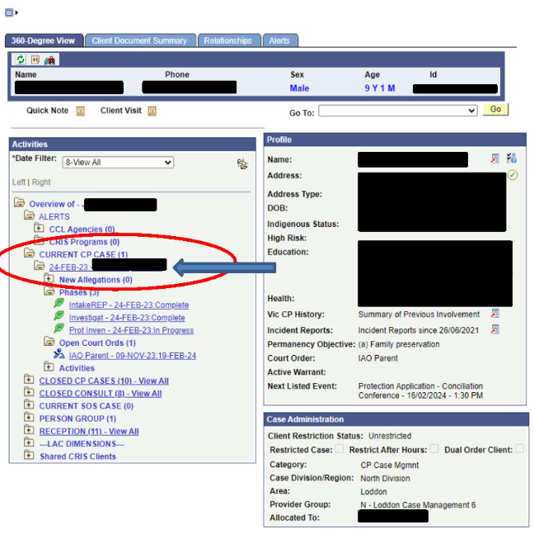

Select Notes and Documents on the tab at the top of the page



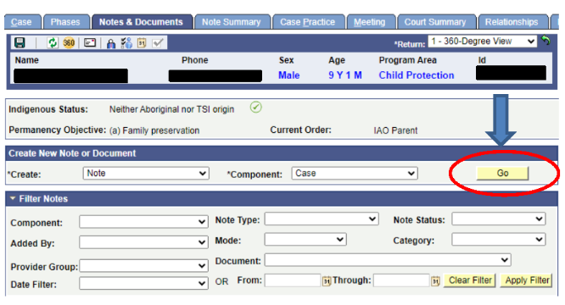

### Select the Statement of Recognition category

1. To categorise the new CRIS/SP case note under ‘Statement of Recognition’:
   * + open the drop-down menu under ‘Category‘
     + select ‘Statement of Recognition.’

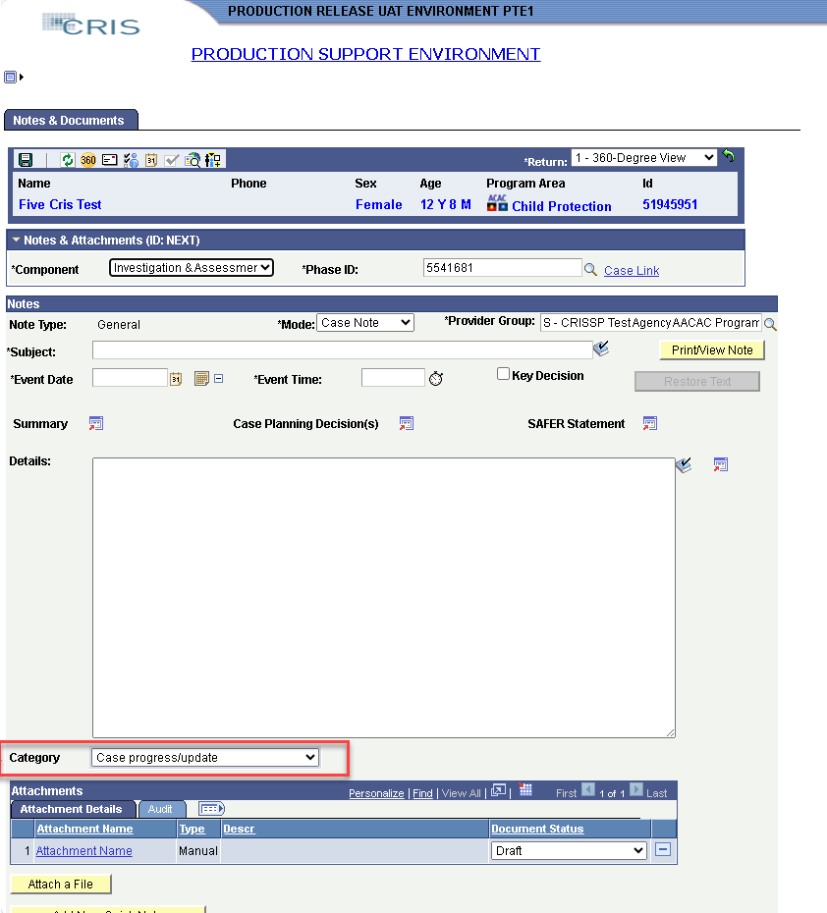

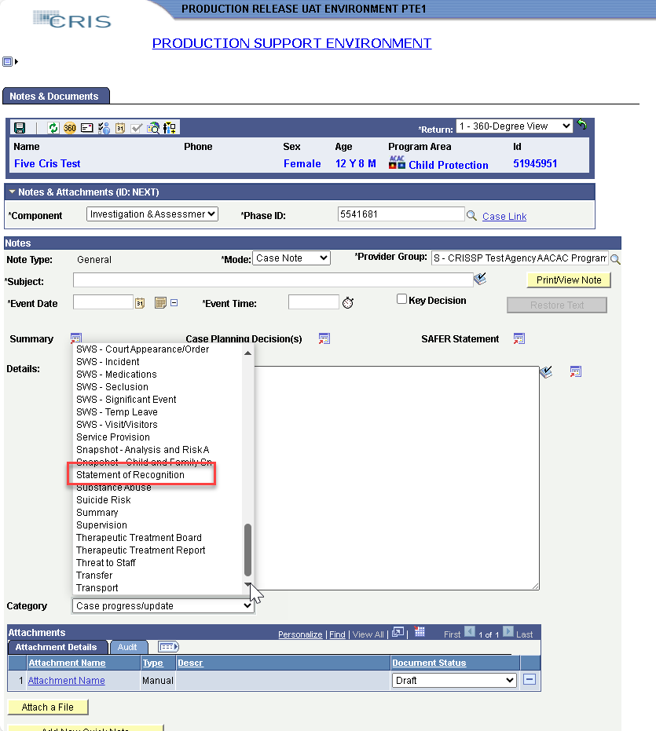

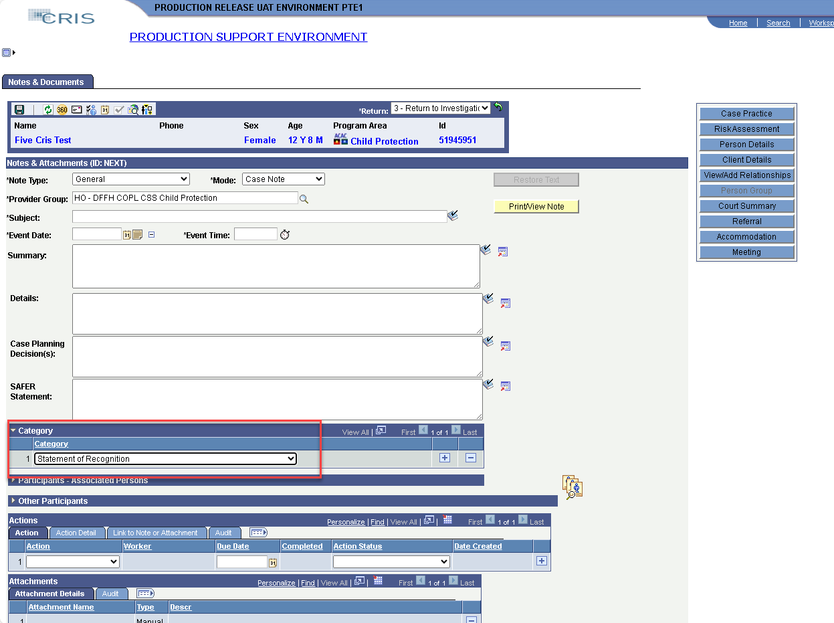

### Record decisions and actions related to the recognition principles (s. 7E)

1. Complete the CRIS/SP case note fields.
2. Record how the relevant recognition principles (s. 7E) were considered in the ‘Details’ field.
   * + This should include decisions and actions completed when working with Aboriginal children and families across all points of involvement.
     + Information may include relevant meetings with the child family, activities to support connection to culture, family and community, placement decisions, and barriers to supporting the principles.
3. Record how the recognition principles (s. 7E) were considered in decision-making and actions completed within the ‘Case Planning Decision(s)’ and ‘SAFER Statement’ fields.

Once the case note is completed, save the case note.

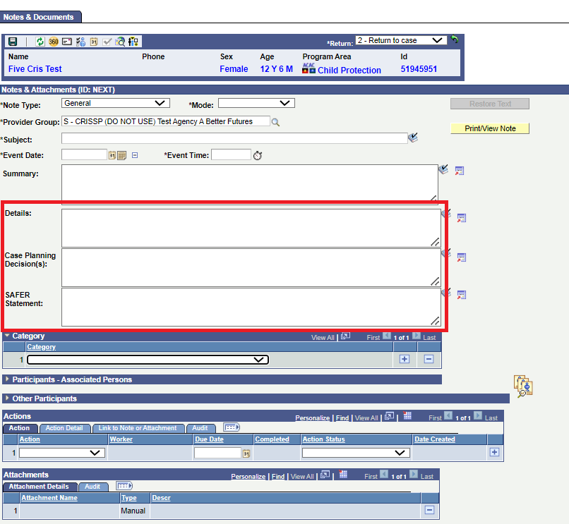

Locating Statement of Recognition case notes on CRIS/SP

* Open the ‘Notes & Documents’ Tab
* Under ‘Filter Notes,’ use the ‘Category’ drop-down menu and select ‘Statement of Recognition.’
* Select ‘Apply Filter’ and all case notes categorised under ‘Statement of Recognition’ will appear.

Note: Consider using the ‘Date Filter’ to assist with locating specific case notes.

When searching for a Statement of Recognition case note category select Statement of Recognition under 'category' type.

Select 'Apply Filter'

To receive this document in another format, email the Aboriginal Initiatives Unit [aboriginalinitiatives@dffh.vic.gov.au](mailto:aboriginalinitiatives@dffh.vic.gov.au)

Authorised and published by the Victorian Government, 1 Treasury Place, Melbourne.

© State of Victoria, Australia, Department of Families, Fairness and Housing, June 2024

In this document, ‘Aboriginal’ refers to both Aboriginal and Torres Strait Islander people.

**ISBN** 978-1-76130-586-3 (pdf/online/MS word)

Available at [Child Protection Manual](https://www.cpmanual.vic.gov.au) https://www.cpmanual.vic.gov.au