

|  |
| --- |
| Acknowledgement and publicity guidelines for Victorian Government funding support |

For organisations funded under a service or funding agreement with the Department of Families, Fairness and Housing, Department of Health, Department of Education and Adult, Community and Further Education Board.

Contents

Introduction 1

Keeping the funding confidential 2

Printed and verbal acknowledgement 2

Department signage at events 3

Government representative opportunities 3

Written acknowledgement statement of Victorian Government funding 3

Victorian Government logo for publishing, printing and signage 3

Which logo to use 4

Official colours and correct logo usage 4

Logo usage and placement 5

Further information 6

Organisations 6

Department staff 6

# Introduction

Under a service or funding agreement, organisations must acknowledge Victorian Government funding support. By acknowledging this support, organisations inform the community about how they are spending public funding.

Organisations must include this acknowledgement in:

* publications and publicity related to services funded. Including in:
  + websites (not including HTML or automatic updates of pages). Only include the funding acknowledgement where there is additional content or a new page about an initiative, program or service funded by the Victorian Government under the service or funding agreement.)
  + media releases
  + print and electronic documents
  + social media
  + speeches and launches.
* an organisation’s annual report.

**Please note:** Organisations do not need to acknowledge funding support in:

* general administrative notices
* messages such as weekly newsletters relating to operational aspects of the business.

These guidelines focus on publications and publicity that relate directly to services funded under a service or funding by the Victorian Government.

Unless otherwise specified in any other applicable departmental policy or schedules to a service or funding agreement, organisations must follow the acknowledgement requirements in this document. Some services have program-specific acknowledgement requirements described in other applicable departmental policies or schedules to an organisation’s service or funding agreement. This is often the case where the State and Commonwealth governments jointly provide the funding. In this case, the program-specific requirements will continue to apply. If there is a conflict between program-specific acknowledgement requirements and the acknowledgement requirements described in these guidelines, the program-specific requirements will override these guidelines.

Organisations should ensure that they are aware of their specific acknowledgement requirements. For questions about the funding acknowledgement requirements that apply to the services they deliver, organisations should contact the service or funding agreement department contact (departmental officer named in their service or funding agreement).

# Keeping the funding confidential

**Organisations may need to keep the funding confidential until there is a public announcement.**

Once approved, funding can remain highly confidential until the relevant minister or their representative publicly announces the funding. The department will advise you in writing if this applies to your funding.

# Printed and verbal acknowledgement

Organisations must acknowledge the Victorian Government’s funding support and any key messages about the department for services funded under the service agreement:

* in speeches and presentations about the project or funded activity
* in media releases
* in relevant job advertisements
* on documents, publications, reports, brochures, posters, flyers and the like. You must give the government the opportunity to contribute a sponsor’s message for any relevant publication
* on websites or other digital communications media, developed with the government’s funding support. These should also include a link to the department website. Contact the department for the relevant department website URL
* in social media text and/or images. Where possible, the social media executions should include a written acknowledgement of Victorian Government funding and/or the Victoria State Government logo and a link to the relevant departmental website (depending on the social media channel.)

In limited circumstances, an organisation may be exempt from using the Brand Victoria logo in some publicity and publications related to services funded. If you have any questions or need to clarify whether an exemption may apply, please contact the departmental officer named in your service or funding agreement.

# Department signage at events

* Organisations must prominently display the department’s signs or banners at all openings, launches and events supported by or associated with government funding support.
* Programs/invitations/websites should display the Brand Victoria logo (as relevant)
* Any speeches and presentations should include a verbal acknowledgement of Victorian Government support. Where appropriate, acknowledge the relevant minister and the relevant program/service name.

Organisations can borrow department signs and banners from the department. Your organisation must organise their collection, display and prompt return. Please contact the department (departmental officer named in your service or funding agreement) about any upcoming openings, launches or events that need a department sign or banner.

Some events may not require a department or Victorian Government banner if organisations develop banners related to the funded service or initiative that include the Brand Victoria logo.

# Government representative opportunities

Organisations that launch or open the funded service or project activity at a public event or similar must:

* give the relevant minister or representative the opportunity to open or launch the service or project activity
* invite the department and the minister to all significant events associated with the service or project activity
* give adequate notice (the department recommends at least two months’ lead time)
* work with the department to coordinate the minister and/or their representative’s role in the opening or launch, or their attendance at events.

# Written acknowledgement statement of Victorian Government funding

Include one of the statements below in acknowledgement statements associated with the funded service activity:

* The [name of program/s/projects/s/ service/s] was/were supported by the Victorian Government.
* The [name of program/s/projects/s/ service/s] are/is supported by the Victorian Government.
* [Name of organisation] acknowledges the support of the Victorian Government.

**Please note:** Organisations must acknowledge the Victorian Government, not the individual department.

# Victorian Government logo for publishing, printing and signage

You must use the Victorian Government logo on all published or printed materials or signage associated with the:

* service
* funding agreement, or
* funded activity.

You cannot alter these logos under any circumstances. Do not copy and paste the logo from this document or any other Victorian Government publication or website. Use the downloadable logos.

## Which logo to use



### How to access the logo

Organisations can download the **Victoria State Government logo** from [Vic.gov.au – Brand Victoria – using our logos – Download Victoria State Government logos](https://www.vic.gov.au/brand-victoria-using-our-logos#page-component-3761) https://www.vic.gov.au/brand-victoria-using-our-logos#page-component-3761.

* Use the .png files for online documents and websites.
* Use the .eps files for professionally designed documents and videos. Note: To open these files requires ed particular software that professional graphic designers use. Your organisation may not be able to open these files.

## Official colours and correct logo usage

Do not alter the logo.

* Black is the official colour of the logo. The web-safe colour is RGB (R = 0, G = 0, B =0).
* Make sure there is enough contrast between the background and the logo.
  + Use a white logo where the background is a solid dark colour.
  + Use a black logo where the background is a light colour.
* Don’t place the logo over an image or a pattern unless there is enough contrast to show the logo clearly.
* Don’t place the logo over other text.
* Don’t stretch or distort logos. Always keep the ratio between width and height measurements the same.
* The area surrounding the text and triangle should show the underlying background colour.
* It should never appear with a white box around it.

The following examples show the correct and incorrect use of the logo. Note that the organisation’s own brand colours can be in the background.

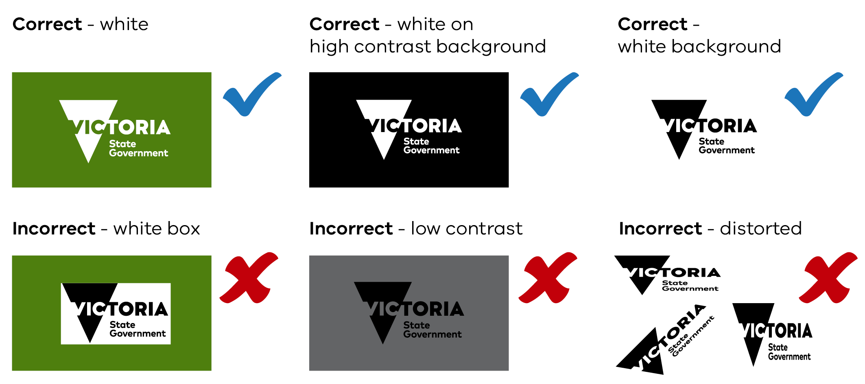

## Logo usage and placement

The visual style of the organisation receiving the funding should be the primary brand of the document or website. The Brand Victoria logo can be on either side, above or below the organisation’s own logo.

The organisation receiving the funding should use their own brand or visual style. They can place the Brand Victoria logo on either side, above or below their own logo.

### Clear space

Maintain ‘clear space’ around the Brand Victoria logo.

Clear space creates an invisible frame that is a minimum area surrounding the logo. It must remain free of any conflicting visual elements.

Wherever possible, apply additional clear space beyond the minimum requirement.

#### Clear space for Print applications

The clear space for print applications is at least 50% of the triangle’s height in the logo.

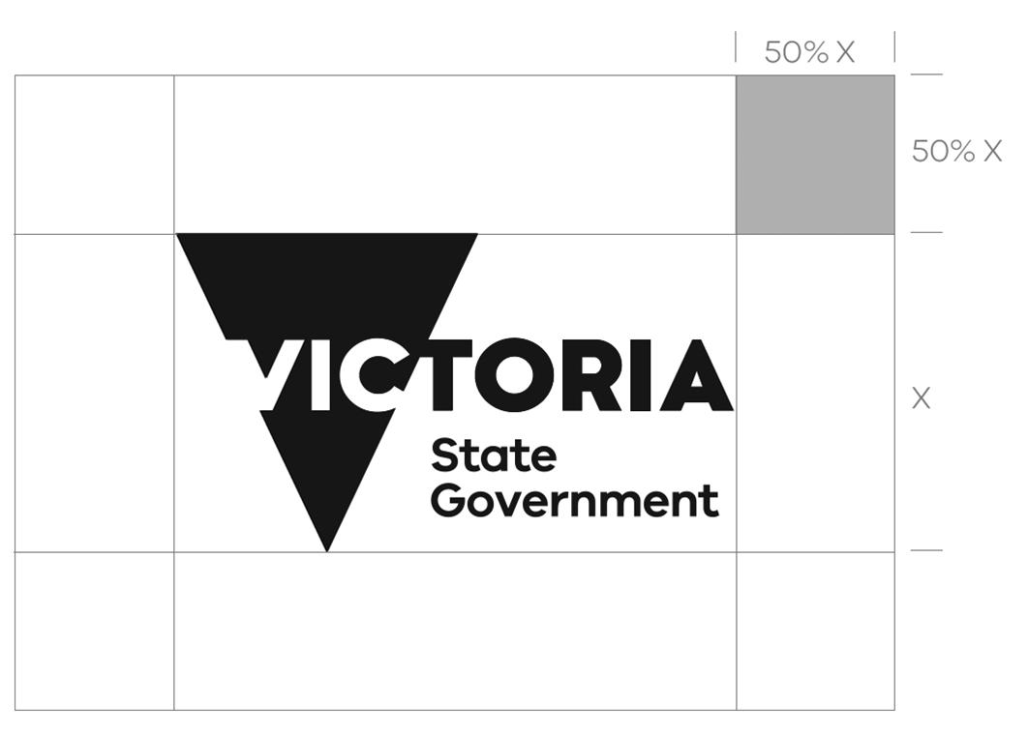

#### Clear space for Screen applications

The clear space for screen applications is at least 20% of the triangle’s height in the logo.



#### Minimum size of logos

The minimum size for **print applications** is 10 mm from the top to the bottom of the triangle in the Brand Victoria logo.



The minimum size for **screen applications** is 60 pixels from the top to the bottom of the triangle in the Brand Victoria logo.



Use the logo larger than the minimum size if there is a question about reproduction quality.

# Further information

## Organisations

In the first instance, organisations should contact the departmental officer named in their service or funding agreement if they have any queries about the acknowledgement and publicity guideline or how to use the logo.

The department staff member will contact the department’s communications team on their behalf to clarify logo usage, where necessary.

## Department staff

If departmental staff have any questions or need to clarify details related to the use of the logo, they can email the relevant communications team below.

* **Department of Families, Fairness and Housing** **–**  [brand.design@dffh.vic.gov.au](mailto:creative.studio@dffh.vic.gov.au)
* **Department of Health –** [creative@health.vic.gov.au](mailto:creative@health.vic.gov.au)
* **Department of Education –** [designstudio@education.vic.gov.au](mailto:designstudio@education.vic.gov.au)
* **Adult, Community and Further Education Board –** [ACFEB.Secretariat@djsir.vic.gov.au](mailto:ACFEB.Secretariat@djsir.vic.gov.au)

|  |
| --- |
| To receive this document in another format, email Service Agreement Communication [sacomms@dffh.vic.gov.au](mailto:sacomms@dffh.vic.gov.au)  Authorised and published by the Victorian Government, 1 Treasury Place, Melbourne. © State of Victoria, Australia, Department of Families, Fairness and Housing, updated and reissued July 2024.  **ISBN** 978-1-76130-629-7 (Online/Word)  This document is available on ‘Acknowledgement and publicity guidelines for Victorian Government funding support’ on [Funded Agency Channel](https://fac.dffh.vic.gov.au/acknowledgement-and-publicity-guidelines-victorian-government-funding-support) https://fac.dffh.vic.gov.au/acknowledgement-and-publicity-guidelines-victorian-government-funding-support |