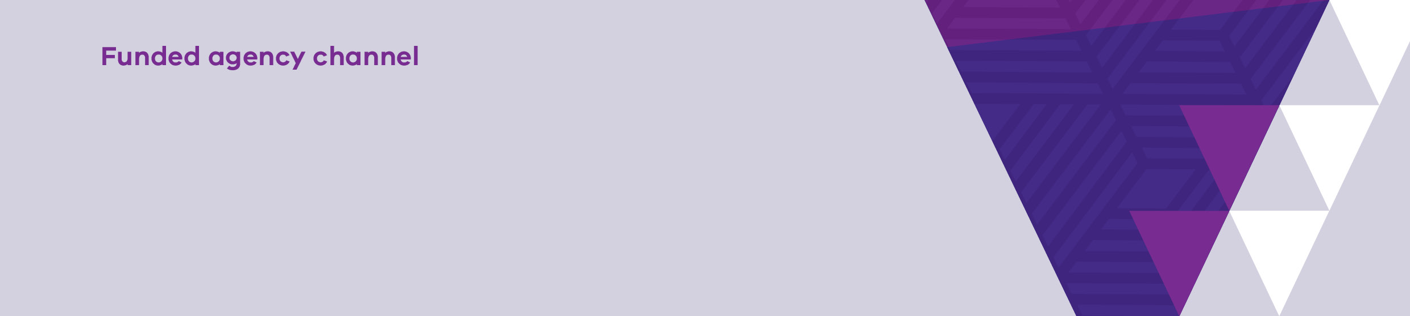

|  |
| --- |
| Transcript – How to run the Payment schedule report in My Agency |
| Payment schedule report |

Welcome to this video on how to run and view, the Payment schedule report.

This report displays the payment schedule of the contract version of the agreement at commitment level.

To access the report, Select the Payment schedule report link from My Agency.

The first page of the report allows you to filter the report data by Department, financial year, agreement number, service plan division/region/group, service plan template, activity and area.

If you change any of the default values you must select ‘View Report’ to update the values.

In this example, we will select “DHHS”. Remember to untick “All”.

SELECT “View Report”.

The first page of the report displays details about the payment schedule for DFFH agreements. The payment schedules are displayed in chronological order.

To view the second page, SELECT the forward arrow.

Details about payment schedule at agreement level are displayed to the end of the financial year.

To view payment schedule details at service plan, activity and commitment level, select the forward arrow.

Details about the Organisation, Agreement, Service plan, Activity, Commitment, Payment schedule and Invoices are displayed.

You can see the breakdown of each payment schedule, for example <DD-MM -YYYY>.

To export and save data, follow the same process as shown in the Video titled – How to run Organisation User report in My Agency.

Thanks for watching.

|  |
| --- |
| To receive this publication in an accessible format email [Service Agreement Communications](mailto:sacomms@dhhs.vic.gov.au) <sacomms@dffh.vic.gov.au>  Authorised and published by the Victorian Government, 1 Treasury Place, Melbourne.  © State of Victoria, Department of Families, Fairness and Housing, April 2024.  Available at [fac.dhhs.vic.gov.au](https://fac.dhhs.vic.gov.au/fac-online-training) <https://fac.dhhs.vic.gov.au/fac-online-training> |