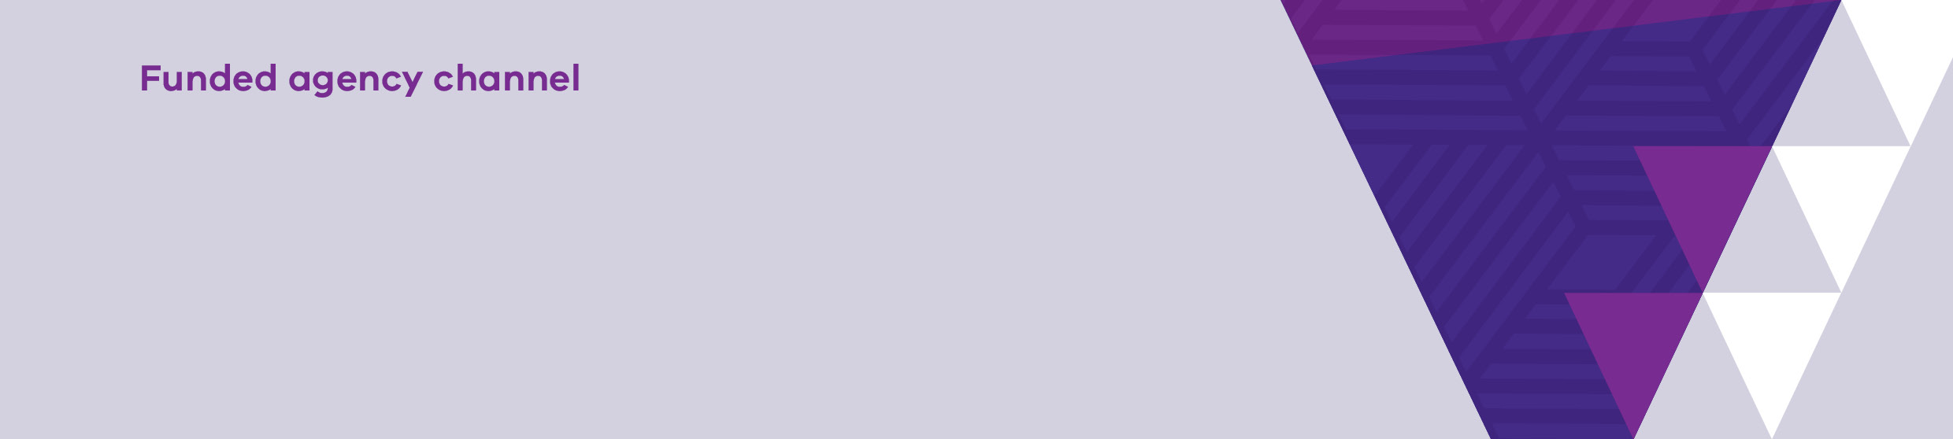

|  |
| --- |
| Transcript – How to run the Invoices  report in My Agency |
| Invoices report |

Welcome to this video on how to run and view, the Invoices report.

This report displays all invoices paid to the organisation for the current agreement period.

Unpaid invoices are not shown.

To access the report, Select the Invoices report link from My Agency.

The first page of the report allows you to filter the data by Department, financial year, agreement number and service plan division/group/region.

If you change any of the default values you must select ‘View Report’ to update the values.

In this example, we will select “DFFH”. Select “View Report”.

The first page of the report displays details about invoices paid at the agreement level for DFFH.

The invoice details are in chronological order.

To view the second page, SELECT the forward arrow.

Details about invoices paid at agreement level are displayed from the start of the financial year.

To view payment details at service plan, activity and commitment level, select the forward arrow.

Details such as invoice number, Service plan division/group/region, activity code, activity name, Commitment id and the amount paid are displayed.

On this page, you can view the breakdown of a particular invoice down to commitment level.

You can now see the breakdown of the invoice dated <<DD-MM-YYYY>>.

To export and save data, follow the same process as shown in the Video titled – How to run Organisation User report in My Agency.

Thanks for watching.

|  |
| --- |
| To receive this publication in an accessible format email [Service Agreement Communications](mailto:sacomms@dhhs.vic.gov.au) <sacomms@dffh.vic.gov.au>  Authorised and published by the Victorian Government, 1 Treasury Place, Melbourne.  © State of Victoria, Department of Families, Fairness and Housing, April 2024.  Available at [fac.dhhs.vic.gov.au](https://fac.dhhs.vic.gov.au/fac-online-training) <https://fac.dhhs.vic.gov.au/fac-online-training> |