

|  |
| --- |
| Targeted Care Packages |
| Key worker standardised hourly payment rates:  Community Service Organisations – FAQ |
|  |

# Purpose

This document defines Targeted Care Packages (TCPs) key worker rates for Community Service Organisations (CSOs), including Aboriginal Community Controlled Service Organisations.

The key worker has a pivotal role in supporting TCP implementation through case management functions that adhere to the child or young person’s case plan and cultural support plan.

Key worker standardised hourly payment rates were established to provide a fair and reasonable service cost, and to ensure consistent application of these rates across CSOs and divisions.

# Key worker hourly rates

#### What are the hourly payment rates for key workers, taking into consideration the complex needs of children and young people in residential care or at risk of entering residential care?

The key worker hourly rates include all face-to-face direct care services costs, including the delivery of these services at a prescribed level.

The hourly rates represent fair and reasonable prices for the delivery of high-quality case management service delivery outputs.

The hourly rate is inclusive of:

* salary and associated salary on-costs
* supporting non-wage costs
* fully costed case worker supervision allowance

Non-wage standardised items include:

* management costs
* staff vehicle allowance costs
* administrative costs
* agency overheads

In addition to salary on-costs and supporting non-wage costs, these rates include an allowance for part lease of a motor vehicle and backfill allowance for compliance requirements.

#### How are administrative costs funded under the hourly rate schedule?

Key worker hourly rates include administrative costs, on cost items or non-wage items. Additional administrative costs, including agency overheads, should not be claimed on top of key worker services payment.

The key worker hourly rates do not extend to services purchased from other service providers (e.g. funding for a therapeutic specialist service purchased from another agency).

The hourly payment rates do not include key worker after hours services.

A schedule of payment rates has been established (at Table 1) that takes into consideration the complex nature of care required to support children and young people transitioning from residential care or at risk of entering residential care.

Table 1. Key worker hourly payment rates[1]

| **Worker classification / description** | **Hourly rate* 1 October 2023** | **Annualised cost^** |
| --- | --- | --- |
| **Key worker: Level 1** | $109.32 | $143,252.93 |
| **Key worker: Level 2** | $118.53 | $155,321.71 |
| **Key worker: Level 3** | $128.57 | $168,478.13 |

**\***The hourly rate represents face to face direct care service costs. Salary on-costs and non-wage items are included.   
**^**The annual cost represents total 1.0 FTE cost based on annual effective service hours.

~Key Worker Level 3 is applied when the key worker delivers contracted case management.

The required face to face direct care service costs must be clearly identified in the proposal including how the key worker’s specialist skills, decision making ability, and experience is needed to meet the child/young person’s support needs. The TCP team assess the key worker classification and the DFFH Executive Directors or Care Service Managers, endorse it.

To assist with this process, *TCP Funding Schedule* calculates the annual cost of weekly face to face direct contact hours. For example:

* 5 face to face direct contact hours per week at Key Worker Level 1 = 5 x $109.32 (annual cost = $28,423.20)
* 10 face to face direct contact hours per week at Key Worker Level 1 = 10 x $109.32 (annual cost = $56,846.40)
* 25.2* face to face direct contact hours at Key Worker Level 1 = 25.2 x $109.32 (annual cost = $143,252.93)

\***25 hours per week is a full-time position** – to calculate the annual cost in the *TCP Funding Schedule*, enter 25.2 hours in ’Number of direct service hours per week’.

Table 2. TCP Funding Schedule Key Worker Service Cost Calculator examples

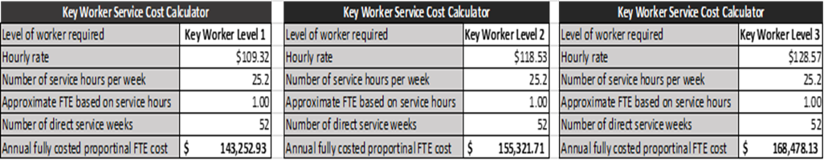

**In general, an appropriate number of hours should be allocated to support clients with complex needs.** That is, total support hours are proportionate to the child or young person’s complex needs.

The Key Worker Level 3 rate is applied when the key worker needs to deliver contracted case management to children and young people with multiple and complex high-risk behaviour and emotional difficulties.

If the application of these rates is still unclear, contact your Divisional Targeted Care Packages Coordinator

How do the standardised hourly rates apply to other CSO support staff funded under a package?

Key worker classification levels provide flexibility in delivering key worker services (e.g. contracted case managers versus case workers delivering case management like functions).

The standardised hourly rates support shared arrangements for key worker services. For example, a specified number of hours can be applied against each of the worker classification levels based on client need.

Support workers undertaking services, such as assisting with transportation or day to day care, do not fall within the hourly payment rates as above.

#### What does the application of standardised hourly rates involve?

**New packages**

Since October 2017 packages have standardised key worker hourly rates. Packages that started before October 2017 transitioned to the standardised hourly payment rate by July 2018.

CSOs and department staff must ensure the packages standardised hourly rates are appropriately reflected in the proposal submission and assessment. This includes the following:

Each proposal submitted to the department is authorised by the relevant CSO staff and approved by department staff with delegation.

CSO and department staff must ensure all key worker administrative, on cost items or non-wage items are included in the hourly rate. Additional administrative costs, including agency overheads, will not be approved.

CSOs provide a clear description of the key worker services in section 5 of The TCP New proposal: Key worker, and/or TCP Review proposal section 7. Key worker hours.

Table 2. Extract from TCP New proposal, Section 5.

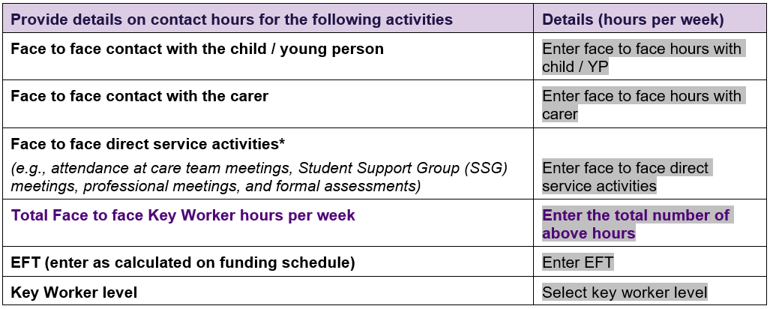

# Key department contacts

For general queries about TCPs and key worker rates please contact the Targeted Care Packages coordinator in your division.

|  |  |  |
| --- | --- | --- |
| Division | Contact | Contact email |
| **North Division** | Targeted Care Packages coordinator | *targetedcarepackagesnorth@dffh.vic.gov.au* |
| **South Division** | Targeted Care Packages coordinator | [*targetedcarepackagessouth@dffh.vic.gov.au*](mailto:targetedcarepackagessouth@dhhs.vic.gov.au) |
| **East Division** | Targeted Care Packages coordinator | [*targetedcarepackageseast@dffh.vic.gov.au*](mailto:targetedcarepackageseast@dhhs.vic.gov.au) |
| **West Division** | Targeted Care Packages coordinator | *targetedcarepackageswest@dffh.vic.gov.au* |

|  |
| --- |
| To receive this document in another format, phone 9500 6353, using the National Relay Service 13 36 77 if required, or email [DFFH Care Services Design and Improvement](mailto:lisa.vella@dffh.vic.gov.au) <careservices@dffh.vic.gov.au>.  Authorised and published by the Victorian Government, 1 Treasury Place, Melbourne.  © State of Victoria, Australia, Department of Families, Fairness and Housing, October 2023.  ISBN/ISSN 978-1-76069-150-9 (online/print)  Available at [Funded Agency Channel](https://fac.dffh.vic.gov.au/policies-and-procedures) <https://fac.dffh.vic.gov.au/policies-and-procedures>. |

1. Key worker hourly rates will be indexed every 1 July to reflect the application of NGO indexation.