

|  |
| --- |
| Digital Opportunities CRIS Updates |
| Infant Response/Intensive Infant Response (IR/IIR) |
| OFFICIAL |

## Purpose

This article gives guidance on:

* Changes to the management of IR/IIR in CRIS,
* Updates to recording critical IR/IIR information,
* Updates to the management of IR/IIR referrals for a Principal Practitioner/Practice Leader Consult and Internal and External Panel meetings.

## Guidance

A step-by-step video walkthrough of the updates to IR/IIR client case management activities in CRIS can be accessed in the Child Protection Learning Hub Digital Opportunities - ICCMS Enhancements.

## Management of IR/IIR in CRIS

#### Recording of IR/IIR decision

A new mandatory function for staff with a Team Managers and above role, has been added to CRIS to record the IR/IIR decision when endorsing the first SAFER risk assessment.

1. From the SAFER risk assessment screen, when the risk assessment is ready for endorsement, select the pre-endorsement checklist and record your decision. For any client under two years of age, CRIS will ask for an IR decision to be recorded.

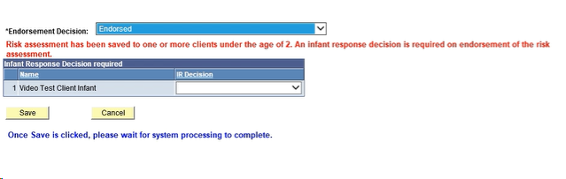

#### Navigating to the IR/IIR workspace

#### The IR/IIR workspace is accessible from the workspace tab in CRIS and will take a worker to a high-level overview of all open IR/IIR cases and their status.

#### 

#### From the IR/IIR workspace users will be able to view their own clients and staff with a Team Managers or above role will have the option of selecting to view their teams clients or areas clients with an IR/IIR classification.

#### 

#### Navigating to the IR/IIR page from Case Practice

1. The case practice index has an updated High-Risk Infant Response link under the SAFER Analysis index area. This new High Risk and Infant Response index hyperlink takes you to a screen that will store all information in relation to IR/IIR activities.

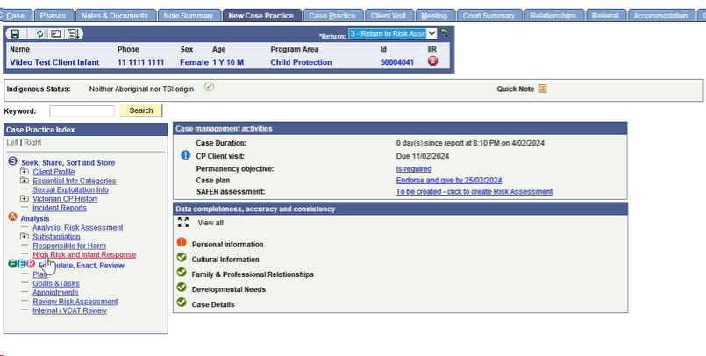

1. Clicking on the High Risk and Infant Response index hyperlink will bring up the High-Risk Schedule page. Click on the more details icon in the details column to view and record information in relation to the IR/IIR decisions and activities.

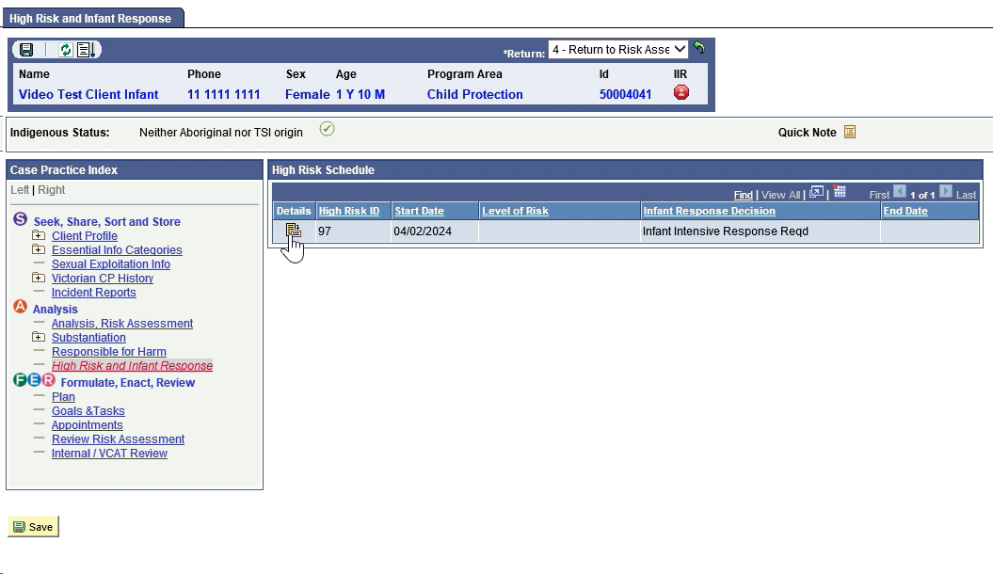

1. This will open the High Risk and Infant Response page where practitioners can view current activities that have been completed or are due, including allocation status, visit details and PP/PL consultations and Internal and External Panel Meeting details.

#### High Risk and Infant Response Page

1. The High Risk and Infant Response page has been updated to enable users to easily manage, record and update IR/IIR activities.

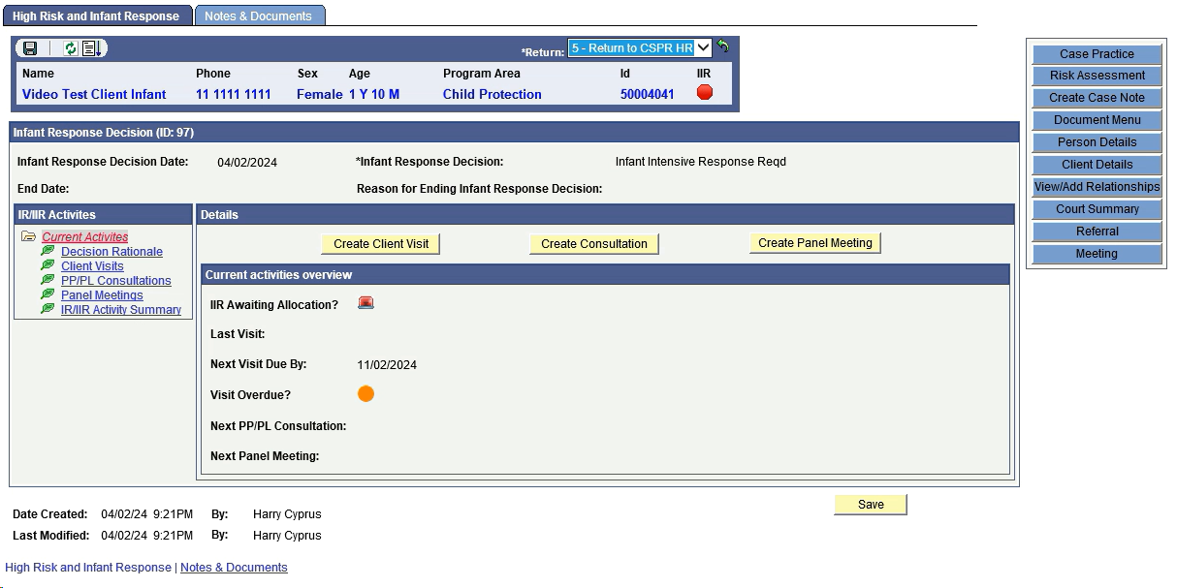

#### Create Client Visit

Users can create a client visit from the 360 page quick link, the notes and documents tab and the High Risk and Infant Response page; any client visit record that is created will automatically populate the client visit activity summary in the High Risk and Infant Response page on finalisation of the visit (refer to page 9).

1. From the High Risk and Infant Response page, click ‘Create Client Visit’ and the following will open:

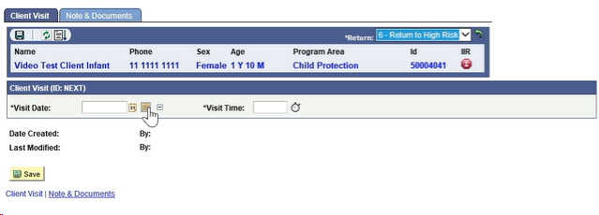

1. Enter the visit date and visit time information and select save. This will take you to the client visit record page. The Client Visit Record page for IR/IIRs includes a section specifically for infant response information with practice prompts.

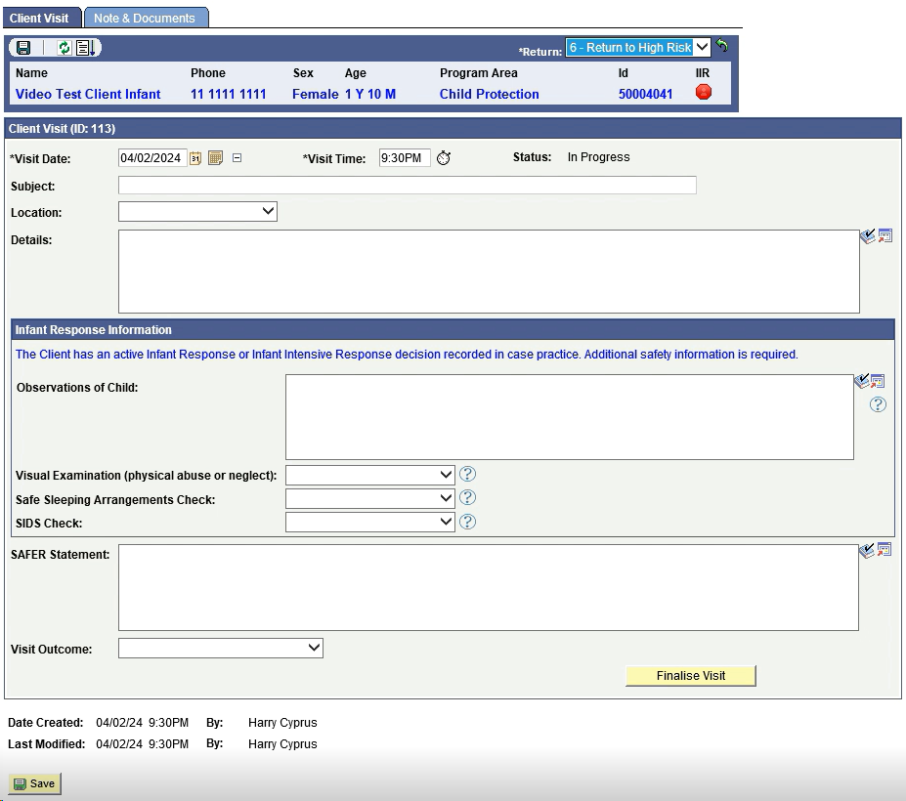

***NOTE****: If you save the client visit, you are able to continue editing and updating the record later. Once you select finalise visit, this will generate the client visit document, and all fields will be made read-only, no changes can be made to the visit case note after selecting finalise.*

1. 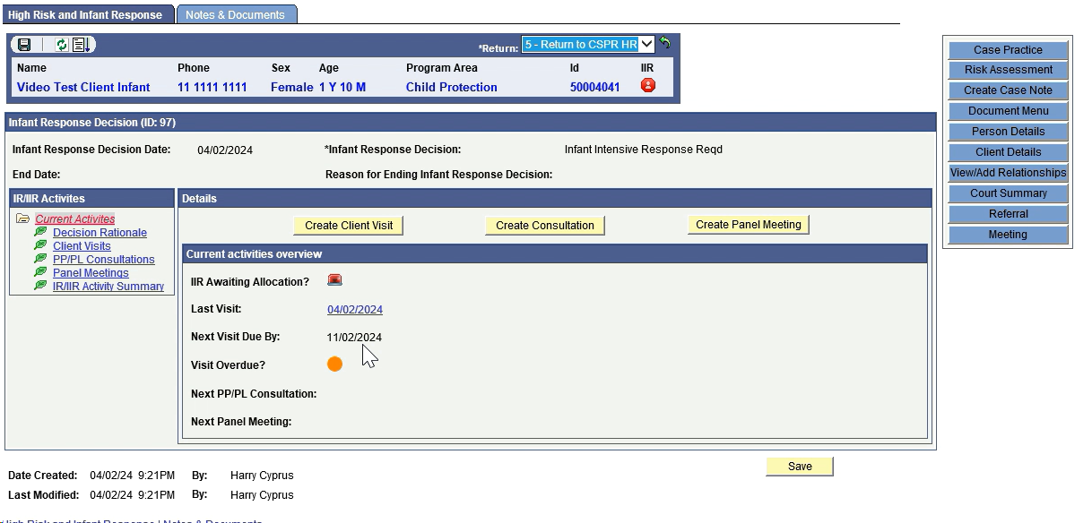After completing the client visit date, time and client visit document, this automatically updates the visit information in the High Risk and Infant Response summary page; see below:

#### Create Consultation

1. From the High Risk and Infant Response page, click Create Consultation and the following will open:

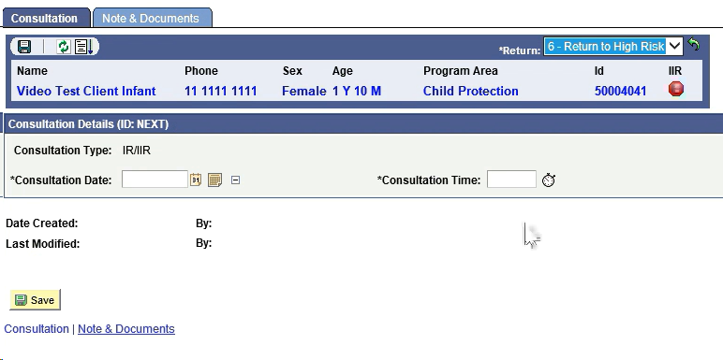

1. Enter the Consultation Date and Consultation Time and select save. This will take you to the Consultation page, where you can preview the consultation request and add consultation details.

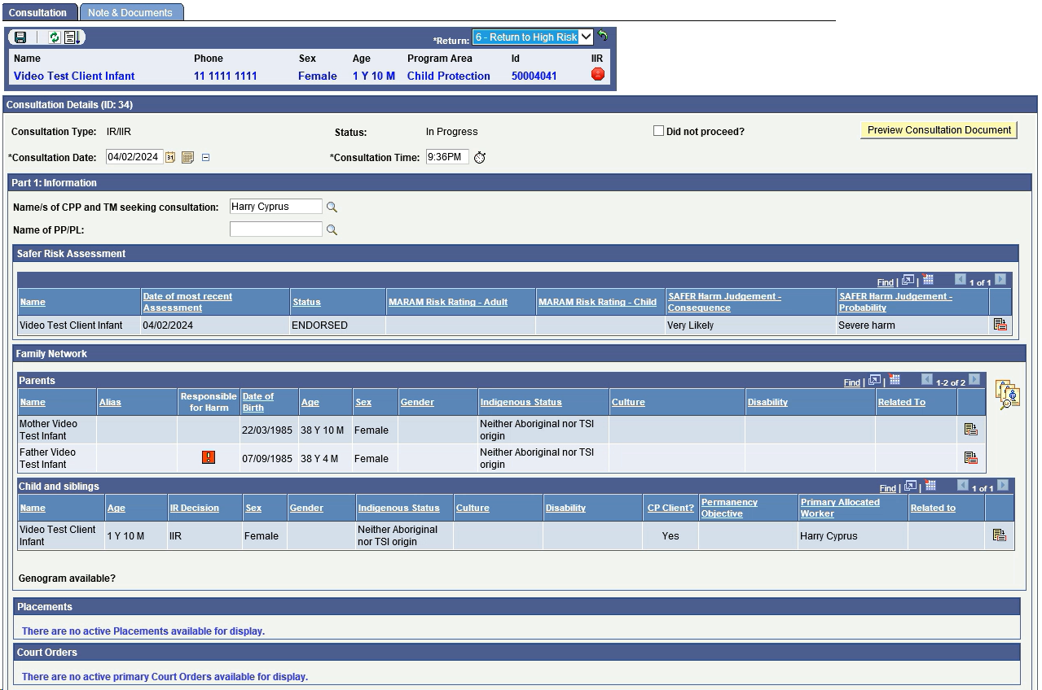

1. In this screen, practitioners can also add details required for the consultation, relevant background information, and the purpose of the consultation.

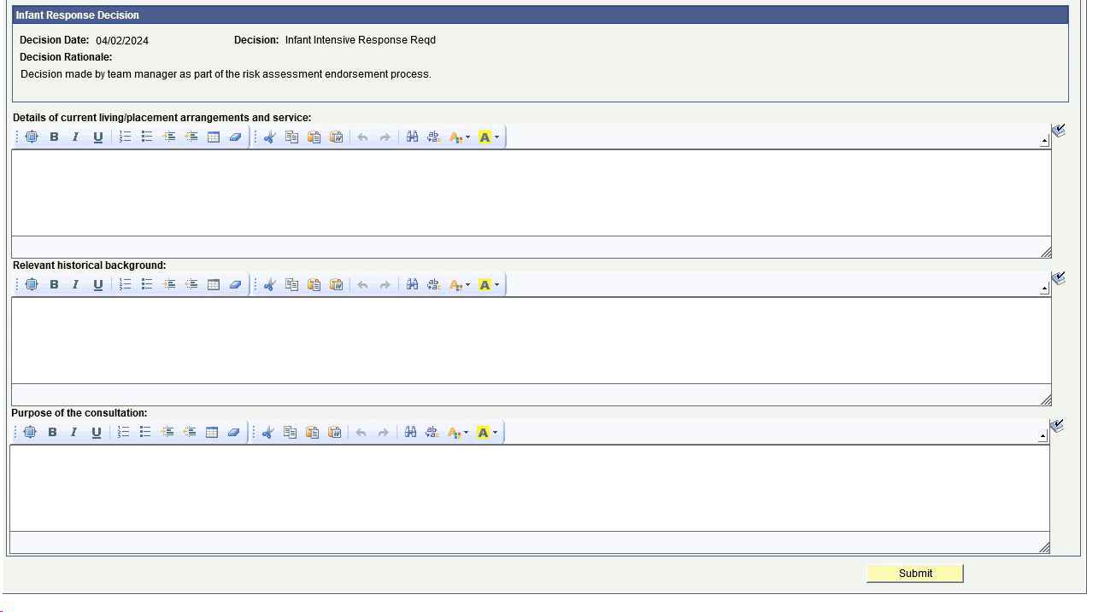

1. Once the referral is ready to be submitted, click submit.

**Note**: once you click submit, the consultation request will be sent to the PP/PL identified in Part 1, and this part of the consultation will no longer be able to be edited.

1. 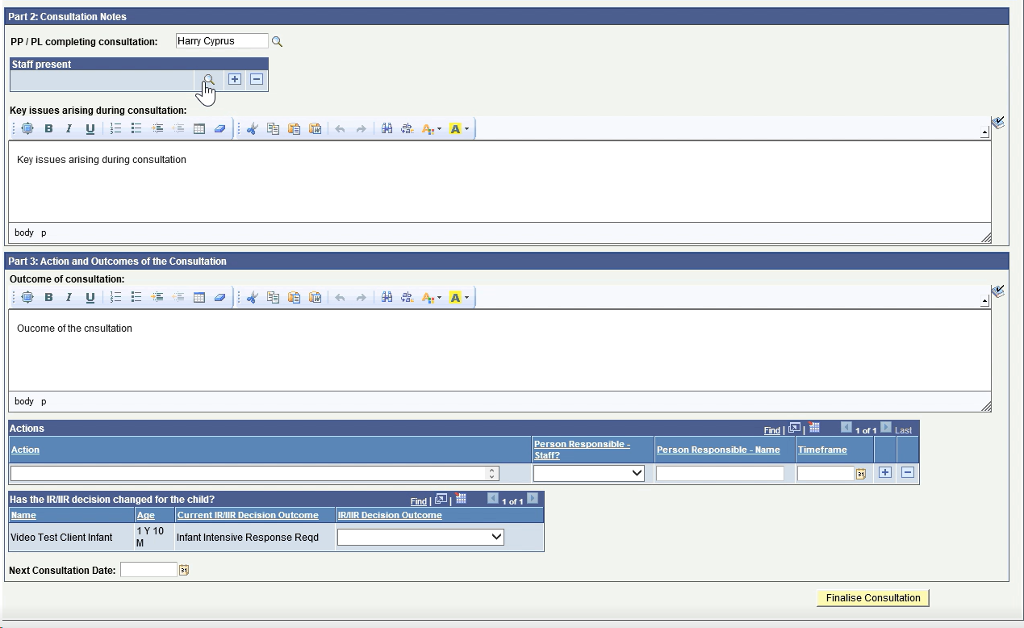After clicking submit, part two of the consultation document opens; this is where the consultation details will be entered.
2. Clicking Finalise Consultation will update the next consultation date in the High Risk and Infant Response Summary tab.

#### Create Panel Meeting

1. From the High Risk and Infant Response page, click the Create Panel Meeting button and the panel meeting details page opens; some of this information auto-populates from CRIS, as shown below. The Internal Panel meeting will always be the first panel type presented to staff.

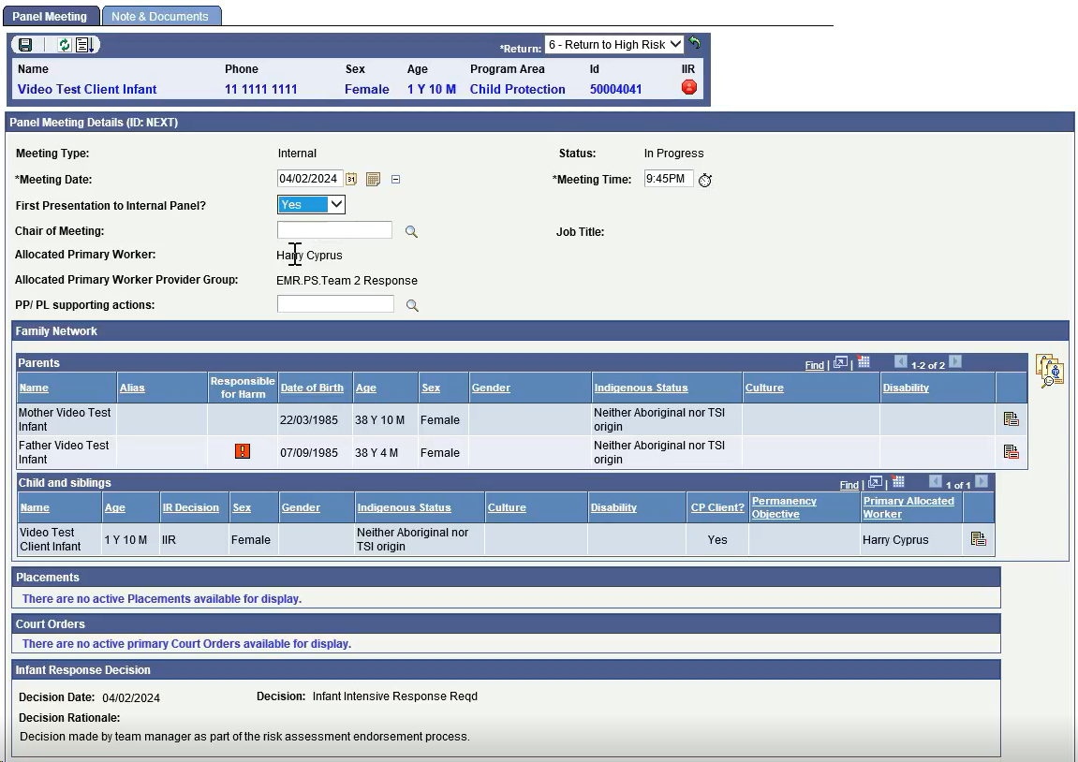

1. 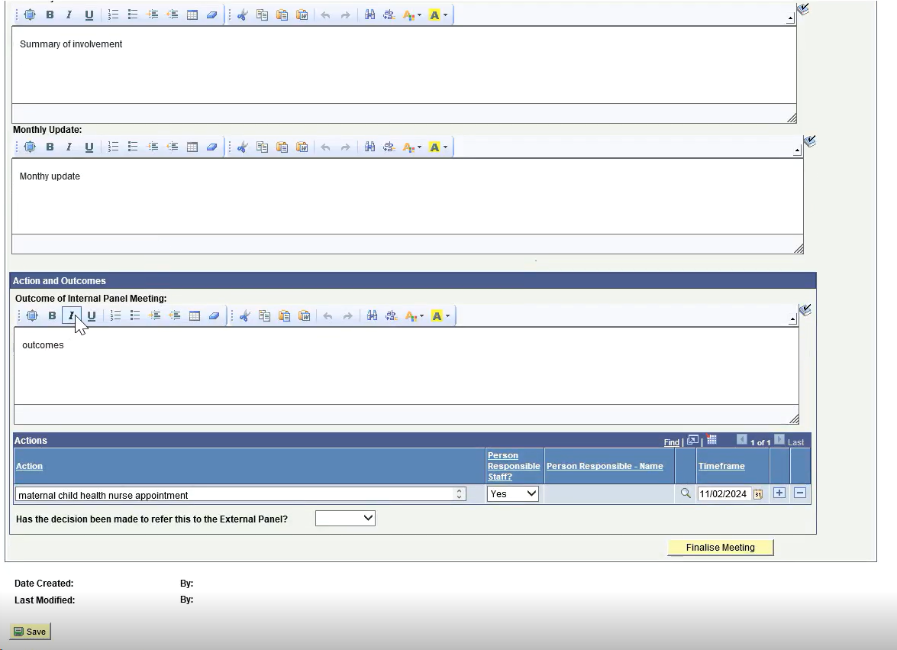Practitioners will be able to enter details in relation to Child Protection’s summary of involvement, key updates for the panel, and actions and outcomes of the panel meeting, including who is responsible for these actions.

***NOTE****: If you save the Consultation request, you are able to continue editing and updating the request later. Once you select finalise meeting, this will generate the Panel Meeting document, and all fields will be made read only, no changes can be made to the visit case note after selecting finalise.*

#### IR/IIR Activities

1. As you create new client visits, consultations and/or panel meetings, a list of completed actions will be displayed under the relevant activities in the IR/IIR activities box. For example, clicking on client visits in the IR/IIR activities box will list all completed client visits from newest to oldest with this record of the IR/IIR decision period.

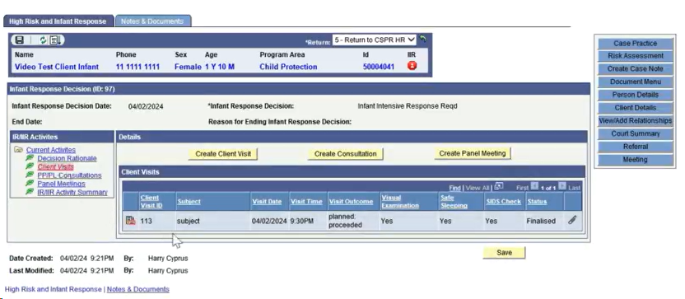

1. To view a summary of all activities undertaken, click on the IR/IIR activity summary link, which will show all activities undertaken for that IR/IIR client.

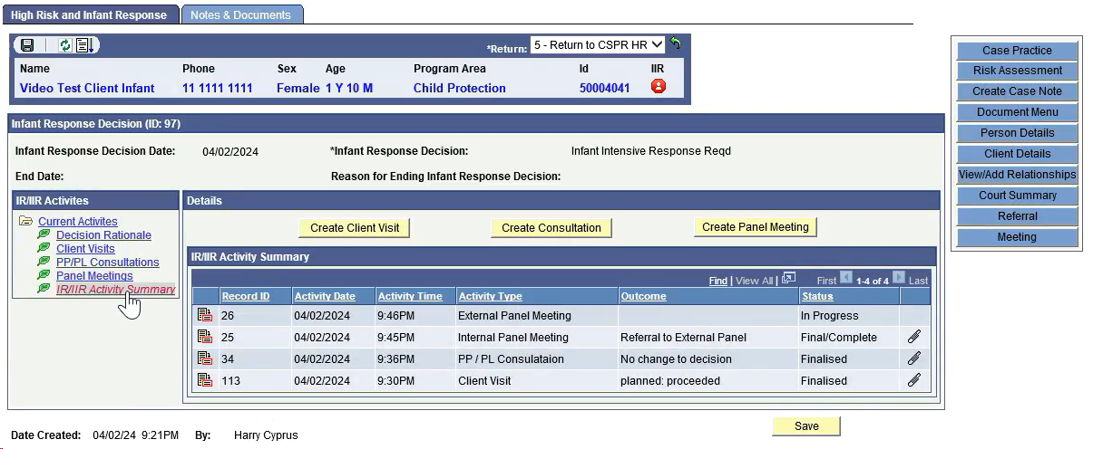

### Useful links

(CP Learning Hub, videos, etc.)

### Version control

| Version | Author | Action | Status | Date |
| --- | --- | --- | --- | --- |
| 1 | Sarah Simons | Initial draft | DRAFT | 14/02/2024 |
| 1.1 | Jadon Lake & Samaia Boccolini | Peer review | DRAFT | 15/02/2024 |
| 1.2 | Sarah Bounden | SME review | DRAFT | 16/02/2024 |
| 1.3 | Brett Eastwood | Director Approval | DRAFT | 21/02/2024 |
| 1.4 | Brenda Boland | Final Approval – Service Enhancement Executive Director | FINAL | 22/02/2024 |