

|  |
| --- |
| How to view your Service Agreement via My Agency |
| Funded Agency Channel |
| OFFICIAL |

Contents

Logging into My Agency 1

Opening the Agreement 2

Navigation tips 2

### Logging into My Agency

Go to the **Funded Agency Channel** website: <https://fac.dffh.vic.gov.au>

Scroll down and Click on ‘[**My Agency login – non DHHS staff’**](https://hns.dhs.vic.gov.au/facadmin/home.aspx)<https://hns.dhs.vic.gov.au/facadmin/home.aspx>

[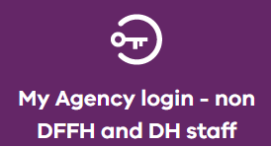](https://hns.dhs.vic.gov.au/facadmin/home.aspx)

Log into the eBusiness portal using the credentials received when you registered for access.

Should you need to reset your password, please contact eBusiness on 1300 799 470 (option 1 then 4).

Click on the **Funded Agency Channel** under **My Applications**

You are now in **My Agency.** Click on the **Service Agreement Module** link (as per below)

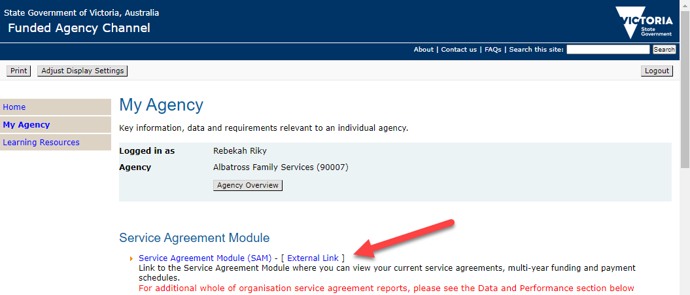

Click on your **organisation’s name**

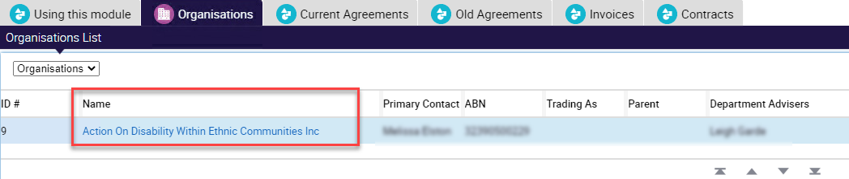

### Opening the Agreement

Go to the **Contracts tab** and click on the Document Type hyperlink to download/open the document (action performed is browser dependant).

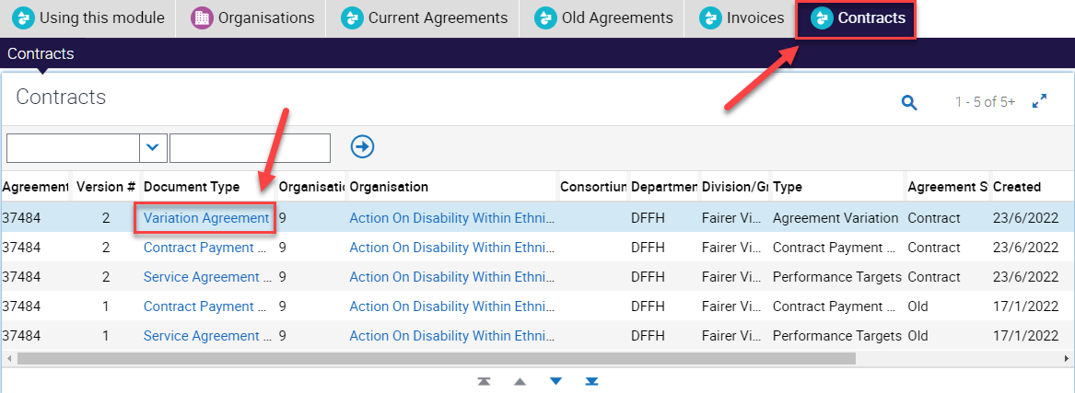

### Navigation tips

Clicking on the right side of **'Version #'** will display the sort control to enable you to sort by Version #

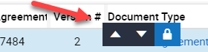

If there are more than 5 records on this screen, you can view further screens by using the down arrows, or you can click on the Show More/Show Less control to expand the view to 20 records.

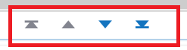 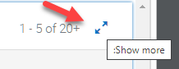

To receive this document in another format, phone 1300 799 470, using the National Relay Service 13 36 77 if required, or email [FAC@dffh.vic.gov.au](mailto:FAC@dffh.vic.gov.au) <FAC@dffh.vic.gov.au>.

Authorised and published by the Victorian Government, 1 Treasury Place, Melbourne.

© State of Victoria, Australia, Department of Families, Fairness and Housing, December 2022