|  |
| --- |
| Funded agency channelRole based security in the Service Agreement Module |
|  |

Contents

Introduction 2

The role of the Access Controller 2

The Contacts tab in SAM 2

Adding a contact in SAM 3

Navigate to the Service Agreement Module 3

Navigate to the Organisation Contacts tab 3

Adding a new contact 3

Permissions 5

Updating Contact details and permissions in SAM 5

Edit a contact’s details 5

Edit a contact’s permissions 5

Enabling the Grant all standard permissions to all users option 6

Making a user inactive 7

# Introduction

My Agency, the secure area of the Funded Agency Channel (FAC) website, provides registered users from funded agencies access to the Service Agreement Module (SAM), to access their service agreement information and to update records and documents through interactive modules.

If you require access to My Agency and are not a registered user, please refer to <https://fac.dffh.vic.gov.au/my-agency-non-dffh-and-dh-staff> <https://fac.dffh.vic.gov.au/my-agency-non-dffh-and-dh-staff > on the Funded Agency Channel home page.

Most registered agency users can see all information, data and reports for their agency in SAM and My Agency. This includes financial, performance and client information.

This guide is for those users who have the access controller permission for their Agency.

Your agencies’ Departmental Adviser or the Funded Agency Channel helpdesk [FAC@dffh.vic.gov.au](mailto:FAC@dffh.vic.gov.au) can also perform these functions.

The red box outline in each screenshot of this guide will identify the area you need to select, action or note. In the example screenshot below, the organisation name has been identified for selection.

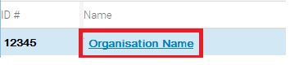

Figure : Example screenshot

## The role of the Access Controller

* The agencies’ Access Controller(s) can change a user’s access which determines what each user can see and do in SAM and My Agency
* Access Controllers must be registered for My Agency Access in eBusiness
* Every Agency must appoint at least one registered user with Access Controller permissions who can update the permissions on other contacts including the Access Controller permission
* Can add and update Agency Contacts under the contacts tab in SAM
* The Access Controller is a role within SAM, this is separate to the Organisation Authority (OA) role within eBusiness, although the same person may hold both roles, this is not always the case.

## The Contacts tab in SAM

Log into My Agency and go to SAM. The Organisations Tab is displayed by default. Select the Hyperlink of your Agency’s name. The Contacts subtab will be displayed by default.

Here you will be able to see who has the Access Controller permission ticked for your Agency. This can be sorted by clicking on the arrows on the heading label. Most columns can be sorted ascending or descending in this way.   
  
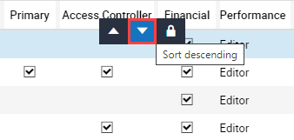

Figure : Screenshot of the sort icons on the contacts tab

You will also be able to see what permissions a contact has within SAM, by hovering over the permission field, a tooltip with a brief description of the access provided is displayed.  
  
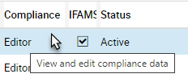

Figure : Screenshot of the tooltip text describing the function of the permission

# Adding a contact in SAM

## Navigate to the Service Agreement Module

1. Log into My Agency (via eBusiness). From the My Agency page, select: Service Agreement Module [External Link] as picture below

Figure : Screenshot of the SAM link in My Agency

1. A new window will open and the Service Agreement Module (SAM) will display. The Organisations tab at the top of the screen will display by default.

## Navigate to the Organisation Contacts tab

1. Select the hyperlink (blue text) with the name of the agency.
2. The Organisations screen will open with a series of lower level tabs. This will default to the Contacts tab.

## Adding a new contact

**Please note: Adding a new user does not provide access to My Agency or SAM.** Each user must register for eBusiness themselves. By adding the user prior to their registration, the Access Controller can determine what additional permissions the user will have once access is granted, for example: EM Key Contact.

Ensure that the person is not already a contact by scrolling through the contact names using the down arrow under the contacts list.

Figure 2: Screenshot of scrolling arrows

Screenshot of scrolling arrows with down arrow highlighted with a red box.

Figure : Screenshot of scrolling arrows

1. To add a new user, select the Add button. The Add Contacts box will display. Select the plus symbol.

Figure 3: Screenshot of Adding a Contact

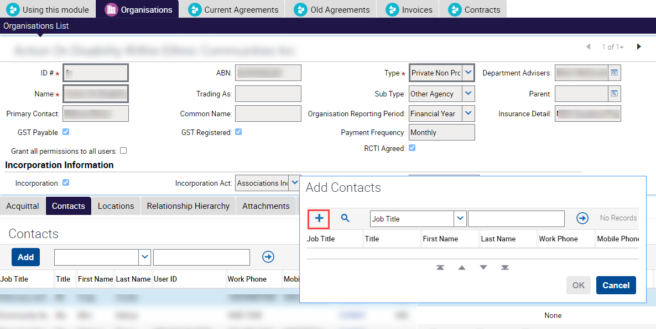

Figure : Screenshot of the Service Agreement Module, Organisation tab (upper), with the Contacts tab (lower) Add selected with a red box indicating where to add a user

1. A new row will appear. User details can be entered except User ID which is system generated when a user’s access is approved by FAC. Scrolling to the right half of the contacts screen will show user permissions. See Figure 5 below.

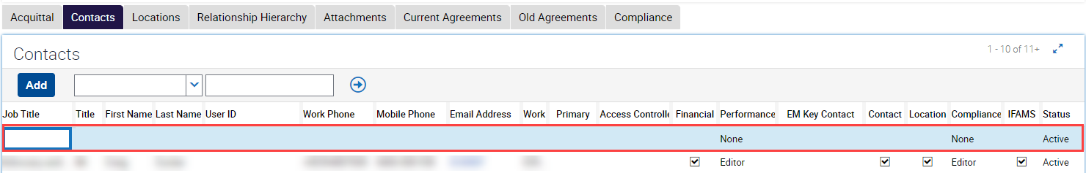

Figure : Screenshot of the Contacts tab new contact row selected with a red box indicating where to add contact details

## Permissions

Table of permissions and visible data

|  |  |  |  |
| --- | --- | --- | --- |
| Permission | Associated tabs in SAM | Editable fields | Associated reports in My Agency |
| Access Controller | All | Update permissions and contact details | All |
| Financial | Current agreements |  | Current financial year reports |
| Old agreements |  | Old version reports |
| Invoices |  | All structured reports |
| Contracts |  |  |
| Performance: Read only | Acquittal |  | Service delivery tracking  Health reports - performance against targets |
| Performance: Edit | Acquittal | Update and submit acquittal | Service delivery tracking  Health reports - performance against targets |
| Contact | Contacts |  | User details |
| Location | Locations |  | Not applicable |
| Compliance: Read only | Compliance |  | Compliance reports |
| Compliance: Edit | Compliance | Upload and submit SACC | Compliance reports |
| IFAMS |  |  | Client specific funding reports |

# Updating Contact details and permissions in SAM

## Edit a contact’s details

1. To edit a contact’s details, select anywhere in the relevant user row. Please note that each row is unique to the user, NOT the job title. Do **NOT** update one person’s details with another.
2. Once the user row is selected, all the fields except User ID will become editable. Changes are saved when you select another row or press Ctrl-S.

## Edit a contact’s permissions

1. To edit a contact’s permissions, select anywhere in the relevant contact row. The permissions are located on the right half of the contacts screen.

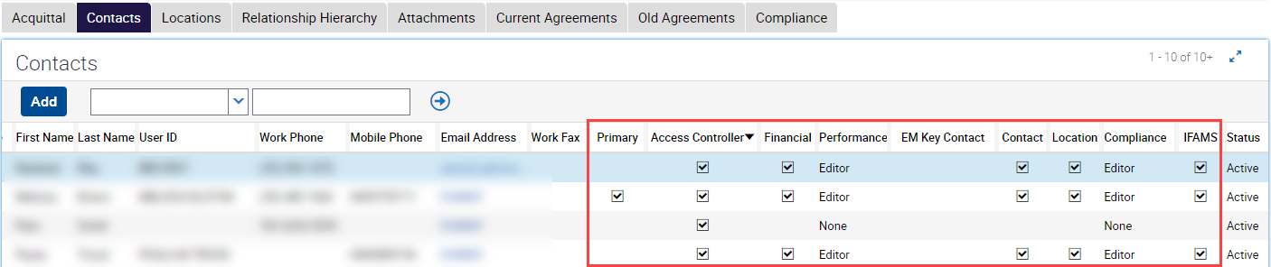

Figure : Partial screenshot of the Service Agreement Module, with the Contacts tab selected with a red box indicating the permission's columns that can be edited by the Access Controller. The Access Controller column has been sorted to display all ticked contacts

1. The user permissions can now be updated and saved. Please refer to the Table of permissions and visible data before editing permissions.
2. The user will either gain or lose access based on whether a permission is added or removed. Changing permissions will generate a system email notifying the user of the change. The Access Controller is also notified of the change.
3. Note that permissions are agency specific, meaning that if a user has access to more than one agency (Multi-Org access), then changes made are specific to that agency only.

## Enabling the Grant all standard permissions to all users option

1. The ‘Grant all permissions to all users’ option provides all users with unrestricted access in SAM and My Agency. **This option cannot be selected if any user requires restricted access.**

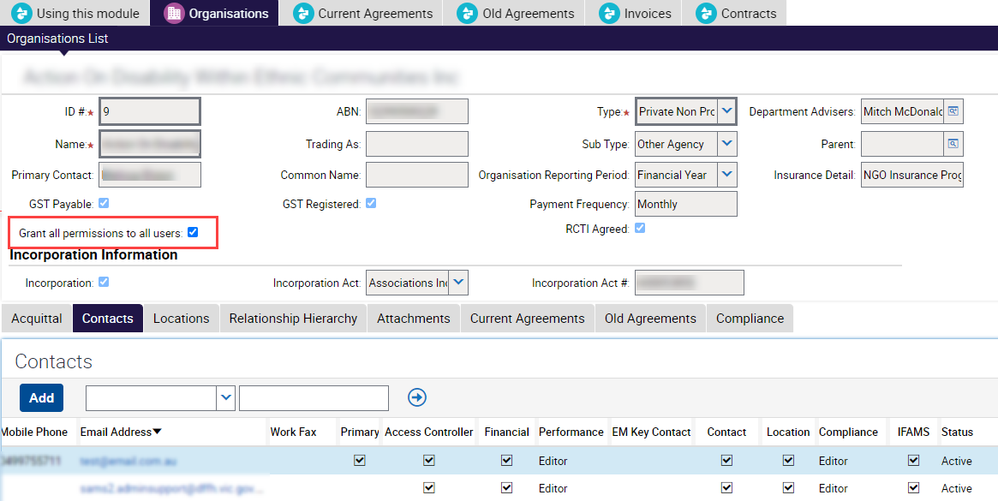

Figure : Screenshot of the ‘Grant all permissions to all users’ checkbox

1. Once the ‘Grant all permissions to all users’ option is selected and saved, permissions are no longer editable. This option can be deselected at any time by an Access Controller but if checked again all users will have unrestricted access in SAM and My Agency.
2. Please ensure all changes are saved by either selecting another user row or using Ctrl-S.

# Making a user inactive

1. The Access Controller can change the status of a user when they no longer work for an agency. Changing status will remove permissions except Access Controller and Primary permissions, which need to be assigned to another user first.

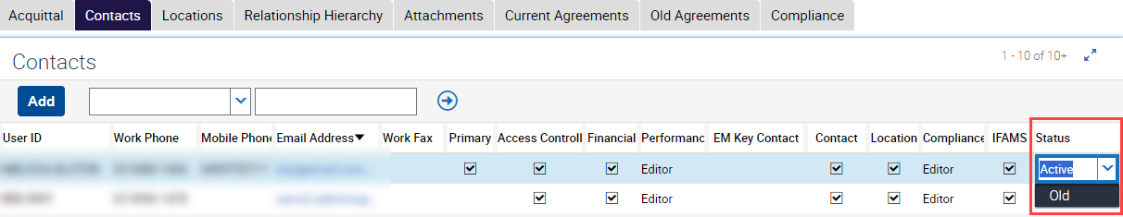

Figure :Screenshot of changing the status of a user.

1. Select the contact record to be made ‘Old’. Scroll across to the status column and click into the field. A drop down arrow is displayed which when selected enables the selection of the status ‘Old’.
2. Changes are saved when you either select another user row or Press Ctrl-S.
3. If the record is not ticked as the primary contact or the only access controller, all the permissions will be removed.
4. Note, if the person has left your Agency, you are also required to advise [FAC@dffh.vic.gov.au](mailto:FAC@dffh.vic.gov.au) to enable access to be revoke across My Agency and eBusiness as well if required.

|  |
| --- |
| To receive this publication in another format, email: the [Funded Agency Channel](mailto:fac@dffh.vic.gov.au) <fac@dffh.vic.gov.au>  Authorised and published by the Victorian Government, 1 Treasury Place, Melbourne.  © State of Victoria, Department of Families, Fairness and Housing, December 2023  Available on the [Funded Agency Channel](https://fac.dffh.vic.gov.au/my-agency-non-dffh-and-dh-staffhttps:/fac.dffh.vic.gov.au/my-agency-non-dffh-and-dh-staff) <https://fac.dffh.vic.gov.au/my-agency-non-dffh-and-dh-staff> |