

|  |
| --- |
| Viewing your remittance advice in the Service Agreement Module (SAM) |
| Funded Agency Channel |
| OFFICIAL |

Contents

Log into My Agency 1

The Service Agreement Module 2

The invoices tab 3

Reports 5

## Log into My Agency

1. Log into the [eBusiness portal](https://hns.dhs.vic.gov.au/EUSPortal) and under My Applications, click on Funded Agency Channel - My Agency.

Screenshot of the eBusiness Portal once logged in with a red box around the
Funded Agency Channel - My Agency hyperlink

Figure 1 Funded Agency Channel - My Agency in the eBusiness Portal

If you have forgotten your eBusiness username or password, select [request username](https://hns.dhs.vic.gov.au/EUSPublic/forgottenUsername.action) <https://hns.dhs.vic.gov.au/EUSPublic/forgottenUsername.action> or [reset password request](https://hns.dhs.vic.gov.au/EUSPublic/forgottenPassword.action) <https://hns.dhs.vic.gov.au/EUSPublic/forgottenPassword.action> links on the eBusiness Login page, or you can contact **eBusiness on 1300 799 470 (option 1 then 4). You will be provided with a temporary password that you will need to manually change.**

## ****The Service Agreement Module****

The Service Agreement Module (SAM) is the organisation’s view of the departments’ Service Agreement Management System (SAMS2). SAM provides real time Service Agreement information for funded organisations.

**From the My Agency home page, click on the Service Agreement Module (SAM) hyperlink.**

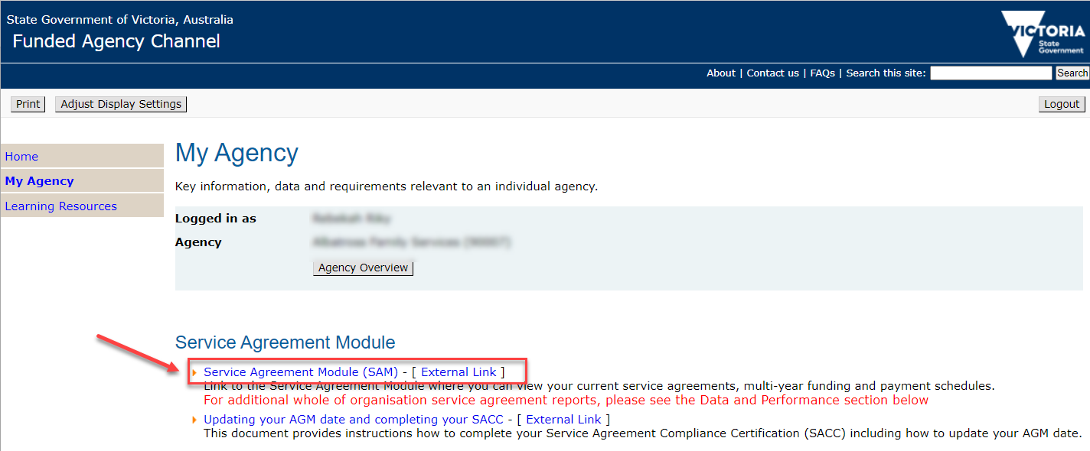

Figure 2 Link to SAM on the My Agency page

**Once in SAM, click on the name of the Agency you are wanting to view.**

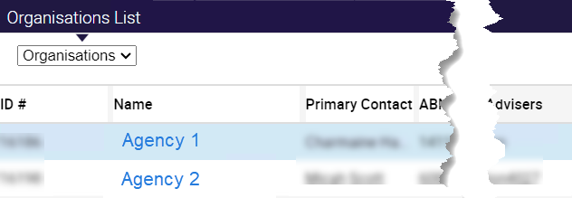

Figure 3 Organisation list in SAM

## ****The invoices tab****

1. Click on the invoices tab
2. then the drop down arrow on the search box
3. select Agreements
4. enter the Agreement Id in the search criteria text box
5. click the Go button.

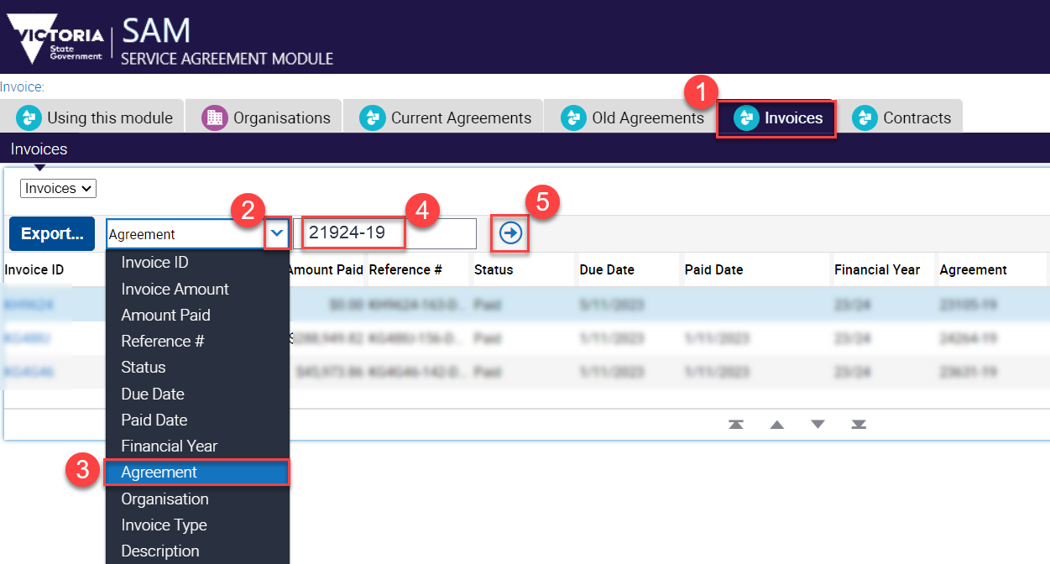

Figure 4 the invoices screen in SAM

1. The list of invoices is returned including paid and unpaid.
2. You can drill into the details of the invoice, by clicking on the Invoice ID.

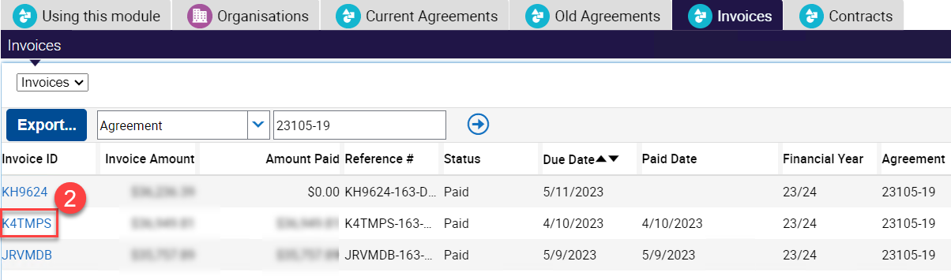

Figure 5 Invoice ID

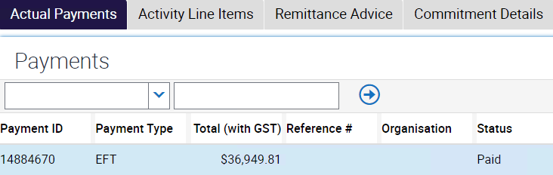

Figure 6 Information on Actual Payments

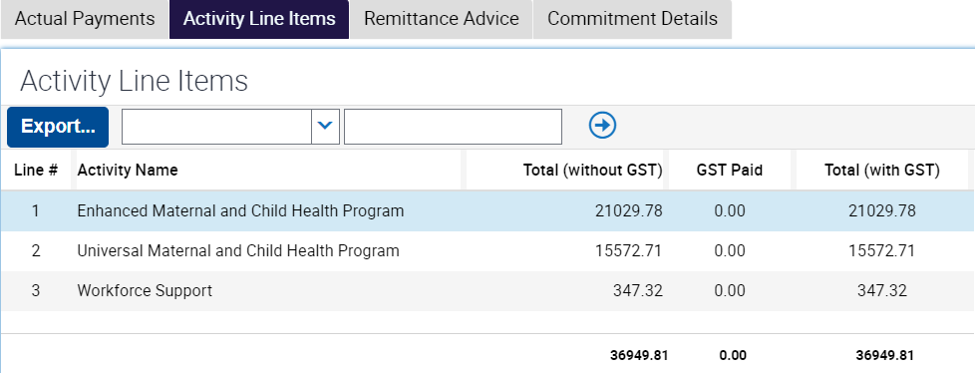

Figure 7 Activity Line Descriptions

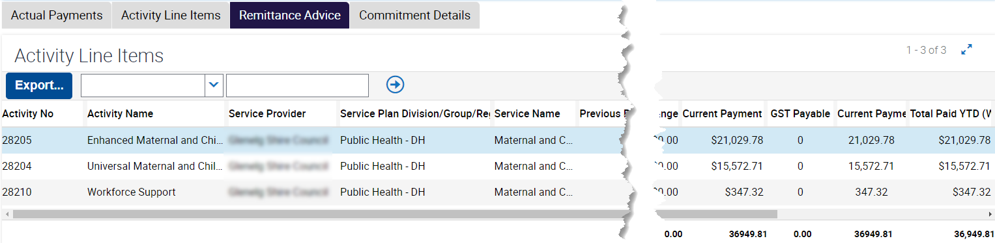

Figure 8 Remittance Advice

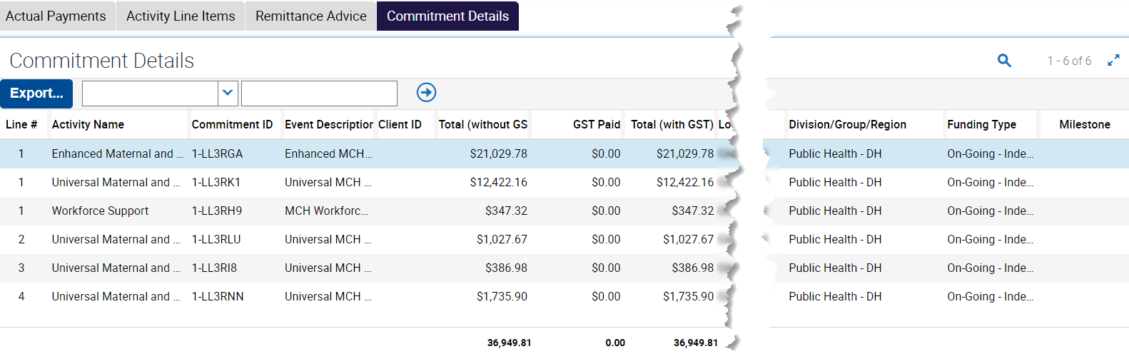

Figure 9 Commitment Details

Activity Line Descriptions, Remittance Advice and Commitment details data can all be exported, via the Export Button.

## Reports

1. In My Agency, you can view several reports, including the SAMS03 – Invoices report by clicking on the hyperlink to open it. The SAM03 Invoice report displays all invoices paid to the organisation. Payment details are displayed at agreement, service plan, activity and commitment level.

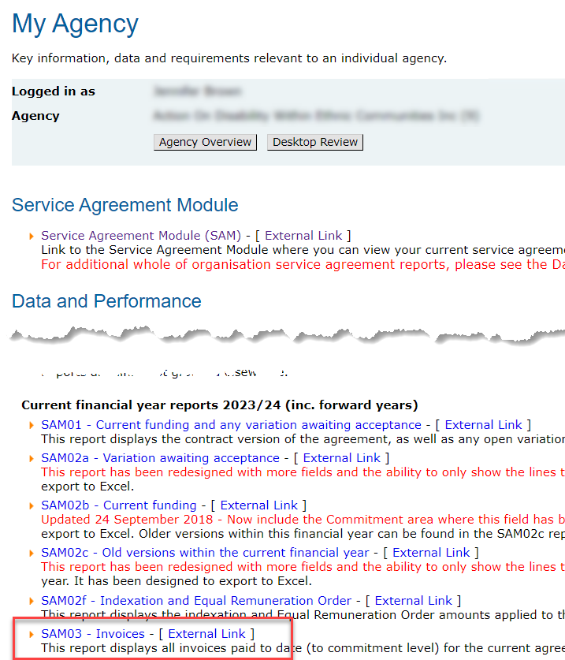

Figure 10 Invoices report in My Agency

1. Refine your criteria

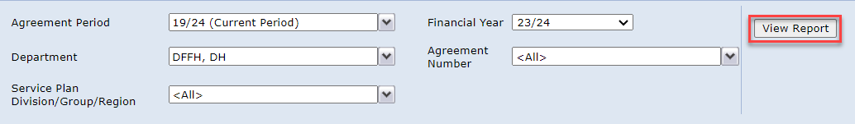

Figure 11 report criteria selection

1. Once the data has loaded, you will see a summary worksheet. You can export the report into various format, however, excel is often the most useful.

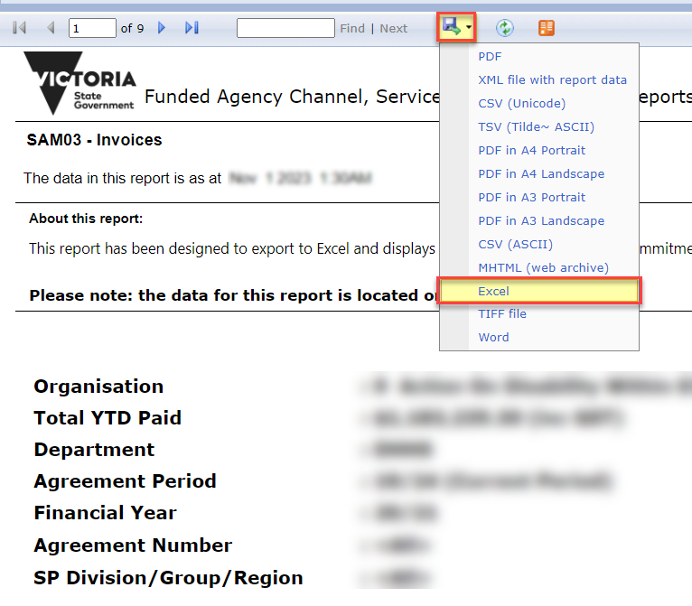

Figure 12 export report data

|  |
| --- |
| To receive this document in another format, [email the Funded Agency Channel](mailto:FAC@dffh.vic.gov.au) <FAC@dffh.vic.gov.au>  Authorised and published by the Victorian Government, 1 Treasury Place, Melbourne.  © State of Victoria, Australia, Department of Families, Fairness and Housing, October 2023  Available at [Funded Agency Channel](https://fac.dffh.vic.gov.au/) <https://fac.dffh.vic.gov.au/> |