

|  |
| --- |
| How to complete your service delivery tracking acquittal template in the Service Agreement Module |
| OFFICIAL |

Contents

Introduction 1

Using this guide 1

Completing your acquittal 2

Navigate to the Service Delivery Tracking page 2

Navigate from the Current Agreements tab to the Acquittal sub tab 2

Complete your organisation’s acquittal 2

Submit the acquittal 3

Exporting data to Excel 3

Counting rules 4

# Introduction

The Service Delivery Tracking process is for organisations to account for service delivery against their service agreement targets.

My Agency is the secure area of the Funded Agency Channel (FAC) website where registered users from funded organisations can access funding and payment information about their service agreement. If you require access to FAC and/or are not a registered user, please refer to the [Accessing My Agency](https://fac.dffh.vic.gov.au/funded-agency-channel/my-agency-non-dhhs-staff#panel-2566) <https://fac.dffh.vic.gov.au/my-agency-non-dffh-and-dh-staff> section of FAC.

Within My Agency, the Service Agreement Module (SAM) allows funded organisations to access their service agreement information and to update some records and documents through interactive modules. One of these modules provides organisations with the ability to submit their monthly service delivery tracking acquittal online.

The following instructions detail the steps required for organisations to submit acquittal data.

## Using this guide

This document includes information on how to:

* find the Acquittal sub tab to determine the activities that need to be acquitted
* complete and submit acquittal data
* export acquittal data.

# Completing your acquittal

## Navigate to the Service Delivery Tracking page

1. When you log in to My Agency, select Service Delivery Tracking Reports under the Data and Performance section.  
     
   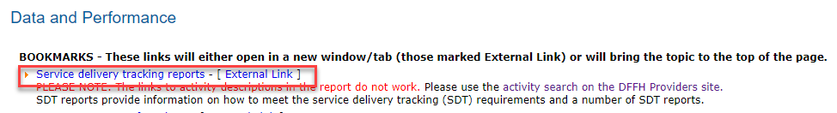
2. On the Service Delivery Tracking page you will find all the information you require to complete your Service Delivery Tracking acquittal template.  
     
   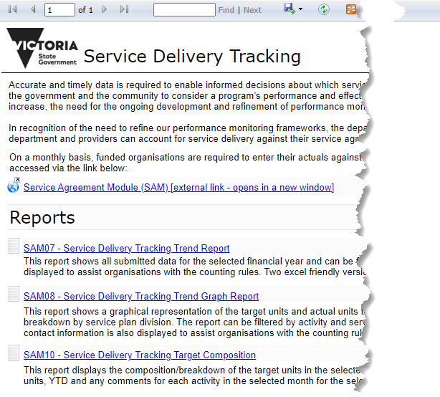
3. There are links to the Service Agreement Module (SAM), Service Delivery Tracking reports, contacts for assistance in your organisation and the department~~.~~
4. Select the Policy and funding plan you wish to view to open the Word document.
5. On the Policy and funding plan, hold down the Ctrl key and select Performance Measure 1 for quick access to the Counting Rules.
6. The counting rules may provide further information to assist you to calculate your actual units for the relevant activity.
7. To complete the Acquittal template, return to the Service Delivery Tracking page and select the link to the Service Agreement Module on the Acquittal tab.

# Service Agreement Module

1. Log into the Service Agreement Module from My Agency and navigate tab to the Acquittal sub tab
2. SAM will open in a separate window. The Current Agreements tab will default.
3. On the Current Agreements screen, select the organisation name hyperlink (blue text) to open the Organisations tab.
4. The Organisation screen will open with a series of tabs below the grey section. The Contacts tab will default.
5. Select the first tab which is Acquittal.

## Complete your organisation’s acquittal

In the top section of this tab, all generated acquittal templates are displayed. The templates are generated on the first day of each month and are due to be completed by the tenth day of that month.

The current month to be submitted will be the first line to display at the top of the sub tab followed by any previous months in descending order. The fields include:

* Financial Year
* Month Number
* Month
* Due Date
* Submitted
* Submitted Date
* Submitted By

The current month will default, but you may complete the acquittal for any un-submitted month. To change to another month, select the arrow on the left side of the screen relevant to that month.

In the section below the generated months, each activity that must be acquitted is listed, together with the Service Plan details relating to that activity. The fields include:

* Service Plan Division Group Region
* Service Plan Name
* Service Plan ID
* Activity Code
* Activity Name
* Performance Measure Description
* Target Period
* Target Units
* YTD Actual
* Actual Units
* Comment
* Updated Date
* Updated By

1. When you move the cursor over the Actual Units field, a description of the counting rules that apply to the activity will be visible. Further information on counting rules is available in the Policy and funding plans as described earlier. See also the Counting Rules section of this document.
2. There are two types of Target Period:
   1. a monthly target period which is a non-cumulative target. You must enter the number of actual results achieved in the reporting month. The YTD Actual field will display N/A.
   2. an annual target period which is a cumulative target. You must enter the actual result achieved in the month. The YTD actual units are generated in the template and the field cannot be edited. This field provides the sum of the data entered for previous months.
3. Against each activity, enter the actual number of units delivered in the month in the Actual Units field. If you provided services across a number of divisions, enter only the data relevant to the division specified in the Service Plan Division/Group/Region field.
4. You may enter comments up to 1,000 characters in the Comment field. It is advisable to enter summarised comments in the field and it is recommended to limit these to around 255 characters.
5. Comments should include explanations for targets not being met, and remediation strategies, where applicable. In order to maintain client confidentiality, client details should not be included in your commentary.
6. You are able to save the data at any time by selecting Save.

## Submit the acquittal

1. When all Actual Units have been entered and the data saved, the Submit button will be enabled. It is located above the selected month. Select the Submit button to submit the completed acquittal. Note you cannot submit a partially completed acquittal.
2. Once the acquittal has been submitted, the Submitted field will be checked and the Submitted Date and Submitted By fields against the selected month will be populated.
3. An email will be sent to your organisation’s Acquittal Contact if one has been nominated, or your Primary Contact advising that the acquittal has been submitted.
4. The acquittal for the month is now complete.
5. If you believe that an acquittal has been submitted with incorrect data, please contact your local engagement officer as display on the Service Delivery Tracking link in My Agency.

# Exporting data to Excel

1. The acquittal form can be exported to Microsoft Excel at any time.
2. To export the data for your records, select Export. The Export window is a pop-up window. You do not need to change anything in the window, select the Next button and the data will export to Excel.
3. You may choose to open the file directly from SAM, or save it prior to opening.
4. It is recommended that you save the file first; otherwise it will open as a temporary file and may be deleted when you reboot your computer.
5. When returning from Excel, select Close on the pop-up window.

# Counting rules

1. Each activity and measure in the acquittal has its own counting rules. A brief description of the counting rules that apply to the particular activity will appear when you place the cursor over the Actual Units field for that activity
2. Data is to be submitted for each service plan activity listed in the template.
3. A full description of the counting rules for each particular activity and measure can be found in the current version of the Department of Human Services Policy and funding plan.
4. The Service Delivery Tracking Page has links to the Policy and funding plan section for each activity you must acquit.
5. When you select the link, the Policy and funding document relating to that activity code will display as a Microsoft Word document.
6. When you open the document, the Table of contents will display.
7. Using the Table of contents, hold down the Ctrl key then select the relevant performance measure. This will take you directly to the performance measure for the activity. The counting rules are found within the performance measure section.
8. You may also scroll through the document to find the counting rules.
9. You may wish to print the document for future reference.
10. Repeat steps 4-9 for each activity.

|  |
| --- |
| To receive this document in another format email [SAComms@dffh.vic.gov.au](mailto:SAComms@dffh.vic.gov.au) <SAComms@dffh.vic.gov.au>.  Authorised and published by the Victorian Government, 1 Treasury Place, Melbourne.  © State of Victoria, Australia, Department of Families, Fairness and Housing, October 2023  Available at [Service Delivery Tracking](https://fac.dffh.vic.gov.au/service-delivery-tracking) <https://fac.dffh.vic.gov.au/service-delivery-tracking> |