

|  |
| --- |
| How to Clear the Cache |
| Instructions for Internet Explorer, Google Chrome, and Firefox |

**Your agency’s IT Services may have access to the clear cache function turned off. If you are unable to follow the below instructions for this reason, please contact your IT services for further assistance.**

# Microsoft Edge

1. Open Microsoft Edge.
2. Go to: edge://settings/privacy

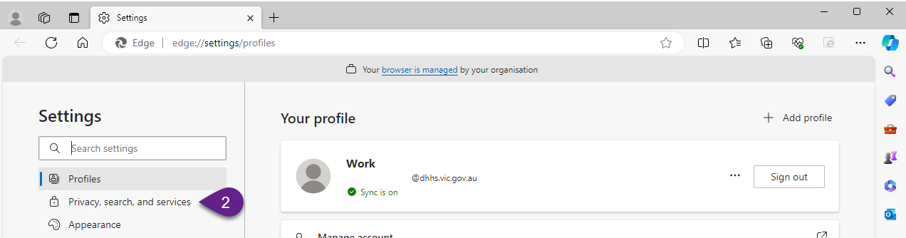

1. Scroll down and to see Clear browsing data
2. Click on Choose what to clear.

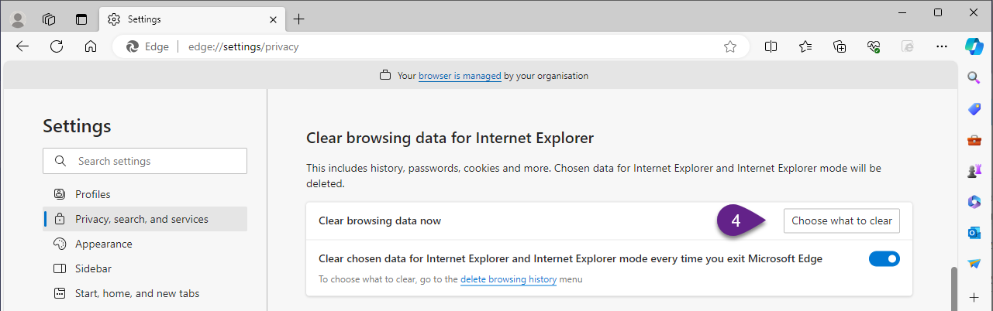

1. Select: Temporary Internet Files, Cookies and History

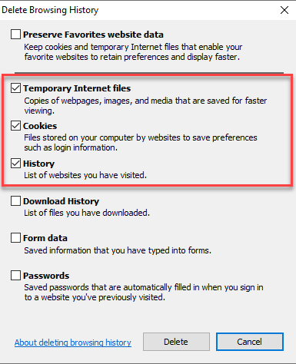

1. Click Delete.

# Other Browsers

The process varies slightly for other browsers, instructions provided below.

## Google Chrome

1. Open Google Chrome.

3. Go to: chrome://settings/privacy

5. Click on "Clear browsing data."

6. Select the time range: All time

7. Check the box next to "Cached images and files."

8. Click on "Clear data."

## Firefox

1. Open Firefox.

2. Go to: about:preferences#privacy

4. Select "Privacy & Security" on the left-hand side.

5. Scroll down to the "Cookies and Site Data" section.

6. Click on "Clear Data."

7. Check the box next to "Cached Web Content."

8. Click on "Clear."