

eBusiness CRIS Login Process

From Monday 27 November 2023

CRIS Login via eBusiness

For users with existing access to CRIS
- Go to: https://hns.dhs.vic.gov.au/EUSPortal/
- Enter eBusiness username and password, check the ‘I have read, understood and agree to abide by the Conditions of Use and Monitoring of Computer Services’ box and click Login.
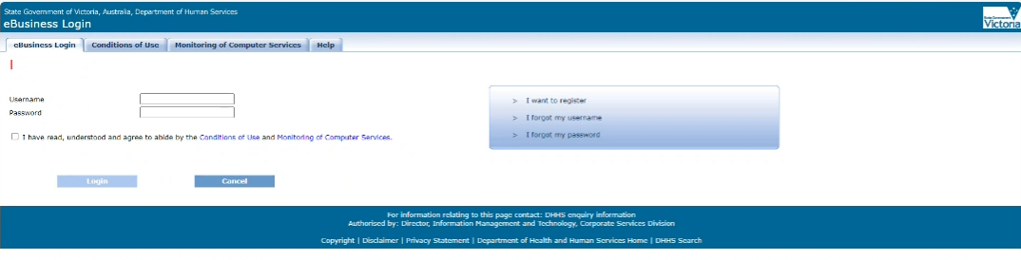

- Select the application – CRIS for Funded Agencies (apply for CRISSP separately) link.

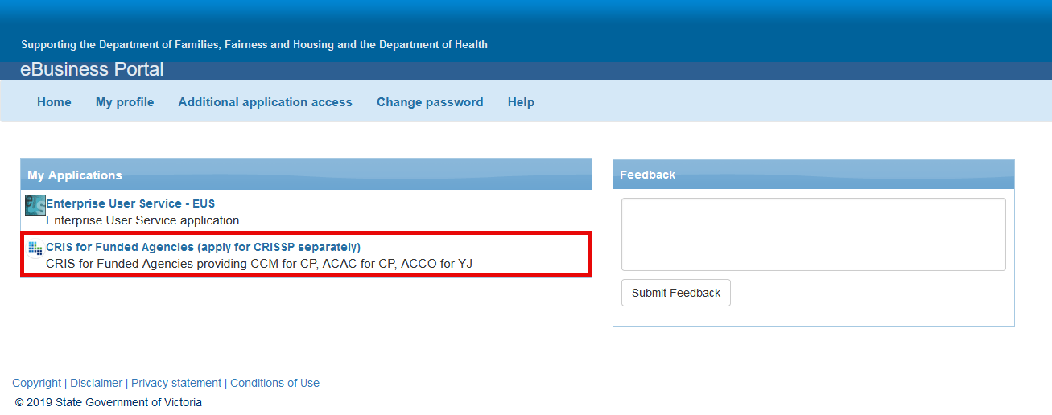
Figure 1: CRIS Cloud Icon

- Security Verification page – re-enter your eBusiness username and password as in Step 2. This is now an additional security requirement to verify access to CRIS before being navigated to the RSA Token Authentication Login page. Click Verify.
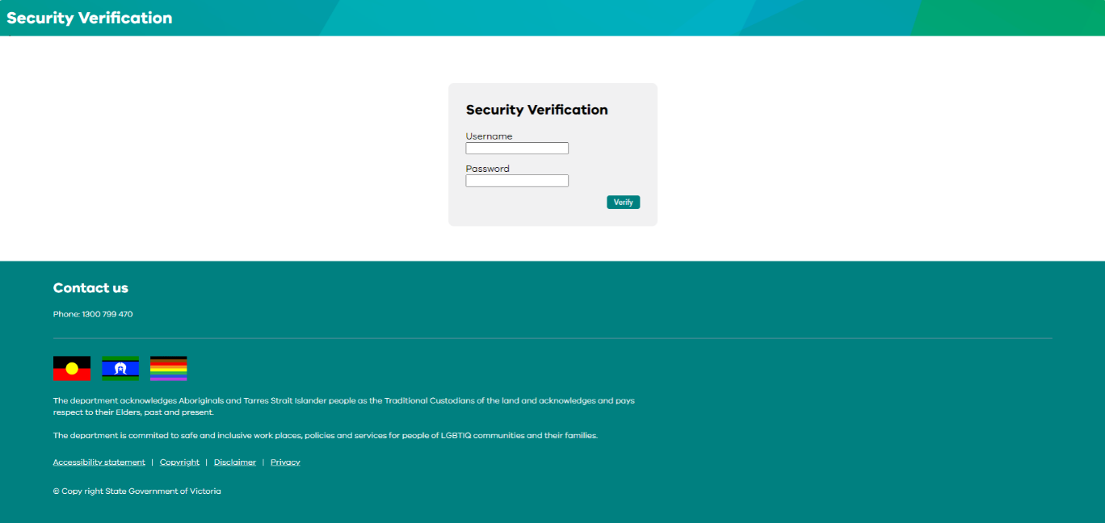

- You will be taken to the Token Authentication page. Re-enter your eBusiness username (if it has not populated through) and token passcode (four digit personal identification number and code displayed on the RSA token - software application or hard token). Check the ‘I have read, understood and agree to abide by the Conditions of Use and Monitoring of Computer Services’ box and click Login. This is an existing step. The page has simply been refreshed to reflect the DFFH branding. 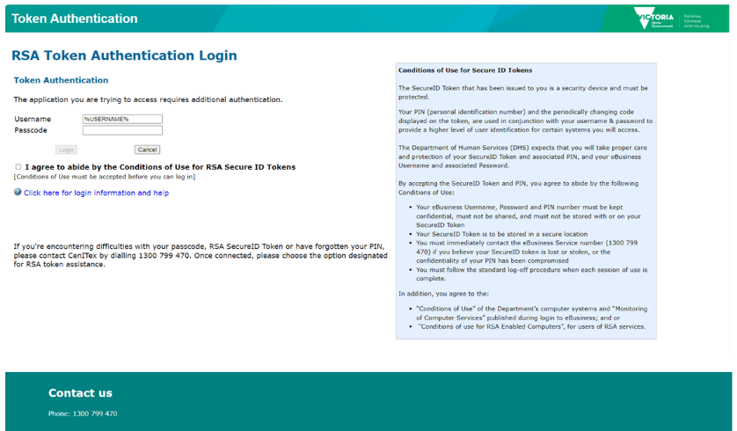
- Upon successful login, you will be taken to the CRIS Application.

Further Assistance
Department eBusiness Support Service Phone: 1300 799 470
Select option 1 for eBusiness support followed by option 4 for assistance with an eBusiness password or to contact eBusiness support.
Select option 2 for CRIS(SP) support.
Select option 4 for RSA token support.

