

|  |
| --- |
| Streamlined acquittal process for placement support brokerage |
| Client support funding framework: Operational update 1-2021 |
| OFFICIAL |

## Using this update

This update supports the operation of the *Statewide client support funding framework: Placement support brokerage and client expenses funding guidelines* (2016). It provides updated guidance in relation to acquittal requirements for placement support brokerage and information about the new acquittal template for service providers.

## Which service providers and placement types are affected?

Placement support brokerage is available to service providers that have been allocated foster care and lead tenant placements for children and young people involved with the child protection program. This funding is provided to agencies in their service agreement under activity 31217 – Client Placement Support Services.

Eligible placement types include: home-based care (general, intensive and complex), therapeutic foster care, adolescent community placement, and lead tenant services.

## How are acquittal requirements changing?

Quarterly reporting of expenditure by item at a client level has been replaced by *annual* reporting of expenditure by *placement support category*.

This means that service providers are not required to routinely provide date, client name, funded activity, item descriptor, and period of service information for acquittal of placement support brokerage expenditure.

Please note that:

* use of funds may be audited at a detailed (item) level by the department to ensure expenditure is in line with its intended purpose, and to support ongoing policy development and planning
* these changes do not apply to the acquittal of *high-cost* placement support[1], for which service providers will still need to provide expenditure information by item at a client level
* these changes do not affect performance reporting against funded targets via service delivery tracking (SDT).

## What is the rationale for these changes?

Placement support brokerage is allocated to service providers based on the number of foster care and lead tenant placement targets they have been assigned. It is not expected that a specific brokerage amount is attached to each client, but that service providers use the brokerage as a pool of funds and based on need.

Reporting expenditure by category on an annual basis streamlines the administrative effort required to acquit funds. It provides proportionate accountability that is more consistent and aligned with the level at which funding is allocated, and supports analysis of expenditure trends.

This level of reporting is also considered appropriate given that:

* requests for high-cost placement support must be approved by the department and acquitted at an item level
* if there are concerns that funds are not being managed in accordance with the funding framework, the department can seek additional detail from service providers for audit purposes
* additional detail can also be requested to support policy development or planning.

## What acquittal information will service providers submit?

Under the streamlined acquittal requirements, service providers are required to report spending against the expenditure categories for placement support brokerage:

1. Items and equipment
2. Assist integration in the household
3. Carer support
4. Childcare under $3,000 where the carer works, studies or attends training
5. Transport under $3,000
6. Insurance
7. Other.

Total expenditure will be deducted from the total funds allocated to the organisation for the financial year to determine funds to be recouped by the department, where applicable.

Note that:

* total funds allocated will be adjusted to reflect full year funding if the number of service provider targets is amended during the year based on performance
* use of funds may be audited at a detailed (item) level by the department to ensure expenditure is in line with its intended purpose, and to support ongoing policy development and planning
* service providers are expected to use their discretion and manage their placement support brokerage budget within their allocation, and are required to keep track of cumulative and projected expenditure on individual clients to identify when applications for high-cost placement support are required.

The structure of the new acquittal template and a link to the Excel file with the new template can be found at Attachment 1. This template replaces the previous, more detailed template that was submitted quarterly.

## What happens to acquittal spreadsheets tracking expenditure for the start of 2020-21?

Service providers should consolidate existing expenditure information in quarterly acquittal spreadsheets in the new annual acquittal template and forward to local contacts at the department for submission at the end of the financial year.

There are no changes to the acquittal template or acquittal process for high-cost placement support.

## Further information

Further information on the client support funding framework and placement support brokerage is available on the department’s website on the [Support for home based carers](https://services.dffh.vic.gov.au/support-carers) at <https://services.dffh.vic.gov.au/support-carers>.

## Attachment 1: Streamlined expenditure acquittal template

Figures 1 and 2 illustrate the structure and use of the streamlined acquittal template for placement support brokerage.

The Excel file containing guidance and the new acquittal template for placement support brokerage can be downloaded from the [Funded Agency Channel](https://fac.dffh.vic.gov.au/data-collection) <https://fac.dffh.vic.gov.au/data-collection>

Figure 1: Template for acquitting placement support brokerage for allocated targets

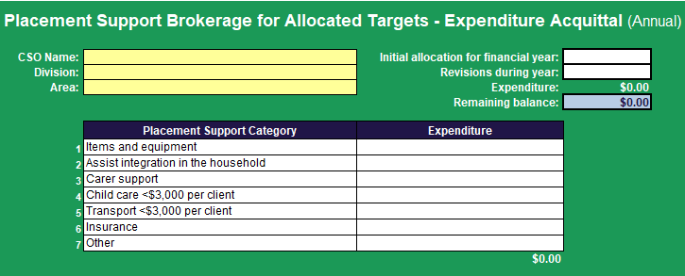

Figure 2: Acquittal of placement support brokerage allocated to a service provider in North Division

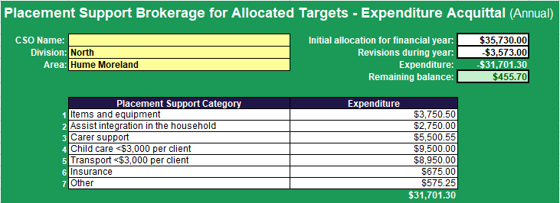

|  |
| --- |
| To receive this document in another format, email the [monitoring framework helpdesk](mailto:monitoring%20framework%20helpdesk) <monitoringframework.helpdesk@dffh.vic.gov.au>  Authorised and published by the Victorian Government, 1 Treasury Place, Melbourne.  © State of Victoria, Australia, Department of Families, Fairness and Housing, May 2021.  Available at [Funded Agency Channel](https://fac.dffh.vic.gov.au/data-collection) <https://fac.dffh.vic.gov.au/data-collection> |

1. High-cost placement support: For placement support that requires either a one-off purchase over $3,000 (per child) or cumulative transport or childcare costs greater than $3,000 for up to a 12-month period, additional placement support brokerage may be sought from the department’s placement and support planning staff.