|  |
| --- |
| Service Agreement Compliance Certification (SACC) guidelines  For agencies funded by the:   * Department of Families, Fairness and Housing * Department of Health * Department of Education * Community and Further Education Board |
| September 2023 |



Department of Health

|  |
| --- |
| To receive this publication in an accessible format, email the [Monitoring Framework Helpdesk](mailto:Monitoring.Helpdesk@dffh.vic.gov.au) <Monitoring.Helpdesk@dffh.vic.gov.au>  Authorised and published by the Victorian Government, 1 Treasury Place, Melbourne.  © State of Victoria, Department of Families, Fairness and Housing, September 2023  Available on the [Funded Agency Channel](https://fac.dffh.vic.gov.au/service-agreement) <https://fac.dffh.vic.gov.au/service-agreement> |

Contents

Introduction 4

Purpose 4

What is Service Agreement Compliance Certification? 4

Accessing the SACC form 5

Exceptions 5

Requirements for funded agencies 6

Certification 6

Completing the SACC 6

Manual completion and submission 8

SACC functions and actions for agencies 8

SACC requirements for departmental staff 10

Actions for departmental staff 10

Example of the Service agreement Certification Compliance form 12

# Introduction

## Purpose

This document provides assistance to funded agencies to complete the Service Agreement Compliance Certification (SACC). It details the context for how SACC was developed and confirms what and how information should be recorded.

The document outlines the responsibilities of agencies and the department staff involved in the management and analysis of SACC data. A copy of the SACC form is provided in Appendix 1.

## What is Service Agreement Compliance Certification?

Agencies that have a Service Agreement with the Department of Families, Fairness and Housing (DFFH), Department of Health (DH), the Department of Education (DE) and/or Adult, Community and Further Education Board (ACFE) (hereafter referred to as the ‘department /s’, and employees thereof as departmental’, in this document) must complete a SACC to annually attest that they are compliant with their contractual requirements. The SACC is an integral component of the department’s Agency Monitoring Framework, which underpins the department’s approach to agency performance monitoring and management.

These requirements include the following:

1. **Financial management**

* Funding has been used as outlined in the agency’s Service Agreement.
* The agency is financially viable and able to continue to provide services.
* Financial reports and other audit reports have been prepared and the agency maintains an asset register.
* For agencies that only receive ACFE funding, a Business and Governance Status (BGS) assessment is required. (refer to point 6.) An annual report for ACFE funding is not required.

1. **Risk management**

* Risks are managed in accordance with the Australian/New Zealand IS031000 - Risk management standard.
* Risks are reviewed annually.
* The board or other oversight committee have confirmed that the agency’s risk management practices are satisfactory.

1. **Safety screening**

* Safety screening checks are in accordance with the departments’ safety screening policies.
* Police record check (or International police record check if lived overseas for 12 months or longer), referee check and Working with Children Clearance have been completed for all relevant staff.

1. **Privacy**

The agency’s practices and systems are compliant with the *Privacy and Data Protection Act 2014 (Vic)*, the *Health Records Act 2001* and the *Privacy Act 1988 (Cth).*

1. **Occupational Health and Safety**

The agency has policies, procedures and systems in place that comply with the *Occupational Health and Safety Act 2004* and to ensure employees are being trained on the management of all safety hazards and risks relevant to services provided to clients.

1. **ACFE Business and Governance Status (BGS)**

The agency has submitted an ACFE BGS assessment, or is eligible for an exemption under current ACFE guidelines (note: reference to ACFE BGS or a Vocational Educational and Training (VET) funding contract under the *Skills First Program* in this document is applicable when the agency is funded by ACFE. For agencies funded only by ACFE, a BGS assessment is required.

All funded agencies must comply with the Service Agreement and the Service Agreement Requirements. By signing and submitting the SACC, agencies are confirming to the department that they have appropriate systems in place to comply with their contractual obligations.

## Accessing the SACC form

The SACC form is completed and submitted via the Service Agreement Module (SAM) accessed through My Agency. Once in SAM, the SACC form is available by navigating to the Compliance tab. The SACC must be submitted to the department within three months after the end of the agency’s financial reporting period, or seven days after the Annual General Meeting or an alternative time, as agreed with the department.

These SACC guidelines and the step-by-step guide, *How to complete your SACC in the Service Agreement Module* are available on the [Funded Agency Channel](https://fac.dffh.vic.gov.au/service-agreement).<hhtps://facc.dffh.vic.gov.au/service-agreement>

# Exceptions

Table 1 outlines the circumstances whereby completion of the SACC is not required or where completion requirements are modified.

Table 1: SACC exceptions

|  |  |
| --- | --- |
| Reporting | Exceptions |
| SACC form | Agencies only funded under a Short Form Victorian Common Funding Agreement.  Hospitals where they:  Already submit monthly financial reports to the department  Complete a risk management attestation/certification and are scrutinised by the Health Services Commissioner in relation to their compliance with the *Health Records Act* and the *Privacy and Data Protection Act*  Undertake staff file sampling as part of accreditation processes and other compliance requirements, including the Australian Health Practitioner Regulations |
| Financial Accountability Requirements (FAR)  (SACC financial management questions still apply) | Local Government  Government schools, universities and TAFE |
| Risk Management questions in SACC form | Risk management questions do not apply to the following agencies:  TAFE and universities  Some statutory bodies  Other agencies that already submit a risk management attestation/certification to the Victorian Government. This could be part of their annual reporting requirements under the Financial Management Act or via publication in annual reports, as required by legislation |

# Requirements for funded agencies

## Certification

Agencies funded by any of the departments are required to complete a SACC form. The exceptions to this are outlined in Table 1.

## Completing the SACC

The agency employee submitting the SACC form must be a director, chairperson, chief executive officer, president, principal, treasurer or hold a similarly authorised role.

Before submitting the SACC, all questions must be answered. For some questions, users will be able to choose the option *Not applicable*.

The SACC form comprises the following sections:

* financial management
* risk management
* safety screening
* privacy
* occupational health and safety
* ACFE BGS (only applicable to ACFE funded agencies)

When an agency submits a SACC, an email alert is provided to the relevant monitoring coordinator.

Figure 1 outlines the SACC process for agencies funded by the department or ACFE, that confirm they are fully compliant with the requirements in the Service Agreement Requirements.

Figure 1: Key steps in the SACC process for agencies that answer yes to all SACC questions

Agency assesses their services against the Service Agreement Requirements

Agency accesses SACC form via the Service Agreement Module

Agency attaches financial statements

Agency with full compliance to requirements answers ‘yes’ to all questions and submits SACC

Department is notified that SACC has been submitted

Department reviews the SACC and data in Desktop review which both inform monitoring requirements

Agencies that respond ‘No’ or ‘In Part’ to any of the SACC questions are required to provide a brief comment against each of the questions. The comment should confirm the actions that the agency will undertake to meet the obligations within the Service Agreement Requirements. The actions should outline how the agency is working to improve practice in relation to finance, risk, safety screening, privacy and occupational health and safety.

Some examples of answers with explanatory comments are outlined below:

* The agency answers ‘In Part’ to the risk management practice question, the comment provided is: *‘Risk management strategy is being reviewed and is expected to be completed by March 2024’.*
* For the safety screening question, the agency answers ‘Yes’ to the three questions, and a comment is provided: ‘*The Human Services Standards accreditation process found gaps in compliance with the department’s police checks policy earlier in the year and the agency has instigated a new procedure that ensures compliance with safety screening requirements’.*
  + The agency answers ‘In Part’ to the privacy question, and the comment provided is: *‘Allegations of breaches of privacy were lodged by complainants with the Health Services Commissioner during the reporting period. The agency is applying new measures for the protection and disposal of personal information’.*

Where an agency submits a SACC which includes answers ‘No’ or ‘In Part’, this will register a Live Monitoring issue in SAMS2 and trigger an alert to the monitoring coordinator to assess the issue and if necessary follow up with the agency to resolve.

Figure 2 outlines the steps involved for the SACC process for agencies that provide ‘No’ or ‘In Part’ responses to the SACC questions.

Figure 2: Key steps in the SACC process for agencies that respond ‘No’ or ‘In-part’ to SACC questions

Agency assesses their services against the Service Agreement Requirements

Agency accesses SACC form via the Service Agreement Module

Agency attaches the financial statements

Agency assesses compliance with requirements. Records ‘no’ or ‘in part’ to some questions.

Department reviews the SACC and data in Desktop Review which both inform monitoring requirements

Department must follow-up with the agency to develop actions to ensure their compliance with requirements as per the Live Monitoring issues raised

For questions with ‘No’ or ‘In part’ response, an issue is created in Live monitoring

SACC form submitted with answers that include ‘yes’, ‘no’ and/or ‘in part’

## Manual completion and submission

In exceptional circumstances, agencies can ask to submit their SACC form manually via email or post. Word versions of the SACC form can be provided by departmental contacts.

## SACC functions and actions for agencies

Table 2 confirms the key SACC functions and the corresponding actions that agencies must undertake. In updating the SACC, users should reference the guide *How to complete your SACC in the Service agreement Module.*

Table 2: SACC functionality and agency actions and responsibilities

| SACC functionality | Agency actions and responsibilities |
| --- | --- |
| **Confirmation of organisational contacts and due dates in SACC**  The system confirms the default due date, which is approximately 90 days after the end date of the annual reporting period | Regularly update the agency email address with the relevant staff member selected as the ‘primary contact’. |
| **Email notifications**  The agency’s primary contact and the agency staff member submitting the SACC form will receive reminder and confirmation emails.  A reminder email from the department will be sent to each agency 90 days prior to their SACC due date  A reminder email will be sent 16 days before the SACC form is due if the form is in open status.  A reminder email will be sent for overdue SACC forms, 7 days after the due date and three months later if still ‘Open’.  The agency user submitting the SACC form will receive a confirmation email. A copy is also sent to the primary contact. | Confirm users involved in updating SACC and regularly update the agency email address, which includes confirmation of the ‘primary contact’.  Record and update the agency’s Annual general meeting (AGM) date in SAM. This will automatically update the SACC due date.  Respond to emails regarding the requirements to update the SACC.  Respond to emails regarding the requirements to follow-up and finalise incomplete SACC forms.  Discuss overdue SACC forms with the department. |
| **Adding attachments to the SACC record**  Agency users are to attach the financial document to the relevant SACC record.  When financial data or a website link is submitted for the SACC, an automatic email is provided to department finance staff to advise them to undertake financial analysis. | Agencies must attach relevant financial data and/or website links in the ‘Attachment section’ of the SACC record in SAM. This can include the Annual report, the location/link for the agency’s Annual report, a [Financial Indicator statement](https://fac.dffh.vic.gov.au/sites/default/files/2018-11/FIS%20and%20Audit%20statement%20template.xls) <https://fac.dffh.vic.gov.au/sites/default/files/2018-11/fis and audit statementtemplate.xls> or a [Cash indicator statement.](https://fac.dffh.vic.gov.au/sites/default/files/2018-11/Template%20CIS.xls) <https://fac.dffh.vic.gov.au/sites/dafault/files/2018-11/template cisxls> |
| **Completing the SACC form**  The Open button allows organisational user to open the SACC form and answer questions.  Agency users can complete one or more questions and allow other questions to remain blank for other users to complete. | Click ‘open form’ at the end of the reporting period.  Provide Yes/No/In Part/Not Applicable responses and provide comments if necessary.  For questions where the agency has provided ‘No’ or ‘In Part’ answers ensure there are follow-up discussions with the department regarding actions required. |
| **Editing SACC**  Organisational users can edit a saved SACC form prior to clicking ‘submit’. | Provide Yes/No/In Part/Not Applicable responses and provide short comments for questions where appropriate.  It is mandatory to provide comments when the answer to a question is No/In Part. |
| **Submitting and viewing the SACC form**  Once submitted, the monitoring coordinator will be sent an email.  The user submitting the SACC form will receive a confirmation email. A copy is also sent to the primary contact.  A new SACC form will be available at the end of the current reporting period.  The submitted SACC form can be viewed from the Organisation Compliance Tab (read only). | Once all questions are answered, to the agency must click ‘submit’ to return the form to the department.  The submitted SACC form can be viewed by clicking on View submitted Form. |

# SACC requirements for departmental staff

## Actions for departmental staff

Table 3 confirms SACC functions and the corresponding actions that department monitoring staff need to undertake to finalise the SACC. To support in completing the actions, departmental staff should reference the guide *How to complete your SACC in the Service agreement Module.*

Table 3: SACC functionality, and department actions and responsibilities

| SACC functionality | Department actions and responsibilities |
| --- | --- |
| **Confirm SACC due date**  The system confirms the default due date for the SACC, which is approximately 90 days after the end date of the annual reporting period.  Departmental users can view and change the SACC due date and AGM date.  Departmental users can change the agency’s SACC optional status in SAMS2. | Departmental staff access SAMS2 to assess which agencies are required to submit SACC forms and the due dates.  Through SAMS2, department staff should review the Risk Attestation Exempt flag, the FAR Exempt flag, the Certification Only flag and the SACC Optional flag. |
| **Email notifications**  The monitoring coordinator is notified when the SACC form is submitted and after FAR analysis is approved and completed.  The monitoring coordinator is notified when an agency has an overdue SACC form. This occurs seven days after the SACC due date and a reminder three months later if the SACC form is still ‘Open’.  The monitoring coordinator is notified if a draft Live Monitoring issue has been automatically created by SAMS2.  Departmental finance staff receive a notification email when financial documents are submitted via SACC. | Departmental users need to follow up on overdue SACC forms when alerted via email. |
| **Submitting the SACC form**  In SAMS2, the field titled ‘submitted by’ displays the name of the agency contact who submitted the SACC form. | View when the SACC form has been submitted.  If the SACC form are sent via email or post, enter SACC forms details in SAM. The access required to do this is ‘Business System Administrator’ or ‘Manual Organisation Compliance Responsibility’. |
| **Viewing the SACC form**  The SACC form can be accessed via Service Agreement Module | Monitor the agency’s completion of the SACC form.  View the latest SACC form and questions/answers in detail.  View past SACC forms and responses.  View when departmental staff have verified and completed the SACC form.  Drawing on the SACC form, be informed of potential risks and discuss these, along with ‘In Part’ or ‘No” answers with the agency. |
| **SAMS2 Live Monitoring**  Answers of ‘No’ or ‘In Part’ will result in the automatic creation of an issue in Live Monitoring. An email is also sent to the monitoring coordinator. | Discuss questions answered No or In Part with the agency to determine a resolution.  The monitoring coordinator is responsible for addressing issues originating from the SACC. |
| **FAR analysis**   * **FAR analysis is required for agencies funded by DFFH, DH and DE except for those listed in Table 1.** * **FAR analysis is not required for agencies funded only by ACFE.** * **When the outcome of the FAR analysis is “Review Required”, the system will automatically create a Live Monitoring issue and send an email to the Monitoring Coordinator for further action.** | Agencies in scope of FAR analysis must submit financial data.  When departmental finance staff have confirmed that the required financial documents have been submitted, the finance staff are required to update the SACC record status in SAMS2 from ‘submitted’ to ‘verified’. If further information is required, contact the agency before changing the status to verified.  When the audited financial statements are submitted and verified, the financial analysis is undertaken by departmental financial staff working within the divisions, regions or central office.  Notes and comments are made by finance staff regarding whether the agency is compliant or if specific issues have been identified. These notes are then submitted to an approver.  The approver reviews the FAR analysis and if satisfied, will approve the FAR statement in SAMS2. This will automatically change the status of the SACC record from ’verified’ to ‘completed’.  If departmental finance staff have identified risks or issues, the FAR record may include recommendations that a review is required, or the outcome is unsatisfactory. If the approver confirms this analysis, their approval on the system will automatically raise Live Monitoring issues for the monitoring coordinator to follow-up. |

# 

# Example of the Service agreement Certification Compliance form

Figure 3: Screen shot of the first question on the SACC form

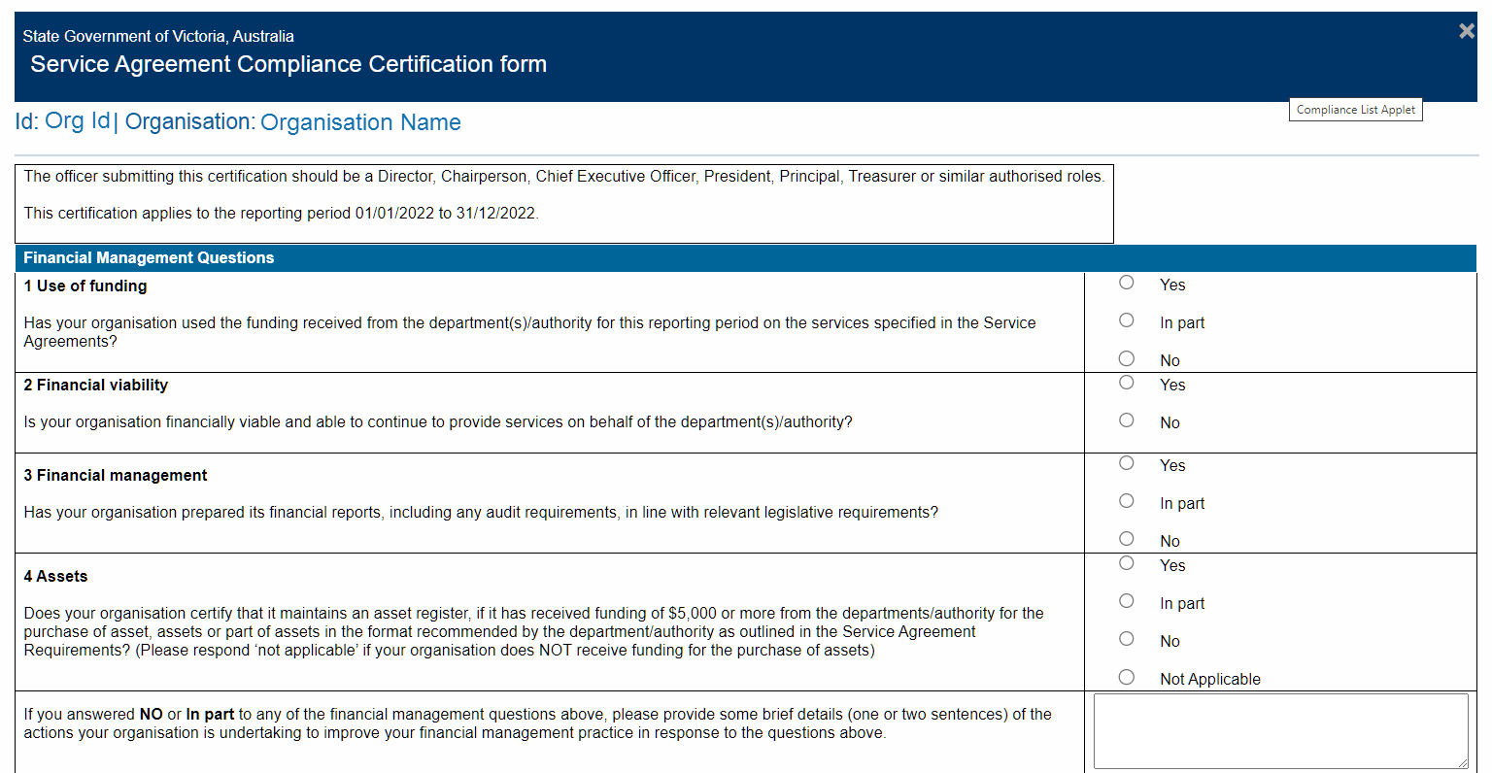

Figure 4: Screen shot of the second question on the SACC form

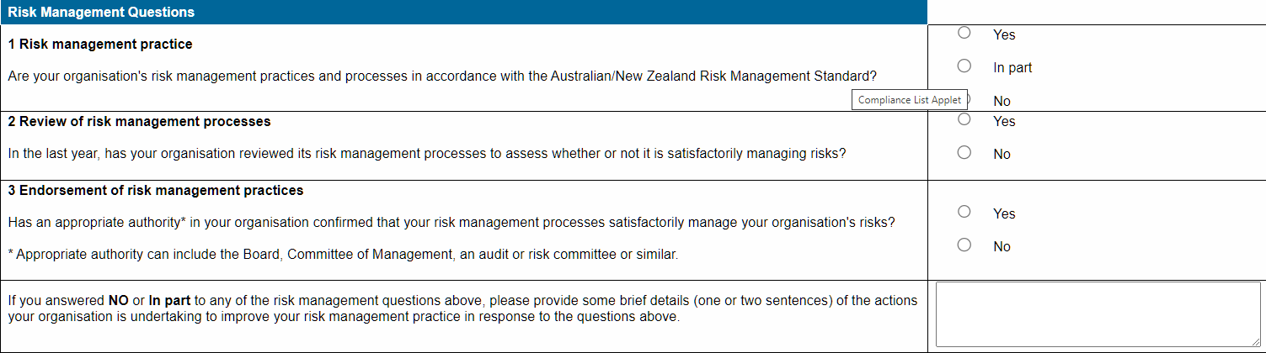

Figure 5: Screen shot of the third and fourth question on the SACC form

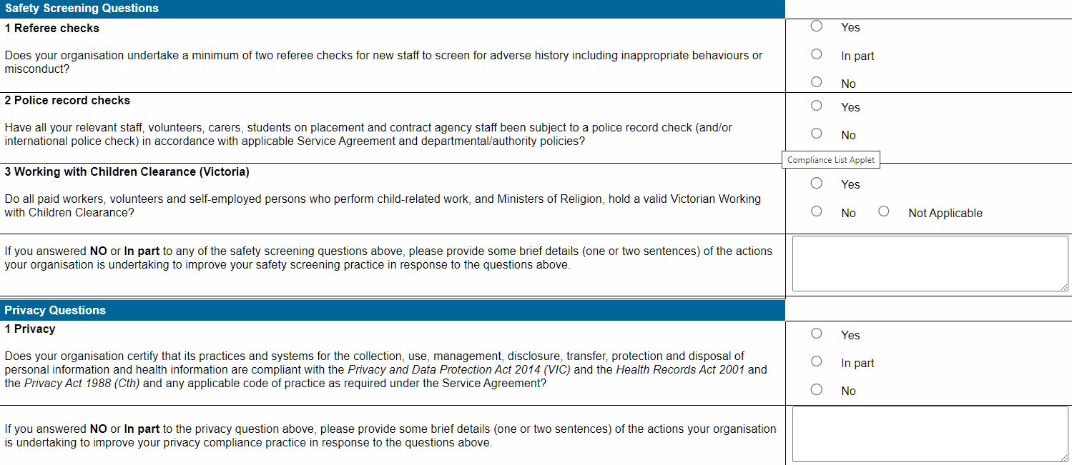

Figure 6: Screen shot of fifth question on the SACC form

