

|  |
| --- |
| L17 Family Violence Portal eBusiness registration guide |
| For Orange Doors, Safe Steps, Men’s Referral Service and Victoria Police |
|  |

|  |
| --- |
| L17 Family Violence Portal eBusiness registration guide  For Orange Doors, Safe Steps, Men’s Referral Service and Victoria Police |
|  |

|  |
| --- |
|  |
| To receive this document in another format, [email Service Delivery Solutions](mailto:L17Portal@dffh.vic.gov.au?subject=eBusiness%20Registration%20Guide) <L17Portal@dffh.vic.gov.au>  Authorised and published by the Victorian Government, 1 Treasury Place, Melbourne.  © State of Victoria, Australia, Department of Families, Fairness and Housing, August 2023.  Available at L17 Family Violence Portal eBusiness Registration Guide on the Funded Agency Channel <https://fac.dffh.vic.gov.au/l17-family-violence-portal-ebusiness-registration-guide> |
|  |

Contents

Document information 6

Changes made 6

Background 7

Purpose 7

Security and privacy 7

Registration overview 8

What is eBusiness? 8

Registration - Step by step instructions 9

Step 1 - Staff registration for eBusiness and the L17 Family Violence application 9

Step 2 - Organisation Authority approves eBusiness request 17

Step 3 – DFFH provides access to the application. 18

Step 4 - Confirmation email sent to staff 18

Step 5 - Access the eBusiness portal and the application 18

Roles and responsibilities 19

Organisation Authority 19

DFFH 19

Troubleshooting 20

My request for eBusiness access or access to the application is not being actioned. 20

My organisation’s OA has approved my request, but I haven’t received confirmation of my access. 20

Support and contacts 21

# Document information

This document has been prepared by the Service Delivery Support Branch, Community Operations and Practice Leadership Division.

|  |  |
| --- | --- |
| **Criteria** | **Details** |
| **Document title** | L17 Family Violence Portal eBusiness registration guide |
| **Document owner** | Executive Director, Service Agreement and Quality Systems, Community Operations and Practice Leadership Division |
| **Document custodian** | Director, Service Delivery Support, Service Agreement and Quality Systems, Community Operations and Practice Leadership Division |
| **Version** | V4 |
| **Issue date** | 29 June 2023 |

# Changes made

|  |  |  |
| --- | --- | --- |
| **Published date** | **Sections amended** | **Description of amendment** |
| December 2016 | L17 eBusiness registration | Guide to registering for the L17 Family Violence portal through eBusiness |
| January 2017 | Update to the registration guide Step 5 number 31, Page 16 | Amendment of Step 5 number 31, Page 16. Removed line (*Please note that the application goes live on 6 December 2016*) which is no longer applicable. |
| August 2019 | Update to the registration guide | Amendment of Step 1, Part A, Page 6 |
| 29 June 2023 | Update to the registration guide | Updated process for allowing new users to select a specific Orange Door location, page 11 and page 16 |

# Background

Family Violence referrals and reports by Victoria Police are made through the Victorian Police Risk Assessment Management Report (L17) to the Department of Families, Fairness and Housing (for child protection) and community services organisations via the L17 Family Violence Portal.

The L17 Family Violence Portal has been created by the Department of Families, Fairness and Housing in collaboration with family violence services and child protection to streamline the referral and report process and improve outcomes for those experiencing family violence. The Portal sees L17 reports converted electronically in real time directly to the appropriate service.

## Purpose

The purpose of this document is to provide staff with steps to access the L17 Family Violence Portal.

## Security and privacy

A registration process is required so that workers can access the L17 portal and services can verify a worker’s access and role.

The L17 portal contains sensitive client information, therefore it has a high level of security and user management protocols.

The Department of Families Fairness and Housing has an authentication process called eBusiness which provides workers with a mechanism to access the department’s computer systems via the internet on the basis that only registered and authorised persons do so.

Staff are required to provide mandatory details, including given name, family name and date of birth to register an eBusiness account to enable access to the L17 portal. Staff will be provided with an individual username and password to login to eBusiness.

# Registration overview

Registration to eBusiness is required so that organisations can verify that a staff member has a business need to access the system before providing them with access to use the L17 portal within their organisation.

All staff requiring access are required to:

* register for a **firstname.surname** eBusiness account*
* request access to the application via their eBusiness account.

*Staff can omit this step if they have an existing **firstname.surname** eBusiness account registered with their current organisation. If staff have an existing eBusiness account under a different organisation, please contact eBusiness Support on 1300 799 470 to have the account deactivated before registering under the current organisation.

## What is eBusiness?

eBusiness is a portal which allows registered and authorised people to access the department’s computer systems via the internet.

To ensure the security of personal information captured within the L17 portal, the application can only be accessed via the eBusiness portal. Staff must register with the eBusiness portal, and log into the application through that portal with an individual username and password.

All organisations have an **Organisation Authority** to help with eBusiness registrations. The Organisation Authority (OA) in each agency is responsible for verifying staff identity and authorising them to use the eBusiness environment and the application.

The **L17 portal team** grant access to the application when the staff member’s OA has approved their access in eBusiness.

The staff member is sent an email confirming when access has been granted, including their eBusiness username and password.

# Registration - Step by step instructions

## Step 1 - Staff registration for eBusiness and the L17 Family Violence application

**Follow Part A if:**

* you do not have an existing eBusiness account

or

* you have an eBusiness account with a username in the following format **abcd.o12345** (for those using CRISSP)

**Follow Part B if:**

* you have a **firstname.surname** eBusiness account.

### Part A – Staff who don’t have an eBusiness account (or an account in the format firstname.surname)

1. Go to the  [eBusiness portal](https://hns.dhs.vic.gov.au/EUSPortal/index.jsp): <https://hns.dhs.vic.gov.au/EUSPortal/index.jsp>
2. Click ‘I want to register’

Figure 1: eBusiness registration and login screen

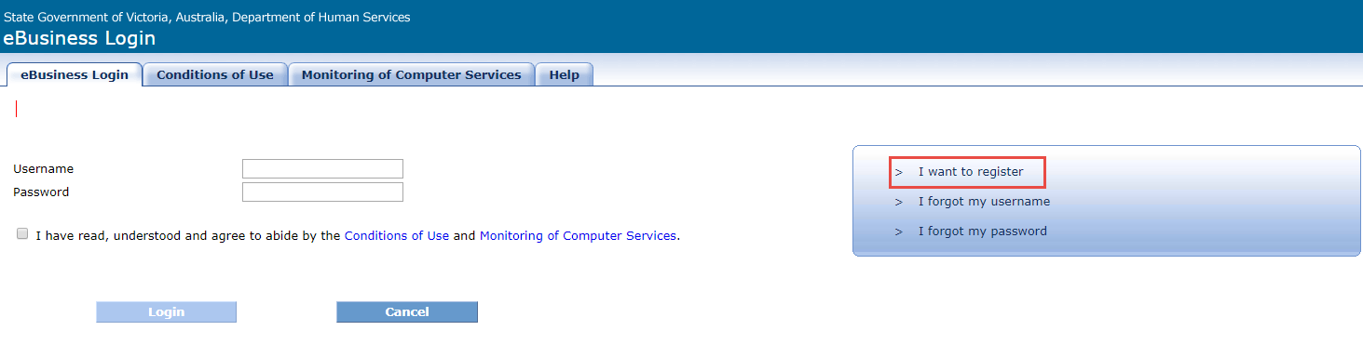

1. The eBusiness application request form will open.

Figure 2: Select applications screen

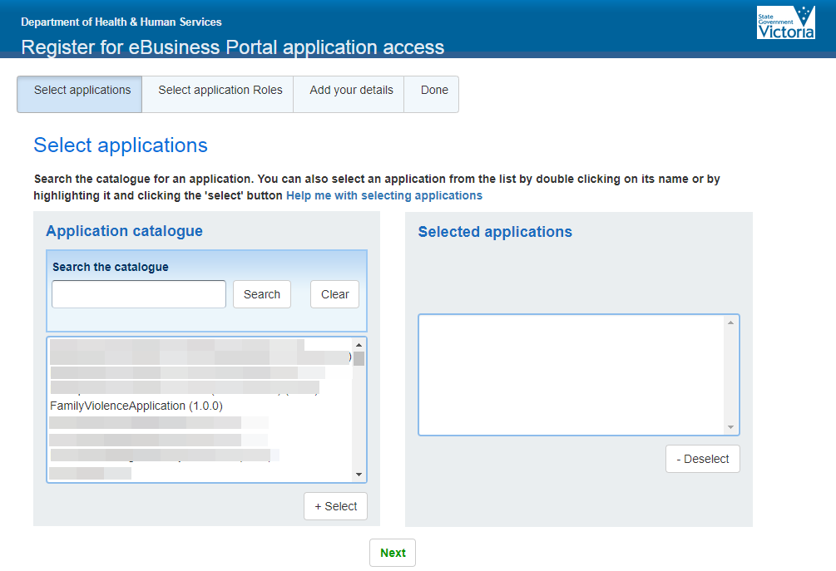

1. Select Family Violence Application from the list or enter ’Family Violence Application’ in the search box. Highlight the application and click the Select button to move it to the right, to the Selected applications box.
2. When Family Violence Application (1.0.0) is listed in the Selected applications box click on the Next button.

Figure 3: Selected applications screen

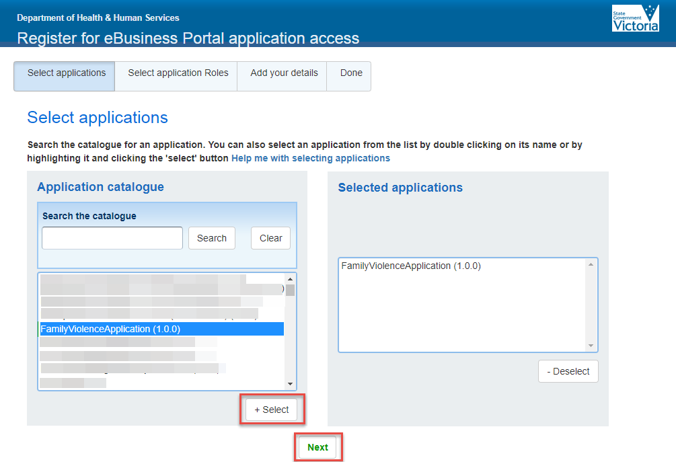

1. Select your application role.   
   Select the desired role you will require when accessing the L17 Portal. Select one role only.

Figure 4: Select application roles screen.

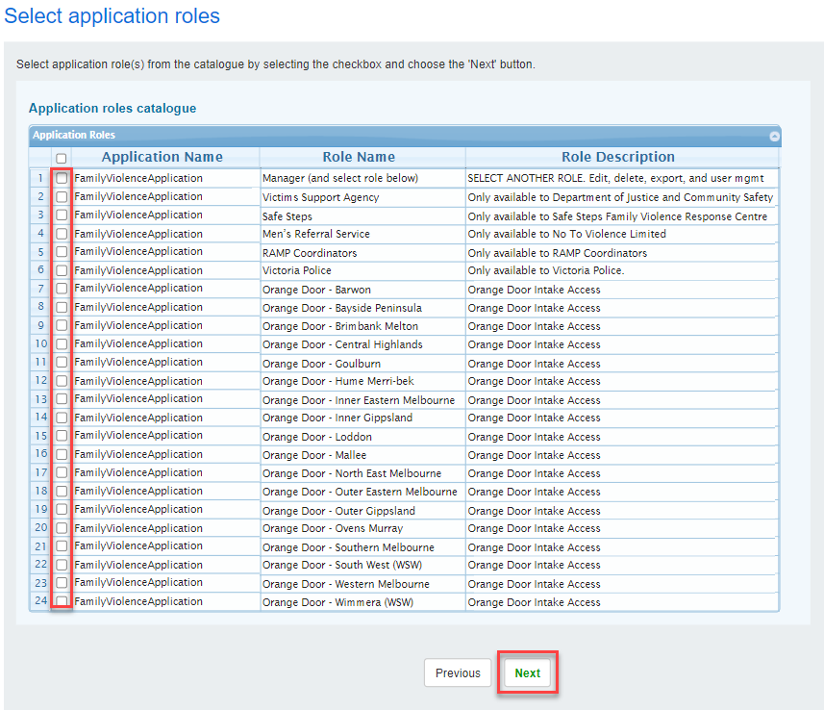

1. Click Next.
2. Add your details and complete all the fields with a red asterisk. red asterisk image *A work email address must be used when registering (do not use a personal email address such as a gmail or hotmail account).*

Figure 5: Add your details screen.

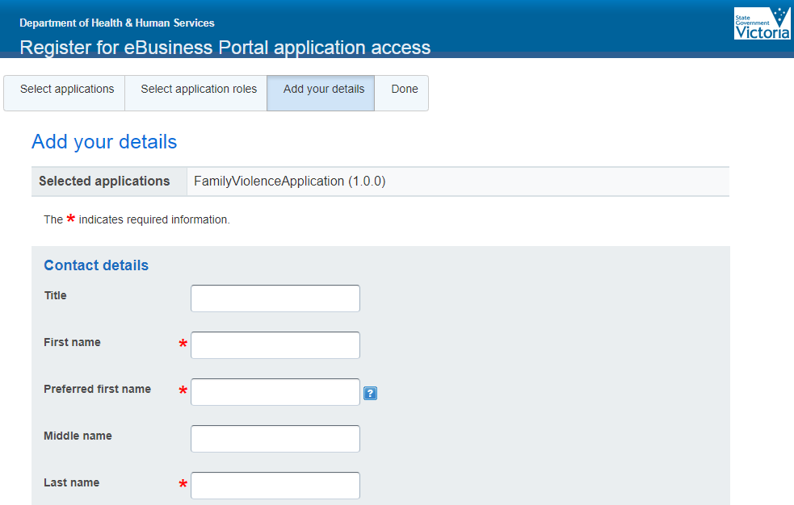

1. Select your Organisation Name and role.
   1. Type your organisation name in the search box. Click Search.
   2. Results matching your search will appear in the ‘Organisations found’ list.
   3. Highlight the organisation and click ‘+ select’.
   4. Select your Role in organisation.

Figure 6: Add your organisation details screen.

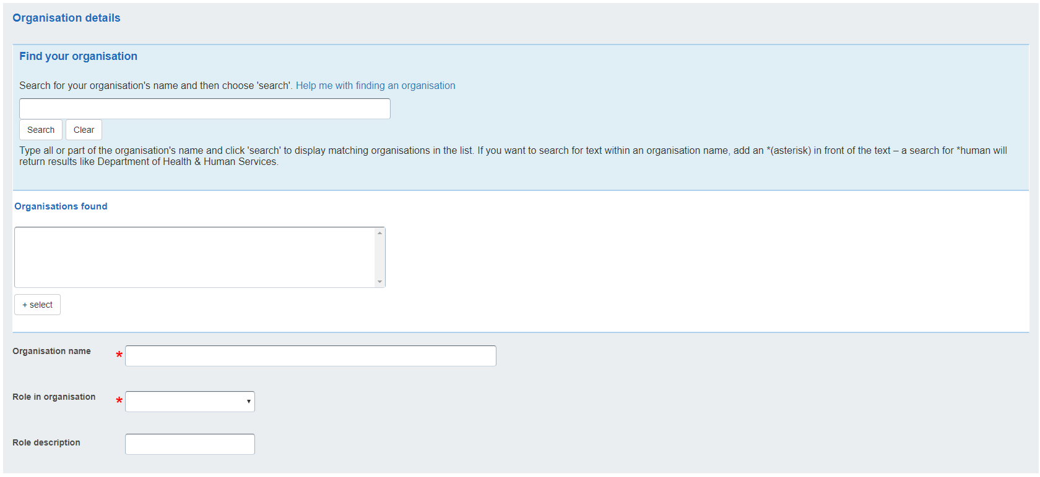

1. Complete all the Security details fields.

Figure 7: Security details screen.

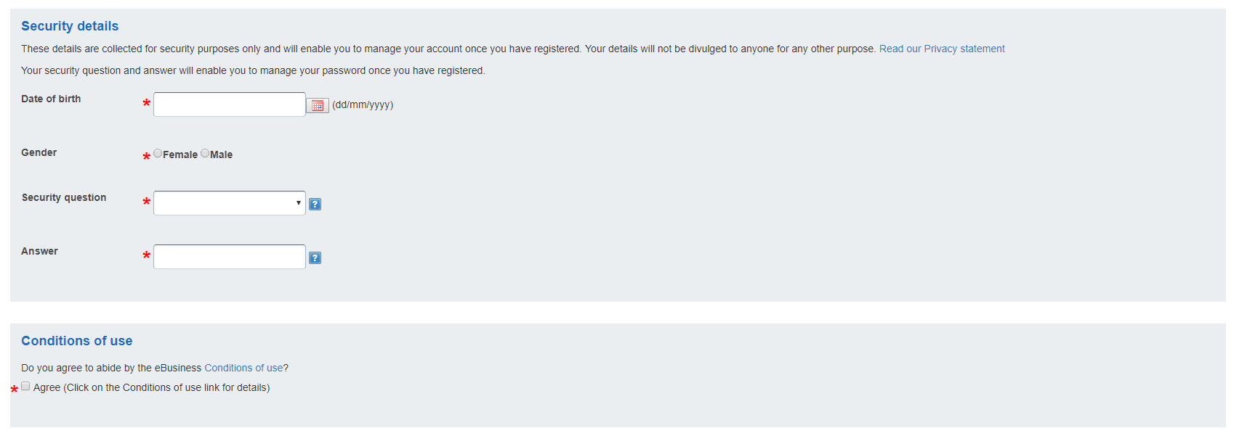

1. Review the *Conditions of Use*, and if you agree, click the ‘Agree’ checkbox.
2. Click ‘Register’.
3. Your request for the application access is now finished.

Figure 8: Request sent screen.

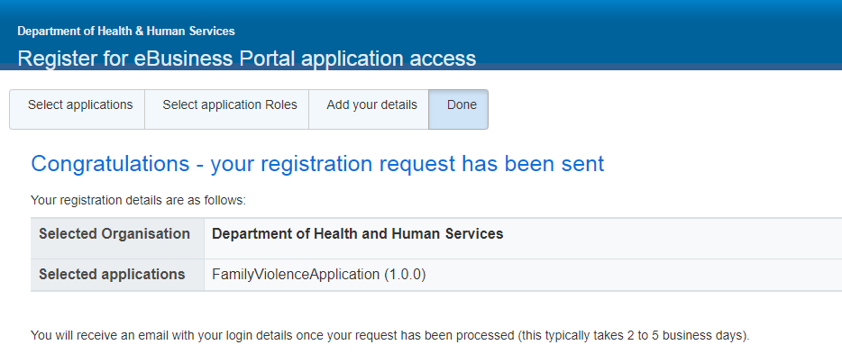

1. Go to Step 2 on page 15 (Organisational Authority approves eBusiness request).

### Part B – Staff who have an existing eBusiness account

eBusiness accounts and access to applications must be removed when they are no longer re quired for business purposes. In some circumstances access to applications may be removed but the account still exists or there is a delay in processing the removal. Contact the eBusiness helpdesk to remove your old account and follow Part A of this registration Guide.

If you are already using eBusiness for another application within your organisation, such as the Victorian Housing Register Application, and want to request access to the L17 portal under:

* the same organisation name, follow the steps below.
* a different organisation name or branch/program area within your organisation, go to Part C.

1. Go to the  [eBusiness portal](https://hns.dhs.vic.gov.au/EUSPortal/index.jsp): <https://hns.dhs.vic.gov.au/EUSPortal/index.jsp>
2. Login to your eBusiness account.

Figure 9: eBusiness login screen.

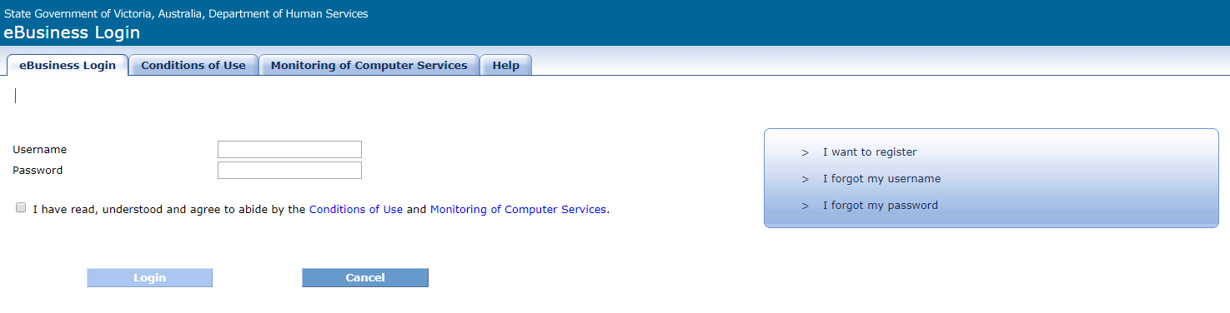

Figure 10: eBusiness home screen after login.

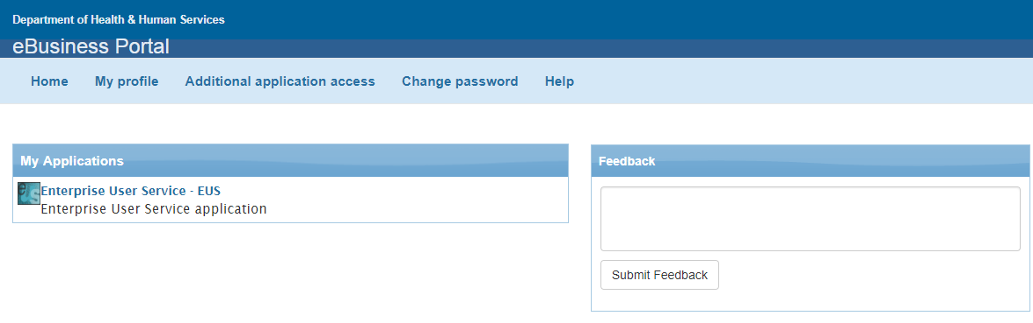

1. Click ‘Additional Application Access’. You will then see a list of applications to choose from.
2. Select ‘Family Violence Application (1.0.0)’ from the applications list.

Figure 11: Request additional application access screen.

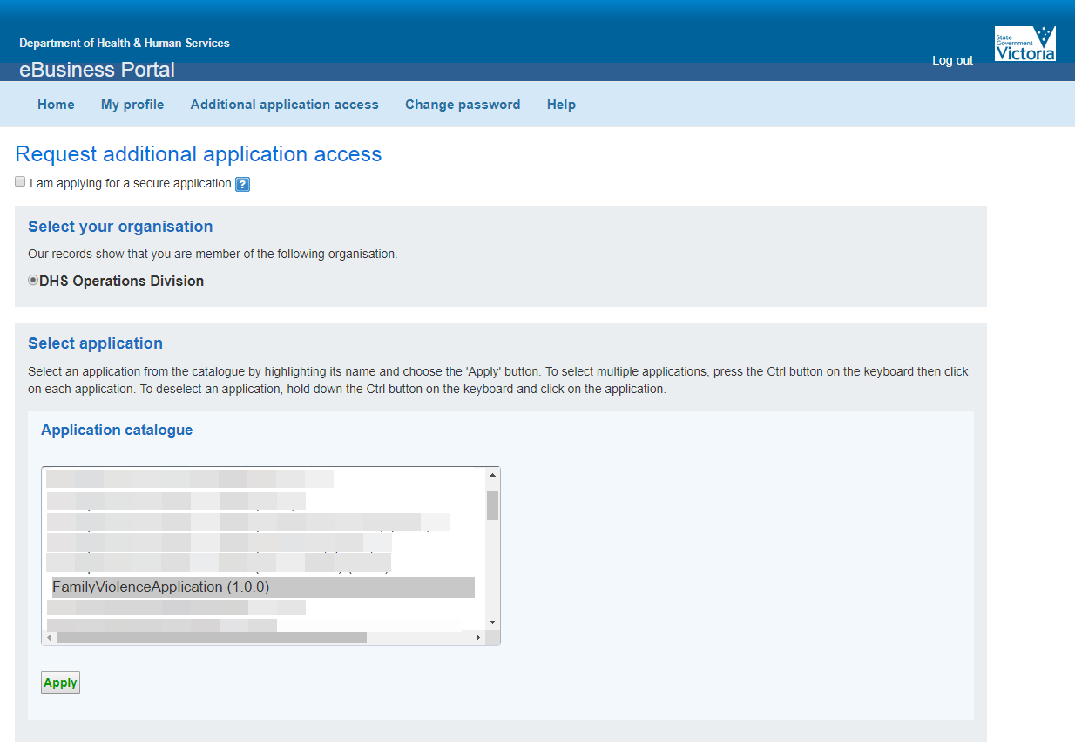

1. Click ‘Apply’
2. Select the desired role you will require when accessing the L17 Portal. Select one role only.

Figure 12: Role selection screen.



1. The screen will then show a confirmation message that your request has been sent. You can then close the window.

Figure 13: Request sent confirmation screen.

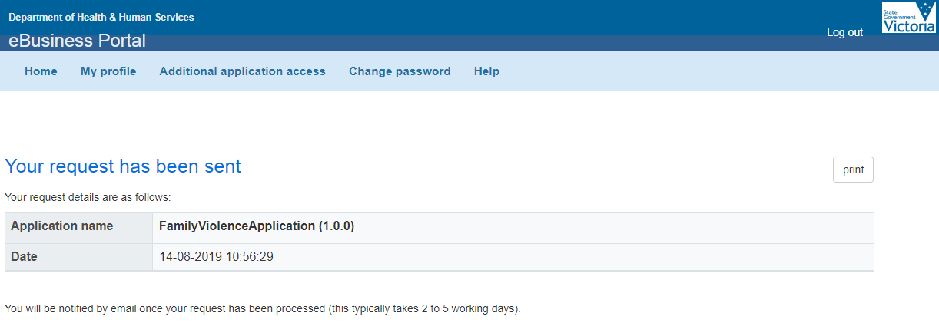

1. Your request has been sent to your Organisation Authority for approval. Go to Step 2 on page 13 (Organisational Authority approves eBusiness request) for further information.

### Part C - Staff who work for different organisations OR need to receive L17 referrals from multiple referral lists within own organisation OR are requesting access under a username which already exists on eBusiness

#### Scenario 1

Staff who work for more than one organisation will need to register for an eBusiness account for each organisation.

#### Scenario 2

Staff who work in an organisation where there is more than one L17 referral list ie. One list for Male Respondents and another list for Women and/or Children, and an individual needs access to both lists. These individuals will need to have multiple eBusiness accounts to access the different lists.

* 1. Staff will need to register to create a new account, and follow the same process stated above to send through a new request.
  2. When staff come to the point of entering their details, they will need to add extra letter(s) in either your Given Name or Family Name to differentiate your additional account to your first account.

For example: if the username for your first account is Joe.Bloggs then you could add a letter to your Family Name so the username would be Joe.BloggsM. We suggest using M for Men’s referral list, W for Women’s referral list or C for ChildFIRST referral list OR if you work for multiple organisations, insert the first letter or two of the organisation you are registering for.

#### Scenario 3

Staff who have sent in a request but have been notified that an account already exists with the same username under a different organisation.

Staff who have an old account with the same username but different organisation, and it is no longer needed, must contact eBusiness Support to request that their old account is removed. Once it is removed, they must notify the L17 Portal Team and send through a new request under their username.

If the old account is still needed or does not belong to the individual in question, then they will need to send a new request with an altered username as per the steps for the above scenarios.

## Step 2 - Organisation Authority approves eBusiness request

The Organisation Authority (OA) will receive an automated email from eBusiness to authorise their staff member’s request. The OA logs into eBusiness to approve eBusiness/application requests.

Secondary Organisation Authorities, chosen by the primary Organisation Authority, will also receive the notification emails, and will be able to log in and approve requests if the primary OA is absent.

*Refer to the Troubleshooting section if your organisation doesn’t have an OA or requires a new OA.

It is the organisations responsibility to make eBusiness aware if an OA has left the organisation and nominate a new OA.

## 

## Step 3 – DFFH provides access to the application.

The L17 Portal team will grant the user access to eBusiness and the Family Violence application.

This step can only be completed when the staff member’s OA has approved their use of the application in eBusiness.

## Step 4 - Confirmation email sent to staff

A confirmation email is automatically sent from eBusiness to the staff member confirming access to the application. The email will contain eBusiness username and password, if applicable.

It is important that staff follow the instructions within the email to update their eBusiness password.

## Step 5 - Access the eBusiness portal and the application

1. Go to the  [eBusiness portal](https://hns.dhs.vic.gov.au/EUSPortal/index.jsp): <https://hns.dhs.vic.gov.au/EUSPortal/index.jsp>
2. Login to your eBusiness account.

Figure 14: eBusiness Login screen

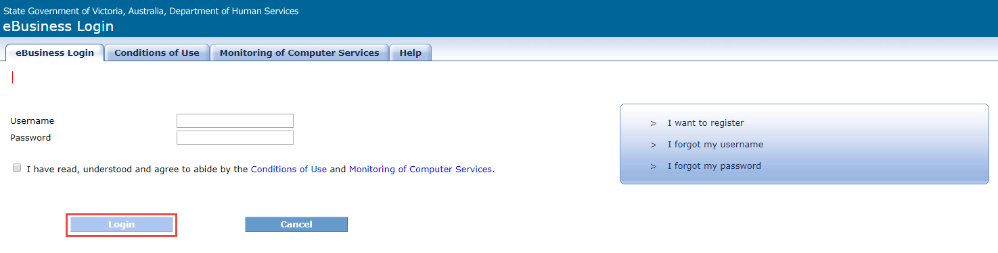

1. Click on the **Family Violence Application** link in the Home page.
2. The application will now open.

# Roles and responsibilities

## Organisation Authority

An Organisation Authority (OA) is a person designated by the organisation to be the key contact for the department in relation to authorising and maintaining users in the department's technology systems. The person nominated for this role must be currently listed as in this role with the department and must be available to assess and authorise staff for eBusiness applications.

The OA in each organisation is responsible for authorising the staff member’s access to use the eBusiness environment and the application. **OA’s must only authorise access for staff whose job/position within the organisation warrants their use of the application.**

## DFFH

The L17 portal team will provide staff with access to the application when the Organisation Authority has approved the staff request in eBusiness.

# Troubleshooting

There are a number of steps in the registration process that can cause registration delays. Below provides information on how to overcome the most common registration issues.

## My request for eBusiness access or access to the application is not being actioned.

The Organisation Authority (OA) or Secondary OA within an organisation must approve all requests related to eBusiness. There are a number of reasons why the request may be delayed from the organisation’s side:

* The OA no longer works for the agency and can’t approve the eBusiness request.
* The OA is on leave and hasn’t approved the eBusiness request.
* The OA does not know the staff member and cannot confirm their identity.

If the OA or Secondary OA no longer works for the organisation, another OA will need to be nominated.

Contact the eBusiness helpdesk via email [ebiz@support.vic.gov.au](mailto:ebiz@support.vic.gov.au) for instructions on how to nominate a new Organisation Authority.

## My organisation’s OA has approved my request, but I haven’t received confirmation of my access.

Possible reasons why a staff member may not have been notified of access is:

* An incorrect email address was provided in the eBusiness registration request, therefore the confirmation email bounced.
* The automated email confirming registration was recognised as SPAM and could be in staff email Trash/Junk folder.
* eBusiness request from staff who have entered a yahoo or hotmail email account. The work email address must be used when registering.

To check your access, please contact the eBusiness Support Desk on 1300 799 470 or email [ebiz@support.vic.gov.au](mailto:ebiz@support.vic.gov.au)

#### I was registered for eBusiness through my old organisation but now work for another organisation.

If a staff member leaves an organisation and needs to register for an application with another organisation, contact the eBusiness Support Desk on 1300 799 470 or [ebiz@support.vic.gov.au](mailto:ebiz@support.vic.gov.au)

#### A staff member has left the organisation and no longer requires access to eBusiness and/or the application.

To prevent unauthorised access it is the responsibility of the staff member’s manager or organisation to send an email to [L17@support.vic.gov.au](mailto:L17@support.vic.gov.au) and [ebiz@support.vic.gov.au](mailto:ebiz@support.vic.gov.au) and request that the staff member’s access be removed.

# Support and contacts

If you have any difficulties with registration, contact **1300 344 727** to lodge an IT Ticket.

If you have any difficulties with an eBusiness account or password contact the eBusiness helpdesk on **1300 799 470**.

Select **option 1** (for assistance with eBusiness)

Select **option 4** (for assistance with an eBusiness password or to contact eBusiness support).