

|  |
| --- |
| Better practice guide for multicultural communications |
|  |
| OFFICIAL |

|  |
| --- |
| Better practice guide for multicultural communications |
|  |

|  |
| --- |
|  |
| To receive this document in another format, email the Stakeholder Engagement and Innovation team <[engagement@dffh.vic.gov.au](mailto:engagement@dffh.vic.gov.au)>.  Authorised and published by the Victorian Government, 1 Treasury Place, Melbourne.  © State of Victoria, Australia, Department of Families, Fairness and Housing, June 2023.  **ISBN** 978-1-76130-129-2 **(pdf/online/MS word)**  Available at [Communicating with multicultural communities](https://www.vic.gov.au/communicating-multicultural-communities) <https://www.vic.gov.au/communicating-multicultural-communities> |
|  |

Contents

Acknowledgements 6

Introduction 6

About this guide 6

A note on terminology 6

Victoria is culturally diverse 7

Principles for better communication 8

Plain language 8

Think about your audience 10

Tips for different audiences 11

Ways to communicate 15

Foundation 15

Standard 20

Better practice 21

How to run a multilingual campaign 22

Research first 22

Consider your budget 22

Language first, channels second 22

Choose the right channels for your audience 22

Work with an agency with multicultural expertise 23

Keep your creative simple 23

Engage with multicultural communities 23

Helpful resources – multilingual campaigns 24

Case studies 25

Organic case study: Things more painful than a COVID test 25

Paid case study: Protect your family. Protect your community. 26

Resources 28

Appendix 1: Co-design tools 29

Activity template: Community participant brief 29

Activity template: Audience and challenge scoping workshop – Warm up 29

Template: Community participant ad 30

Example of co-designed communications 31

# Acknowledgements

This guide was written by the Public Engagement branch in the Department of Families, Fairness and Housing.

We want to acknowledge the many organisations we consulted in writing it: Centre for Culture, Ethnicity and Health, CultureVerse, Ethnic Communities’ Council of Victoria, Ethnolink, LEXIGO and Polaron Language Services. We would also like to acknowledge Tanya Simmons for her expertise on plain language. Finally, we want to acknowledge research by Monash University, the Royal Melbourne Institute of Technology (RMIT), the University of Melbourne and the Burnet Institute which informed this guide.

# Introduction

## About this guide

Multicultural communities have diverse needs that traditional communications do not always meet. If we don't reach this audience, many Victorians may not access the services and information they need to take part in society.

This guide captures what we learnt from communicating with multicultural communities during the COVID-19 pandemic. It is based on:

* qualitative research
* evaluations
* consultations with stakeholders and subject matter experts.

It includes recommendations for government and private organisations to improve how we communicate and engage with multicultural communities in Victoria.

The guide includes two principles for improving communications for multicultural communities. It then explains different ways you can communicate, depending on your organisation’s capacity. Finally, it includes two examples of good practice multicultural communications.

This is a 'better practice guide', not a 'best practice guide'. We recognise that there is always room for improvement and that achieving ‘best practice’ may not be possible for everyone. While we would love everyone to co-design with community all the time, in reality this is not always possible. This guide gives you ways to improve your communications with or without co-design.

This guide focuses on multicultural communities, but its principles can help everyone. Planning to reach diverse audiences will help you reach more Victorians.

## A note on terminology

In this guide we use ‘multicultural’ instead of ‘culturally and linguistically diverse (CALD)’ or ‘non-English speaking background’. This is a deliberate choice, but it is not a perfect one. This terminology is contested. Different terms have different meanings for different people. We need words to talk about this topic and we need those words to be inclusive and affirming. Our words should not other or imply deficit. We value the diversity and strengths that people from all backgrounds bring to our state.

We have chosen ‘multicultural’ to describe the racially, ethnically and religiously diverse people who live in Victoria. We chose this word because it is succinct and broadly inclusive. At this point, we want to acknowledge that most people in Australia are migrants or descendants of migrants, unless they are First Nations Aboriginal or Torres Strait Islander peoples.

There is, of course, no one multicultural community. There is diversity within diversity. There are a diverse range of experiences within multicultural communities including varying levels of English proficiency, understanding of government systems, and the many other factors that people need to understand government communications.

When thinking about the words we choose, we should reflect on who we are trying to describe with these words. What do we really mean when we say ‘multicultural communities’? Are we trying to reach second generation Victorians who are largely reached by ‘mainstream’ channels but have a parent from a different culture or country? Or do we mean newly arrived Victorians who have limited English proficiency?

Ideally, we should use specific words that describe the people we want to reach. For example, young people from South Sudanese communities, people aged 65+ from Vietnamese communities, or international students from India. This guide will help you identify these audiences and learn how to reach them.

# Victoria is culturally diverse

According to the 2021 Census[1]:

* More than 1.7 million Victorians speak a language other than English at home.
* 290 languages are spoken in Victoria
* The number of households who speak only English at home is decreasing.
* More than half of Victorians have at least one parent born overseas.
* 50 per cent of Victorians follow one of more than 130 faiths.
* 10,000 asylum seekers live in Victoria on bridging visas.
* 4,000 refugees settle in Victoria each year through the Commonwealth Settlement Program.
* 285,875 Victorians speak English not well or not at all.

The 2021 Census reached the highest number of Australians ever recorded, however census data only partially portrays the diversity in Victoria. As it is in English, there are likely many more people who could not complete it, or complete it accurately. That said, it is still the best data we have.

For more information about multilingual communities in Victoria, see the reports at [Mapping languages spoken in Victoria](https://www.dffh.vic.gov.au/mapping-languages-spoken-victoria) <https://www.dffh.vic.gov.au/mapping-languages-spoken-victoria>.

# Principles for better communication

## Plain language

Writing in plain language makes information more accessible for everyone. For people with limited English proficiency, writing in plain language makes it more likely they will understand the content. It also makes translations clearer. Plain language does not mean ‘dumbing down’ information.

Something is in plain language if the audience can:

* **find** what they need
* **understand** what they find the first time they read or hear it
* **use** what they find to meet their needs.[2]

### Clear content helps everyone

Writing in plain language helps people with high and low literacy. Even people with the highest literacy may be time-poor and have a lot to read. Plain language makes content quicker and easier to understand for readers of all levels.

### How to write in plain language

#### Start with your audience

What your reader needs to know is often a lot less than what you want to tell them. You should only create content that your reader needs. Avoid giving them too much information.

Ask yourself:

* Who am I writing for?
* What is my purpose?
* Why do I want them to read this?
* What do they need?
* What do they already know?

#### Structure

Structure your content to make it as easy as possible for the reader to scan and find what they need to know. Your audience might not read your content from start to finish.

Put key messages up the top and the detail later. Use descriptive headings to explain and break up content. For example, ‘Who can get this payment?’ is clearer than ‘Key information’. Use lists, graphics and tables to break up information and make it easier to understand.

#### Use short sentences

Short sentences:

* tend to make you use simpler language
* make it easier to scan sentences and take in information
* prevent ‘cognitive overload’ – this happens when your brain tries to process too much information.

Only use as many words as you need for the meaning and tone of voice. Aim for 15 words on average, and no more than 25 words per sentence.

#### Write in active voice

Active voice is all about using verbs. Active verbs give a conversational tone that is engaging and easy to understand. The subject comes before the verb, so the doer of the action is at the front of the sentence. This makes it clear who is doing what. It also helps readers know exactly what they need to do.

**Active voice:**  The cat sat on the mat.

**Passive voice:** The mat was sat on (by the cat).

#### Everyday words

Use everyday words and avoid jargon. It’s OK to use specialised terms if needed, but make sure to explain them so your reader can better understand your content. We’ve included some simple plain language swaps below. You can also find lists of plain language replacements online, like [this list from the Plain Language Action and Information Network](https://www.plainlanguage.gov/guidelines/words/use-simple-words-phrases/) <https://www.plainlanguage.gov/guidelines/words/use-simple-words-phrases>.

#### Keep it conversational

Speaking directly to your reader avoids overly formal writing and helps your message come across as friendly and helpful. You can do this by writing in active voice and using personal pronouns (‘we’, ‘you’ and ‘us’).

### Easy plain language swaps

|  |  |
| --- | --- |
| **Instead of:** | Use: |
| additional | more, extra |
| approximately | about, around |
| assistance | help |
| commence | begin, start |
| communicate | write, tell, talk |
| community members | people |
| comply with | follow |
| concerning | about |
| correspondence | letter, email |
| demonstrate | show |
| indicate | show, say |
| indication | sign |
| notwithstanding | despite, although |
| notify | tell |
| the majority of | most |
| numerous | many, several |
| provide | give |
| regarding | about |
| receive | get |
| sufficient | enough |
| terminate | end, stop |
| undertake | do |
| utilise | use |

### Helpful resources – plain language

* [Australian Government style manual](https://dhhsvicgovau.sharepoint.com/sites/DFFHCommunicationsMediabranch/Shared%20Documents/Stakeholder%20Engagement%20and%20Innovation/15%25%20multicultural%20media%20spend/Better%20practice%20guide%20for%20multicultural%20communications/Australian%20Government%20style%20manual) <https://www.stylemanual.gov.au>
* [Plain Language Foundation](https://dhhsvicgovau.sharepoint.com/sites/DFFHCommunicationsMediabranch/Shared%20Documents/Stakeholder%20Engagement%20and%20Innovation/15%25%20multicultural%20media%20spend/Better%20practice%20guide%20for%20multicultural%20communications/Plain%20Language%20Foundation) <https://www.plainenglishfoundation.com>
* [Plain Language Action and Information Network](https://www.plainlanguage.gov/) <https://www.plainlanguage.gov>
* [Hemingway app](https://dhhsvicgovau.sharepoint.com/sites/DFFHCommunicationsMediabranch/Shared%20Documents/Stakeholder%20Engagement%20and%20Innovation/15%25%20multicultural%20media%20spend/Better%20practice%20guide%20for%20multicultural%20communications/Hemingway%20app) <http://www.hemingwayapp.com>
* [Writing plain language – VicGov](https://www.vic.gov.au/writing-plain-language) <https://www.vic.gov.au/writing-plain-language>

## Think about your audience

There is no singular multicultural audience. Victoria’s population is very diverse, so it is important to think about who your reader is and what their experience is like. What is it like to be them? How can they do what you’re asking of them? What will be the outcome and impact of your message?

This principle applies to all the diverse populations in your audience. But below are some points to consider for multicultural audiences in particular.

* **How does your audience relate to government?** They might have had negative experiences with governments in or outside of Australia which eroded trust. They might not understand how government works in Australia, for instance the differences between commonwealth, state and local services.
* **How will they find your information?** They might not be looking at government websites.
* **How do they like to receive information?** Some people have low literacy, even in their spoken language, and prefer video or audio information.
* **What do you want them to do?** Will they have to use English websites, forms or hotlines? Is translation appropriate? For example, translating a factsheet about a grant program might not work well if they need to apply in English.
* **Do they really want to read a whole strategy?** Would they find a brief summary easier to understand?
* **Are they eligible for what you are promoting?** For example, people on temporary visas are not eligible for Medicare.
* **Think about the in-language user journey**. Does your translated content give them all the information they need? Set up interpreter service for hotlines. Link directly to translated content wherever possible.

#### Example

Information about COVID-19 vaccine side effects told people to ‘monitor for redness around the injection site’ in all languages. However, for people with darker skin tones, their skin may not turn red. Not including information about what to watch for if you have dark skin makes the information unhelpful for many people.

### How to learn more about your audience

Find your data. Sources include:

#### Community insights

Want to speak to experts? There is no better source of information than hearing straight from community members. It is best to do this at the start of your project, not as an afterthought. Make sure to do your research before approaching community members, and make sure they are compensated for their time.

* Engage community organisations, communications agencies or language service providers to consult communities and get insights to inform your work. Plan for this in your budget and timeline.
  + Go to events run by community, learn about them in person – find events on social media or VMConnect <https://victorian-multicultural-commission.hivebrite.com>. Libraries and community centres can also be great places to reach communities.
* Ask the [Victorian Multicultural Commission](https://www.multiculturalcommission.vic.gov.au/) <https://www.multiculturalcommission.vic.gov.au> for help reaching specific communities.
* Join VMConnect <https://victorian-multicultural-commission.hivebrite.com> to connect with community representatives.

For more tips on working with community, see Co-design with community in this guide.

#### Census data

You can search [Census data](https://www.abs.gov.au/census/find-census-data/search-by-area) <https://www.abs.gov.au/census/find-census-data/search-by-area> by location or by country of birth. Use QuickStats in the search results to find ancestry, country of birth and language spoken at home in the searched area.

**Important notes about Census data**

* Language spoken at home and English proficiency are most important.
* Country of birth isn’t enough to infer translation needs.
* The data does not tell us about literacy in language

#### Language maps

The Victorian Government has two reports that map the [languages spoken across regional Victoria and metropolitan Melbourne](https://www.dffh.vic.gov.au/mapping-languages-spoken-victoria) <https://www.dffh.vic.gov.au/mapping-languages-spoken-victoria>.

#### Settlement data

[Settlement data](https://immi.homeaffairs.gov.au/settling-in-australia/settlement-reports) <https://immi.homeaffairs.gov.au/settling-in-australia/settlement-reports> from the Australian Government is helpful for identifying new migrants to Australia. This is especially helpful in the years between the Census to get up-to-date data, and as we experience increased migration post-COVID.

#### Data from your department or ask other organisations

See what data you already have about the communities you are trying to reach. This could include:

* who is using interpreters when they access services
* how many people have visited translated pages on your website or downloaded translated resources.

## Tips for different audiences

### Young people

*Create relevant, short, and entertaining content.*

* **Many multicultural young people speak English.** They don’t always need translations.
* **Involve young people.** Young people need targeted, simple, youth-friendly information developed for and by young people. The more we can build the capacity of young people to share important messages the more effective they are going to be.
* **Make it relevant.** Young people find messages that seem relevant to them personally or their situation more attractive. Personalised communication makes it easier for people to understand the costs or benefits of a particular behaviour. Working with trusted influencers can be a good way to do this.
* **Make it short.** There is an overwhelming preference for 15–30-second ‘bite-sized’ videos.
* **Make it positive**. Do not focus on negative behaviours or challenges.
* **Make it entertaining.** Comedic content is more likely to be attention-grabbing, memorable and shareable. Although there is a risk that your audience won’t find the content funny, co-designing content with your audience reduces this risk. It also offers more opportunities for distribution through co-design partners.
* **Brand the content.** This improves credibility. Young people also appreciate when government makes an effort to reach them where they are.
* **Young people can be a messenger for older generations.** Families often rely on young people to translate and share information. This is because young people tend to have better language skills, awareness of current affairs and digital literacy. ​We should equip young people with the information they need to help their families, but not rely on them to reach older generations.
* **Young people are not always the decision makers.** You might need to reach their parents or grandparents with translated information too to help them understand what their young people need to do.

#### Resource

[Youth Social Media Playbook](https://playbook.actionlab.dev/) <https://playbook.actionlab.dev/>

Practical tips for using social media in your projects.

### Seniors

*Focus on audio and visual translated assets.*

* **Community distribution is key.** Community organisations and leaders often help people get information by sharing resources via Facebook and other social media.
* **Go beyond digital distribution.** Non-digital ways of communicating are vital for reaching older people, like newspaper ads, community radio or in-person events.
* **In-language information is more often needed.** Some older people may forget or lose their additional languages like English and ‘revert’ to their original or native languages. This is known as language reversion.
* **Audio and visual information is easier to understand.** For a variety of reasons, older people may not be able to read the language they speak.
* **Multicultural media.** Traditional and community multicultural media channels can reach older audiences, like in-language radio and newspapers. Refer to the How to run a multilingual campaign section for more information.
* **They won’t find translations on websites.** This can be due to low digital literacy as well as low literacy in their preferred language.
* **Create one-page resources as a JPEG.** Short resources with images, clear layout and limited text make it easier for older people to understand what to do. Longer, text-heavy resources with jargon and few images are less effective. Create one-page resources with brief dot points and in a sharable format (such as a JPEG file). This will ensure print resources are shared and better understood.[3]
* **Community leaders are highly influential.** Community and religious leaders can help build trust in the community, particularly when they lead by example. Note that these leaders do not always reach or represent everyone in their community. Working with multiple leaders in the community can overcome this.

### People with refugee and asylum seeker backgrounds

*Informal networks are powerful.*

* **Audio and visual content.** In general, people prefer information through spoken (for example, phone calls, community forums) rather than written channels. This is especially true for people with lower literacy (in English or in their preferred language) as well as those from a culture where language is mainly spoken rather than written (for example, many African communities).
* **Social media is the preferred channel.** The audio-visual format is the most effective for receiving information.
* **Community-led initiatives are very effective.** People trust community leaders. This makes them better placed to be advisors and messengers. Provide materials and support for community information programs.
* **Confirm eligibility.** Many government initiatives and services are not available to people on temporary visas. If you do not specify that they are eligible they will assume they are not.
* **Reiterate if a service is free.** Some people do not expect governments to offer services for free and might not take them up because they are worried about the cost.

#### International students

*Social media and education providers are highly influential.*

* **Use the tips for young people.** Most international students are young people.
* **Confirm eligibility and reiterate if a service is free.** Similar to the tip for refugee and asylum seekers, international students may not be able to access all services and may not expect services to be free.
* **Social media and education providers are more influential than community networks.** International students are less likely to be actively involved with a broader cultural community (including community organisations). This means they rely more on social media, websites, employers, and education providers, and less on family, cultural and faith-based groups, and community organisations.
* **They usually have a high English proficiency** because of their course requirements.

Study Melbourne is part of the Victorian government that supports international students in their study journey. Study Melbourne Ambassadors can share their experience, knowledge and insights to help you reach students. There is also a Study Melbourne Facebook group ‘[International Students of Melbourne and Victoria](https://www.facebook.com/groups/studymelbourne)’ <https://www.facebook.com/groups/studymelbourne>.

#### Barriers to engagement: mistrust, marginalisation and disadvantage​​

* Some young people, refugees and asylum seekers may be wary of authority, law enforcement and other public institutions​​. This is often with good reason if they have had previous bad experiences.
* Some people may have a lack of resources and technology (limited devices or data), unstable internet connection and digital literacy challenges​​.
* Many people are wary of scammers impersonating government. They might not trust calls from private numbers.

#### Intersectionality

The audiences we describe here cover only a small part of the intersectionality in multicultural communities. There are people with disability, LGBTIQ+ people, and many more communities that people from multicultural communities belong to. It is important to try and include people at these intersections. The best way to do this is to consult with these audiences to learn about their needs and how you can meet them.

# Ways to communicate

Now that we have covered the principles for better communication and tips for reaching different multicultural audiences, we will delve into different ways to communicate. This section covers all the ways of communicating that are not paid campaigns and advertising.

There are three ways of communicating included here. They all build upon each other. Where possible, we encourage you to aim for better practice, but we know this is not always possible. Often how you communicate will be determined by the time and budget available to you. You can combine different parts of the different levels based on the resources you have available.

## Foundation

Foundation is the minimum level of multicultural communication that the Victorian Government should provide. You can use this level when you do not have much time or budget. At the foundation level, you should write in plain language and translate key information.

### Plain language

Writing in plain language improves communication with all audiences, especially people with limited English proficiency. It also makes translations clearer. Refer to the Plain language section earlier in this guide for more information.

### Translation

#### Why are translations important?

High-quality translations give everyone equal access to information and services. They do more than change language, they should accurately convey meaning and context. For example, there are words in English that don’t have a direct translation in other languages that will need further context or description to support understanding.

Good translations also build trust by showing you want everyone to understand your information. Alongside helping people with limited English proficiency to understand, translations also:

* engage Victorians who understand English well but speak a different language at home
* provide resources for people who understand English well to share with their friends and family who do not read English well
* help Victorian Government departments and agencies comply with the *Multicultural Victoria Act 2011*.

The Multicultural Victoria Act says that every Victorian is entitled to opportunities and to take part in and contribute to the social, cultural, economic and political life of the state. It also requires all Victorian Government departments to report each year on how they use interpreting and translation services.

### Tips for good translations

#### Write in plain language

Translators will translate the style and tone of your writing, as well as the meaning. This means that if your writing is formal and complicated, your translations will be the same. This is a common mistake that often leads to negative community feedback.

#### Don’t use wordplay, colloquialisms or phrases with double meanings

They do not translate well.

#### Build in quality control

When working with a translation agency, ask that a NAATI-certified translator translates the content first. Then ask that a second NAATI-certified translator checks it.[4] You wouldn’t publish content without having at least one other person check it, so don’t publish translations without having them checked. Make sure your translation provider has a clear way to deal with community feedback once your translations are published too.

#### Do not use machine translation

Machine translation tools cannot guarantee accuracy. They do not consider important factors like variations in dialect and language, cultural references and nuance like politeness. Victorian Government policy advises against using machine translations.

If you do use machine translation as a first step, make sure you have it checked by a NAATI-certified translator.

#### Keep it as short as possible (save money too!)

Translation agencies often charge by the word. Fewer words = less cost. Briefer content will also be easier for your readers to understand – win-win!

#### Engage your agency early

Translation agencies can help you understand your audience and adapt your content for them. Giving your agency plenty of time and context will give you better quality translations.

#### Leave extra room for translated text

Some languages take up more space than English, and some languages read right to left. These are important considerations for any documents, especially posters.

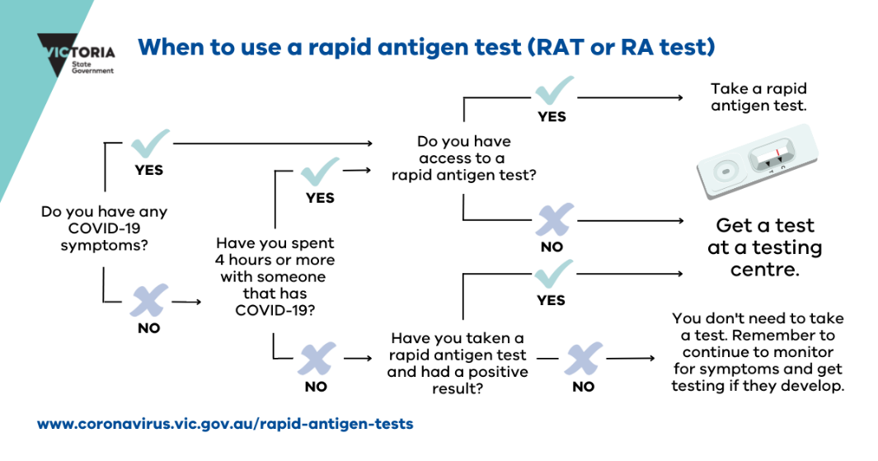 The document will be flipped for languages that read right-to-left such as Arabic.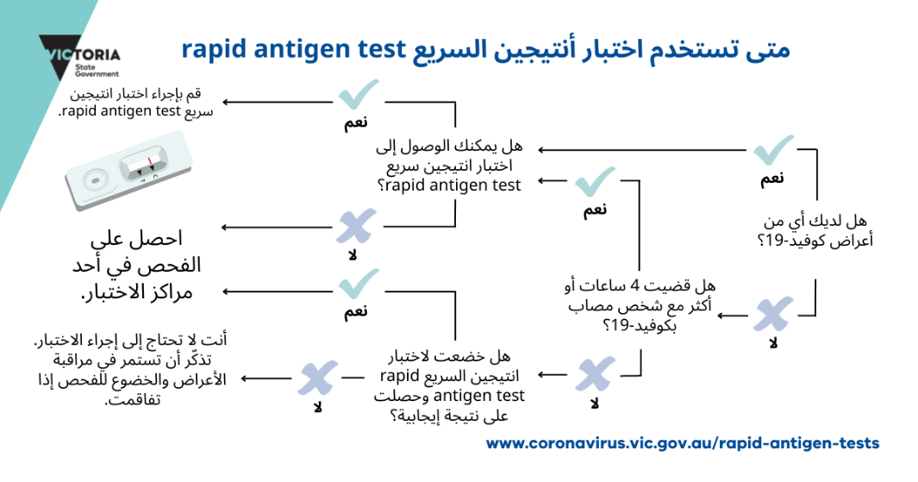

Leave extra space for languages that take more space such as Tamil.

#### When to use a rapid antigen test poster in Tamil - exemplifying text that takes more space than English

### How to choose languages for translation

Choose the languages spoken by your audience (refer to Think about your audience above).

Carefully consider your audience, using all the data you can get:

* Who is your audience?
* Where do they live?
* How old are they?
* How is their English proficiency?
* How do they like to receive information?

Consider whether you are aiming for ‘high reach’ or ‘high need’. Some language communities have high English proficiency, and some have low English proficiency. This means the top 10 languages with the most speakers in Victoria aren’t always the best languages for translation. If you are trying to reach the Victorian population broadly, we recommend combining English proficiency data with the top languages spoken at home. Some communities have a smaller population, but higher level of low English proficiency. These communities can benefit greatly from tailored communications.

Please note, the Census only asks about *spoken* language, not written language. This means two things. First, it does not tell us how well someone reads or writes in the language they speak. Many people have low literacy in their spoken language for various reasons. Second, some languages are only spoken, not written. For example, Mandarin is a spoken dialect of Chinese. Many Mandarin speakers read Simplified Chinese, but some read Traditional Chinese.

Make sure you also consider the linguistic diversity within the communities you are trying to reach. Some languages will have regional variations, like Arabic which is spoken in over 20 countries. There may also be many languages spoken by people from one country, like people from Afghanistan.

**Ask your translation agency for advice on the best written languages to reach your audience.**

If you engage with community organisations on your project, you can also ask them what languages they recommend.

#### Top 10 languages spoken in Victoria[5]

1. Mandarin
2. Vietnamese
3. Cantonese
4. Greek
5. Arabic
6. Italian
7. Punjabi (from the Punjab region of Pakistan and India)
8. Turkish
9. Khmer (the national language of Cambodia)
10. Hazaragi (a dialect of Persian)

## Standard

If you have more time and resources, you should move beyond the foundational level to create audio and visual communication and think about how it will be distributed.

### Audio and visual communication

* Audio and visual materials are important because:
  + Not everyone can read their preferred language.
  + Audio and visual content can be more engaging.
  + It is often easier to share through social networks.
* Think beyond factsheets – consider posters, audio, community leader videos or animation.

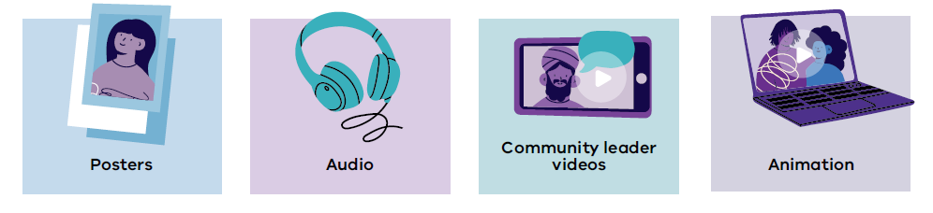

#### Tips for visual communications

* Make sure your imagery recognises and reflects the community you are trying to reach.
* If you are translating a voiceover for a video, translate any text in the video too.
* The length of time needed to read different languages out loud in animations can vary. Ask your translation agency about how to allow for these differences.

### Distribution

There is little value in producing a great translation only to have it sit on your website with no views. Think about how you will distribute your work to your audience.

Some channels and networks available to the Victorian Government include:

* Victorian Multicultural Commission – Multifaith Advisory Group, Regional Advisory Councils, VMConnect, Multicultural Youth Network, Multicultural Chamber of Commerce Group, community networks
* local councils, ethnic councils and peak bodies
* service providers
* English language schools
* community organisations.

## Better practice

Co-creating with communities is the better practice way of communicating with multicultural communities. This way of communicating can take more time and resources, but it is always worth the investment as it builds trust and creates stronger relationships between communities and government. It also means that communications reflect the voice and needs of the communities they are designed for.

### Co-design with community

* Involve the communities you want to reach early and at every stage. This includes messaging, design, production and distribution.
* Set expectations for the scope of the project.
* Be clear about what the community can expect from their involvement – if they identify a need that you didn’t know about, will you be able to respond?
* Define everyone’s roles.
* Fund communities to create and send out content in a way that is meaningful to them. Do not expect people to work for free.
* Give multicultural communities training, resources and support.
* Set up ongoing channels of communication with community leaders​.
* Use existing connections if you have them.
* Acknowledge community input in products.
* Allow enough time.

### Tools for co-design

In Appendix 1 you will find some tools for co-design. These are replicated with permission from Burnet Institute’s [Multicultural community communications handbook](https://peat-legume-665.notion.site/Burnet-Institute-Community-Led-COVID-19-Communications-65cc067721f747d2bfbd1fa5ca0d7f10) <https://peat-legume-665.notion.site/Burnet-Institute-Community-Led-COVID-19-Communications-65cc067721f747d2bfbd1fa5ca0d7f10>.

# How to run a multilingual campaign

## Research first

* Let your research and knowledge of your audience guide you.
* Research can be:
  + from external sources
  + desktop research
  + completed by an external agency
  + guided by your work within your program area
  + from lessons from other campaigns and engagements.
* If you are unsure and would like some help, please [email the Campaigns team](mailto:email%20the%20Campaigns%20team) <advertising@dffh.vic.gov.au>.

## Consider your budget

* What is the budget for this campaign? The budget will guide your campaign and what you can achieve.
* Budget for more than your community language media spend – set aside budget for creative, translations and media as well.
* Choose your languages at the start of your campaign to ensure you have enough budget.
* You will need to translate each asset you are creating. The more assets = the more translations = the bigger budget you will need.

## Language first, channels second

* Remember: **Do not let your media agency choose your languages.**
* Before you brief your media agency you need to choose the languages you will be targeting.
* For detailed information about choosing audiences and languages refer to Think about your audience in this guide.
* If you are unsure and would like help picking languages, please [email the Campaigns team](mailto:advertising@dffh.vic.gov.au) <advertising@dffh.vic.gov.au>.
* The languages you choose will guide your marketing channel selection.   
  Each language is its own target audience. It will have different channel preferences and demographics.
* Once you have picked your languages you should include these in your brief to the media agency.

## Choose the right channels for your audience

* Use the [Language persona document](https://www.vic.gov.au/community-profiles) <https://www.vic.gov.au/community-profiles>. These personas include key demographics you can use to brief your media agency such as age, life stage and location.
* Social and radio – If you are short on both budget and time and need to reach as many of your target audiences as possible, social media and radio are your go-to channels for culturally diverse groups.
* Your media agency can help with channel selection for specific languages.
* The Campaigns team will also help you choose the right channels for your audiences, please [email the Campaigns team](mailto:advertising@dffh.vic.gov.au) <advertising@dffh.vic.gov.au>.

## Work with an agency with multicultural expertise

* Skills are improving in major agencies. But ensure there is experience and understanding of multicultural audiences beyond organising translations. Or look at using an agency with specialist skills in multicultural communications.
* Ensure you are briefing your creative and media agencies on multicultural communications at the same time as your ‘general population’ brief.
* While your creative agency is building your assets/creative, the translation agency should be translating the content. This is to ensure general population and in-language materials go out at the same time.
* Allow additional time for translations.  
  This will be dependent on the number of languages, the chosen agency and the complexity of the translations required.

## Keep your creative simple

* Keep it simple for in-language creative translations. Refer to Tips for good translations in this guide.
* Consider multicultural audiences from the start. Ask for creative for in-language materials alongside your English creative in the first round (even if the creative they supply is in English).
* Key messages – Keep key messages for in-language creative simple (no more than three).
* Call to action – Have a clear call to action that will lead communities to more useful, translated information.
* Where are you leading your audience?
  + If you are leading your audience to a website, ensure you have allowed time and budget for translating or creating in-language webpages.
  + It is not useful to the community to lead them to websites and content that is not in language. It will not get your message across and in turn will hinder your campaign.
* Incorporate visual icons, graphics, or photographs to tell the story.  
  Many people in multicultural communities can speak their language a lot better than they can read and write. Images are incredibly important in getting your message across simply and quickly.

## Engage with multicultural communities

* This is what we refer to as **below the line** communication because it takes place at the community level.
* Because you won’t have a paid channel for every language you want to target, community distribution and engagement is an essential part of all multicultural campaigns.

1. **Build a stakeholder kit**  
   Build a short document that explains your campaign, its key message and purpose. Include links to download translated creative material so community groups can share these through their community channels. Also include your social media schedule in your stakeholder pack. Multicultural community Facebook groups can then look out for and reshare your posts.
2. **Choose an agency with community contacts**   
   Translation services often have connections with community groups. Ask your agency to check if there are Facebook groups you could send your marketing materials to. Consider tabling materials at community meetings.
3. **Engage the Victorian Multicultural Commission**   
   The VMC team has a network of community businesses and members to send out your in-language messaging and materials to. You can house your materials on the VMC website for community groups to download.
4. **Use other VPS departments**  
   Several government departments work closely with multicultural communities. These departments have channels that can help you reach your target audiences.

## Helpful resources – multilingual campaigns

For more information you can use:

[Language personas](https://www.vic.gov.au/community-profiles) <https://www.vic.gov.au/community-profiles>.

# Case studies

## Organic case study: Things more painful than a COVID test

### Challenge

At the start of the COVID-19 pandemic, there was concern international students may not be getting tested when they felt unwell because of two barriers:

* perception that the COVID-19 PCR test was painful
* perception that international students would have to pay to get tested because they don’t have Medicare (but the test was free for everyone regardless of whether they had Medicare).

### Insight

#### Behavioural insights

* Establish new social norms: We are all influenced by what those around us are doing. Especially in uncertain times when the ‘right thing’ can be unclear. Influential people can create new social norms by making clear what we ‘should’ do.
* Provide relevance: People are drawn to messages they perceive as relevant to them personally or to their situation. Personalised communication makes it easier for people to understand the costs or benefits of a particular behaviour (such as complying with physical distancing requirements).

#### Audience insights

* International students have high English proficiency due to requirements of their study visa, so they do not need translated information.
* Young people respond the most to content that is short and entertaining. Just because the message addresses a serious topic (getting tested for COVID-19) it does not mean it has to be serious in tone.

### Solution

* 30-second video designed for sharing on Instagram and other social media channels featuring things we do every day that are more painful than getting tested for COVID-19.
* The video starred international students from the Study Melbourne Student Ambassador program. It was filmed on their own smartphones with direction provided by a director remotely.
* Key message: We do these things every day. They are more painful than a COVID-19 test. They don’t even save lives.
* Call to action: *‘Feel sick? Get tested. It’s free.’*
* The [video](https://www.instagram.com/p/CGHHWnej2HR/?hl=en) <https://www.instagram.com/p/CGHHWnej2HR/?hl=en> was shared on Study Melbourne’s social channels. The students featured were also invited to share it through their networks.

### Outcome

* More than 50,000 organic views, largely from the Study Melbourne Student Ambassadors’ networks.
* Feedback was all positive and spread internationally. Commentary came from people in India, Sri Lanka and China.
* RMIT University research showed that young participants held the video up (unprompted) as a great example of content that engages young people.

## Paid case study: Protect your family. Protect your community.

### Challenge

During the peak of COVID in 2021, young adult men from multicultural communities were not following public health advice. They weren’t getting tested if they had COVID symptoms, and they were meeting friends to work out and socialise.

### Insight

* *’Protecting my family and my community is important to me’*

Market research indicated that multicultural communities would be more receptive to public health advice if it was framed as being a way to keep their family and broader community safe from COVID.

### Solution

* The campaign used the first insight in the creative development. The final campaign used emotive language and cues to connect action and positive results in the community to drive behaviour change.
* Words like ‘family’, ‘community’ and ‘safe’ were put together with images supplied by real families from multicultural communities.
* The images used included extended family to emphasise the effect of actions on the broader community.
* Demographic information such as location and corresponding languages most spoken at home were used to target and select paid marketing channels.
* **Key message**: Keep your family and community safe. Get tested if you have any symptoms.
* **Call to action**: Visit coronavirus.vic.gov.au for more information
* **Creative example** (social post):

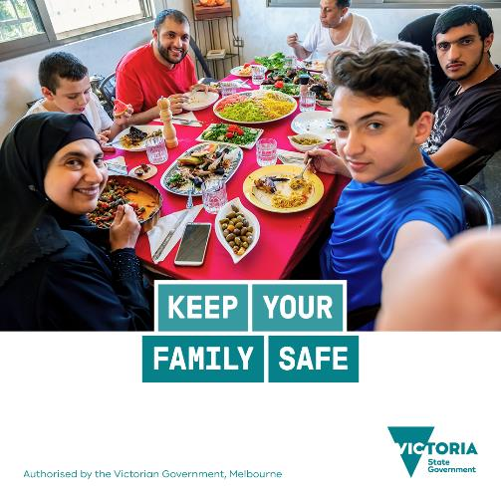

### Outcome

* Successfully reduced average time-to-test in targeted areas (data from Department of Health)
* ‘[Multicultural] Victorians are more likely to say the current rules are reasonable’ (results from the Behavioural Attitudes Survey, August 2021).

# Resources

* [Welcoming Cities: Inclusive Communications Toolkit](https://welcomingcities.org.au/inclusive-communications/) <https://welcomingcities.org.au/inclusive-communications/>
* [Co-designing and scaling effective COVID-19 communication strategies for young people from culturally and linguistically diverse communities in Victoria, Monash University](https://bridges.monash.edu/articles/report/Final_Report_Co-designing_and_scaling_effective_COVID-19_communication_strategies_for_young_people_from_culturally_and_linguistically_diverse_communities_in_Victoria/16959154/1) <https://bridges.monash.edu/articles/report/Final_Report_Co-designing_and_scaling_effective_COVID-19_communication_strategies_for_young_people_from_culturally_and_linguistically_diverse_communities_in_Victoria/16959154/1>
* [Understanding the experiences and communication needs of culturally and linguistically diverse communities during the COVID-19 pandemic, University of Melbourne](https://findanexpert.unimelb.edu.au/scholarlywork/1641179-understanding-the-experiences-and-communication-needs-of-culturally-and-linguistically-diverse-communities-during-the-covid-19-pandemic) <https://findanexpert.unimelb.edu.au/scholarlywork/1641179-understanding-the-experiences-and-communication-needs-of-culturally-and-linguistically-diverse-communities-during-the-covid-19-pandemic>
* [Community-led Communications Handbook, Burnet Institute](https://peat-legume-665.notion.site/Burnet-Institute-Community-Led-COVID-19-Communications-65cc067721f747d2bfbd1fa5ca0d7f10) <https://peat-legume-665.notion.site/Burnet-Institute-Community-Led-COVID-19-Communications-65cc067721f747d2bfbd1fa5ca0d7f10>

# Appendix 1: Co-design tools

## Activity template: Community participant brief

**Define the demographics**

For example:

* 18-35
* Casual workers
* Cultural background

**Explain the participation requirements/time commitment ethics**

For example:

* Group session discussing concerns about COVID
* Provide feedback and input into communication designs
* Attend a community session

**Will participants be compensated for their time?**

For example: Yes, $100 per hour

**Contact details to register interest**

For example: Email us at [info@us.org](mailto:info@us.org)

**Where will you share the ad? Where will your audience find it?**

For example:

* On community facebook groups
* Clients of our services

## Activity template: Audience and challenge scoping workshop – Warm up

### Welcome

In Melbourne we are located on the traditional lands of the Wurundjeri/Woiwurrung people of the Kulin Nation. We pay our respects to Elders both past and present, and recognise and respect their abiding connection to this land, its waterways and community. Wurundjeri/Woiwurrung people have nurtured this land for over 50,000 years and continue to do so today. Sovereignty was never ceded.

### Example warm up 1

Introduce yourself and pick the emoji that best represents how you are feeling coming into this session.

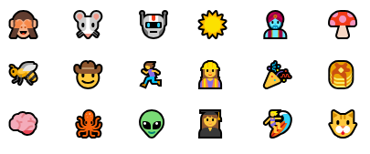

### Example warm up 2

To get to know each other we're going to ask a few questions. Go around the group and tell us;

1. Your name
2. What brought you here
3. One community you are a part of
4. One thing you'd like to see come out of this project

### #Tips

* It can be good to introduce a level of abstraction (like the emoji) to get people to move from a words based analytical frame of mind to a more creative mode.
* Some people will find it important to explain why they are there, or what their story is. So find a way to have people introduce themselves that doesn't reinforce existing power dynamics.

## Template: Community participant ad

Create an ad, poster or social media post to attract potential participants. Be specific about the requirements and provide contact details for someone to talk to and screen participants. You can use this template or create something you feel will resonate more with your community or audience.

Ad template that reads:
[Headline goes here]
[Our organisation] is looking for
[description]
If you
• [Recruitment specification]
• [Recruitment specification]
• [Recruitment specification]
• [Recruitment specification]
You will be paid for your participation
Add your logo here
Call or email [contact details]

## Example of co-designed communications

This poster was co-created by Indian Care and the Burnet Institute. It is included with their permission.

In English:



In Hindi:

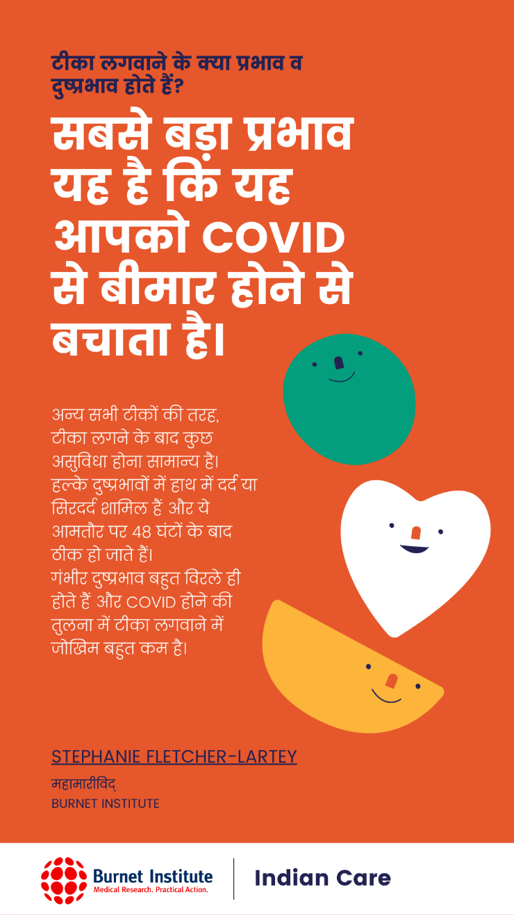

1. <https://www.abs.gov.au/census>
2. Definition from [plainlanguage.gov](https://www.plainlanguage.gov/about/definitions/) <https://www.plainlanguage.gov/about/definitions>.
3. While JPEGs are a great format to share on social media, they are not accessible for people who are blind or live with low vision. Make sure you have alternative formats, like Word documents or webpages, so that your content is accessible for everyone.
4. NAATI stands for National Accreditation Authority for Translators and Interpreters. NAATI is the national standards and certifying body for translators and interpreters in Australia. Learn more at [NAATI’s website](https://www.naati.com.au/) <https://www.naati.com.au/>.
5. Based on 2021 Census data. This list is the ten languages with the largest population and lowest English proficiency, not just the largest populations.