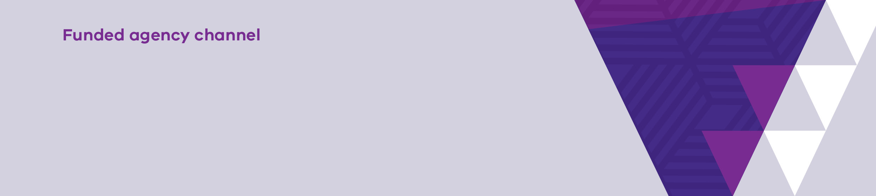

|  |
| --- |
| EOTS – Viewing Case History |
| Video Transcript |
|  |

This video contains a short tutorial on how to view Case History in the Enterprise Outcomes Tracking System.

All Cases that have been created for a client by users within your agency can be viewed in the system.

You are not able to view the details of Cases that were created in other organisations.

On the dashboard screen, locate a client you wish to view Case History for, then click the "View" icon.

This will take you to the "Manage Cases and Groups" screen.

On the "Manage Cases and Groups" screen, click the "View Client Details" icon.

This will take you to the "Client Details" screen.

Select the "Cases" tab on the top left of the screen.

The "History" tab will be displayed, and you will see a list of all Cases created in your agency for this Client.

Click the "View Case Details" icon for more information, if required.

Thank you for watching.

|  |
| --- |
| To receive this document in another format email [Service Agreement Communications](mailto:sacomms@dffh.vic.gov.au) <sacomms@dffh.vic.gov.au>  Authorised and published by the Victorian Government, 1 Treasury Place, Melbourne.  © State of Victoria, Australia, Department of Families, Fairness and Housing, February 2022.  Available at [fac.dffh.vic.gov.au](https://dhhsvicgovau-my.sharepoint.com/personal/michelle_ilosfai_familysafety_vic_gov_au/Documents/EOTS/videos/transcripts%20doc/fac.dffh.vic.gov.au) < http://fac.dhhs.vic.gov.au/fac-online-training > |