|  |
| --- |
| Decorative |

IRIS Training Notes

Feb 2020

# Introduction

IRIS is the DHHS-supplied reporting software for use by funded agencies. The following points provide a brief overview of the IRIS system.

* IRIS is a reporting tool provided to funded agencies to capture de-identified client and service delivery data for use by the department. IRIS can, however, also be useful as a client management system, although it must be noted this is not it’s primary function.
* Data is collected on a monthly basis; all DHHS funded agencies are required to report by the 10th of every month; all DEECD funded agencies are required to report every quarter starting from 15th January.
* All user accounts are created by the appointed IRIS administrator within the funded agencies; they will reset passwords as well. The IRIS Helpdesk does not create user accounts and does not have access to agency IRIS databases, this is all localised and the database file to be stored on the organisation’s server.
* The department only receives de-identified data, and it's important to backup your database regularly. This is best done just prior to doing your data export.
* The fundamentals of IRIS involve creating a client and creating new cases against those clients. *The exception to this is if a Child First partner agency receives a referral, in which case they just import the referral into their IRIS system.

# Creating a Client record

- Firstly, search for the client name using the search function to make sure the client isn't already there in the system (we don't want duplicates in the system).

- Click Clear Filters, type in surname and tick the box 'Include Inactive', then click Refresh (less info is best when using the search and report filter functions in IRIS).

To create a new client, click on the New button and be sure to fill in all the yellow mandatory fields.

*The yellow fields throughout IRIS are mandatory fields that must be completed. The system will not let you close a case until ALL mandatory fields have been completed.

*Note: Be sure to click Apply to save the record and any changes you make as you go along.

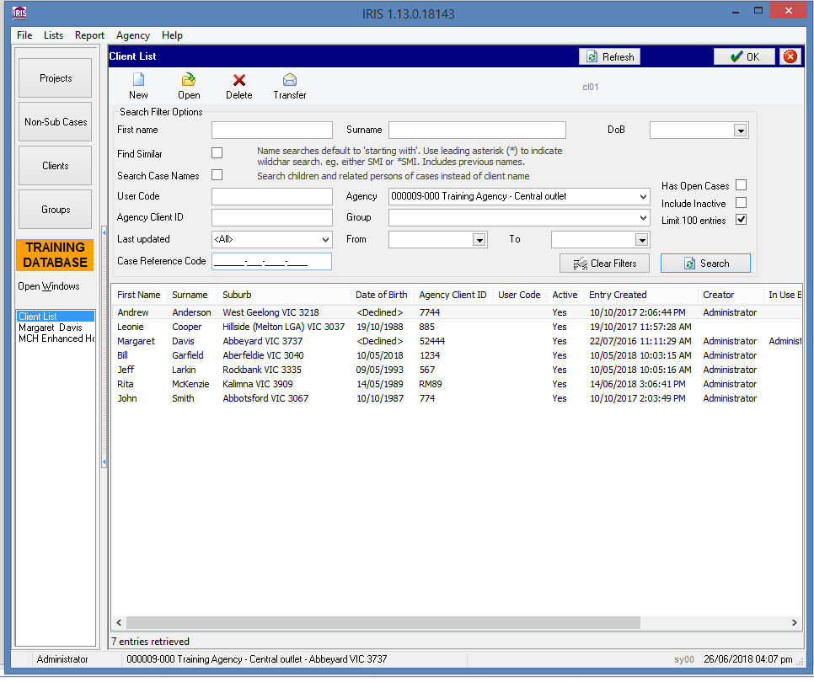

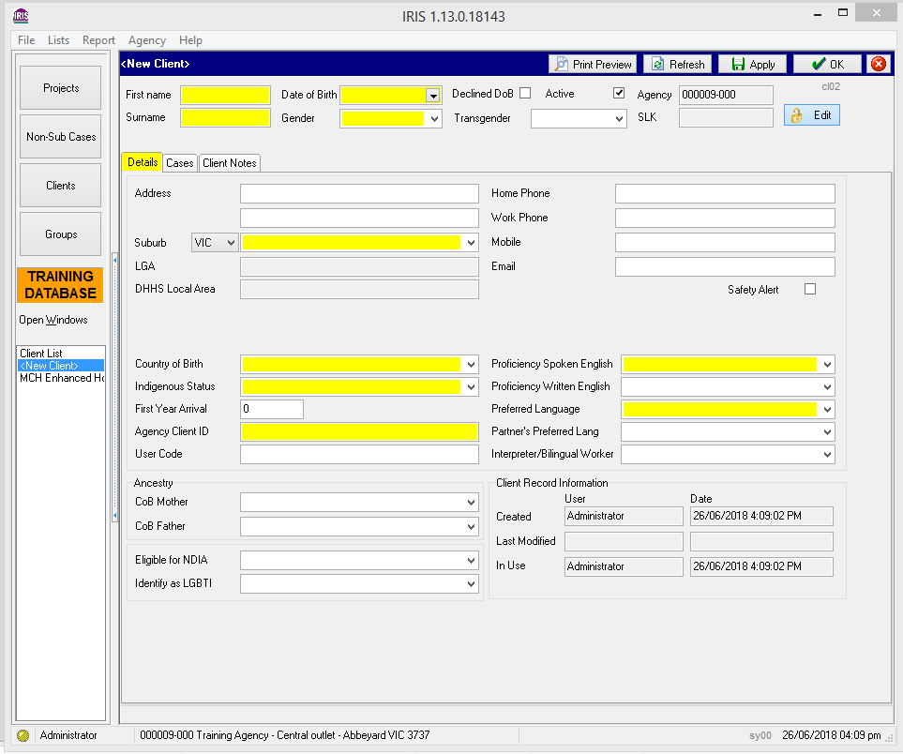

- The Agency Client ID is a unique identifier you create for a client to make it easy to find them when searching for client records, e.g. JS75 for John Smith with a birth year of 1975. It’s a free-form field and can be numeric, alpha or alpha-numeric. *Advise them to check with the IRIS administrator as to the desired or established format in use.

- User Code: this field is a unique identifier for the IRIS user. Again, this is a free-form field and be sure to check with the IRIS administrator as to the desired or established format in use.

*Safety Alert: this can be used to put a note in the system in relation to any potential danger or sensitive issue to aware of when dealing with this client and carer/family, i.e. client has a violent partner or vicious dog.

# Creating a Case for a Client

Once you have created your client record, you can create/add a new case against this client.

* Click on the Clients button on the left to bring up the client list, then double-click on your new client to bring up their details. Then click on the Cases tab.
* Click on the New Case button on the right to create a new case.

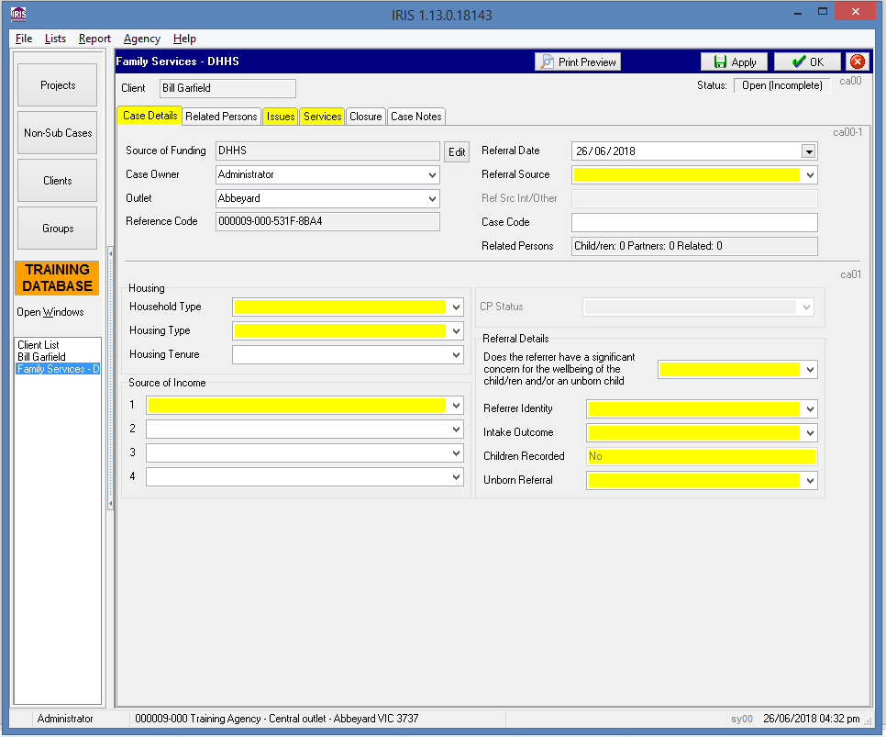

*Note: Whilst you can have multiple cases open for a client, you cannot have more than one specific case type open at the same time, i.e. 2 Family Services cases. The system will prohibit it.

‘Be sure to click Apply to save any changes you make as you go along’.

Case Details tab

*Note: It’s important to make sure the referral date is correct and to also be mindful that no future dates, such as services or issues, pre-date this. The system will prohibit this. All services must be dated AFTER the referral date.

*Note: ‘CP Status’ refers to Child Protection Status.

Related Persons tab

*You need to be sure to be sure to add a person in Related Persons for Family Service cases – this is a mandatory field for this case type. For most other case types, however, this field is optional.

*If you are creating a Family Services case, the demographics and engagement tabs also need to be completed.

Issues tab

This is a mandatory field and each case must have at least one issue recorded against it. You can record multiple issues in the one case.

Services tab

Services: This is where contact time with the client is recorded. This hours recorded here must relate directly to the case and involve client contact. Training or staff meetings, for example, are not to recorded in this section. (These could potentially be recorded under ‘Projects’, which is not, incidentally, captured in the data file sent to the dept.)

Case Notes tab

Case Notes: This is where any information or notes directly related to the case can be recorded (by clicking New and typing into the body of the screen). *It’s important to note any information on the case notes entered into IRIS can be subpoenaed by the courts. So be mindful to use professional language and be accurate with the information. You can also print individual case notes by clicking the Print button. If you click on ‘Combined View’ you can print all of the case notes recorded there.

Closure tab

You can close the case by clicking on the Update Case Status button; the date of closure should be today’s date. Once completed and saved, the case status in the top right-hand corner should have changed to ‘Closed’.

*If there’s no other open cases for the client, then it’s best to make the client inactive (in the Client screen) for housekeeping purposes. This is done by going into the Client section and taking the tick out of the ‘Active’ box. Only IRIS users with administration access are able to make a client inactive.

*Once a case is closed and exported (has an ‘Exported’ status), that's it, it can't be reopened (this is to stop people from changing the case after we have the data). A case can only be reopened when in a ‘Closed’ status.

Non-Sub Cases

The general rule for using non-sub cases is:

- Where the client is assisted in a one-off intervention and/or delivered a service of less than 2 hrs. Any longer and more involved than this then you will need to open a regular substantive case.

- It is also possible to link a non-sub case to as client record, if there is one, or if one is later established.

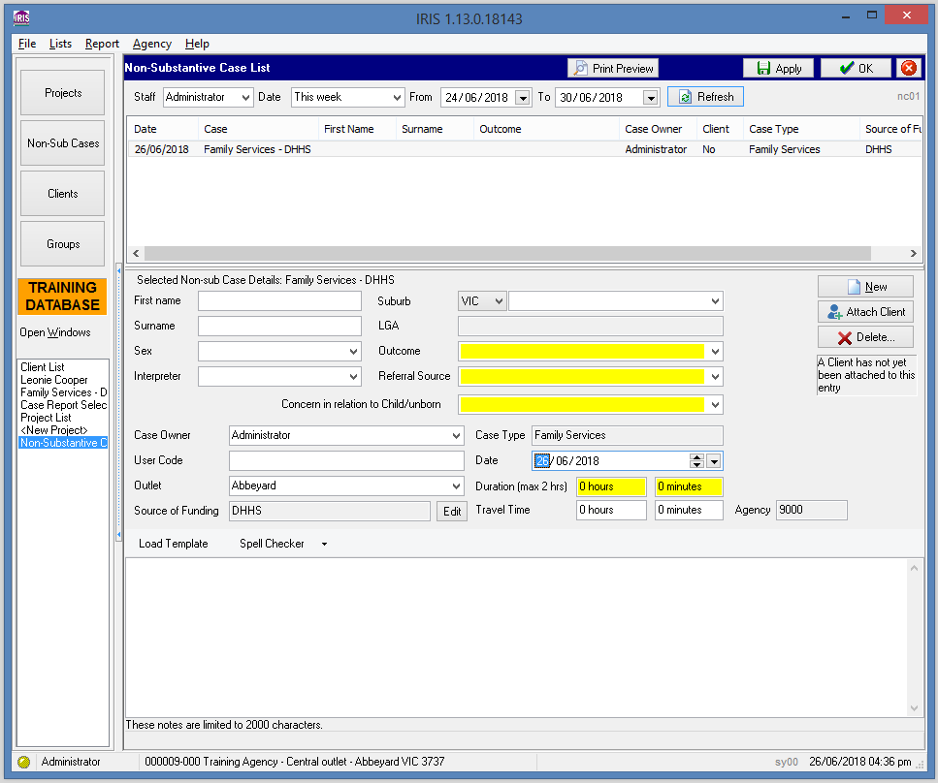

Groups

- The Groups function can be used to record a service for a number of people in one go. Group work could take the form of, for example, an anger management group or a parenting group. And the hours recorded against that group will also show up in the Services section of the individual client’s case.

- The group can be ongoing, i.e. Monday every week, or for a fixed duration.

*Tto create a Group

- Click on the Groups button

- Click New and select a case type.

- Click the ‘Add Client’ button to add clients to the group

- Once the clients have been added, then click the ‘New Service’ button, select a service type and record the hours.

*It’s important to note that in order to be able to add a client to the group and record a service against them, **the client must have an open case that matches the case type of the group.** For example, if the group is opened as a Family Services case type, then the system will only permit a client with an open Family Services case against their name to the added to the group.

Clients who are registered but who do not have an open case can be added to a group, but the system will not permit a service to be recorded against their name. An error: ‘*An open case with a referral date on or prior to the specified service date was not found for the following client(s). NO service will be added for these: …clients names listed*

- A report can be generated and printed off showing the group sessions and attendees by clicking on the ‘Print Preview’ button.

- If a client drops off from a group or is no longer attending, it is possible to make the client inactive by clicking on the clients name (inside the Group section) and removing the tick from ‘Client is Active’.

- Where a client attends at least one session of one of these groups and is not registered as a client, then a new client should be registered and a new case will need to be opened.

Groups screen (John Smith has been made inactive in this example.)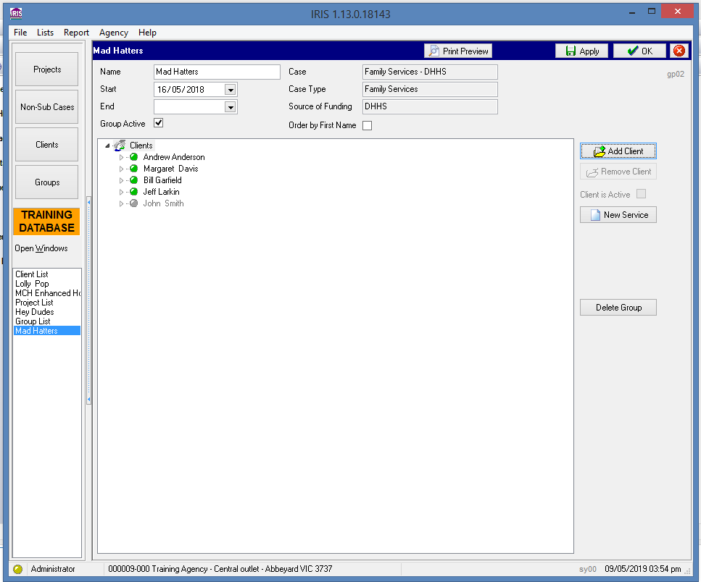

Reports

The reports are essentially designed to assist in the case management of clients, the day to day operational management of the agency.

If you click on ‘Report’ at the top you’ll see the following available report categories in IRIS:

• Projects,

• Non-substantive cases (NSC),

• Cases,

• Throughput,

• Clients.

- The Cases reports often provide the most useful and relevant information for most agencies, and so these are the most frequently used reports in IRIS, with the Stats-Basic & Stats-Full reports offering the most useful comprehensive information.

- The top half of the screen contains the search criteria, and the main search criteria used is: Case Type, Source of Funding and Date Range. *Tick the ‘Open Only’ box if you just want data on open cases.

- Before beginning click ‘Clear’ to clear filters, then key in your selection criteria and hit ‘Refresh’.

*Note: it’s often best not to put too much info in the selection criteria as this can sometimes limit the returns too much. A good start may be inputting the case type, the data range (either referral date or date of service activities in this period).

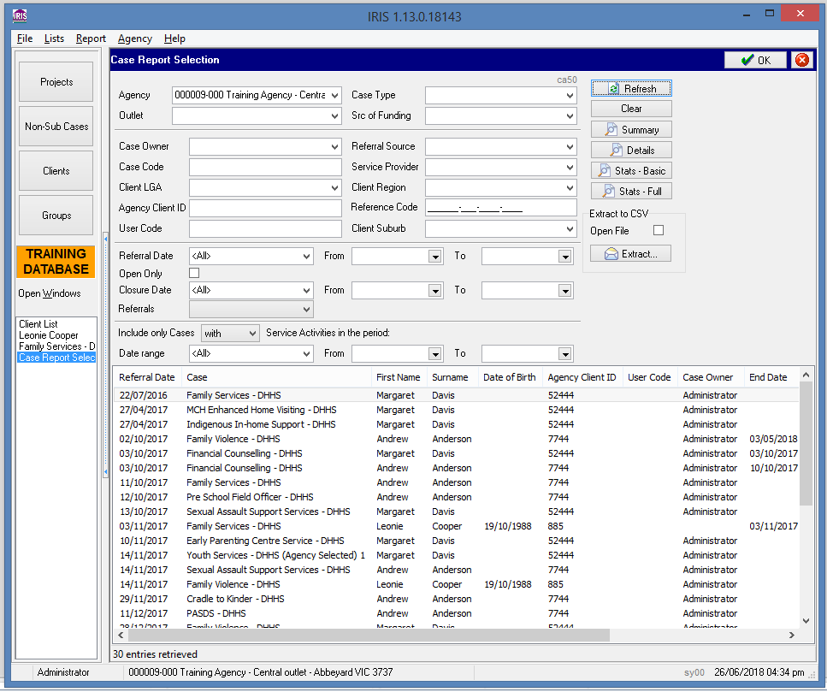

Once you have keyed in your selection criteria and hit ‘Refresh’, the bottom half of the screen will display the number of entries retrieved.

Then select from the report options on the right, i.e. Summary, Details, Statistics etc. (Stats-Basic and Stats-Full are commonly the most useful reports. Just run these if pressed for time.)

Run a Stats-Basic report and scroll down and briefly go through the categories (click the top red arrow to move to the next page).

Projects

Projects can be used to record the work your agency does that does not involve working with groups of registered clients. This project work is variously described as community education, community development, community support or community participation but is not restricted to these descriptions.

Some examples of project work could include:

• Staff member gives a talk to students at a local school;

• Staff member gives a presentation at a local community meeting held after hours;

• Agency provides its facilities for a community fund-raising following a natural disaster; and

• Staff member participates in a community committee

- The project may be ongoing or have a fixed duration, eg. six weeks.

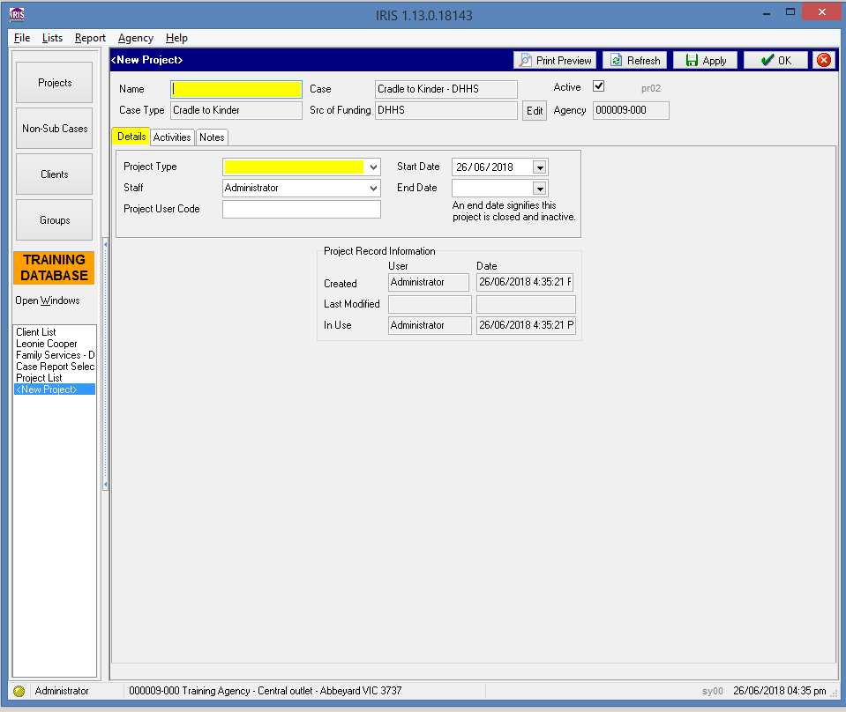

- Click ‘New’ to create a project and select the appropriate case type. Then name the project and specify the start date – **the end date is only used when the project has finished and no more work is to be recorded**.

- Click on the Activities tab to record the duration, project members and duration.

- Click on the Notes tab to add any relevant project information and details.

**Notes:**

* For those agencies who do **Family Services** cases there is a case referral/track process that regularly takes place. The lead agency, known as the Child First agency, often refers or ‘tracks’ cases to a partner agency. The partner agency does the work on the case and when completed, closes the case and ‘tracks’ it back to the Child First agency (using the Track button in IRIS). **For this referral/track process to work, both agencies must be on the same database version for the referrals to be able to be transmitted from one agency to the other.**

* For those running the data export process, agencies must have received a confirmation email to ensure the data has been successfully sent and received by the department. If they received no email, then send the data again or contact the Helpdesk.

# If not on latest IRIS version 1.13.0 Build 18148 please contact the IRIS Helpdesk to get upgraded.

# IRIS Helpdesk: 03 9096 6919

|  |
| --- |
| To receive this publication in an accessible format phone 03 9096 6919, using the National Relay Service 13 36 77 if required, or email [IRIS.Helpdesk@dhhs.vic.gov.au](mailto:IRIS.Helpdesk@dhhs.vic.gov.au)  Authorised and published by the Victorian Government, 1 Treasury Place, Melbourne.  © State of Victoria, Department of Health and Human Services July 2016 |

Email [IRIS.Helpdesk@dhhs.vic.gov.au](mailto:IRIS.Helpdesk@dhhs.vic.gov.au) (Help desk) [IRIS.Data@dhhs.vic.gov.au](mailto:IRIS.Data@dhhs.vic.gov.au) (Data export)